**KodeGo Web Development Batch 3**

Mini Project Number 1 Documentation

**Theme and Sitemap**

**(Revision #1: October 24, 2021)**

**Ryan Gerome V. Regis**

Student

**Ms. Ciel Palacio**

Instructor

**SITEMAP**

Below is the revised planned sitemap for the whole website.

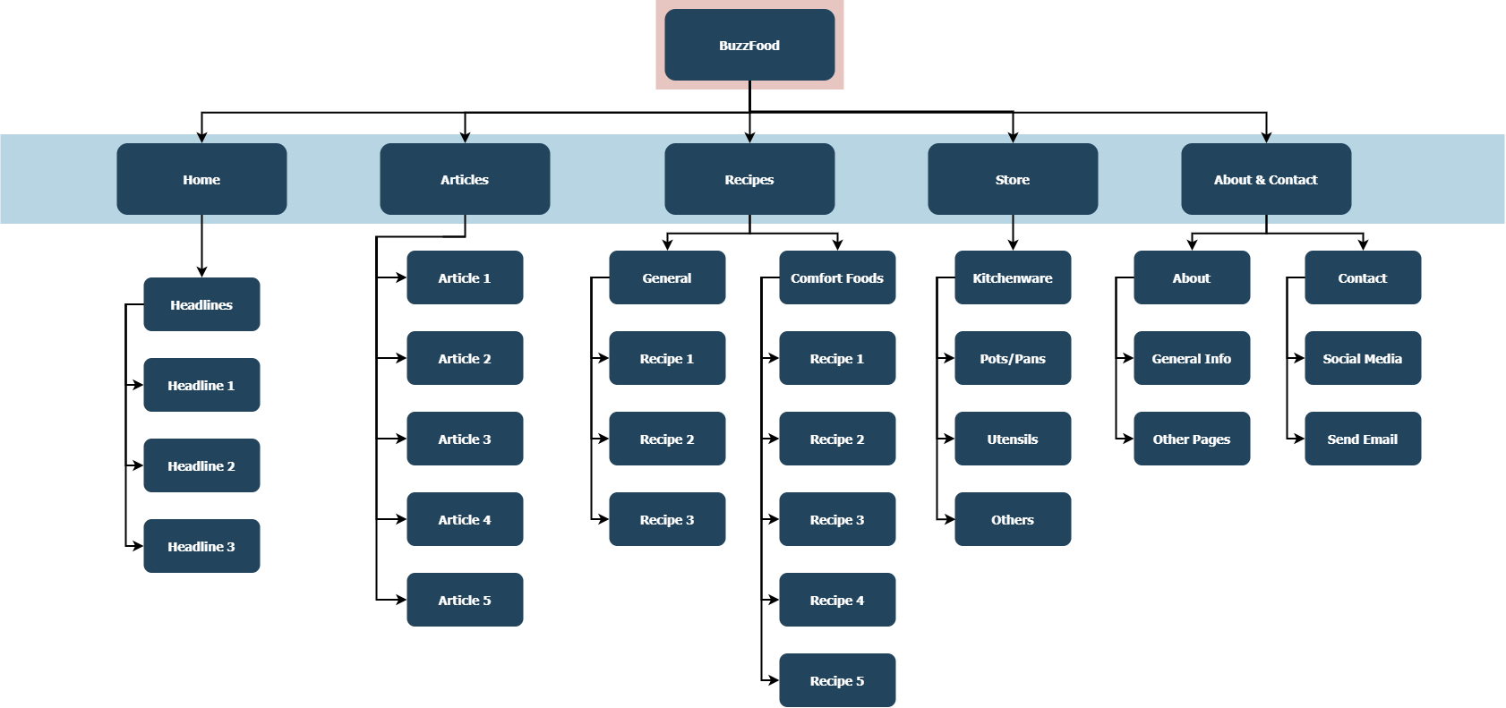

**THEME**

The theme of my mini project is about a **Food Online Magazine**. The title of the mini project is: **BuzzFood**.

The webpage created will have 5 landing pages:

1. Home page

- The main page of the whole website displaying the headlines linking to the articles page.

1. Articles Page

- Contains some articles regarding chefs and the food world.

3. Recipes Page

- containing recipes categorized by "General" and "Comfort Food".

4. Store Page

- A dummy page of where to buy kitchenware provided from the Recipes page.

5. About & Contact Page

- General Info about the creator of the website with links to social media and the ability to send an email to the creator.

**Website Logo**

The following figure is a self-made logo from Figma.

