SYSC 4906: Methodologies for Discrete Event Modelling and Simulation

Carleton University

March 24, 2025

Ryan Rizk 101149094

Repository Link: <https://github.com/ryanrizk1/SYSC4906_Assignment2_101149094>

Fire and Rain Simulation Project

# Introduction

The purpose of this project is to demonstrate understanding of modeling cell spaces using the Cell-DEVS formalism and to convert an existing CD++ project to a new Cadmium V2 project. This project contains a simulation of a field fire that is put out by a moving rain cloud. Multiple scenarios are tested to show the interaction of the fire and rain.

# Cell DEVS Model

## Atomic Model Definition:

TDC = < X, Y, S, N, delay, d, δint, δext, τ, λ, D >

X = Null

Y = Null

I = Null

S = {int state, bool ignited, bool rained}

Rain: state = 0

Grass: state = 1

Weak fire: state = 2

Burnt grass: state = 3

Strong fire: state = 4

N = {(-1, -1), (-1, 0), (-1, 1), (0, -1), (0, 1), (1, -1), (1, 0), (1, 1)} (moore config)

D(state = 0) = 2.0

D(state = 3) = 2.0

D(state = 1) = infinity

D(else) = 1.0

Τ = N -> S

## Rules:

1. If at least one neighbor is raining and it has not previously rained in the cell:
   1. Current cell is raining
2. If state was previously raining:
   1. If cell was previously on fire:
      1. Cell is burnt grass
   2. If cell was not previously on fire:
      1. Cell is grass
3. If at least 3 neighbors are on fire:
   1. Current cell has weak fire
4. If at least 7 neighbors are on fire:
   1. Current cell has large fire

## Sample Configuration:

Define in which cells the rain and fire will begin:

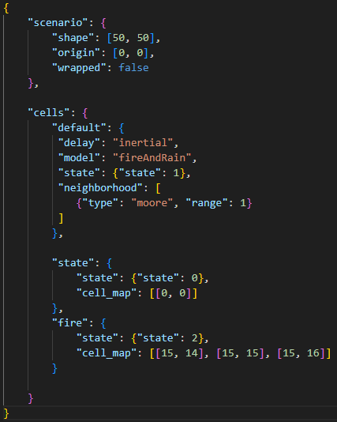

Figure 1: Default configuration

From figure 1, we can see that the fire will begin near the middle of the grid at (15, 14), (15, 15), (15, 16). The rain starts at the origin in the top left of the grid at (0, 0).

# Testing

To test the model, various scenarios were tested in the 50x50 grid. Initially, all cells are set to grass (state = 1). To simulate, rain is spread from the origin cell and fire cells are placed throughout the grid. Over time the simulation shows the spread of the fire to unburnt grass nearby and then being extinguished by the rain. If grass is ignited, it will be burnt when extinguished.

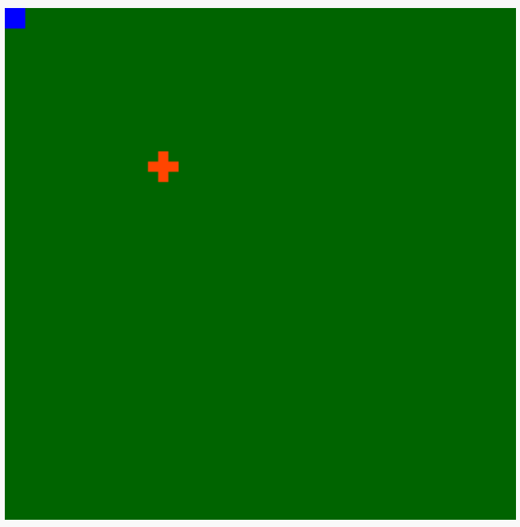

Figure 2: Simulation Testing t = 0

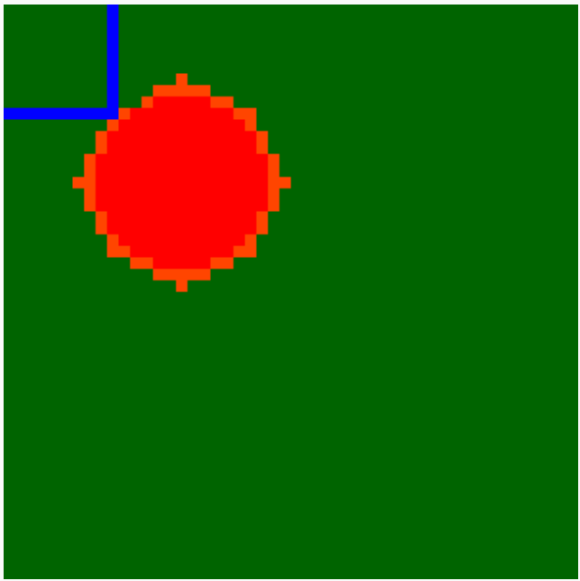

Figure 3: Simulation Testing t = 16

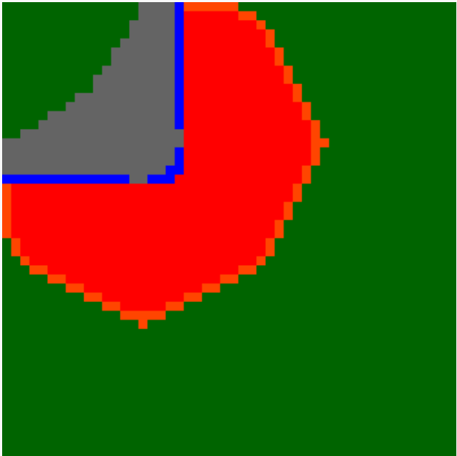

Figure 4: Simulation Testing t = 38

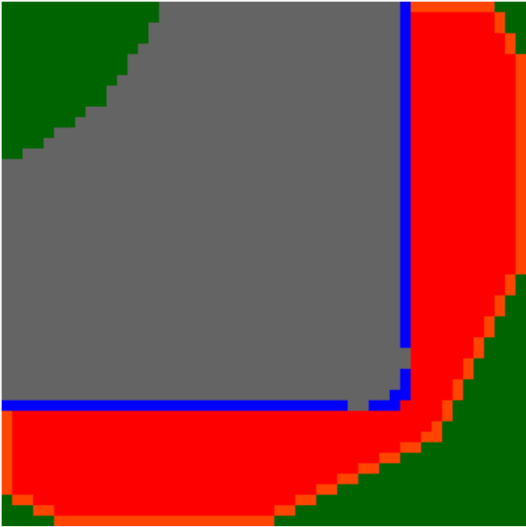

Figure 5: Simulation Testing t = 76



Figure 6: Simulation Testing t = 109

From figures 2-6, we can see that the fire and rain both spread from their initial cells. Any cell that was ignited by the fire and extinguished by the rain ends gray (state = 3). Cells that were not ignited by the fire remain green (state = 1).