# 报关系统维护手册

## 报关

放在深圳的电脑：

恒远TeamViwer：1309376548 密码：112316

芯达通TeamViwer：1205013681密码：112316

### 1、软件开启：

1、中国国际贸易单一窗口客户端（开机自启动，一般不会有问题）

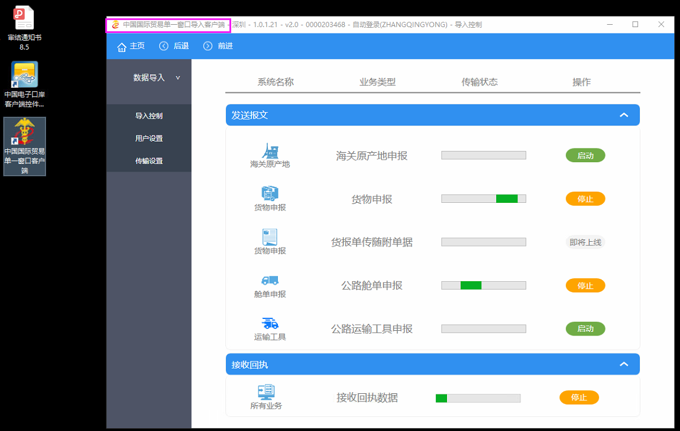

2、报关辅助工具（开机自启动，一般不会有问题）

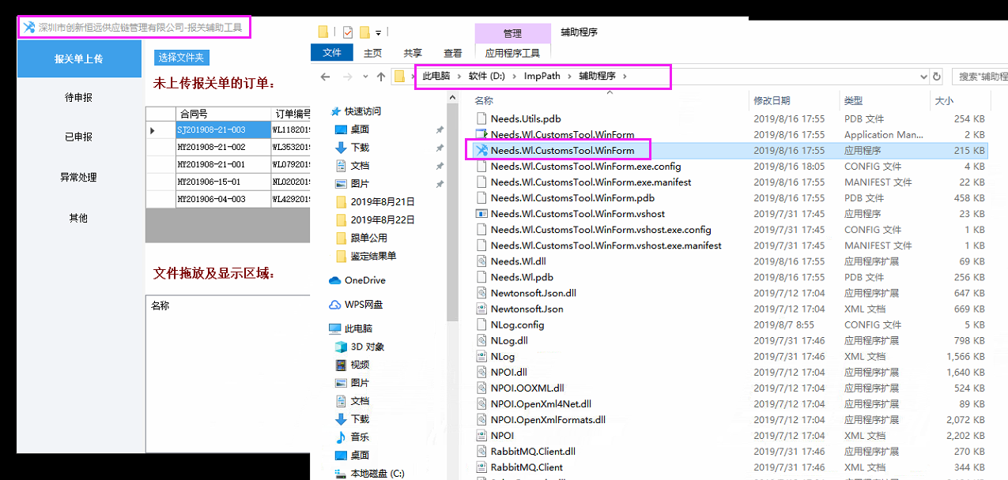

### 2、海关文件夹说明：

1、报关单、舱单主文件夹

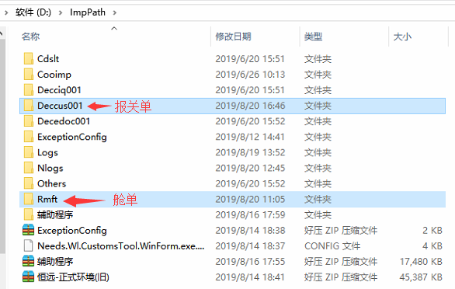

2、

### 3、报关单发送海关失败

* 1. 报关员卡没插好，解决方法，联系报关部，重新插卡后重启电脑

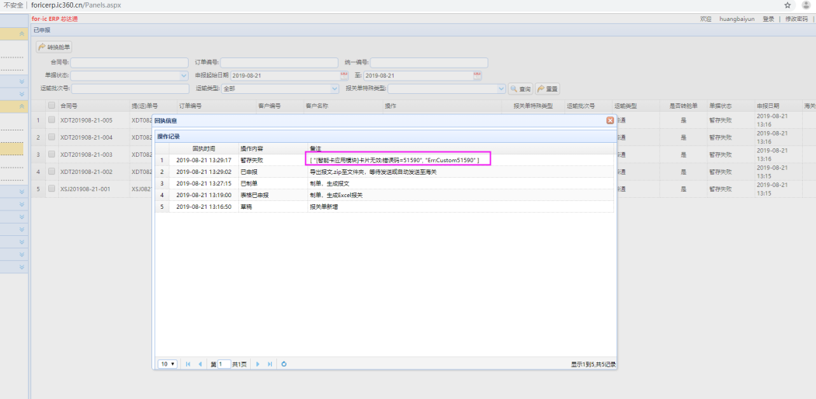

* 1. PDF加签失败

需要手动将失败的PDF去掉，重新压缩后发送海关：

EdocReleation节点，哪个文件失败了就将对应的节点去掉

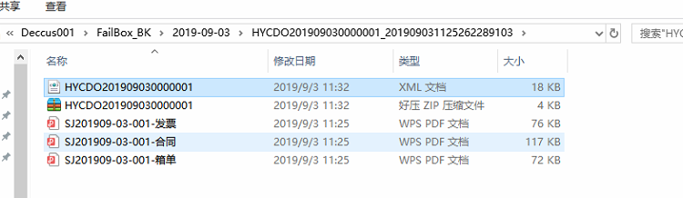

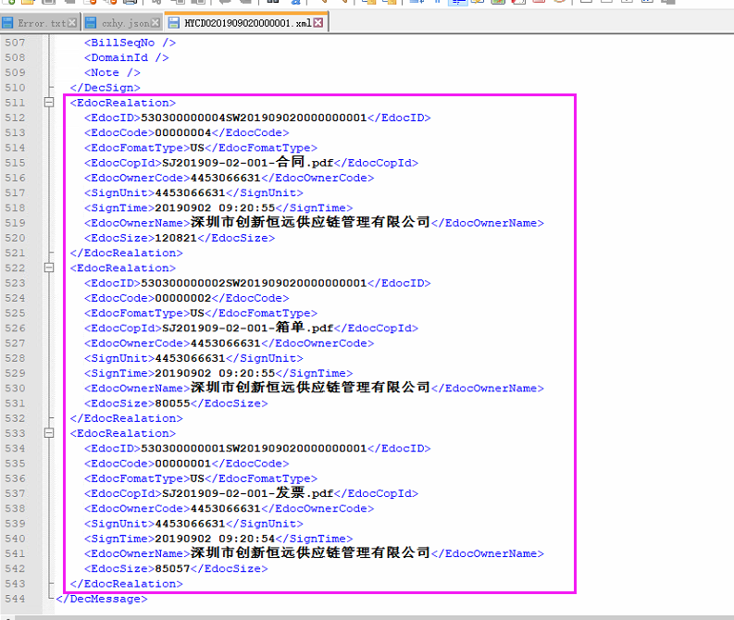

* 1. 重新发送海关

在FailBox中找到相应的报文，移动到OutBox即可（海关程序会自动读取）

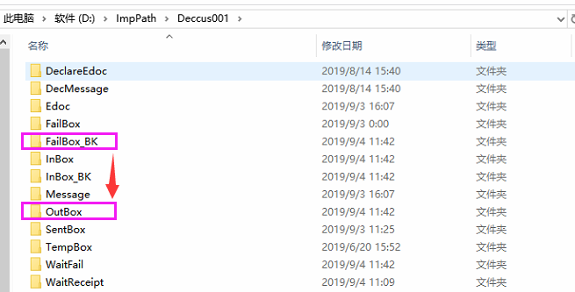

### 4、报关单附件加签失败

看提示可知是发票加签失败

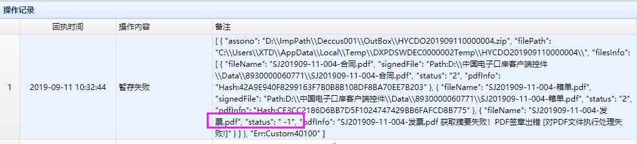

链接到深圳的电脑：

1. 从D:\\ImpPath\\Deccus001\\FailBox_BK\\日期\\HYCDO201909110000004.zip中找到报文
2. 解压后，修改HYCDO201909110000004.xml:拉到最下面，删除发票的EdocRealation节点：

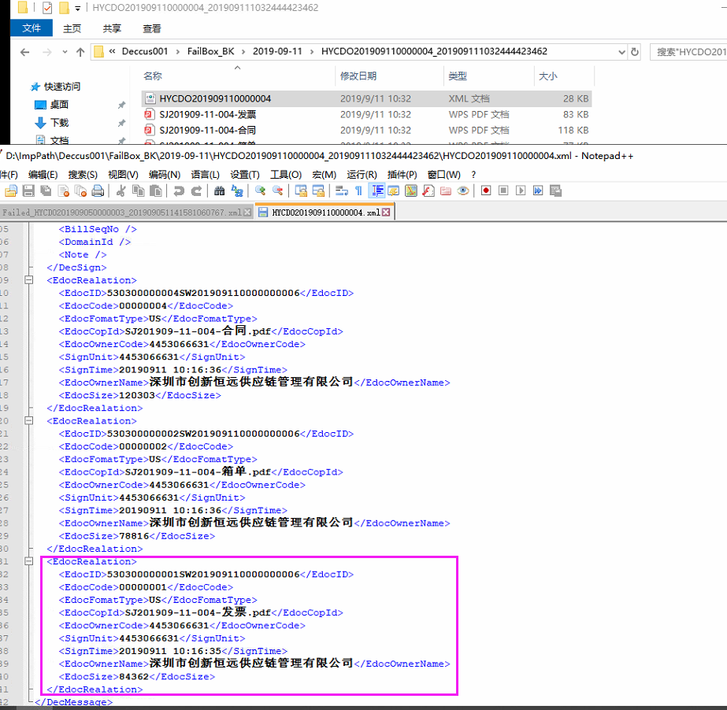

1. 排除掉发票PDF后，其它文件压缩为：HYCDO201909110000004.zip

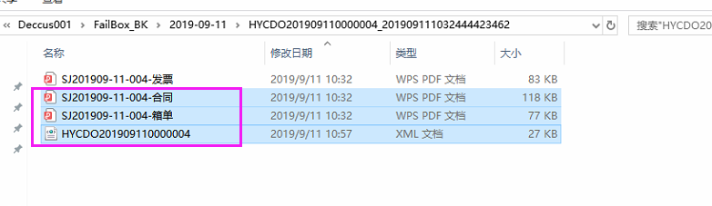

1. 将新生成的报文HYCDO201909110000004.zip
2. 复制到D:\\ImpPath\\Deccus001\\OutBox文件夹中即可。

### 5、商检/3C改为正常单申报

* 1. 找到那份报关单

select * from DecHeads order by CreateTime desc

select * from DecHeads where ContrNo = 'XDT201907-26-004'

select * from DecLists

* 1. 修改相关字段：合同号、提运单号改为“XDT”/“HY”开头

update DecHeads set ContrNo = 'XDT201907-26-004',BillNo = 'XDT0726004', OrgCode = null,VsaOrgCode = null,InspOrgCode = null,PurpOrgCode = null,DespDate = null,

UseOrgPersonCode = null,UseOrgPersonTel = null,DomesticConsigneeEname = null,OverseasConsignorCname = null,OverseasConsignorAddr = null,

CmplDschrgDt = null,IsInspection = 0 where id = 'XDTCDO201907260000004'

update DecLists set GoodsSpec = null,Purpose = null,GoodsAttr = null,GoodsBatch = null,CiqName = null where DeclarationID = 'XDTCDO201907260000004'

## 订单

### 删除还未封箱的型号，剔除型号

* 1. 确认还未报关，没有封箱；
  2. 查询到OrderItemID:

SELECT * FROM dbo.OrderItems LEFT JOIN dbo.Products ON Products.ID = OrderItems.ProductID

WHERE OrderID = 'WL42920190821002' AND Model = 'SF-0603FP025F-2'

* 1. 直接删除相关表：

DELETE FROM dbo.DecLists WHERE OrderItemID = 'OrderItem201908210000000216'

DELETE FROM dbo.PackingItems WHERE SortingID = (SELECT ID FROM dbo.Sortings WHERE OrderItemID = 'OrderItem201908210000000216')

DELETE FROM dbo.DeclarationNoticeItems WHERE SortingID = (SELECT ID FROM dbo.Sortings WHERE OrderItemID = 'OrderItem201908210000000216')

DELETE FROM dbo.Sortings WHERE OrderItemID = 'OrderItem201908210000000216'

DELETE FROM dbo.OrderItemCategories WHERE OrderItemID = 'OrderItem201908210000000216'

DELETE FROM dbo.OrderItemTaxes WHERE OrderItemID = 'OrderItem201908210000000216'

DELETE FROM dbo.EntryNoticeItems WHERE OrderItemID = 'OrderItem201908210000000216'

DELETE FROM dbo.OrderPremiums WHERE OrderItemID = 'OrderItem201908210000000216'

DELETE FROM dbo.OrderItems WHERE ID = 'OrderItem201908210000000216'

备注：已经制单的型号被删掉了，需要修改DecLists表GNo顺序，从1开始排列，不能中断

### 修改型号

* 1. 找到要修改的订单型号ID

SELECT * FROM dbo.OrderItems LEFT JOIN dbo.Products ON Products.ID = OrderItems.ProductID

WHERE OrderID = 'WL42920190823001' AND Model = 'ADUM140D1BRZ-RL7'

* 1. 从product表通过型号找到正确的ProductID

SELECT * FROM dbo.Products WHERE Model = 'ADUM140D1BRZ'

* 1. 修改为正确的Product ID

UPDATE dbo.OrderItems SET ProductID = '37A5A7AB49C70D6CA510F5CAC9E0C359' WHERE ID = 'OrderItem201908230000000024'

### 代理费按照正常收取

* 1. 意思是这个订单不按照最低代理费300/400收，是多少就收多少，原因是单个需要商检的型号，单独作为一单

SELECT * FROM dbo.Orders WHERE id= 'WL43020190822001'

SELECT * FROM dbo.ClientAgreements WHERE ClientID = '10cbbfe9df9721acec8e24374205ffc1'

* 1. 改为1块钱的最低代理费，修改的是此订单使用的协议ID

UPDATE dbo.ClientAgreements SET MinAgencyFee = 1 WHERE ID = 'BCACB0F3405ABBC9DCF2CDFDF914CAB1'

* 1. 待跟单员生成对账单之后，将协议改回去

UPDATE dbo.ClientAgreements SET MinAgencyFee = 300 WHERE ID = 'BCACB0F3405ABBC9DCF2CDFDF914CAB1'

### 特殊对账单要求

一个订单两个实时汇率

SELECT * FROM dbo.Orders WHERE id= 'WL12020190621001'

SELECT * FROM dbo.ClientAgreements WHERE ClientID = '93103b134e228594bd8eabb32cf3fab1'

SELECT * FROM dbo.ClientFeeSettlements WHERE AgreementID = '1C544155D9E77BAD1D8347136DA81C74' AND FeeType = 3

UPDATE dbo.ClientFeeSettlements SET ExchangeRateValue = 6.8940 WHERE AgreementID = '1C544155D9E77BAD1D8347136DA81C74' AND FeeType = 3

--假的

UPDATE dbo.Orders SET ClientAgreementID = '1C544155D9E77BAD1D8347136DA81C74' WHERE ID = 'WL12020190621001'

--真的

UPDATE dbo.Orders SET ClientAgreementID = '845ae52f902930d2a9e5831fb8f671dc' WHERE ID = 'WL12020190708001'

### 付汇申请退回重新审核(跟单)

SELECT * FROM dbo.Orders WHERE ID = 'WL48520190828001'

SELECT * FROM dbo.PayExchangeApplies WHERE ClientID = '3872227B56EB69CB486E221384EC9956'

根据创建日期等确定是哪一条记录，修改状态为“未审核 = 1”

UPDATE dbo.PayExchangeApplies SET PayExchangeApplyStatus = 1 WHERE ID = 'PEA20190906003'

## 归类

### 预归类型号退回重新归类

SELECT * FROM dbo.PreProductCategories WHERE Model = '643815-2'

根据归类日期确定ID后修改ClassifyStatus 即可

UPDATE dbo.PreProductCategories SET ClassifyStatus = 1 WHERE ID = '1E59D1AADEA64D059AE4CD30E7577F3F'

### 产品归类型号退回重新归类

SELECT * FROM dbo.OrderItems

LEFT JOIN dbo.Products ON Products.ID = OrderItems.ProductID

WHERE OrderID = 'WL42920190821002' AND Model = 'SF-0603FP025F-2'

UPDATE dbo.OrderItems SET ClassifyStatus = '1' WHERE ID = 'OrderItem201907130000000412'

## 库房

### 1、统计运输批次对应总件数

SELECT SUM(PackNo) FROM dbo.DecHeads WHERE VoyNo = '1100319013892'

### 深圳库房自动出库异常

SELECT * FROM dbo.ExitNotices WHERE OrderID = 'ICG0120190903001'

SELECT * FROM dbo.EntryNotices WHERE OrderID = 'ICG0120190903001'

DELETE FROM dbo.StoreStorages WHERE SortingID IN(SELECT ID FROM dbo.Sortings WHERE OrderID = 'ICG0120190830004' AND WarehouseType = 200)

DELETE FROM dbo.Sortings WHERE OrderID = 'ICG0120190830004' AND WarehouseType = 200 AND CreateDate <= '2019-08-16 15:51'

UPDATE dbo.ExitNotices SET ExitNoticeStatus = 2 WHERE ID = 'N20190814012'