http://www.for-ic.net

芯达通-代理报关委托书

订单编号:

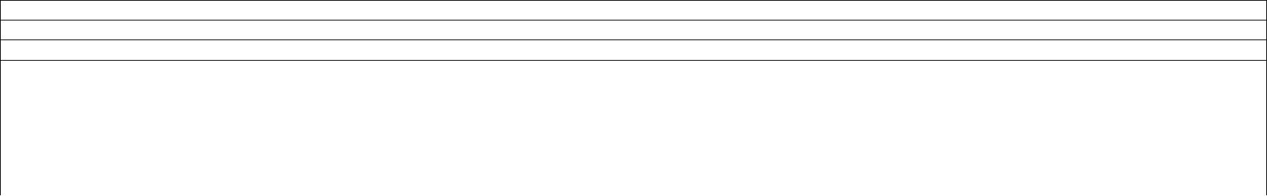

委托方名称:

委托方收货信息: /地址: /联系人: /电话:

代理方名称: 深圳市芯达通供应链管理有限公司

代理方收货信息: HONGKONG CHANGYUN INTERNATIONAL LOGISTICS CO.,LIMITED/地址: 香港九龙官塘鸿图道/联系人: 林团裕/电话: （852）31019258

|  |  |  |  |  |  |  |  |  |  |  |  |  |
| --- | --- | --- | --- | --- | --- | --- | --- | --- | --- | --- | --- | --- |
| 序号 | 批号 | 品名 | 品牌 | 规格型号 | | 产地 | 数量 | 单位 | 报关单价 | 报关总价 | 关税率 |  |
| (HKD) | (HKD) |  |
|  |  |  |  |  |  |  |  |  |  |  |
| 1 |  |  |  |  | |  |  |  |  |  |  |  |
| 2 |  |  |  |  | |  |  |  |  |  |  |  |
| 3 |  |  |  |  | |  |  |  |  |  |  |  |
|  |  |  | 合计: |  |  |  |  |  |  |  |  |  |
| 包装类型: 散装 | |  |  |  |  |  |  |  |  |  |  |  |
|  | |  |  |  |  |  |  |  |  |  |  |  |
| 温馨提示: | |  |  |  |  |  |  |  |  |  |  |  |
| 1.我单位保证遵守《中华人民共和国海关法》及国家有关法规保证所提供的委托信息与所报的货物相符。 | | | | | |  |  |  |  |  |  |  |
| 2.委托方务必真实填写，若因委托方虚报、假报、多报、少报等因素造成的扣关、罚款等后果由委托方自行承担。 | | | | | |  |  |  |  |  |  |  |
| 3.委托方一份报关单最多20个型号，超过部分按另一单结算，依此类推。 | | | |  |  |  |  |  |  |  |  |  |
| 4.委托方需即时签字盖章回传，如因委托方延误回传造成的延迟申报，代理方不承担责任。 | | | | | |  |  |  |  |  |  |  |
|  | |  |  |  |  |  |  |  |  |  |  |  |
| 代理方盖章:： | |  |  |  | 委托方(签字/盖章): |  |  |  |  |  |  |  |
|  |  |  |  |  |  |  |  |  |  |  |  |  |



深圳市芯达通供应链管理有限公司