INDIAKART
E-COMMERCE ANALYTICS
Management Report
Data Analytics Project

Prepared by | Hemanth
Tools | Python • Pandas • SQL • Power BI
Report period | Project dataset covering 2023–2025
Prepared | September 2026

Purpose: Provide management with a concise view of revenue, customers, products, operations, and inventory risks, supported by the completed five-page Power BI dashboard.

INDIAKART • EXECUTIVE SUMMARY
Executive Summary
Headline performance and business priorities
GMV  ₹314.74 Cr | Net Revenue  ₹205.39 Cr | Total Orders  50K | Delivered Orders  32K
Total Customers  10K | AOV  ₹63.20K | Inventory Fill Rate  92.20% | Return Rate  30.77%

IndiaKart generated ₹314.74 Cr in gross merchandise value and ₹205.39 Cr in net revenue across 50K orders. The customer base stands at 10K, with an average order value of ₹63.20K. Operationally, 32K orders were delivered, while the cancellation rate was 11.99%, the return rate was 30.77%, and the payment failure rate was 3.50%.
Revenue is highly concentrated: the leading product category contributes 57.41% of category revenue. Inventory availability is strong overall at 92.20%, but 76 products are low stock and 2 are out of stock, creating a targeted replenishment requirement rather than a system-wide stock shortage.
Priority management focus: Reduce returns and cancellations, protect availability of high-revenue products, improve category diversification, and use customer segmentation to increase repeat purchasing and premium-segment value.

Key management questions answered
- Which categories and products contribute the most revenue?
- Which customer segments spend and order the most?
- Where are operational losses occurring through cancellations, returns, and payment failures?
- Which inventory items require immediate replenishment attention?
- Which geographic and payment patterns can guide commercial decisions?

INDIAKART • DATA & METHODOLOGY
Data Foundation and Analytical Method
Project dataset, quality checks, modelling, and dashboard workflow
The analytical model combines eight business tables covering customers, orders, order items, payments, products, inventory, returns, and suppliers. A dedicated Date Table was used in Power BI for time-based analysis and monthly trend reporting.
Table | Rows | Role in analysis
Customers | 10,000 | Customer profile, segment, geography, spend
Inventory | 1,000 | Availability, reorder levels, stock status
Order Items | 100,000 | Product-level quantity and revenue analysis
Orders | 50,000 | Order status, dates, value, channel
Payments | 50,000 | Payment method, failure, refund analysis
Products | 1,000 | Category, supplier, pricing, ratings
Returns | 10,000 | Return reasons and return records
Suppliers | 200 | Supplier and sourcing attributes

Data quality check: Duplicate-row checks returned zero duplicates across all eight source tables. The dashboard model also uses explicit relationships between core entities and a Date Table for consistent filtering.

Analytical workflow
- Python/Pandas: initial inspection, row counts, duplicate checks, and exploratory analysis.
- SQL concepts: structured querying and business-rule validation.
- Power BI data model: relationships across customers, orders, products, inventory, payments, returns, and suppliers.
- DAX measures: revenue, customer, cancellation, return, payment, inventory, and product KPIs.
- Power BI dashboards: five management pages with slicers for time, geography, segment, supplier, payment method, and warehouse.

INDIAKART • DASHBOARD REVIEW
1. Revenue Overview
Power BI dashboard page and management interpretation
GMV  ₹314.74 Cr | Net Revenue  ₹205.39 Cr | AOV  ₹63.20K | Top Category Share  57.41%

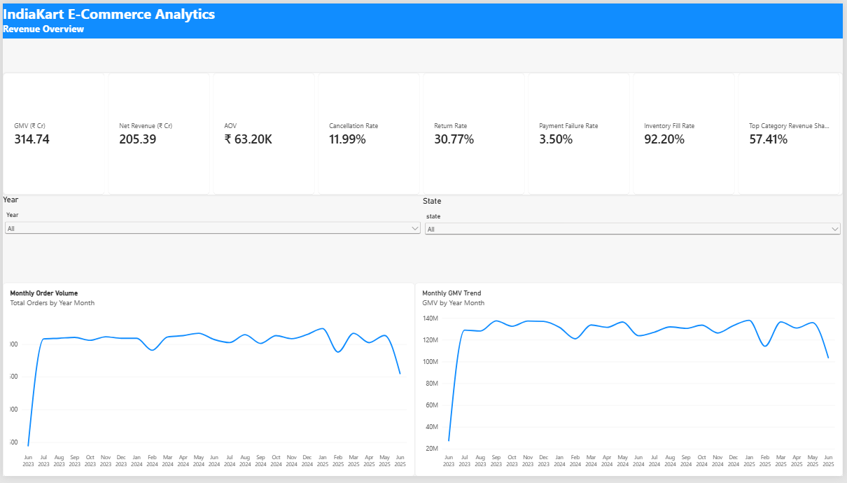
Key observations
- Monthly GMV is broadly stable after the initial ramp-up, with several short-term dips that warrant event-level investigation.
- Net revenue is materially below GMV, indicating the combined effect of cancellations, returns, discounts, refunds, and related deductions.
- A single category contributes 57.41% of category revenue, creating both a strong revenue engine and a concentration risk.
- Year and state slicers make it possible to isolate seasonal and geographic performance quickly.
Management implication: Protect the leading revenue category while building growth in secondary categories. Track the causes of monthly revenue dips alongside return, cancellation, and stock-availability metrics.

INDIAKART • DASHBOARD REVIEW
2. Customer Analysis
Power BI dashboard page and management interpretation
Customers  10K | Avg. Spend  ₹314.74K | Avg. Orders  5.00 | Premium Share  15.01%

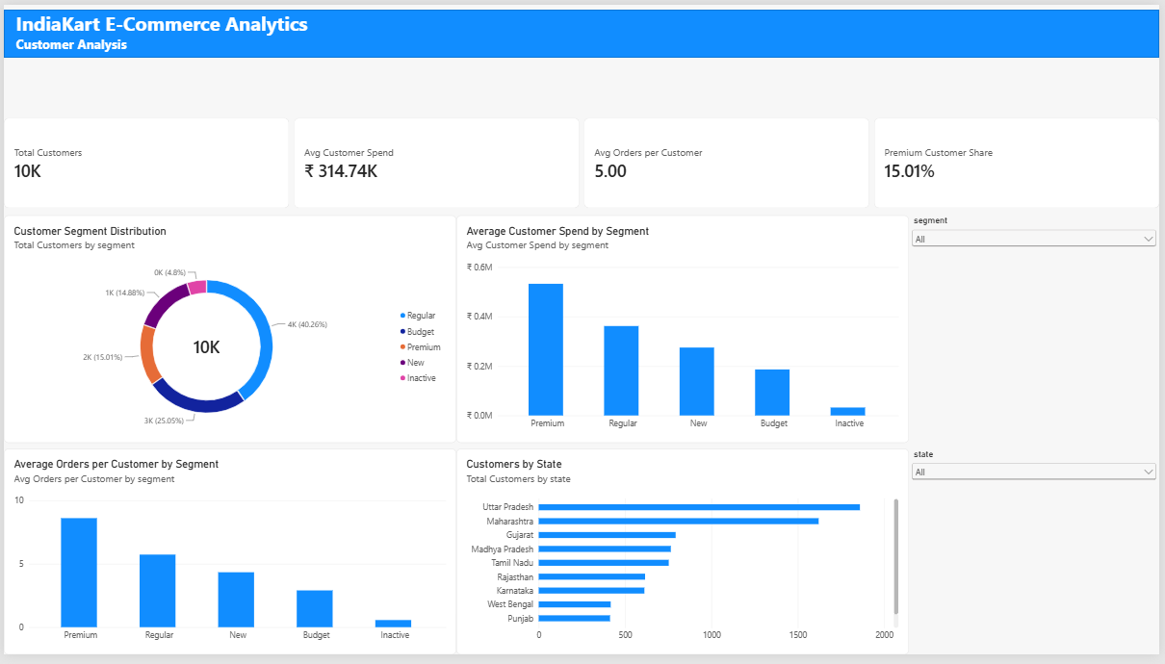
Key observations
- Regular customers are the largest segment, while Premium customers form a smaller but higher-value group.
- Premium customers lead both average customer spend and average orders per customer, indicating strong lifetime-value potential.
- Uttar Pradesh and Maharashtra are the largest customer states in the Top 10 view, followed by Gujarat and Madhya Pradesh.
- Segment and state slicers support targeted campaign and regional performance analysis.
Management implication: Prioritize retention, loyalty, and cross-sell initiatives for Premium and Regular customers. Use state-level concentration to localize promotions and service improvements.

INDIAKART • DASHBOARD REVIEW
3. Product Analysis
Power BI dashboard page and management interpretation
Products  1K | Categories  10 | Avg. Product Price  ₹13.38K | Units Sold  200K

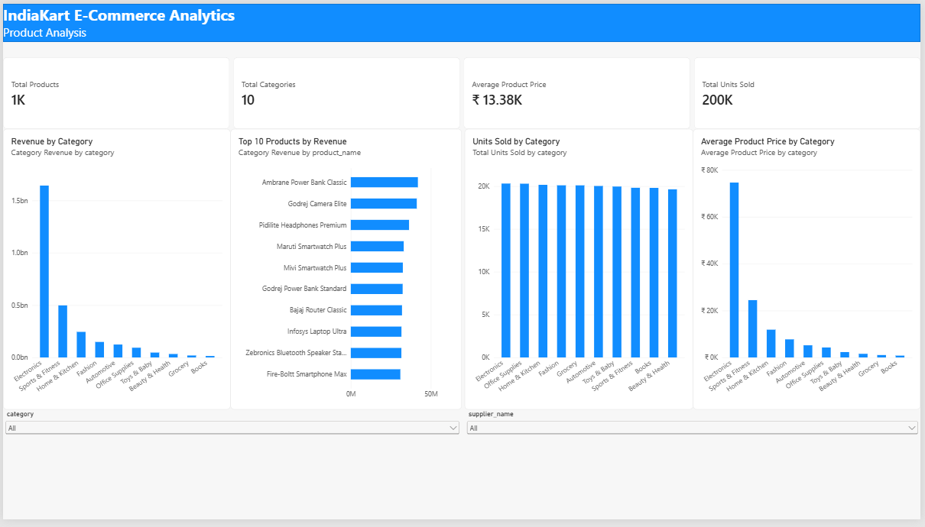
Key observations
- Electronics dominates revenue by a wide margin and is also the highest-priced category on average.
- The Top 10 revenue products include items such as Ambrane Power Bank Classic, Godrej Camera Elite, and Pidilite Headphones Premium.
- Units sold are relatively even across categories, suggesting that revenue differences are driven strongly by price and product mix rather than volume alone.
- Category and supplier slicers allow product performance to be analyzed by sourcing partner.
Management implication: Protect availability and supplier performance for high-value electronics while evaluating margin and growth opportunities in categories with high unit volume but lower revenue contribution.

INDIAKART • DASHBOARD REVIEW
4. Orders & Operations
Power BI dashboard page and management interpretation
Total Orders  50K | Delivered  32K | Cancellation  11.99% | Payment Failure  3.50%

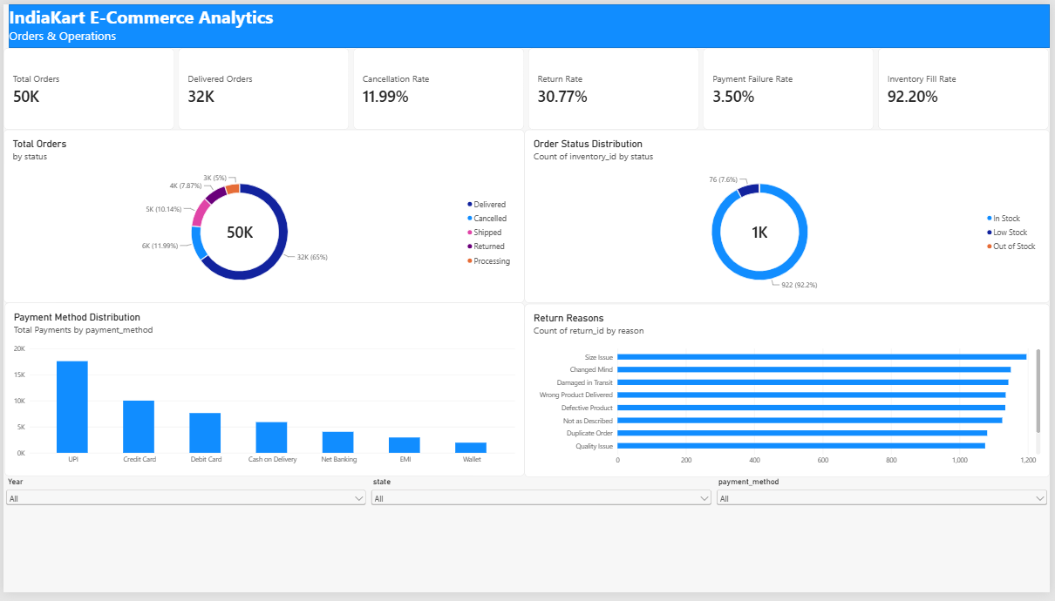
Key observations
- Delivered orders account for roughly two-thirds of total orders; cancellations, shipped, returned, and processing orders make up the remainder.
- UPI is the most-used payment method, followed by credit card and debit card.
- The return-reason chart shows several sizeable causes rather than one isolated issue, including size issues, changed mind, damaged-in-transit, wrong-product, and defective-product cases.
- The same page combines order, payment, return, and inventory status views, enabling cross-functional operational monitoring.
Management implication: A focused return-reduction program should address product quality, fulfilment accuracy, packaging, and product-description/size clarity. Payment-failure analysis should prioritize the highest-volume payment methods.

INDIAKART • DASHBOARD REVIEW
5. Inventory Alert
Power BI dashboard page and management interpretation
Inventory Value  ₹211.19 Cr | Low Stock  76 | Out of Stock  2 | Fill Rate  92.20%

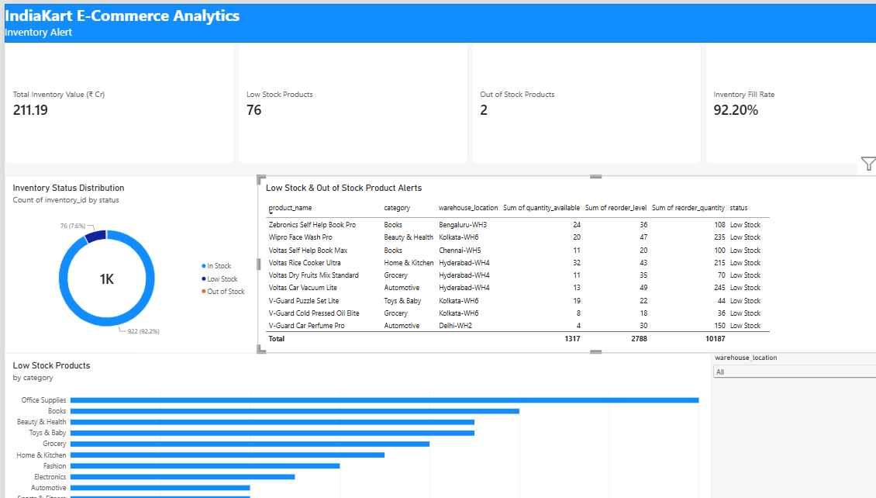
Key observations
- Overall inventory health is strong, with 92.20% of SKUs in stock.
- The main immediate risk is concentrated in 76 low-stock products and 2 out-of-stock products.
- Office Supplies has the highest count of low-stock products, followed by Books; several other categories also require targeted replenishment.
- The alert table identifies affected products by warehouse together with quantity available, reorder level, reorder quantity, and status.
Management implication: Use the alert table as a replenishment worklist. Prioritize stock actions by sales velocity, revenue contribution, warehouse location, and reorder quantity rather than applying blanket replenishment.

INDIAKART • MANAGEMENT ACTION PLAN
Management Recommendations
Prioritized actions derived from the dashboard
# | Action | Management rationale
1 | Reduce returns at source | Create a return-reason action plan covering size/description accuracy, fulfilment errors, damaged shipments, and defective products. Track return rate by category and supplier.
2 | Lower cancellation leakage | Analyze cancellation rate by state, channel, category, and order stage. Address preventable cancellations through stock validation, delivery promise accuracy, and proactive customer communication.
3 | Protect high-value revenue | Electronics drives a disproportionate share of revenue. Maintain high availability, monitor supplier reliability, and avoid stock-outs on top-revenue products.
4 | Diversify category contribution | The top category contributes 57.41% of category revenue. Build growth plans for secondary categories to reduce concentration risk while preserving the core category.
5 | Monetize high-value customers | Use Premium and Regular customer segments for loyalty, personalized recommendations, bundles, and reactivation journeys based on spend and order frequency.
6 | Act on inventory alerts | Replenish the 76 low-stock and 2 out-of-stock SKUs using warehouse-level reorder quantities, weighted by sales velocity and revenue importance.
7 | Improve payment reliability | Prioritize monitoring of UPI and card payment failure patterns because they account for the largest transaction volumes.
8 | Institutionalize weekly KPI review | Review GMV, net revenue, AOV, cancellation, return, payment failure, fill rate, low-stock count, and top-category share together to avoid siloed decisions.

Suggested review cadence: Weekly operational review for cancellations, returns, payments, and inventory alerts; monthly management review for revenue mix, customer segments, category concentration, and supplier performance.

INDIAKART • CONCLUSION
Conclusion
How the analytics solution supports management decisions
The IndiaKart analytics solution converts transaction, customer, product, payment, return, supplier, and inventory data into a single management view. The five-page Power BI dashboard gives decision-makers both high-level KPIs and drillable operational detail.
The strongest commercial opportunity is to protect the high-performing product and customer segments while reducing value leakage from returns, cancellations, payment failures, and low-stock situations. The completed dashboard provides a practical foundation for recurring performance reviews and future predictive or automated analytics.
Project outcome: A complete end-to-end analytics portfolio project covering data inspection, modelling, DAX KPI creation, interactive Power BI dashboarding, and management-level interpretation.

Dashboard pages delivered
- Revenue Overview
- Customer Analysis
- Product Analysis
- Orders & Operations
- Inventory Alert

— End of Report —

