StreamFlix — Data Dictionary
Companion reference for the Content Analytics Project
This document defines every table and column in the StreamFlix dataset. The data is organised as a star schema: watch_history is the central fact table, with subscribers and titles as the two main dimension tables. The ratings, reviews and watchlist tables each link a subscriber to a title.

1. Entity-Relationship Diagram
The diagram below shows the six tables and how they join. Every event table links back to both subscribers (via subscriber_id) and titles (via title_id).
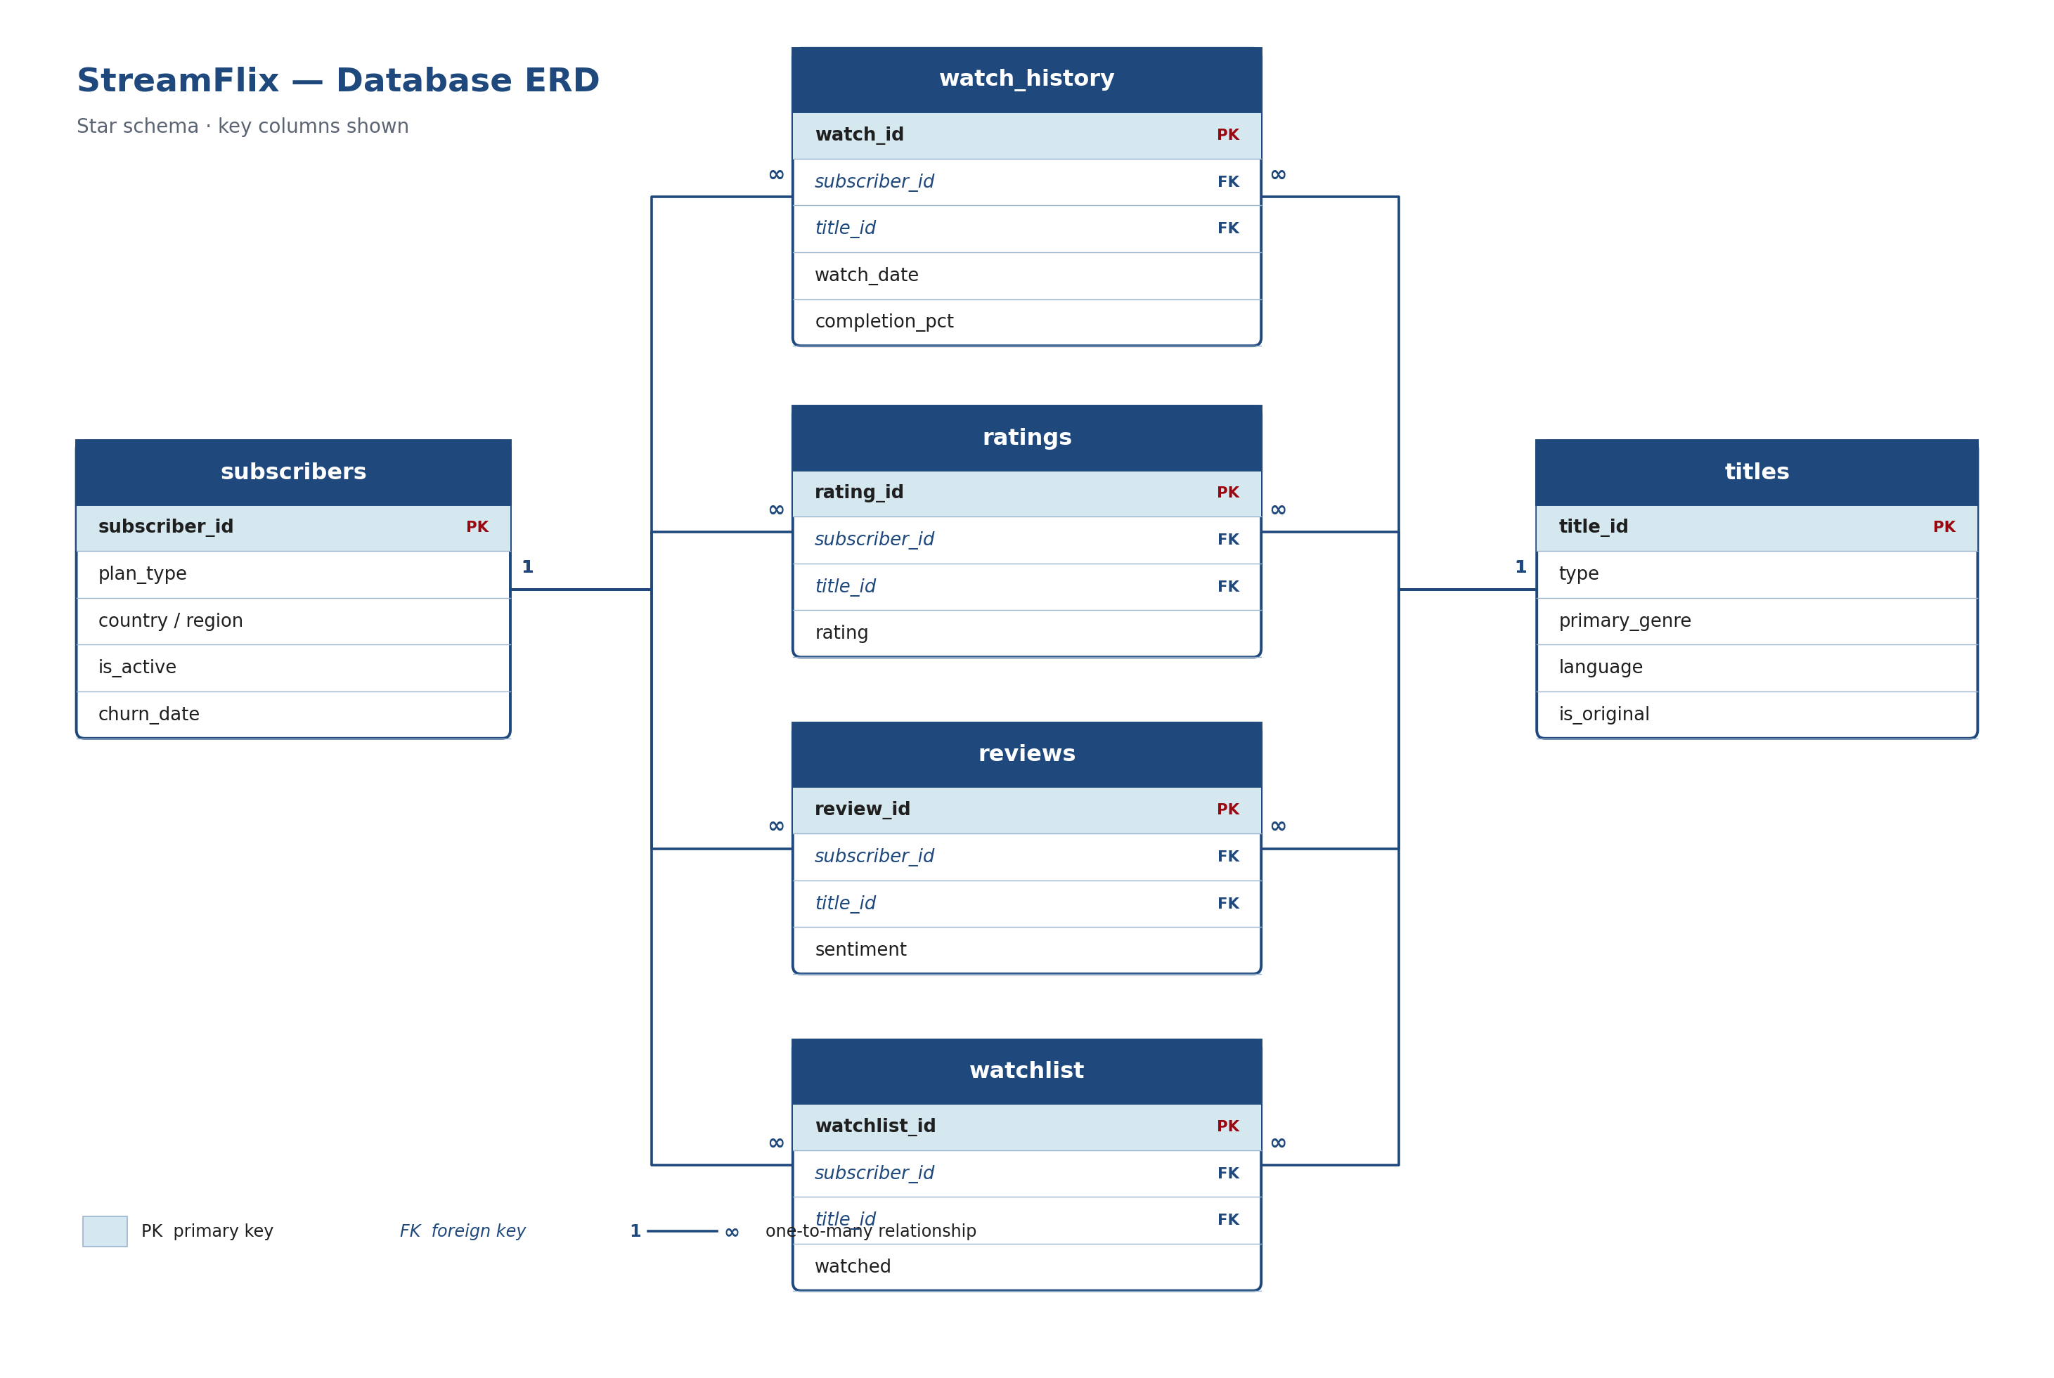

2. Tables at a Glance
Table | Grain (1 row =) | Rows | Primary Key
subscribers | one subscriber | 15,000 | subscriber_id
titles | one movie or series | 9,000 | title_id
watch_history | one viewing session | 650,000 | watch_id
ratings | one star rating | 130,000 | rating_id
reviews | one written review | 110,000 | review_id
watchlist | one saved title | 65,000 | watchlist_id

3. Column Definitions

3.1 subscribers
Column | Type | Key | Description
subscriber_id | VARCHAR | PK | Unique subscriber identifier
signup_date | DATE |  | Date the subscriber joined StreamFlix
country | VARCHAR |  | Subscriber's country (20 values)
region | VARCHAR |  | World region derived from country (9 values)
age | INT |  | Subscriber age in years (13–85)
gender | VARCHAR |  | Female / Male / Non-binary / Undisclosed
plan_type | VARCHAR |  | Basic with Ads / Standard / Premium
monthly_price_usd | DECIMAL |  | Monthly subscription price (6.99 / 15.49 / 22.99)
household_size | INT |  | Number of people in the household
primary_device | VARCHAR |  | Device most used by the subscriber
payment_method | VARCHAR |  | Credit Card / Debit Card / PayPal / Mobile Wallet / Gift Card / Carrier Billing
tenure_months | INT |  | Months since signup (as of 2026-06-01)
is_active | BOOLEAN |  | Whether the account is currently active
churn_date | DATE |  | Date of churn; blank if still active

3.2 titles
Column | Type | Key | Description
title_id | VARCHAR | PK | Unique title identifier
title_name | VARCHAR |  | Name of the movie or series
type | VARCHAR |  | Movie or TV Show
primary_genre | VARCHAR |  | Main genre (16 values)
country | VARCHAR |  | Country of origin (20 values)
language | VARCHAR |  | Primary language (14 values)
release_year | INT |  | Year the title was released (1969–2026)
date_added | DATE |  | Date the title was added to the catalogue
maturity_rating | VARCHAR |  | Content rating (e.g. PG, TV-MA, R)
seasons | INT |  | Number of seasons; 0 for movies
content_duration_min | INT |  | Runtime per play in minutes
is_original | BOOLEAN |  | Whether it is a StreamFlix Original
license_type | VARCHAR |  | Original / Exclusive License / Non-Exclusive License / Co-Production
director | VARCHAR |  | Director name
cast | VARCHAR |  | Comma-separated principal cast
quality_score | DECIMAL |  | Internal quality score (0–100)
popularity_score | DECIMAL |  | Relative popularity weight (0–1)
license_cost_usd | DECIMAL |  | Cost to license or produce the title
license_expiry | DATE |  | Licence expiry date; blank for Originals
total_watch_hours | DECIMAL |  | Total hours watched across all subscribers
total_plays | INT |  | Total viewing sessions started

3.3 watch_history (central fact table)
Column | Type | Key | Description
watch_id | BIGINT | PK | Unique viewing-session identifier
subscriber_id | VARCHAR | FK | Links to subscribers.subscriber_id
title_id | VARCHAR | FK | Links to titles.title_id
watch_date | DATE |  | Date of the viewing session
device | VARCHAR |  | Device used (6 values)
region | VARCHAR |  | Region where the session occurred (9 values)
content_duration_min | INT |  | Full length of the content in minutes
watch_duration_min | DECIMAL |  | Minutes actually watched in the session
completion_pct | DECIMAL |  | Percent of the content completed (0–100)
completed | BOOLEAN |  | Whether the session passed the completion threshold

3.4 ratings
Column | Type | Key | Description
rating_id | BIGINT | PK | Unique rating identifier
subscriber_id | VARCHAR | FK | Links to subscribers.subscriber_id
title_id | VARCHAR | FK | Links to titles.title_id
rating | INT |  | Star rating on a 1–5 scale
rating_date | DATE |  | Date the rating was given

3.5 reviews
Column | Type | Key | Description
review_id | BIGINT | PK | Unique review identifier
subscriber_id | VARCHAR | FK | Links to subscribers.subscriber_id
title_id | VARCHAR | FK | Links to titles.title_id
review_text | VARCHAR |  | Free-text review
sentiment | VARCHAR |  | Positive / Neutral / Negative
helpful_votes | INT |  | Number of helpful votes the review received
review_date | DATE |  | Date the review was posted

3.6 watchlist
Column | Type | Key | Description
watchlist_id | BIGINT | PK | Unique watchlist-entry identifier
subscriber_id | VARCHAR | FK | Links to subscribers.subscriber_id
title_id | VARCHAR | FK | Links to titles.title_id
added_date | DATE |  | Date the title was added to the watchlist
watched | BOOLEAN |  | Whether the saved title was later watched

4. Relationships
All relationships are one-to-many, flowing from the dimension tables to the event tables:
- subscribers (1) → (many) watch_history, ratings, reviews, watchlist — via subscriber_id
- titles (1) → (many) watch_history, ratings, reviews, watchlist — via title_id
Join example: pd.merge(watch_history, titles, on='title_id', how='left') links each session to its content metadata. Add a second merge on subscriber_id to bring in subscriber attributes.

5. Category Value Reference
Field | Allowed Values
plan_type | Basic with Ads, Standard, Premium
type | Movie, TV Show
primary_genre | Action, Animation, Comedy, Crime, Documentary, Drama, Fantasy, Horror, Kids & Family, Musical, Mystery, Reality, Romance, Sci-Fi, Stand-Up, Thriller
language | Arabic, English, French, German, Hindi, Indonesian, Italian, Japanese, Korean, Portuguese, Spanish, Swedish, Thai, Turkish
region | Africa, East Asia, Europe, Latin America, Middle East, North America, Oceania, South Asia, Southeast Asia
primary_device / device | Smart TV, Mobile, Laptop, Tablet, Game Console, Streaming Stick
payment_method | Credit Card, Debit Card, PayPal, Mobile Wallet, Gift Card, Carrier Billing
gender | Female, Male, Non-binary, Undisclosed
maturity_rating | G, PG, PG-13, R, NC-17, TV-Y, TV-G, TV-PG, TV-14, TV-MA
license_type | Original, Exclusive License, Non-Exclusive License, Co-Production
sentiment | Positive, Neutral, Negative

6. Notes for Analysts
- total_watch_hours and total_plays in titles are pre-aggregated from watch_history — use them for quick rollups, or recompute from the sessions for full control.
- Dates are stored in ISO format (YYYY-MM-DD). Parse with pd.to_datetime().
- churn_date is populated only for inactive subscribers; treat it as an outcome, not a predictor.
- seasons is 0 for movies; content_duration_min is the length of a single play (episode or film).

