**Point Gun Whitepaper**

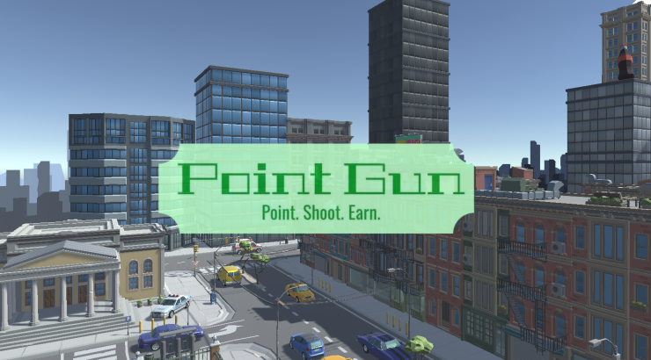

**TABLE OF CONTENTS:**

**What is Point Gun?** 3

**The Game** 3

**Game Mechanics** 4 - 6

Drugs 4

Houses 5

Stores 6

**Visual Representation** 7

**Mint details and allocations** ………………………………………………………………8

**Why Choose Point Gun?** 8

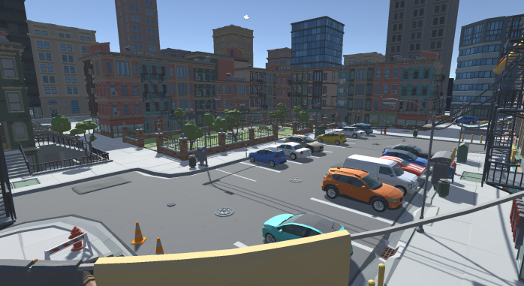

# **What is Point Gun?**

We will be building a 3d rendered third person top-down shooter game, inspired by Grand Theft Auto. We will be delivering a Beta version that will demonstrate what all you can do with our game! Completing missions will help you earn in game currency and EXP.   
We currently are working on a playable interface for both mobile and desktop that will be seamlessly used within our website.

# **The game**

We want to deliver an experience that is fun, addictive, and violent in all the right areas. This will be a third person top-down shooter that is meant to deliver the ability to grow passive income while enjoying all sorts of wild crimes and events.

Our missions will consist of drug dealing, robberies, home invasions, murder for hire, and much more. From massive crime sprees to buying and selling virtual real estate, this game is designed to create a new experience that is as addictive as your favorite shooter games, like Grand Theft Auto or Saints Row.

# **IN-Game mechanics:**

## *Drugs and Drug dealers:*



There will be multiple points on the map where you can access drug dealers. You will be able to buy and sell the drugs and items you get from these dealers. Varying on the mission and how long you take in the mission, the prices for the items and drugs will vary and change throughout the in-game day. You will come across these mechanics often within our in-game missions.  
Inspired by GTA China Town, only with a twist; here you will be able to profit from flipping bags! Sound familiar? With the right grind, this in game mechanic can really help with profits.

This mechanic genuinely can be amusing and very entertaining. Although it can contain some violence sometimes, especially if a robbery is involved.

## *Houses:*

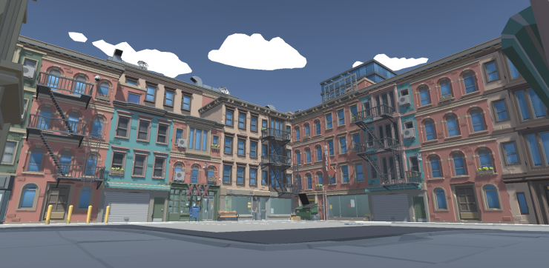

The houses in Point Gun will be used in a very similar mechanics that the drug dealers will be running on. You will be able to buy these houses and you will also be able to sell the land in-game. You can also upgrade and customize the land. This land will be yours, virtually, and quite literally, until you sell or flip the land for profits and EXP. There will be three tiers within this mechanic that will differentiate the houses between low, middle, and high tier status. The price, value, and mint price will all be affected by the tier of the house.

Our virtual real-estate will become a new place for people to buy, rent, own, and sell land as well. This project will be the first of its kind of do something of this magnitude, but applied within a game, and to help carry on a larger scale of user game play.

## *Stores:*

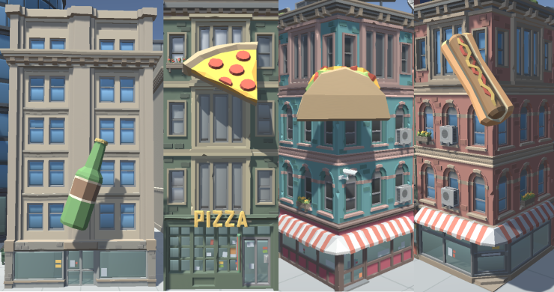

Stores will provide a form of business to the game. You will be able to purchase Stores and make passive income within the game’s features.

Stores are a place where the player will be able to stock up on items. We will have different stores that carry different things throughout the map. Not every store will carry the same inventory, but these items will help the user in his in-game usability of the game. These will also help the user interact with the in-game mechanics more regularly.

## **Visual Representation:**

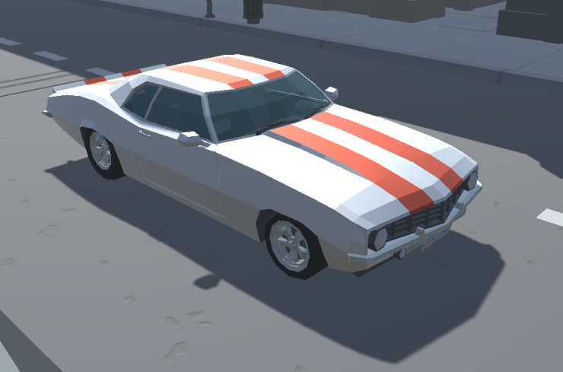

The top character is an example of one of our models. These will be the sprites in the game and will also be held as an NFT.

# **Mint Details and fund allocations:**

The mint of our Point Gun NFTs will consist all on Polygon. 1,000 NFT’s will be dedicated and marketed for 25 Matic and the rest of the 9,000-piece collection will be dedicated and marketed on 30 Matic.  
Mint price will be 25 Matic and the team will have 25 of their own NFT’s used for marketing. The team will be allocating the funds made into a 50 – 70% range that will be deployed back into Point Gun’s marketing and game development. The rest of the remaining portion will be given to the teams behind maintenance, website costs, and staff salary.

# **Why choose pointgun?**

We are a team of dedicated friends who are determined to personally bring the same inspiration to a user in playing the game as we get to experience in developing the Point Gun 3D shooter.  
This community is under construction in building a foundation of devoted users who will be family to us.  
We are here to build a dope game, and within this game you will be given the ability to buy and sell in-game products as NFT’s and make passive income while having some fun shooting shit up.