Document Title
  - Descriptive Subtitle
Your Name
2025-12-18
Table of contents

1. Introduction
This document template provides a clean, professional layout with University of Arizona branding. It’s designed for training materials, research protocols, documentation, and other professional documents.

1.1 Key Features
This template includes:
- Left-side navigation with automatic table of contents
- UA brand colors throughout
- Custom callout styles for different types of content
- Margin notes for supplementary information
- Mermaid diagrams with neutral theming
- Collapsible sections for detailed content
Margin notes appear in the right margin and are useful for supplementary information, definitions, or cross-references.

2. Using Callout Boxes
Quarto’s built-in callout boxes are styled with UA colors:
 Note
Use notes for supplementary information that clarifies the main content.

 Tip
Tips provide helpful suggestions or best practices.

 Warning
Warnings alert readers to potential issues or common mistakes.

 Important
Important callouts highlight critical information that shouldn’t be missed.

3. Custom Content Classes

3.1 Highlighted Statements
Use the .highlight-box class for key statements or examples:
Example Statement: “This is an important statement that deserves visual emphasis in your document.”

3.2 Definition Boxes
Use .definition-box for defining key terms:
Term: A clear, concise definition of the term with relevant context.

3.3 Practice or Exercise Boxes
Use .practice-box for exercises, practice questions, or worked examples:
Practice Question: How would you apply this concept in your work?
Answer
The answer to the practice question goes here. Collapsible sections keep the document clean while providing detailed explanations when needed.

4. Diagrams and Visuals

4.1 Mermaid Diagrams
Create flowcharts and diagrams using Mermaid:
flowchart LR
A[Input] --> B{Decision}
B -->|Yes| C[Process A]
B -->|No| D[Process B]
C --> E[Output]
D --> E
style A fill:#e6f0ff,stroke:#0C234B
style E fill:#ffe6e6,stroke:#AB0520

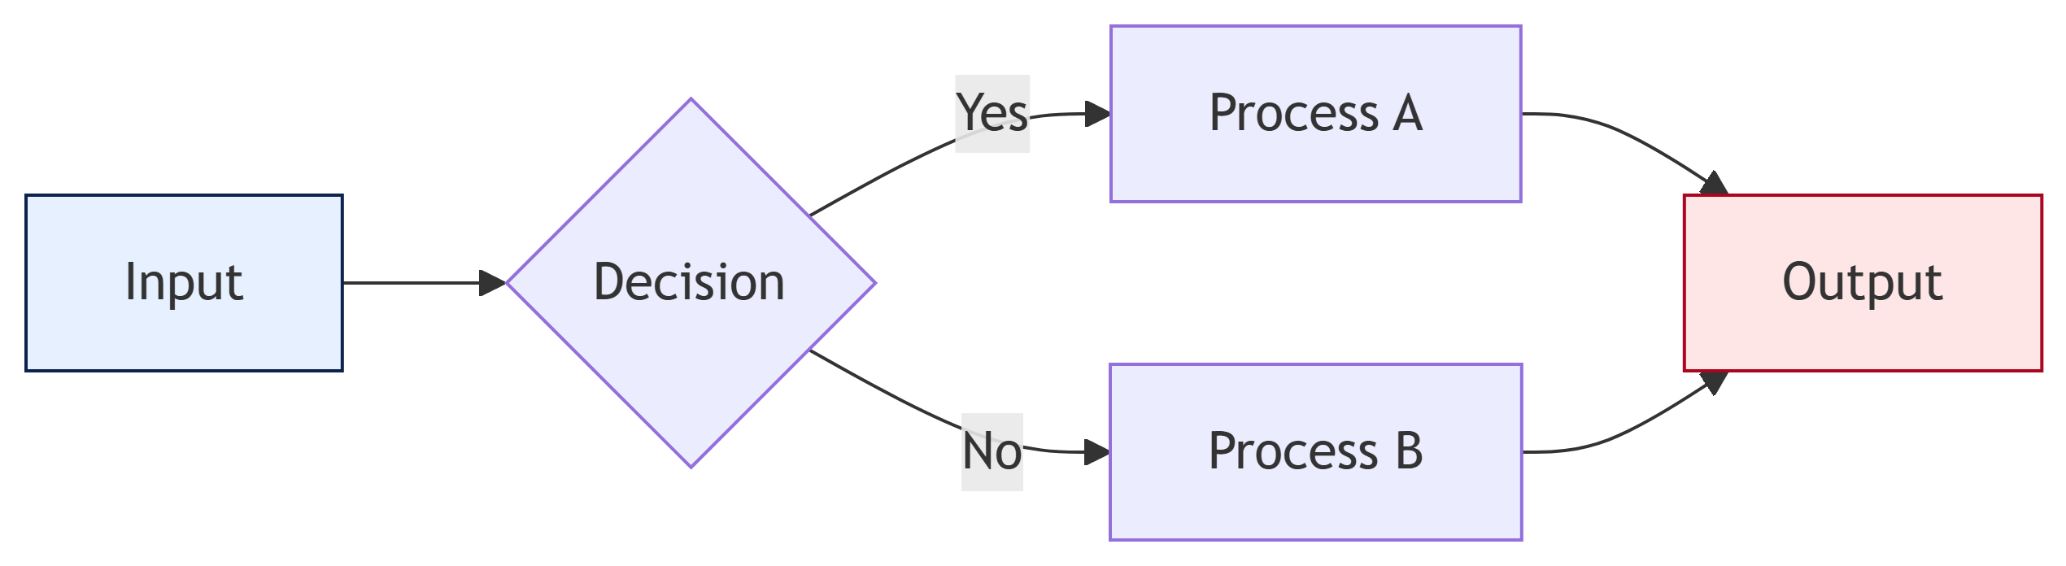

4.2 Workflow Diagrams
flowchart TD
A[Step 1] --> B[Step 2]
B --> C[Step 3]
C --> D[Step 4]
D --> E[Complete]
style A fill:#0C234B,color:#fff
style E fill:#AB0520,color:#fff

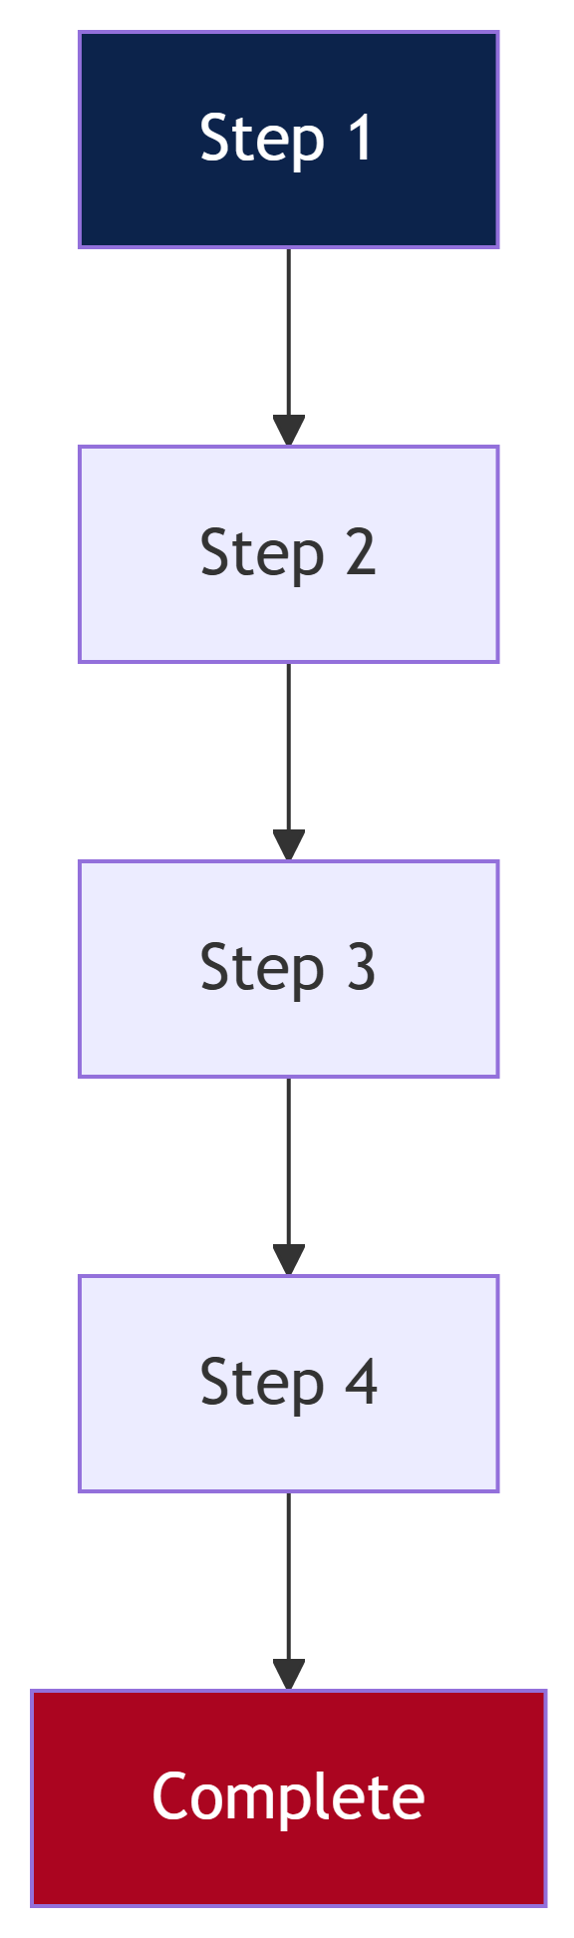

5. Tables
Standard markdown tables are styled consistently:
Column A | Column B | Column C
Item 1 | Value 1 | Note 1
Item 2 | Value 2 | Note 2
Item 3 | Value 3 | Note 3

6. Code Examples
Code blocks use UA-branded styling:
# Example R code
library(tidyverse)
data |>
filter(category == "example") |>
summarize(mean_value = mean(value))
# Example Python code
import pandas as pd
df = pd.read_csv("data.csv")
result = df.groupby("category").mean()

7. Two-Column Layout

7.0.1 Left Column
Content for the left column goes here. This is useful for comparisons or parallel content.

7.0.2 Right Column
Content for the right column goes here. Both columns will display side by side.

8. Summary
This template provides a professional foundation for various document types:
- Training guides - Use callouts, practice boxes, and collapsible sections
- Research protocols - Use definition boxes and structured headings
- Documentation - Use code blocks, diagrams, and tables
- Reports - Use all features with a clear hierarchical structure
Next Steps
Customize this template by modifying the YAML header and replacing the content with your own material.

