AuthenticationExample

README

Last Updated August 8th, 2019

Contents

Overview 3

Touchpanel GUI Overview 4

Equipment 5

Devices 5

Software / Firmware 5

Important Notes 5

Before Loading the Program 5

Loading the Program and Project Files 6

Load Auth.cpz to the Control System 6

Load AuthSettingsPanel.vtz to the TSW 6

Connect the TSW to the Control System 6

# Overview

This AuthenticationExample project was created to exercise the static Authentication class and related types from the SIMPL# Pro library. It provides a TSW interface through which a user can sign in with an admin account to gain access to an authentication control page. From here, the administrator may perform a number of operations related to user authentication, user group membership, and access control. These operations include:

* Add a new user to the control system
* Add a new group to the control system
* See a list of all users
* See a list of all groups
* Change a user’s password
* Add a user to a group
* Remove a user from a group
* Delete a user from the control system
* Delete a group from the control system

Each of these touchpanel buttons wraps around a corresponding method from the Authentication class.

All SIMPL# Pro source code defining the program is provided in the following files:

* ControlSystem.cs
* Joins.cs

These source files are thoroughly commented and are intended to provide an illustrative application of various SIMPL# Pro APIs.

In addition, the VT Pro-e touchpanel’s source file is provided:

* AuthSettingsPanel.vtp

**Note:** The VT Pro-e project by default builds for a TSW-752, but it could be recompiled to target other models. File -> Save Project As… will allow you to change the panel type. Also, see the Note in the Equipment section.

## Touchpanel GUI Overview

The user begins on the Start Page, which contains only a button named “Authentication Settings.” When clicked, the panel transitions to an Administrator Login page. In order to proceed, the user must type the username and password of a member of the control system’s Administrators group into their respective fields, then click “Login:”

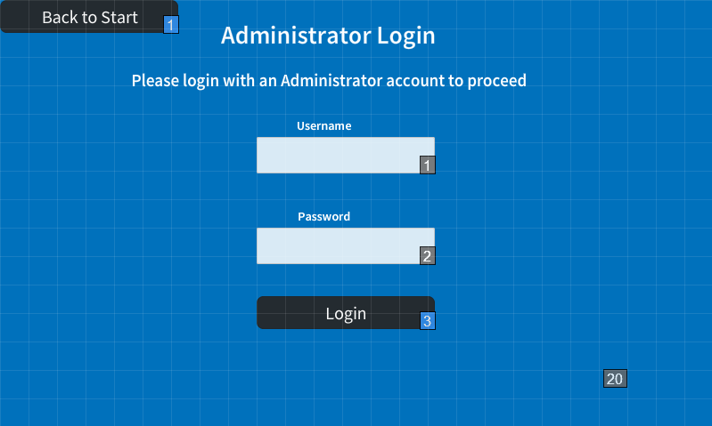

If successful, the Authentication Settings menu will appear, providing buttons for the nine authentication operations mentioned above. The user may now select any of these operations or click “Log Out” in the top left corner. Additionally, the user will automatically be logged out after 5 minutes of inactivity in either the Authentication Settings page or any of the operation pages.

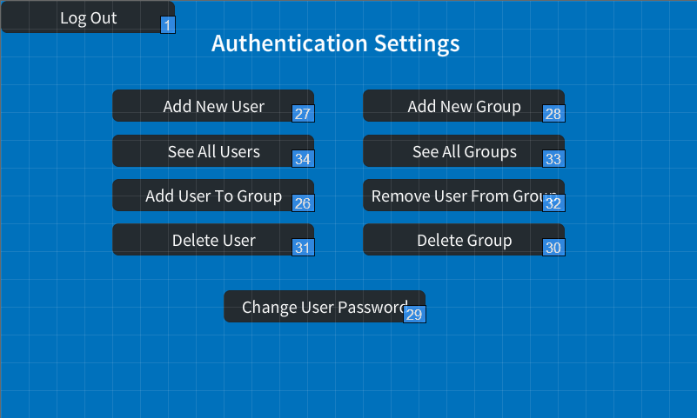

# Equipment

This program is designed to work with the following hardware/software:

## Devices

* 3-Series Control System
* A 7” (or larger) TSW, such as a TSW-752

**Note:** This example was tested using a TSW-752, but a similar TSW model may be used. The AuthenticationExample program may be reconfigured simply by replacing line 62 of ControlSystem.cs…

panel = new Tsw752(0x3, this);

…with the equivalent constructor for the alternative TSW model, then building. For example, a user with a TSW 760 would modify the line to the following:

panel = new Tsw760(0x3, this);

Documentation for each TSW class can be found in the SIMPL# Pro helpfile under the Crestron.SimplSharpPro.UI namespace.

## Software / Firmware

|  |  |
| --- | --- |
| Device | Firmware Version |
| 3-Series Control System | 1.601.xxx or later |
| TSW-752 | 1.004.0012 or later |

|  |  |
| --- | --- |
| Software | Version |
| Toolbox | 3.03.xxx or later |
| VisionTools Pro-e | 2.15.xx.xx or later |

# Important Notes

## Before Loading the Program

* On the control system:

1. Set SSL to SELF (or CA if possible).
2. Set Authentication to ON, which requires an Administrator account to be created.
3. Reboot.

# Loading the Program and Project Files

## Load Auth.cpz to the Control System

1. In the AuthenticationExample directory, open the top-level solution file, Auth.sln, in Visual Studio 2008.
2. Press F6 to Build All. This will place the .cpz file in the Auth\bin\Debug folder.
3. Transfer the .cpz file to one of the control system’s program slots.
4. On the control system, invoke **progload -p:#**, where **#** is the number of the slot into which you placed the .cpz file.

## Load AuthSettingsPanel.vtz to the TSW

1. Add the TSW’s hostname/IP address to the address book in Toolbox.
2. In the AuthSettingsPanel directory, open the VT Pro-e file, AuthSettingsPanel.vtp
3. Press F12 to compile the project. A Toolbox dialog box will appear asking where the load the project files. Select your TSW and click OK.
4. In the next dialog, click Send, and wait for the program to be loaded onto the touchpanel.

## Connect the TSW to the Control System

1. Enable SSL NOVERIFY.
2. Open a Toolbox console on the TSW and type the command line:

*addmaster 3 <hostname>*

Where <hostname> is the hostname (or IP address) of the control system running the AuthenticationExample program. The program will accept a touchpanel on IPID 3.

1. Next, invoke **setcsauthentication** on the TSW, providing a username and password for any user on the control system that has Connect-level privileges or higher. The touchpanel may use the credentials of any existing user on the control system; however, it is better practice to create a separate user on the control system with just Connect-level privileges to represent the touchpanel.
2. Wait for the message “*Update request from IP-ID-03 in Program 01”* or similar to appear on the control system’s console. At this point, invoke the **ipt** command at the touchpanel’s console and ensure that the panel has connected to port 41796 on the control system, which ensures that the two devices will communicate over TLS.