Use of color_seq.pl, color_nums.pl, and color_cols.pl scripts
Ryan Koehler 12/24/15
update 10/7/17 RTK
ryan@verdascend.com

Background and overview
The three scripts color_seq.pl, color_nums.pl, and color_cols.pl are simple command line filters intended to colorize specific value-associated “words” contained within simple ASCII text. This is useful to highlight specific values for quick value identification and pattern visualization within a terminal. The tools take text from a file or standard input then output contents with ANSI escape sequences interjected to color specific characters in a terminal display. The tools also accept various command line options to allow user control over character or token selection, color choice, and other data-dependent options.

This document briefly describes options available for these tools and, probably more importantly, provides example uses. Given that the point of these tools is to colorize text, examples are accompanied by screen captures illustrating outputs. This documentation is in pdf format to allow these graphics.

The README file, in markdown format, breifely describes the software (mainly dependencies).

=======================================================================
color_seq.pl is for coloring DNA sequences. The default behavior is to color what appears to be sequences with a four-color scheme associated with A C G and T. The script contains logic to guess whether a “word” (or token; continuous block of characters) is sequence-containing or not based on the fraction of ACGT characters; Words deemed to not be sequence-containing are not colored. Within sequence words, it is possible to limit the range of characters that are colored, with the range being relative to either the beginning or end of the word. By default, entire lines beginning with “#” or “>” are not colored, as these traditionally are associated with comments or the header lines of fasta format files. This behavior can be changed via command line switch.

In addition to simply finding and coloring DNA sequences, color_seq.pl can be used to highlight attributes often encountered in sequence files. For example, lower case sequence can be ignored (i.e. not colored), or non-ACGT characters within (what appears to be) sequence can be highlighted. This is useful to quickly find IUB characters and any non-sequence characters (both colored differently to stand out).

Another behavior is to color continuous runs of like bases. This yields sparsely colored patterns that aids visual identification of specific sequences / subsequences within larger sets. The length of runs may be specified and the coloring scheme may be inverted (i.e. only non-continuous runs are colored).

Finally, color_seq.pl can be used to highlight window-based sequence features. With this feature runs of contiguous characters containing, as well as not containing, a specific base are highlighted. This feature supports IUB degenerate codes in addition to the normal ACGT bases. For example, using window-based highlighting on can readily identify runs of GC (IUB code “S”), runs of purines (IUB code “R”), etc. In addition to highlighting windows containing the specified base (or bases corresponding to an IUB code), windows not containing runs of the chosen base(s) are also highlighted in a second color.

=======================================================================
color_nums.pl is for coloring numbers. The default behavior is to highlight numbers within text using a single color (This is distinct from simply coloring numeral characters). By default, entire lines beginning with “#” are not colored, as these traditionally are associated with comments, but this behavior can be changed via command line switch. It is also possible to only color a subset of number-containing “columns” via command line switch.

Assigning colors based on value allows rapid identification of “high” or “low” values. In addition, coloring a whole table of numbers together can serve as s simple means to visualize patterns in the data.

=======================================================================
color_cols.pl is for coloring columns (or rows) so that different columns (e.g. “fields”) in a data table may be readily identified. The default behavior is to cycle through a set of colors for odd number columns and leave even number columns white, such that the cycle repeats every ten columns. Other schemes and cycling frequencies are available (e.g. every 5 or 2 columns), a range of columns to color may be specified, and specific columns may be selected for coloring. By default, entire lines beginning with “#” are not colored, as these traditionally are associated with comments, but this behavior can be changed via command line switch. It is also possible to specify that columns are separated by tabs rather than the default spaces.
Use of color_seq.pl
Calling color_seq.pl without any arguments (or with “-help” or an unrecognized argument) yields this splash / help screen:

=============================================================================
color_seq.pl V0.59; RTK 10/7/17

Usage: <infile> ['-' for stdin] [...options]
<infile> Sequence file
-cabi Color scheme 'ABI' style
-cigv Color scheme 'IGV' style
-corg Color scheme 'original' style
-cgc Color scheme GC-warm / AT-cool style
-win X Color by windows of base type X (IUB is OK)
-ws # Window size #; Default is 5
-nacgt Only color non-ACGT bases; IUB = red; Other = blue
-run Only color runs of bases
-rs # Run size #; Default is 3
-lw Lowercase white (i.e. upper = color, lower no)
-all Color all lines; Default ignores fasta '>' and comment '#'
-bran # # Limit base range # to # (1-base coords)
-rre Range relative to end; i.e. base range is backwards
-not NOT; Invert coloring so non-runs / out-of-range colored
-verb Verbose; print color mapping
=============================================================================

Each command line switch has a brief description of what it does. Given only input and no command switches, default coloring is performed. Figure S1 shows a test-case sequence file displayed via the cat command. Figure S2 shows this same content with output from cat piped through color_seq.pl, which is given a “naked dash” to indicate input is from standard input (stdin). Other color schemes may be specified with the -cabi, -cigv and -cgc switches; -corig is for the default scheme. Results of coloring with different schemes is shown in Figure S3, with three separate calls illustrating IGV, ABI and GC-based coloring schemes (top to bottom).

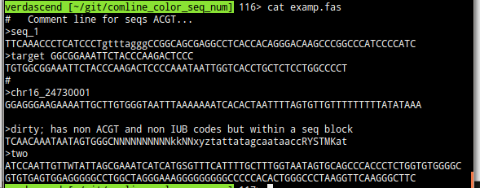
Figure S1. Test-case sequence file.
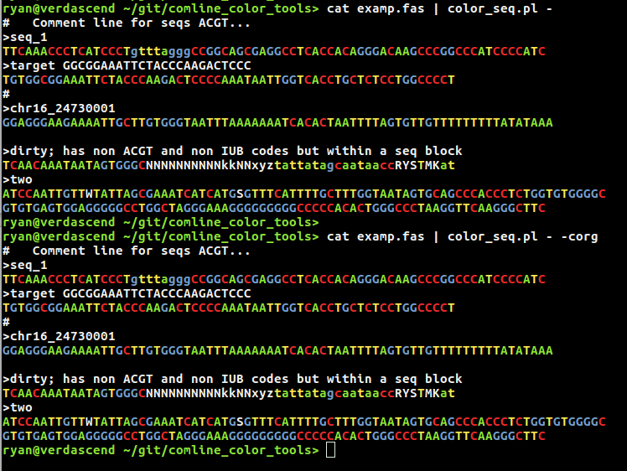
Figure S2. color_seq.pl Default coloring. Test-case sequence 'piped' as input. The command switch '-' is used to indicate input will come from stdin. Two sequential calls are shown; the second one with -corg to explicitly request default color scheme.

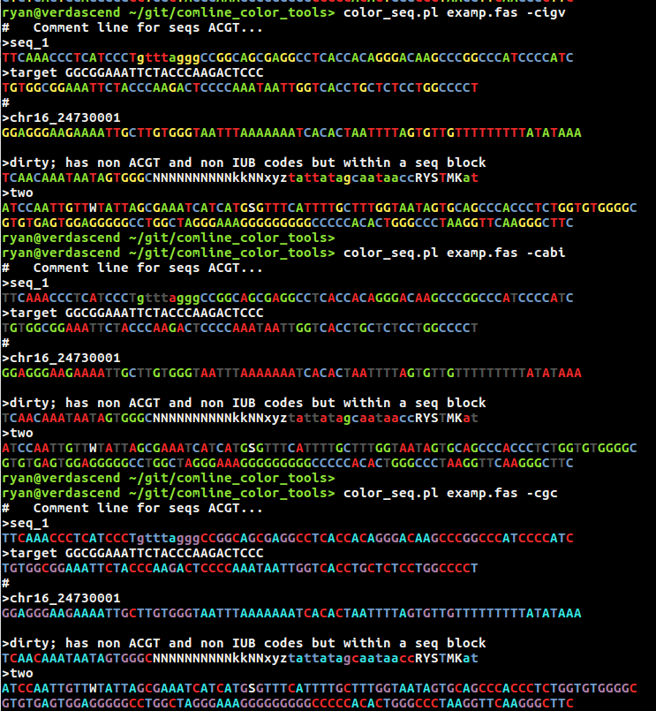
Figure S3. color_seq.pl IGV, ABI and GC-based coloring schemes.

Some options can be combined, such as the -lw and -all switches, which, respectively, direct the script to color lowercase characters white (i.e. do not color them) and to include all lines (i.e. do not ignore lines starting with “>” or “#”). The result is shown in Figure S4, which uses the default color scheme. Note that the “ACGT” in the comment on the first line is colored, while the lowercase sequence characters on the third line (and further down) are not. Highlighting non-ACGT within sequence-like strings is showin in Figure S5 with the -nacgt switch. Normal ACGT bases are not colored, IUB code letters are colored red, and other (non-DNA) characters are colored cyan.

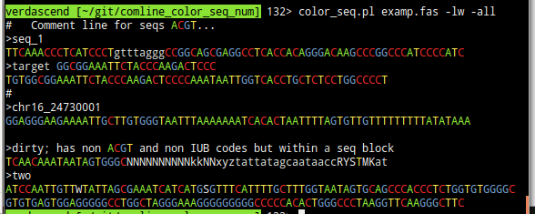
Figure S4. color_seq.pl Changing which characters are considered for coloring. The -lw and -all switches result in no color for lower case characters, and all lines being “colorable”, respectively.

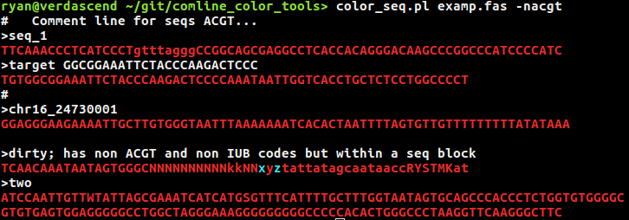
Figure S5. color_seq.pl Highlighting non-ACGT characters within sequence-containing strings.

Highlighting window-based sequence features is shown in Figure S6. Contiguous runs of specified base characters, and runs devoid of these, are colored within sequence-containing strings, while the remaining sequence characters are not colored. Two parameters define windowing behavior: base type and window size. Base type may be ACGT or any IUB code. Window size dictates the minimal length of runs that qualify for coloring. Runs of selected bases (and non-selected bases) that are at least window size long are colored; Selected base type(s) are red, and non-selected base type(s) are cyan.
NOTE. Only ACGT bases qualify for selection and lines are considered independently. This means that IUB characters within strings do not count for runs, and runs spanning multiple lines are not colored.... (Maybe in a future version???)

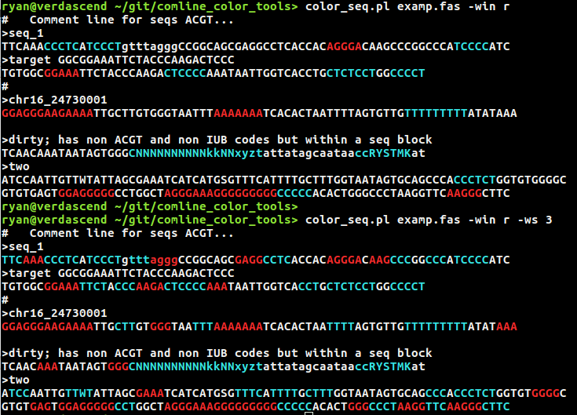
Figure S6. color_seq.pl Coloring windows with like-base runs. Red denotes selected base type(s) and cyan denotes absence of selected base type. Top example highlights runs of purine bases (A or G) in red, specified with IUB code “R”, using default window size ( = 5). Bottom example highlights runs of C, with window size given as 3.

Coloring runs of continuous bases is shown in Figure S7. The top shows default behavior and the middle shows the inverted case (i.e. all bases except runs are colored) with the default run size of 3 bases. The bottom shows runs with size set to 4.

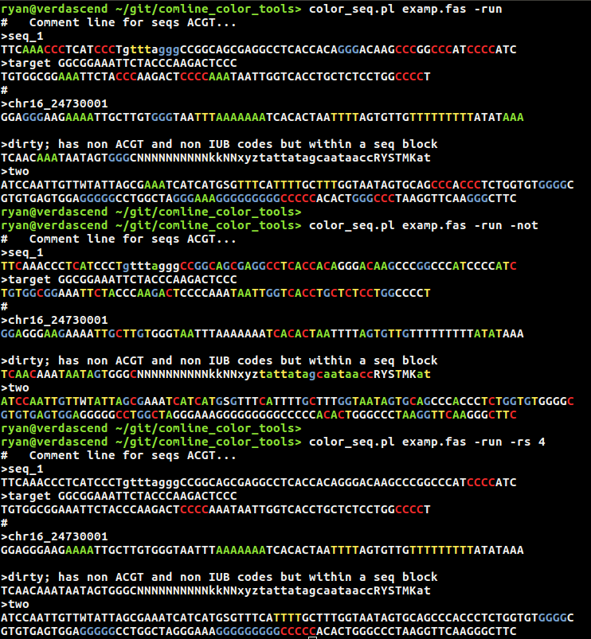
Figure S7. color_seq.pl Coloring runs of like-bases. Top shows default coloring, middle shows the inverted case (i.e. bases in runs are not colored), bottom shows runs with (minimum) size set to 4.
Use of color_num.pl
Calling color_num.pl without any arguments (or with “-help” or an unrecognized argument) yields this splash / help screen:

=============================================================================
color_nums.pl V0.22; RTK 11/18/16

Usage: <infile> ['-' for stdin] [...options]
<infile> Text file (e.g. matrix of numbers)
-rwb Color scheme Red White Blue
-ryc Color scheme Red Yellow Cyan
-rg # # Range from # to #
-lt # Less than #
-gt # Greater than #
-nr Normal range: Color 0 to 1
-n2 2-sided normal range: Color -1 to 1
-ok Only qualifying numbers colored
-iz Ignore zero (i.e. no color)
-col # # Columns # to # (Token-based count)
-not Invert col qualifications
-all Color all lines; Default ignores comment '#'
-verb Verbose; print color mapping
=============================================================================

Each command line switch has a brief description of what it does. Given only input and no command switches, default coloring is performed. Figure N1 shows the first five lines of three number-containing files displayed via the head command. Figure N2 shows this same content with output from head piped through color_num.pl, which is given a “naked dash” to indicate input is from standard input.

Specific number values can be highlighted. For example, the -rg switch can be used to specify a range of values; Numbers within the range are shown with one color, numbers less than the range are shown in another color, and numbers more than the range are shown in still another color. It is also possible to highlight only the within-range values using the -ok switch. Figure N3 shows this behavior, using a chosen range of 69 to 71. There are also options to differentiate only two classes of numbers; Those with values greater than or less than some chosen threshold and the rest.

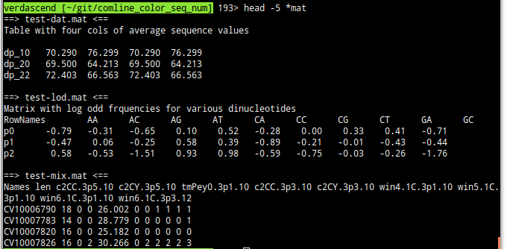
Figure N1. Test-case number-containing files (first five lines for each of three).

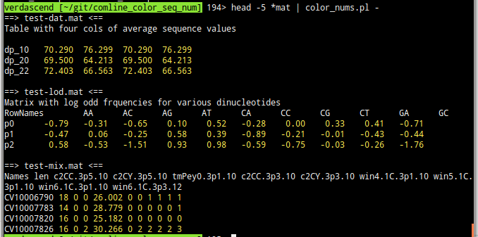
Figure N2. color_nums.pl Test-case number-containing files with default coloring.
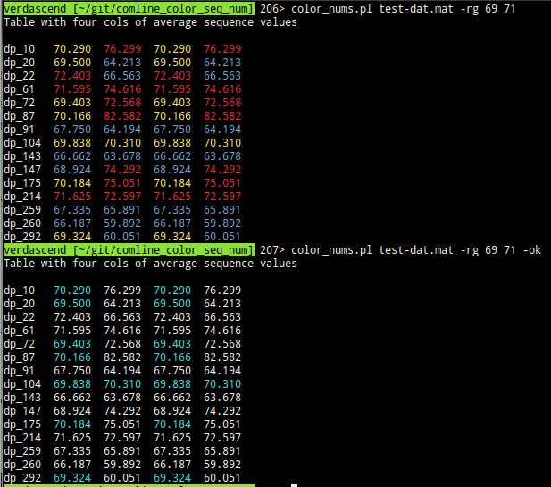
Figure N3. color_nums.pl Specifying a range of values to highlight (e.g. 69 to 71).

To better highlight specific numbers, subsets of (potentially) number-containing tokens may be ignored. Only values found in a range of columns can be colored, thus allowing some number-containing columns to be easily ignored. Column selection is done with the -col switch, which is associated with two number to specify start and end columns. Use of the -not switch inverts column selection criteria, so that numbers within selected columns are not colored but numbers in other columns may be colored. The -iz switch allows zero values to be ignored. Figure N4 shows the result of combining all three above mentioned options, in this case selecting all columns except column 5, specifying a coloring range from 2 to 3, and ignoring zeros.
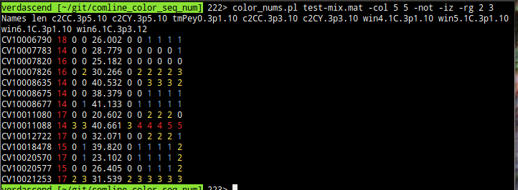
Figure N4. color_nums.pl Selecting specific columns, ignoring zero values and coloring by value range. All columns except column 5 are selected via the combination of switches -col 5 5 -not and zeros are ignored (i.e. not colored) because of the -iz switch. Finally, a color range of 2 to 3 is specified for differential value-based color assignment (i.e. in range values are yellow; under range values are blue; over range values are red).

Options for predefined ranges include the -nr switch for 0 to 1, and the -n2 switch for -1 to 1. Figure N5 shows an example.

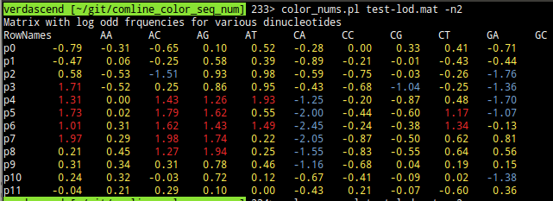
Figure N5. color_nums.pl Predefined range coloring, from -1 to 1.

Use of color_cols.pl
Calling color_col.pl without any arguments (or with “-help” or an unrecognized argument) yields this splash / help screen (which includes colors to illustrate cycling patterns):

=============================================================================
color_cols.pl V0.53; RTK 2/1/17

Usage: <infile> ['-' for stdin] [...options]
<infile> Text file (e.g. data with 'word' tokens)
-m # Mark col # (1-based index on tokens)
-s # Step; Mark every #'th col (starting from 0)
-o # Offset for starting steps (default 0)
-g # Group columns / rows # at a time (default 1)
-cr # # Colums in range # to # colored (1-based)
-nc Invert column range qualifications
-rr # # Rows in range # to # colored (1-based)
-nr Invert row range qualifications
-tab Separate input columns by tab (default is space)
-sep X Separate input columns by X string
-2c Two color scheme: Cycle 1 2
-5c Five color scheme: Cycle 1 2 3 4 5
-10c Ten color scheme: Cycle 1 2 3 4 5 6 7 8 9 10
-10r Ten rainbow scheme: Cycle 1 2 3 4 5 6 7 8 9 10
-fg X Set foreground color to X [RYGBCMW] (default red)
-bg X Set background color to X [RYGBCMW] (default white)
-iv Invert foreground / background (i.e. for -mark or -step)
-all Color all lines; Default ignores comment '#'
-row Apply coloring to *Rows* not columns
-prd Previous row differences (per token)
-pld Previous line differences (per char)
=============================================================================

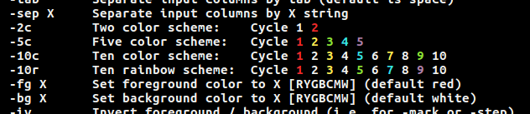
Figure C1. color_cols.pl Color cycle portion of splash / help screen.

Each command line switch has a brief description of what it does. Default behavior is to color columns by counting non-whitespace “words” and applying the chosen color scheme. Examples of several color schemes using the test file “test-lod.mat” are shown Figure C2.
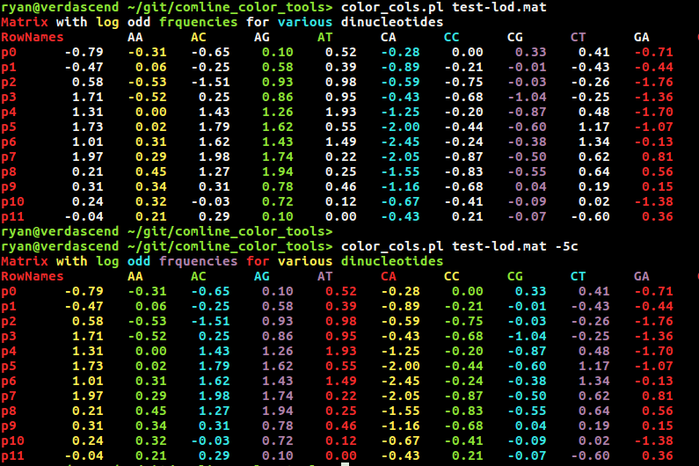
Figure C2. color_cols.pl Coloring schemes: top default (“-10r”); bottom “-5c”.

Selection of subsets of columns / rows is possible by specifying ranges -cr and -rr respectively. Indexes are one-based, and column and row subsets may be specified together. Inversion of range selection (i.e. color columns / rows outside of specified ranges) is accomplished with -nc and -nr respectively. Examples of subset selection are shown in Figure C3 where we also explicitly set the background color (to ‘m’ = magenta) so that subset selection is more clear.

Columns (or rows) can be marked singly or periodically, or processed as multi-token (or multi-row) groups. The mark -m X option will color column (or row) X with the foreground color. Using step -s X one can mark every X’th col (or row), starting at the first X; Combined with offset -s Y the starting position of the stepping can be changed to Y as shown in Figure C4. Grouping columns (or rows) N at a time is done with -g N as shown in Figure C5.

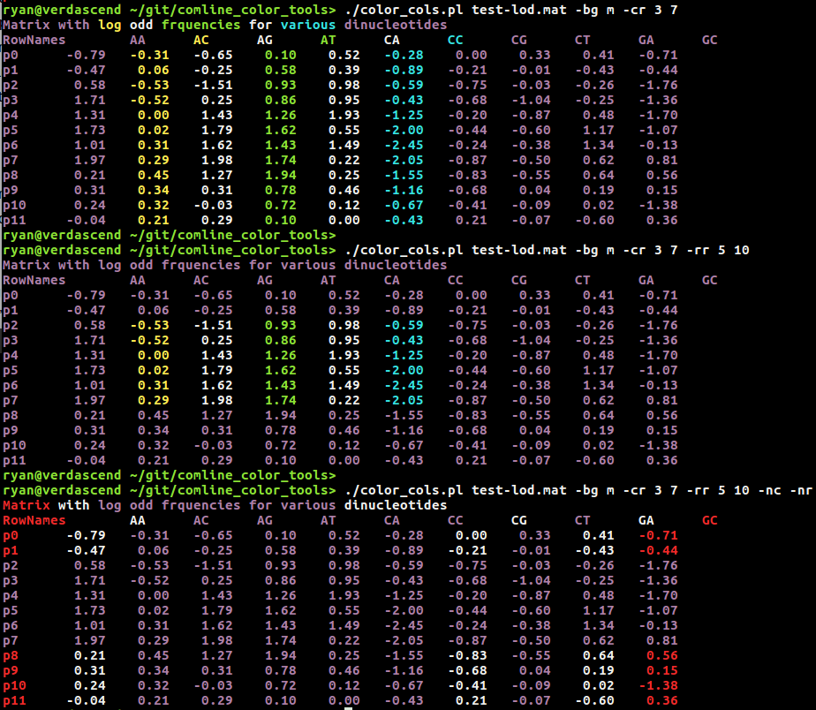
Figure C3. color_cols.pl Column / row subset selection. Top shows selection of columns 3 through 7; Middle shows selection of columns 3-7 and rows 5-10; Bottom shows inverted
selection of columns 3-7 and rows 5-10. In all cases, the background color is explicitly specified as magenta (-bg m).

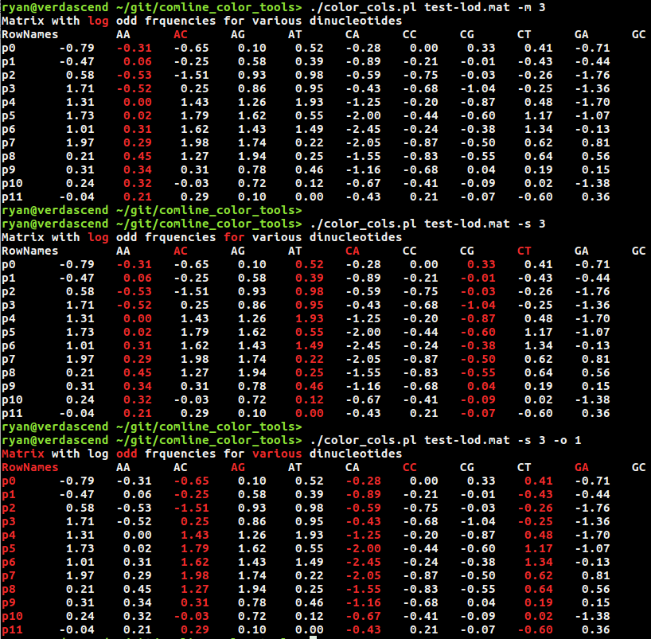
Figure C4. color_cols.pl Column / row marking and stepping (cycling). Top shows marking of column 3; Center shows stepping every 3 (with default start of zero); Bottom shows stepping every 3 but with an offset of 1.

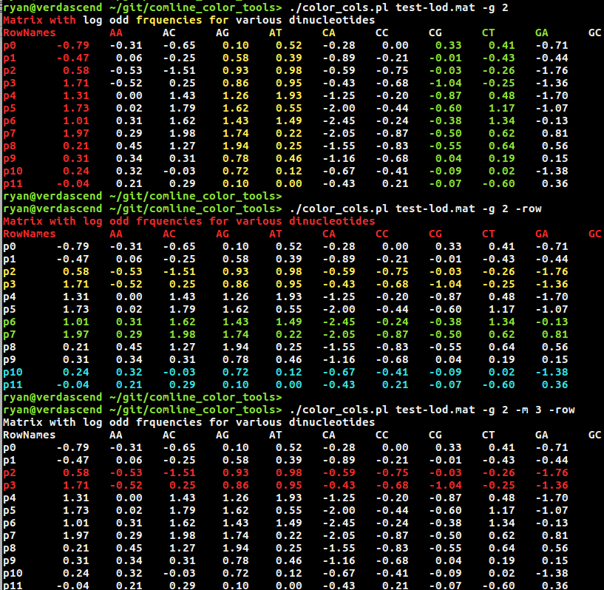
Figure C5. color_cols.pl Column / row grouping. Top shows grouping of columns by 2 (with default column color scheme); Center shows grouping of rows by 2; Bottom shows grouping and marking combined. The third group (-m 3) of two rows (-g 3) is marked.

