C:N Ratios

Meyer, R.

2022-4-4

Table of Contents

# Summary Tables

## C:N ratios

|  |  |  |  |
| --- | --- | --- | --- |
| spp | avg_pct_n | avg_pct_c | c_n_ratio |
| ar | 1.741304 | 35.23478 | 20.77427 |
| cr | 1.471064 | 37.33830 | 26.15907 |
| gm | 1.500851 | 41.41702 | 27.92590 |
| pc | 1.847447 | 41.87021 | 23.27899 |

## C:N ratios with soil type as plot 1 and 2

|  |  |  |  |  |
| --- | --- | --- | --- | --- |
| spp | plot | avg_pct_n | avg_pct_c | c_n_ratio |
| ar | 1 | 1.657727 | 33.89545 | 20.80510 |
| ar | 2 | 1.817917 | 36.46250 | 20.74602 |
| cr | 1 | 1.433043 | 36.73478 | 26.18316 |
| cr | 2 | 1.507500 | 37.91667 | 26.13600 |
| gm | 1 | 1.453809 | 41.26190 | 28.80456 |
| gm | 2 | 1.538846 | 41.54231 | 27.21621 |
| pc | 1 | 1.792174 | 41.24348 | 23.57482 |
| pc | 2 | 1.900417 | 42.47083 | 22.99549 |

# Summary Figures

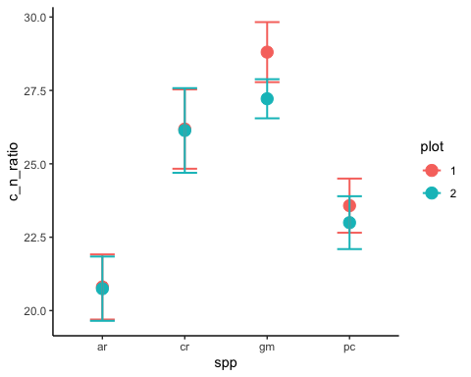

# Statistics

## Do species significantly differ in their C:N ratio, does soil type have a significant effect?