**TECHNICAL UNIVERSITY OF MOLDOVA**

**FACULTY OF COMPUTERS, INFORMATICS AND MICROELECTRONICS**

**DEPARTMENT OF SOFTWARE ENGINEERING AND AUTOMATION**

**Laboratory Work Nr. 4**

**Actuators with binary and analog interface**

**Done by: Chihai Nichita**

**st. gr. FAF-213**

**Verified by: Moraru Dumitru**

**univ. lect.**

**Chisinau, 2024**

# THE TASKS OF LABORATORY WORK

Develop a MCU-based application to control actuation devices with commands received from the serial interface and reporting to the LCD. The actuation devices will be as follows:

- A light bulb through a relay with commands for ON and OFF.

- Implement relay commands from the serial interface.

- Implement the layers of the electric light bulb driver.

Also develop a MCU-based application to control actuation devices with commands received from the serial interface and reporting to the LCD.

- A DC motor with commands to set the motor power between (-100% to 100%), i.e., forward and backward, and speed through the L298 driver. Peripheral control drivers will be implemented at abstraction levels.

- Implement motor control commands from the serial interface.

- Display actuator status on the LCD.

- Implement the layers of the DC motor control driver.

Here's the translation of your request:

# 2 PROGRESS OF THE WORK

For this laboratory work, I utilized the Arduino IDE, a software designed for writing and compiling code for the Arduino development board, along with Proteus, a software used for electronic design simulation.

**2.1 Main function description**

**Table 1 Used functions**

|  |  |
| --- | --- |
| **Function** | **Description** |
| setup() | It initializes the serial communication with a baud rate. It sets up the standard input/output streams to communicate over the serial port using fdevopen. It initializes the LiquidCrystal display with the specified width and length. It calls the lamp_init() and motor_init() functions to init. the lamp and DC motor. |
| loop() | This function is called repeatedly in a loop after the setup() function has been executed.It waits for input from the serial port using scanf, which reads characters into the cmd array. Once input is received, it calls the execute() function to process the received command. |
| execute() | It checks if the command is "on" or "off" to control the lamp accordingly using the lamp_on() and lamp_off() functions. If the command is within the specified range, it sets the power of the DC motor using the motor_set_pow() function and adjusts the motor speed using motor_pow_up() or motor_pow_down() based on the sign of the command. |

**2.2 Block diagram**

This block diagram provides a visual representation of the main components and their interactions for my Arduino program.

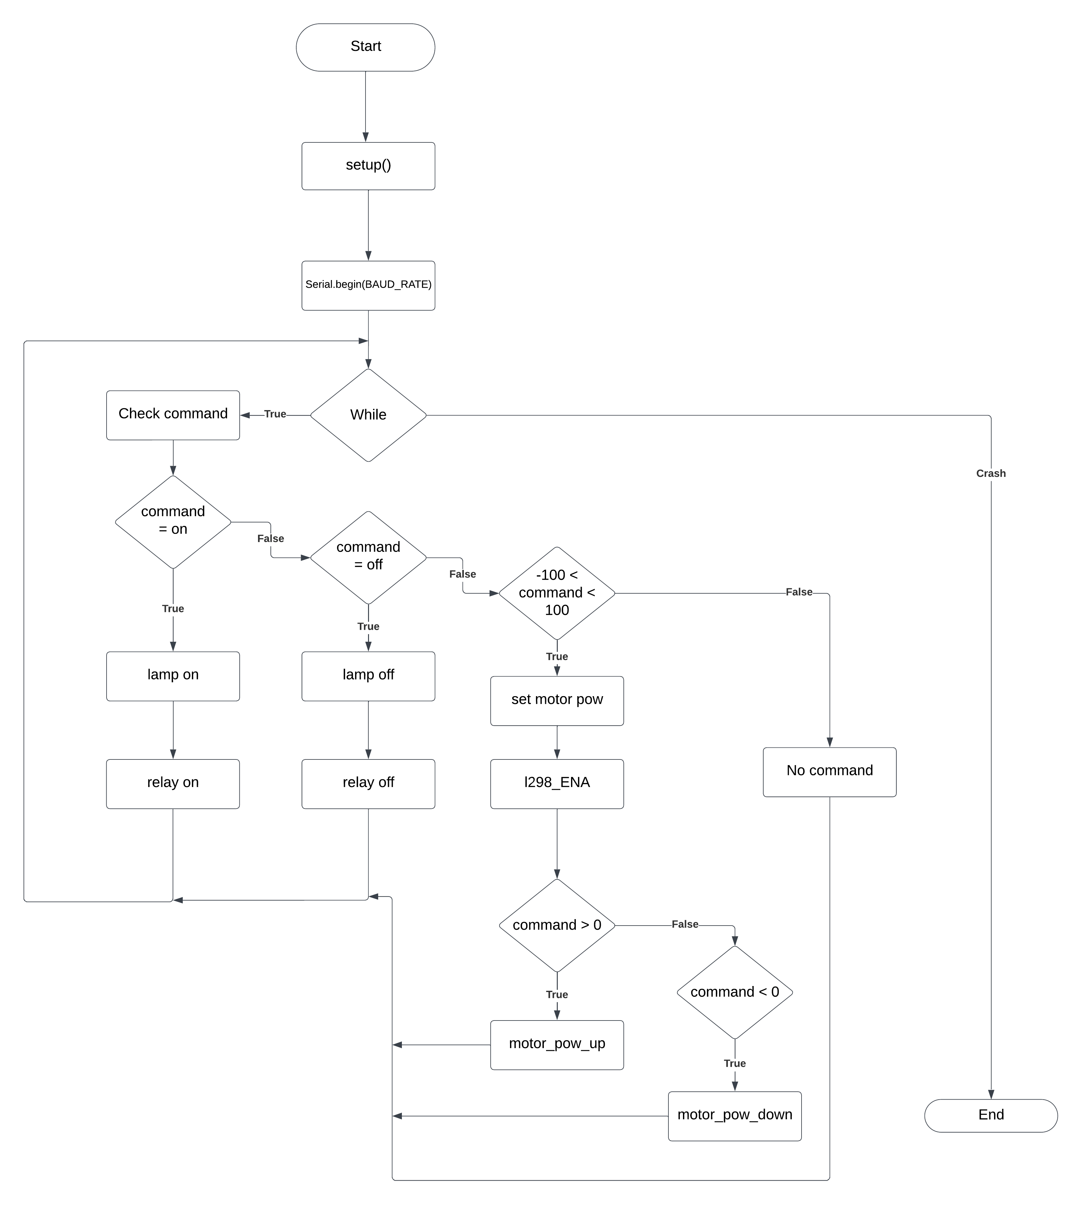

**Figure 1 Block diagram**

**2.3 Simulated schematic**

This is the simulated Arduino Uno scheme assembled in Proteus.

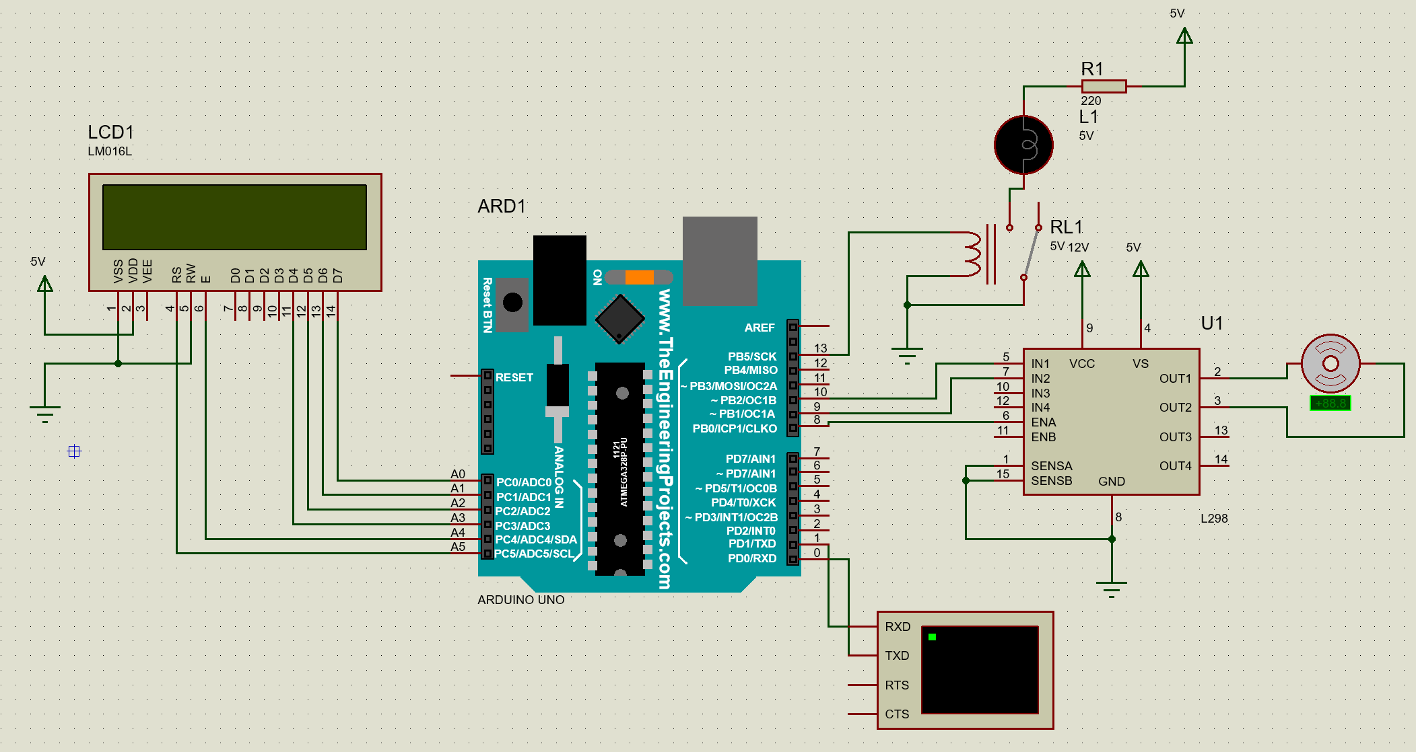

**Figure 2 Electrical schematic**

This circuit is composed of several elements such as: Arduino Uno, one resistor, two actuators (dc motor, relay), four power source, l298 module, light bulb, lcd and a virtual terminal. For this laboratory task, I assembled this circuit that meets all the requirements that were set at the beginning.

**2.4 Photos of running simulation**

In this picture it is shown the use of the actuator relay. When the actuator receives the command on, it switches the relay and the light bulb turns on. Here it shown the parts of the circuit that are responsible for the light bulb to turn on. Also, it shown the use of the lcd that prints the commands that were triggered [1].

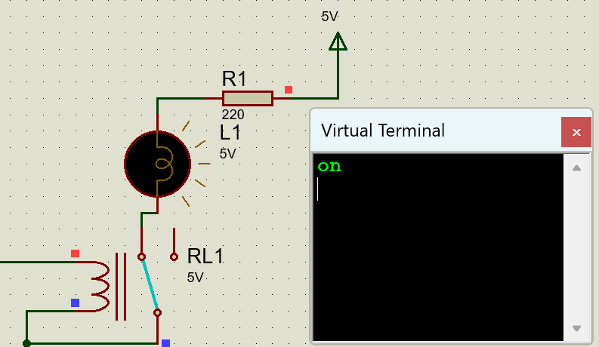 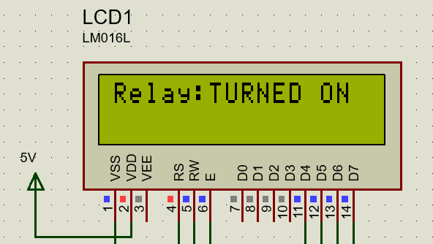

**Figure 3 Relay On**

This picture depicts the use of the same actuator but with the relay off which means that the light bulb will turn off as well. Here is also shown the lcd that is triggered with the right command when it switches on or off.

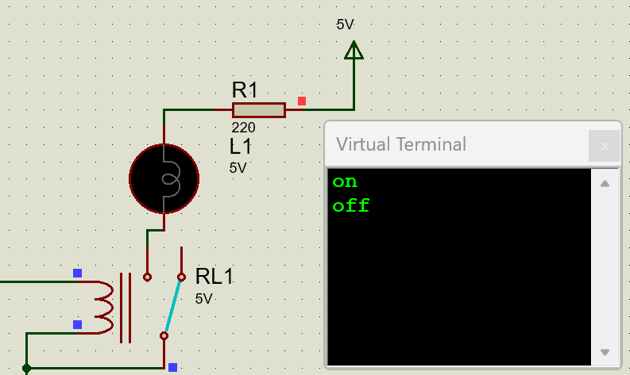 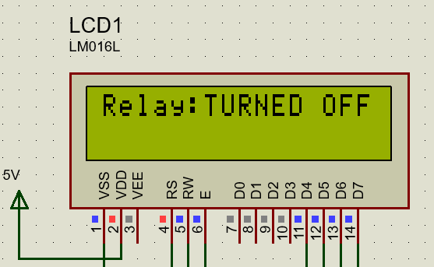

**Figure 4 Relay Off**

This picture shows the use of the second actuator, the dc motor and it’s module l298. Here the module is connected to the Arduino Board with pins IN1 and IN2 which are responsible for the rotation of the motor. The ENA pin is responsible for the speed that the motor has. Also here is shown the lcd that prints the speed and direction of the motor [2]. 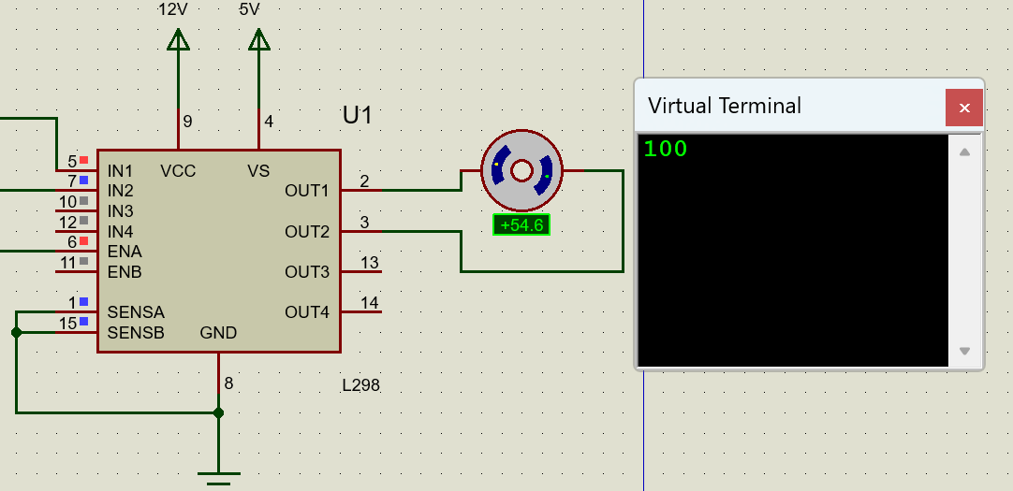 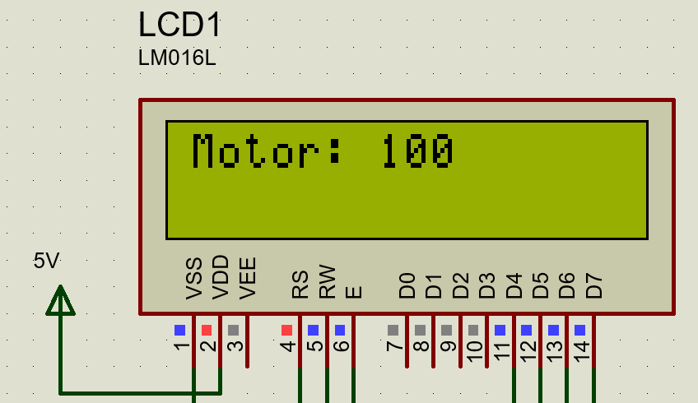

**Figure 5 Motor Rotates Counterclockwise**

This picture depicts the opposite case of the one above. Here the motor rotates in the opposite direction, the sign – is a symbol of it. The value -100 means that the motor rotates at the maximum speed in a clockwise direction [3].

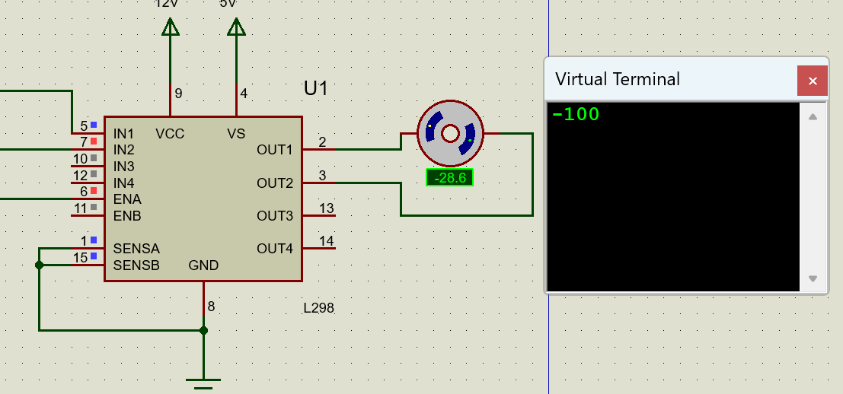 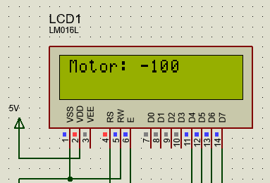

**Figure 6 Motor Rotates Clockwise**

# CONCLUSION

This laboratory work was a great experience for me. I learned a lot of small concepts, rules that helped me realize this project.

First of all, I used two actuators to do certain things. By utilizing two actuators, the relay and the DC motor, I gained practical insights into electronic circuitry and Arduino development. While connecting and programming the relay for controlling the light bulb was relatively straightforward, the DC motor posed some challenges. However, through careful wiring and coding, particularly with the L298 module, I successfully managed to integrate the motor into the project.

Second of all, I was able to create a simple scheme that has helped me simulate my project in real-time. I was able to make certain drivers for my components so that they would work right, and print the command on a lcd screen. Also I was able to use the l298 module which helped me connect the dc motor.

To sum up, this laboratory work has deepened my understanding of electronic circuits and Arduino development. The project’s success will contribute to my future projects in the field of embedded systems.

# BIBLIOGRAPHY

**1** Arduino: Arduino Relay. [online], [accessed at 06.04.2024]. Available at: [Arduino - Relay | Arduino Tutorial (arduinogetstarted.com)](https://arduinogetstarted.com/tutorials/arduino-relay)

**2** Arduino: Arduino DC Motor. [online], [accessed 07. 04. 2024]. Available at: [Arduino - DC Motor | Arduino Tutorial (arduinogetstarted.com)](https://arduinogetstarted.com/tutorials/arduino-dc-motor)

**3** Deepblue: L298 module. [online], [accessed 07. 04. 2024]. Available at: [Arduino L298N DC Motor Driver Interfacing With Code Examples (deepbluembedded.com)](https://deepbluembedded.com/arduino-l298n-dc-motor-driver-interfacing-tutorial/)