Abstract

This is an abstract describing what this project is all about…

# Introduction and Objectives

Explain the objectives here…

# Methodology

Discuss the approach and tools used…

# Results

Cut/paste graphs and plots results here…

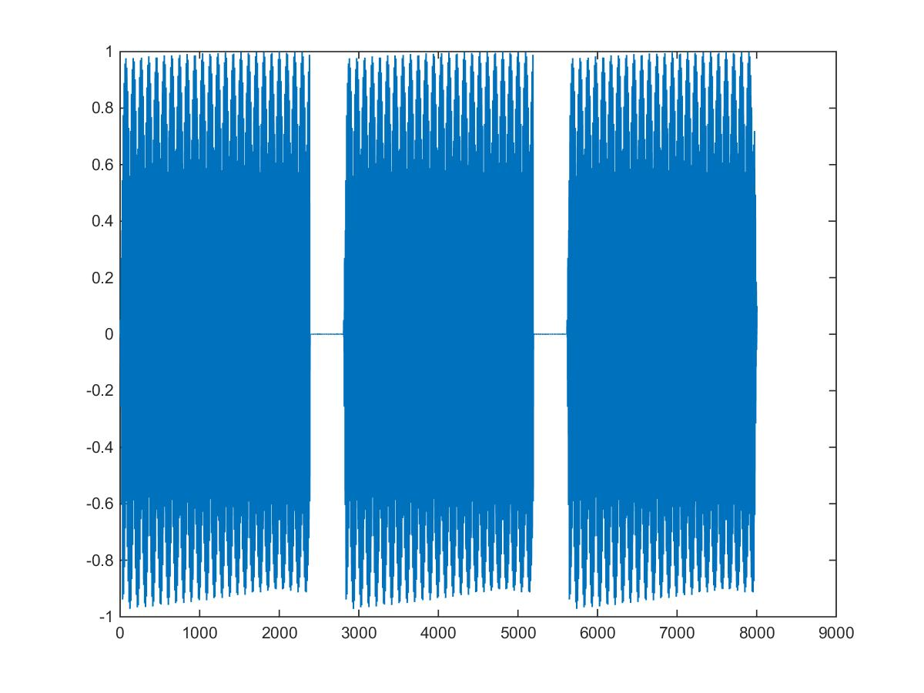

**Wave1 Waveform**

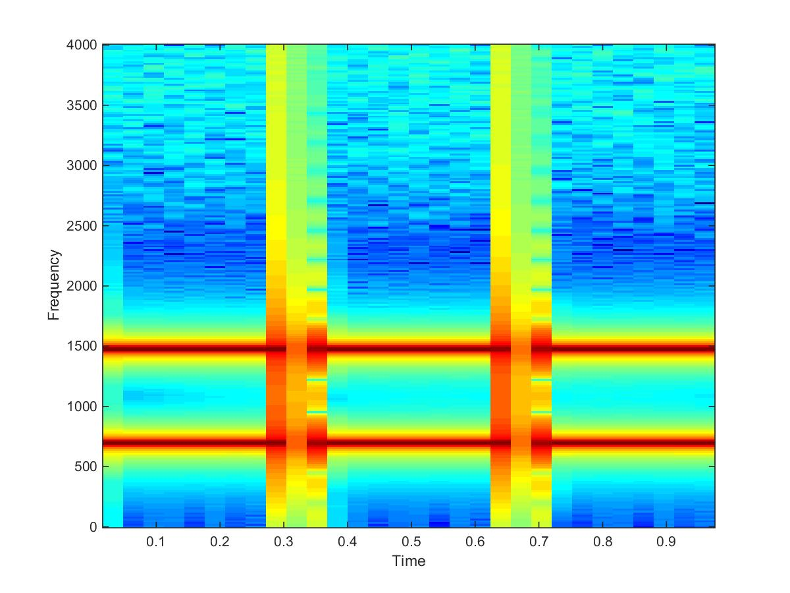

**Wave1 Spectrogram**

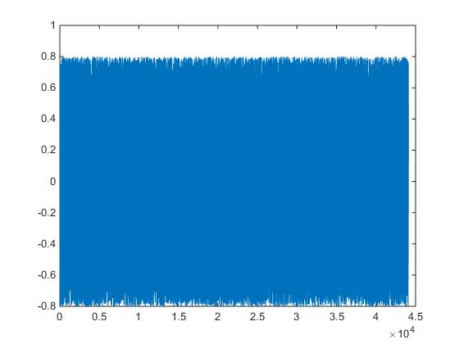

**White Noise Waveform**

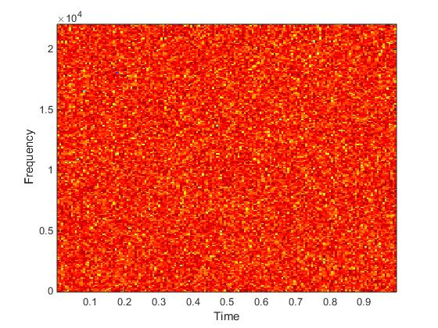

**White Noise Spectrogram**

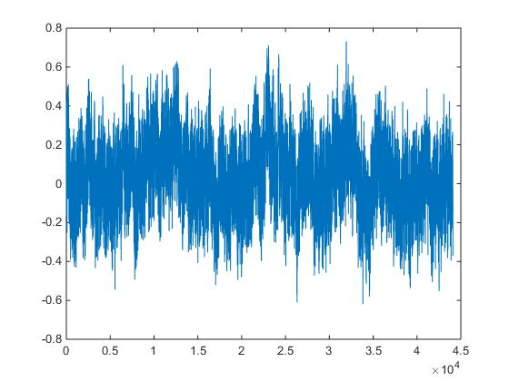

**Pink Noise Waveform**

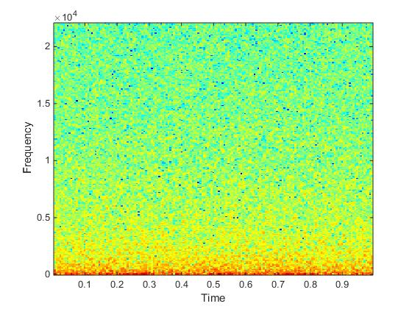

**Pink Noise Spectrogram**

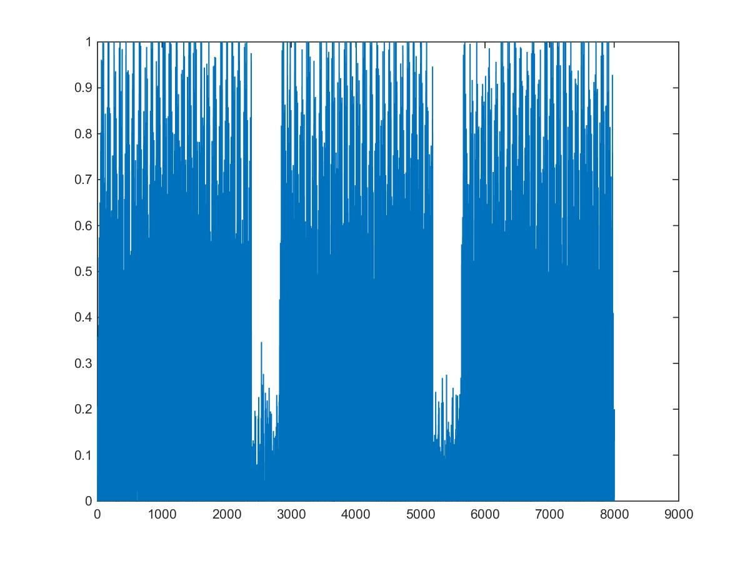

**Wave1 Gaussian Noise**

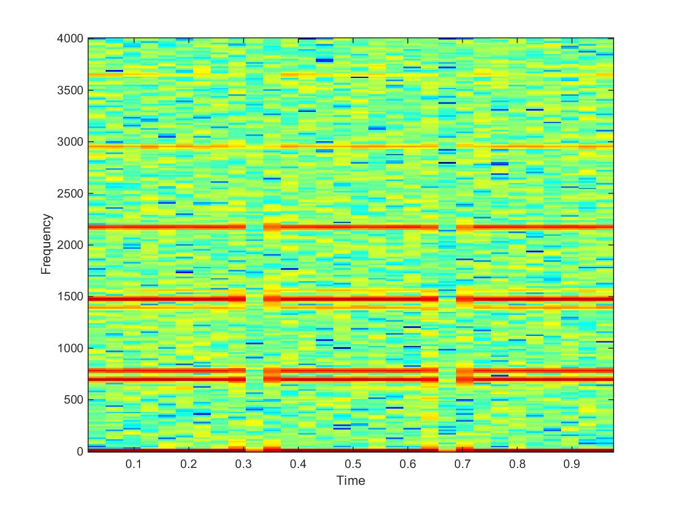

**Wave1 Gaussian Spectrogram**

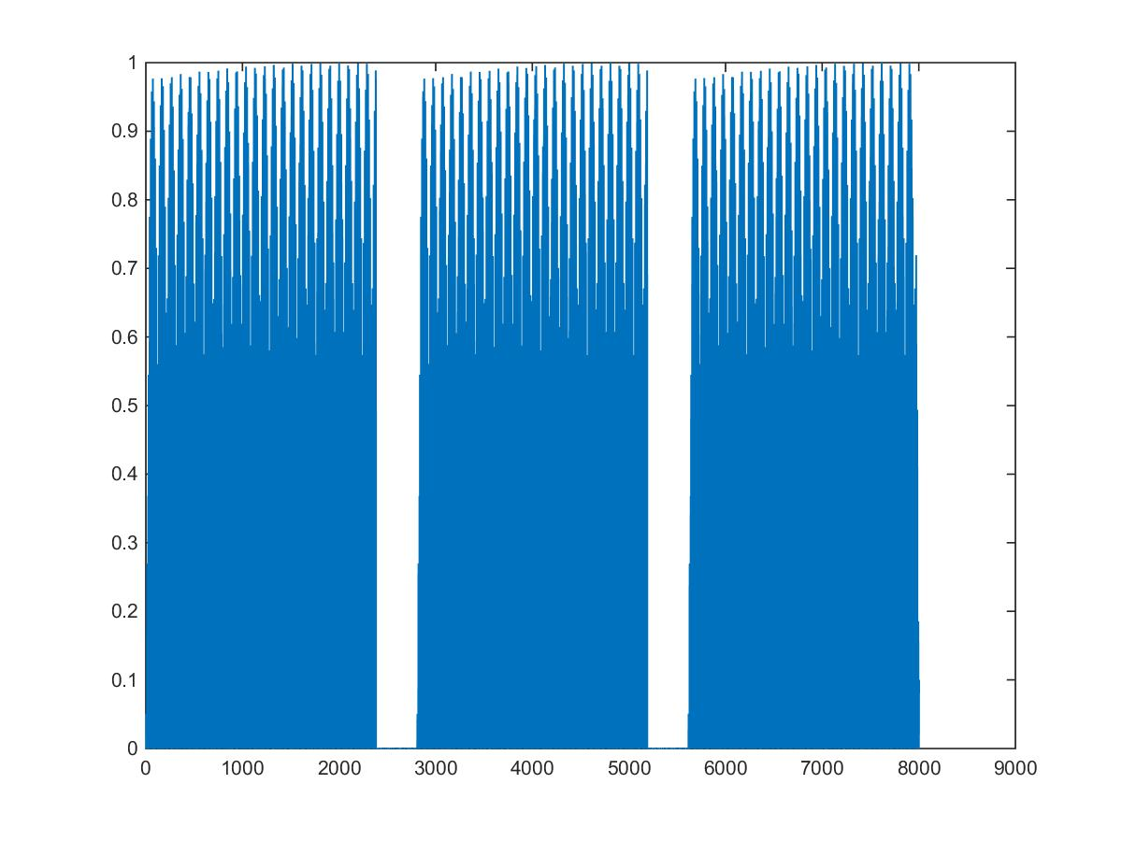

**Wave1 Poisson Waveform**

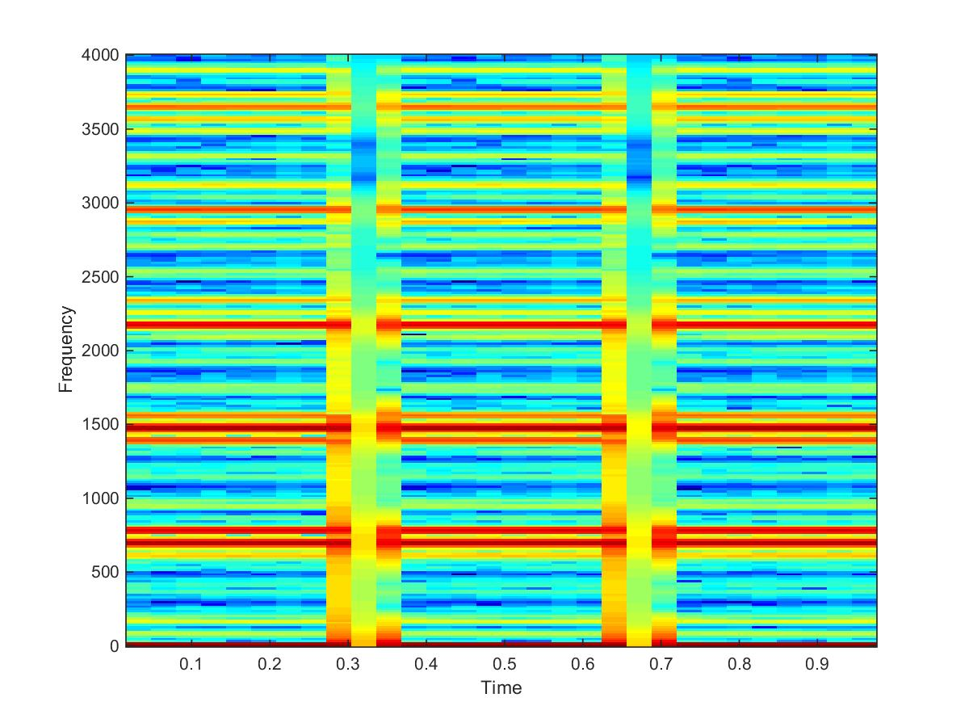

**Wave1 Poisson Spectrogram**

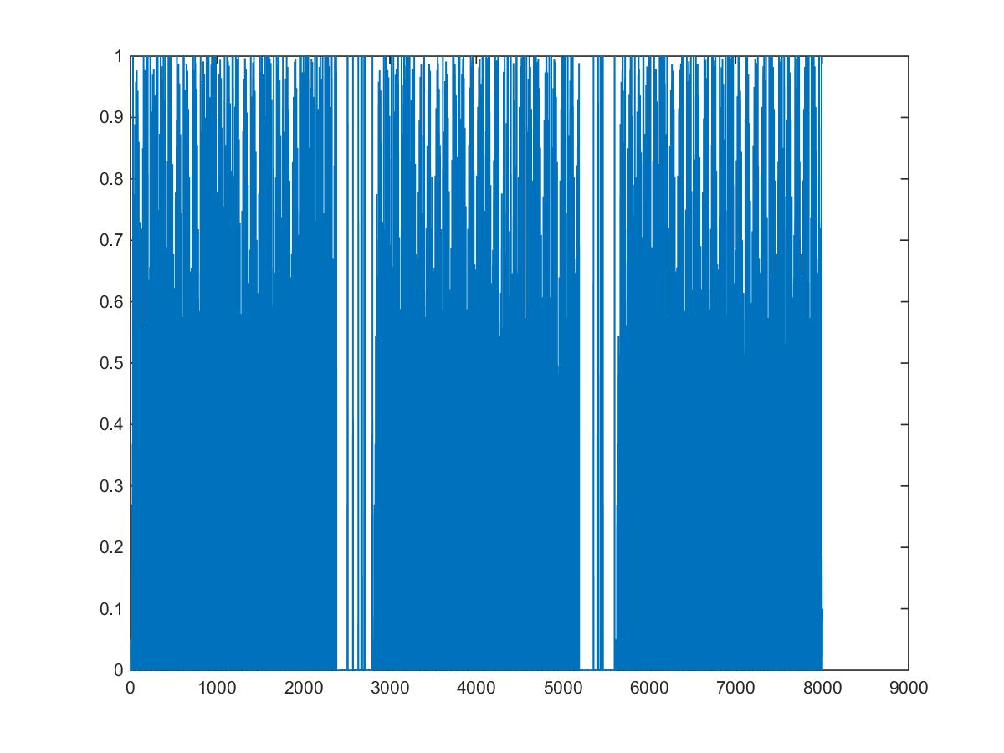

**Wave1 Salt & Pepper Waveform**

**Wave**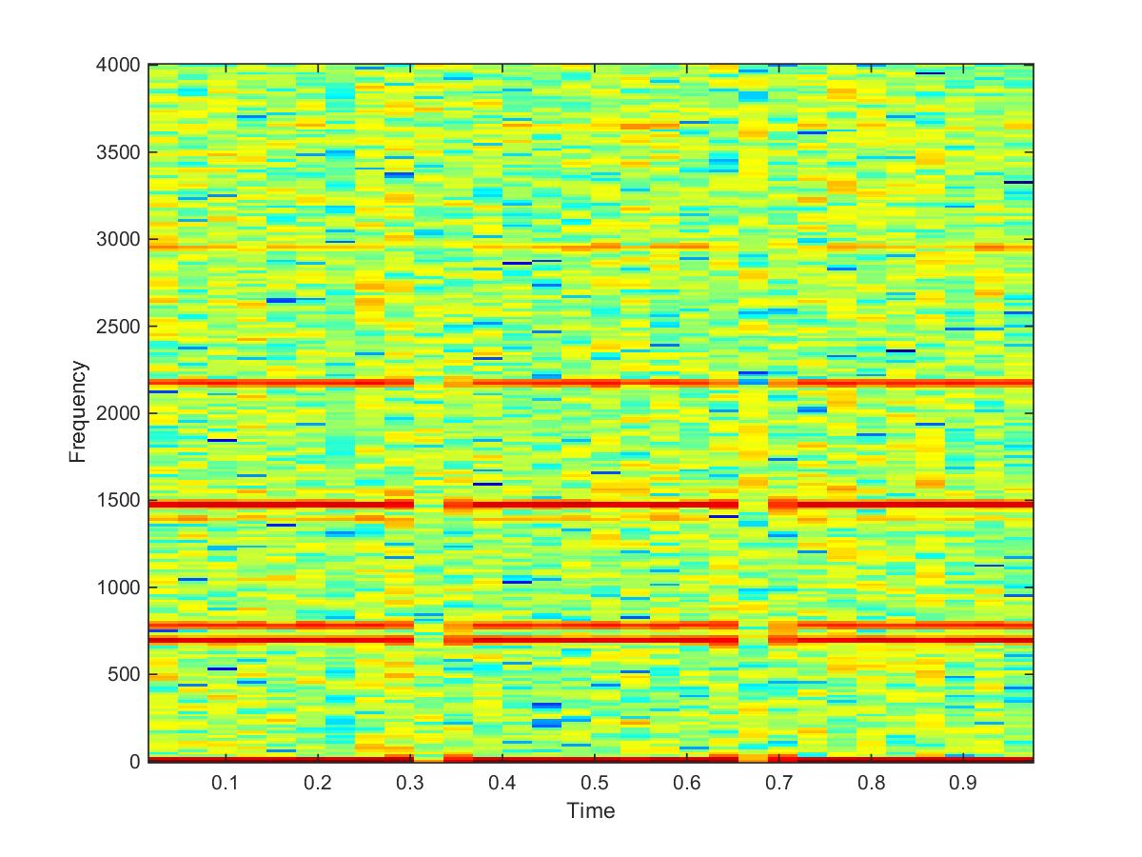

**Wave1 Salt & Pepper Spectrogram**

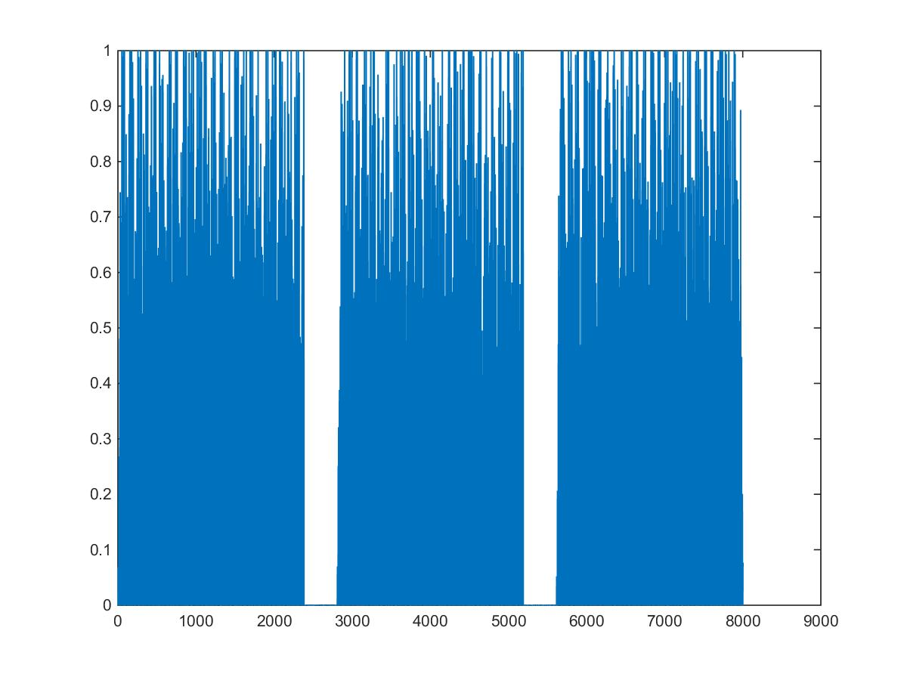

**Wave1 Speckle Spectrogram**

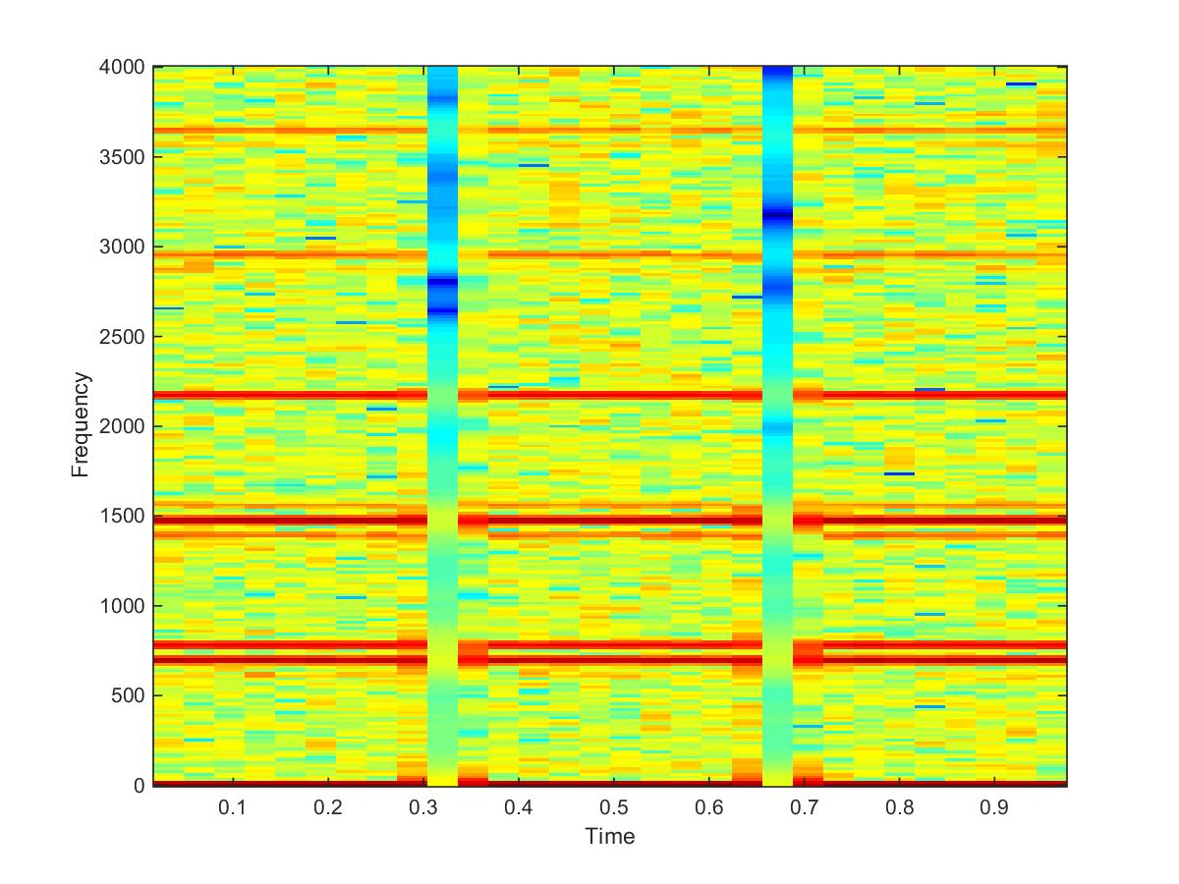

**Wave1 Speckle Spectrogram**

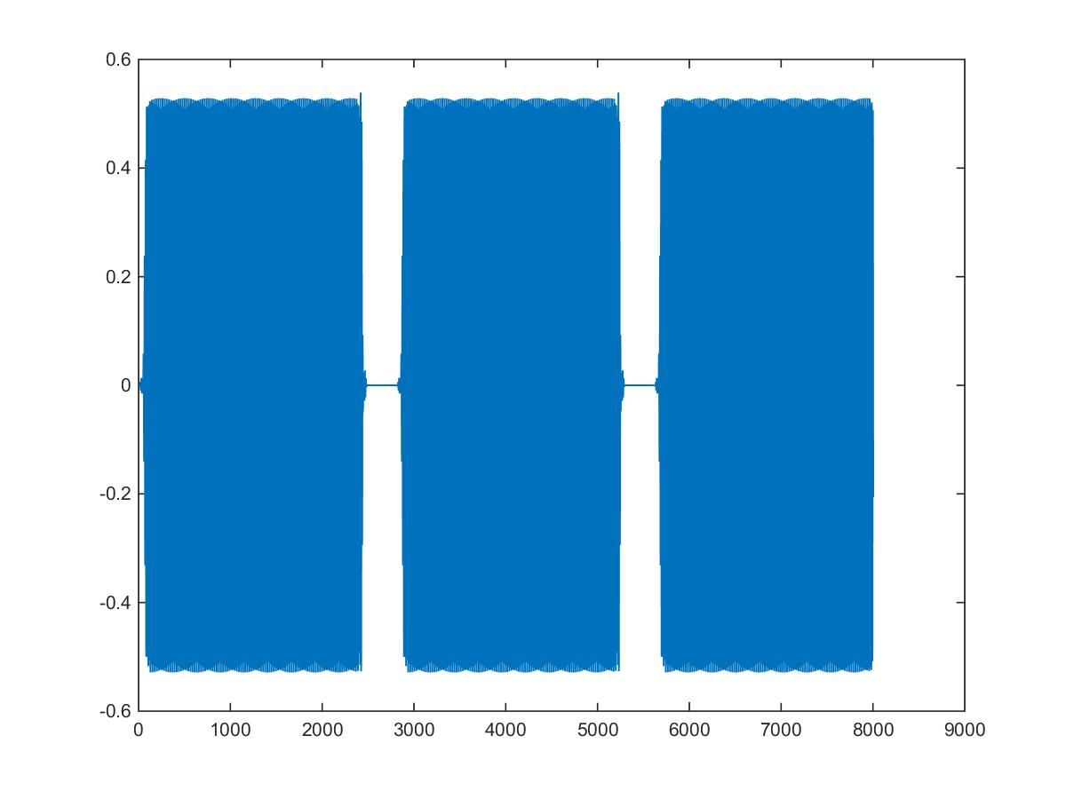

**Wave1 Low pass Waveform**

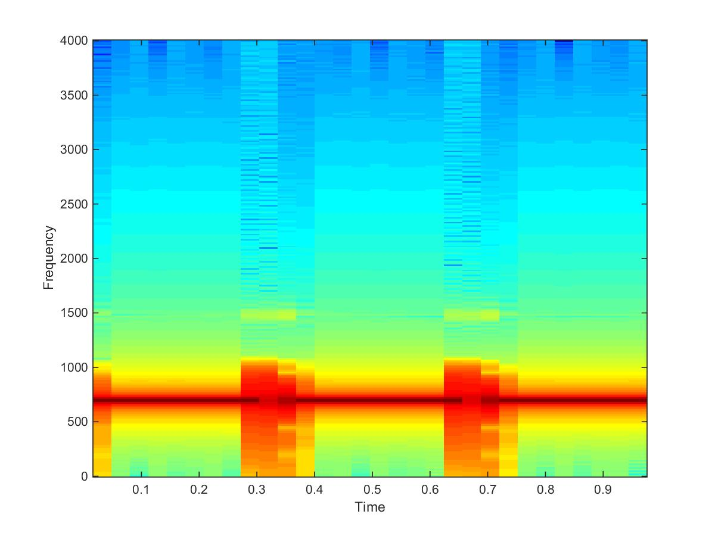

**Wave1 Low Pass Spectrogram**

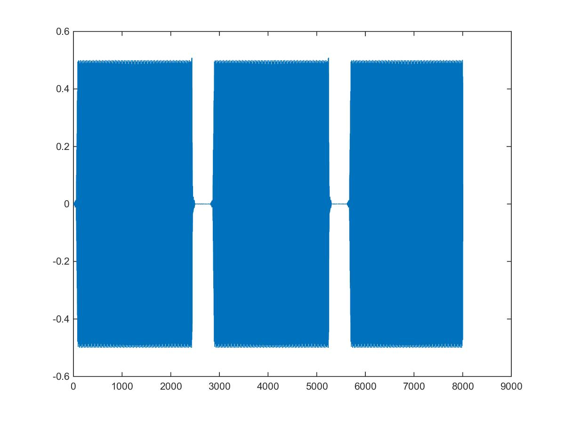

**Wave1 High Pass Waveform**

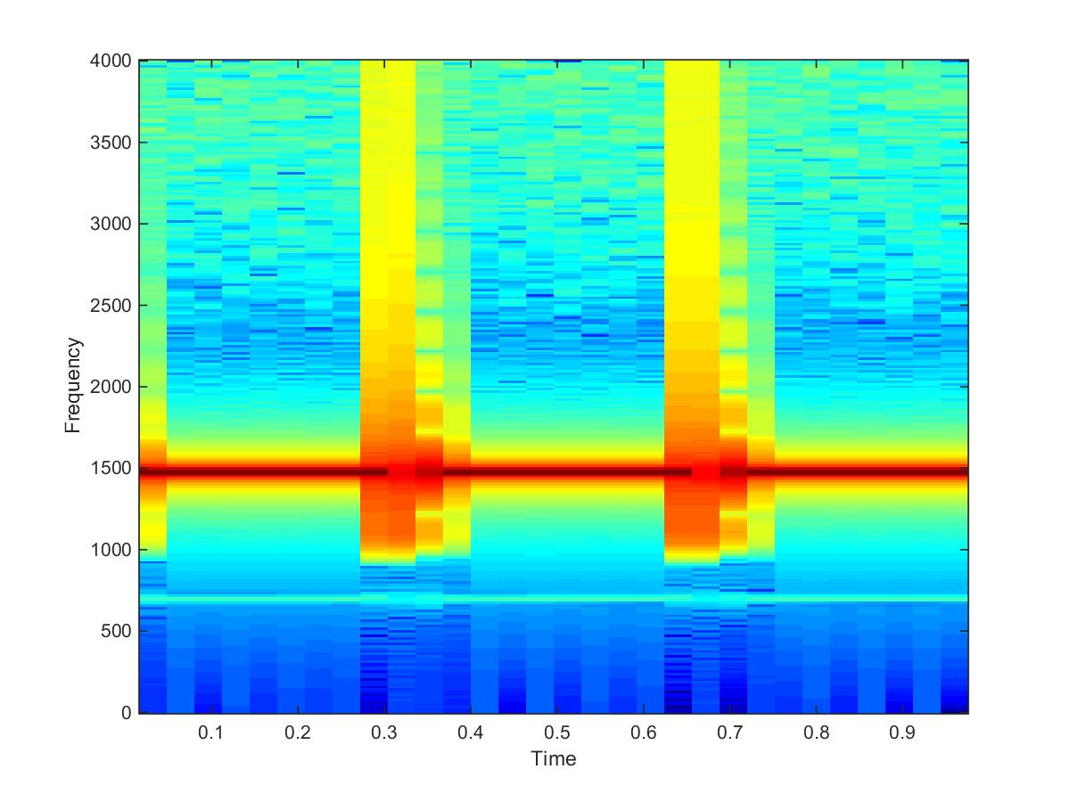

**Wave1 High Pass Spectrogram**

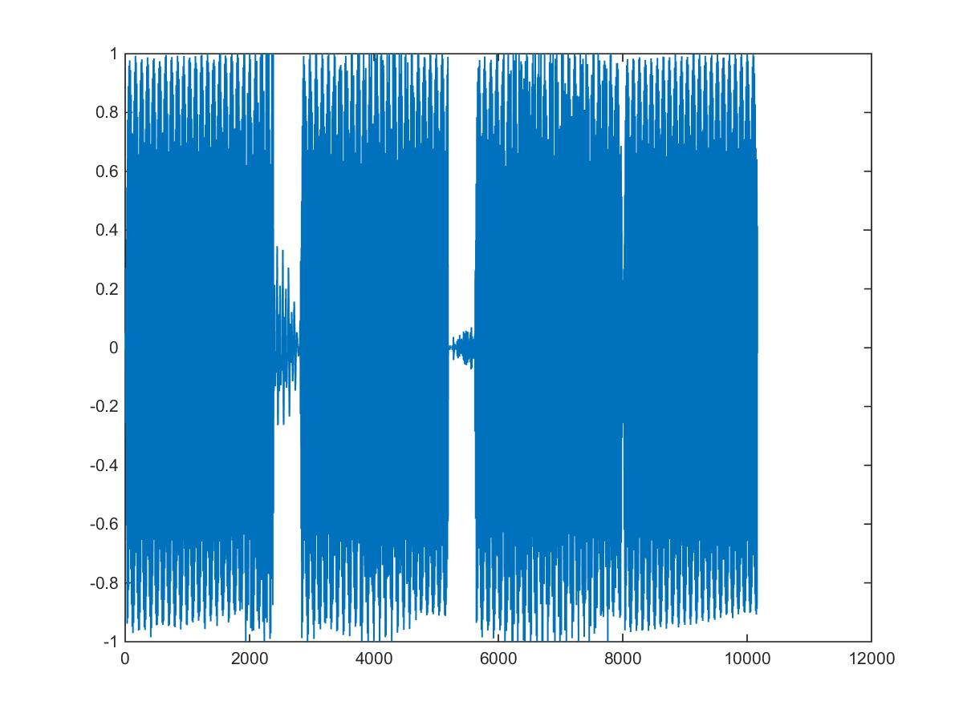

**nsp0 Unfiltered Waveform**

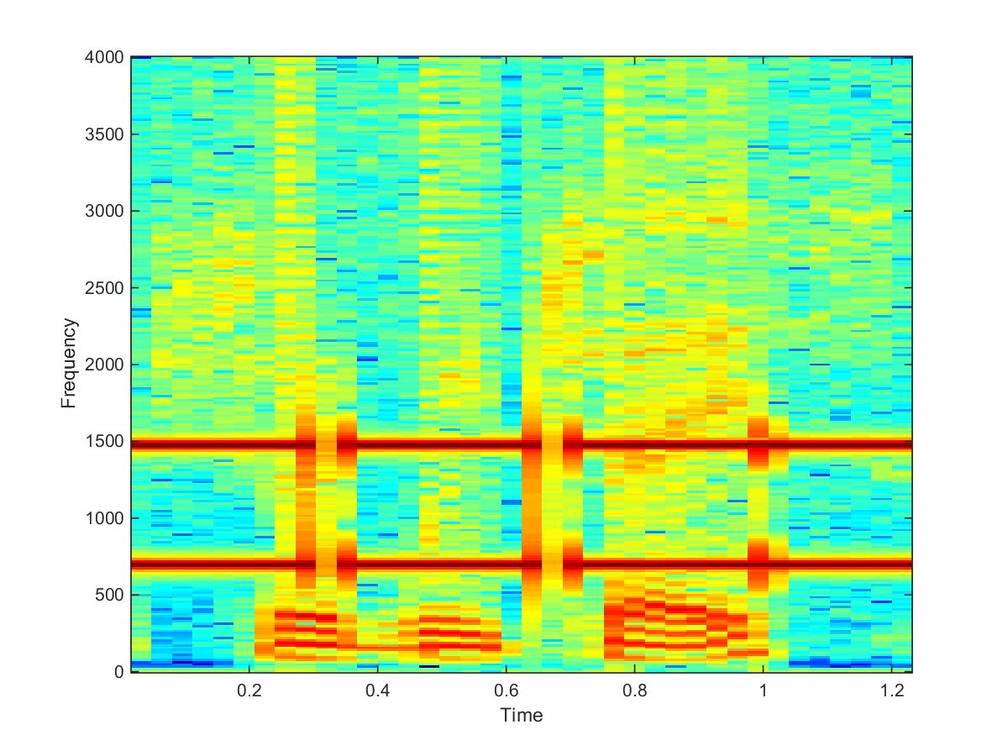

**Nsp0 Unfiltered Spectrogram**

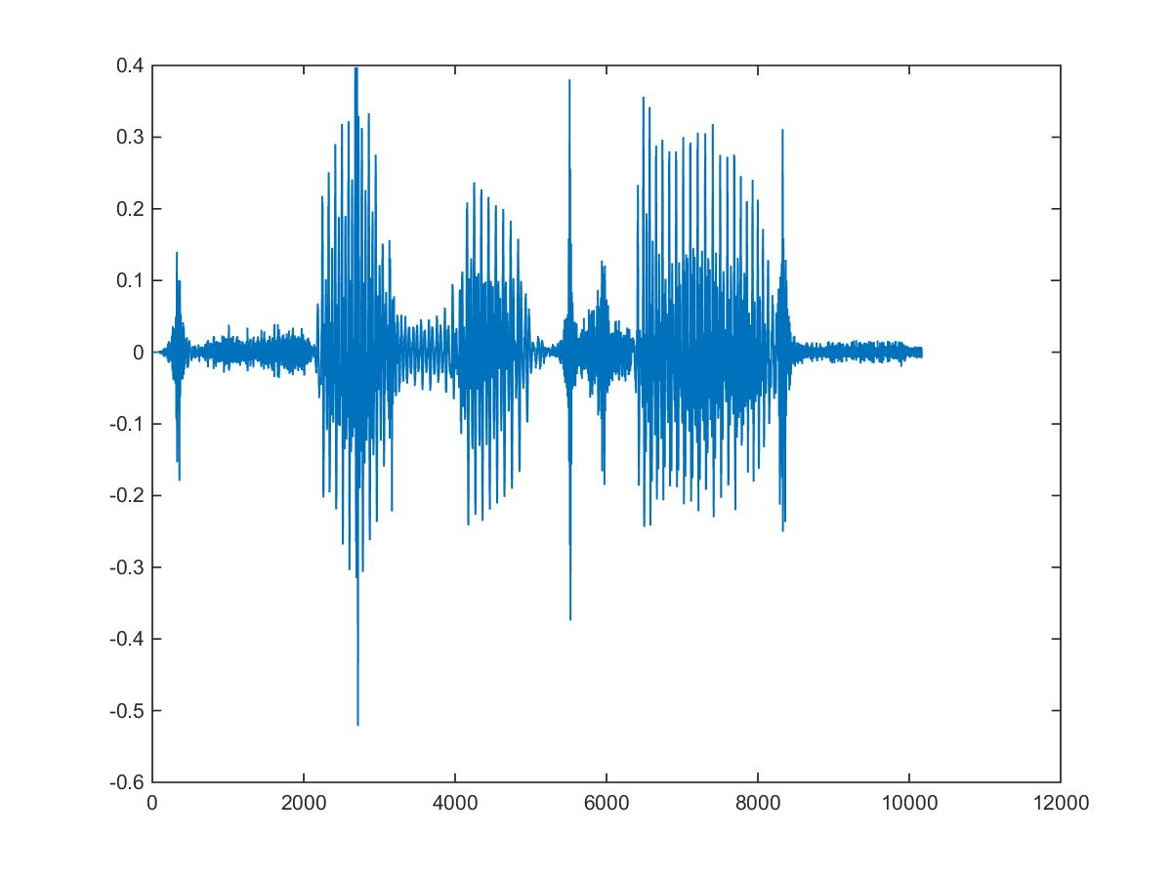

**Nsp0 Filtered Waveform**

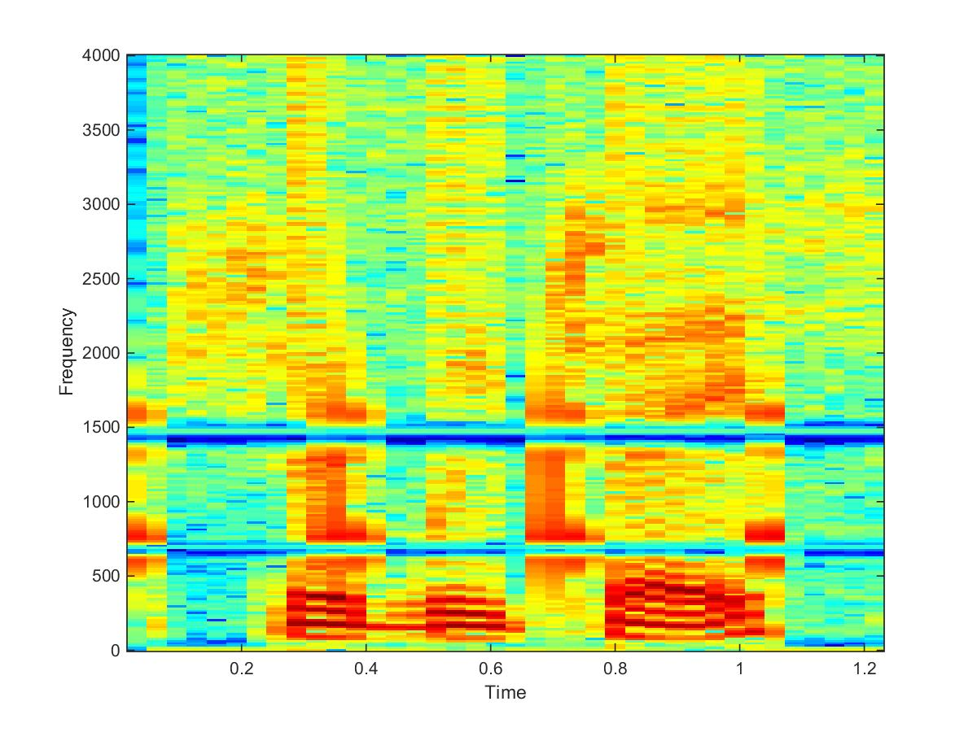

**Nsp0 Filtered Spectrogram**

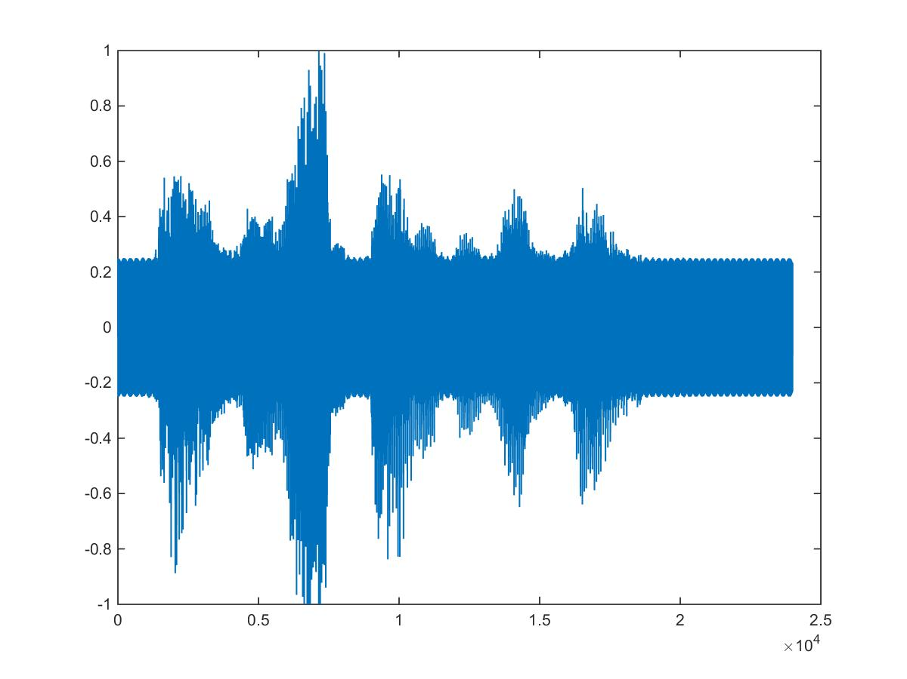

**Nsp1 Unfiltered Waveform**

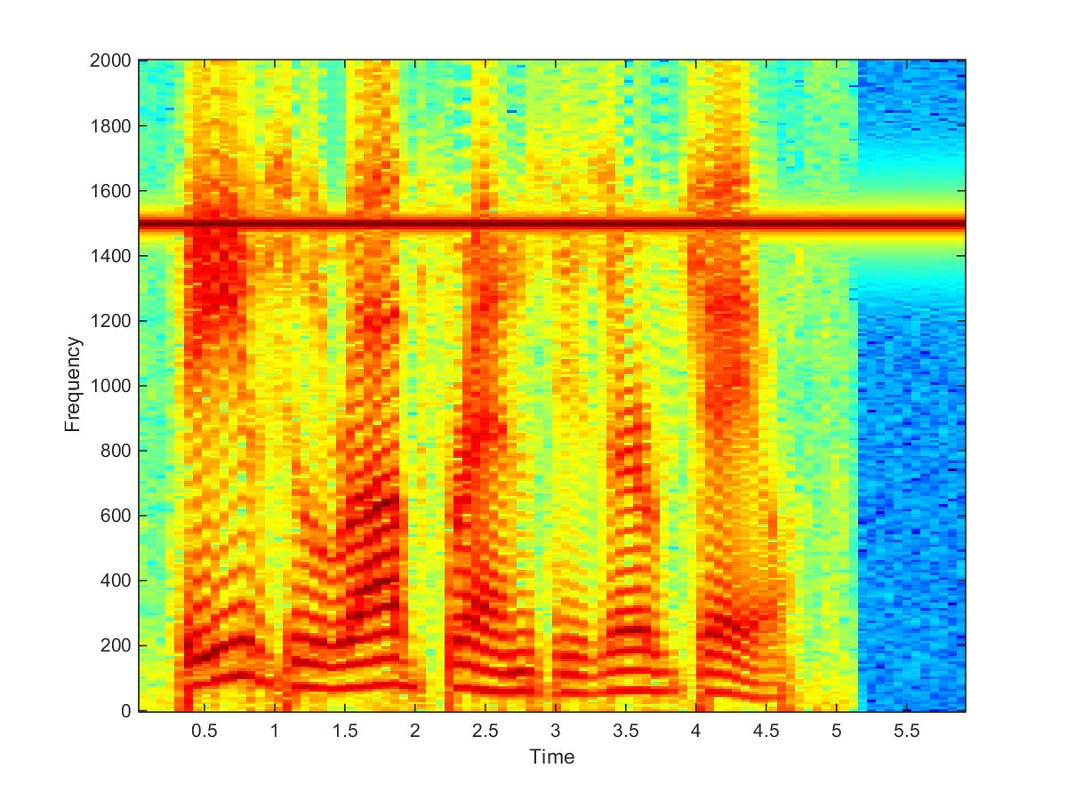

**Nsp1 Unfiltered Spectrogram**

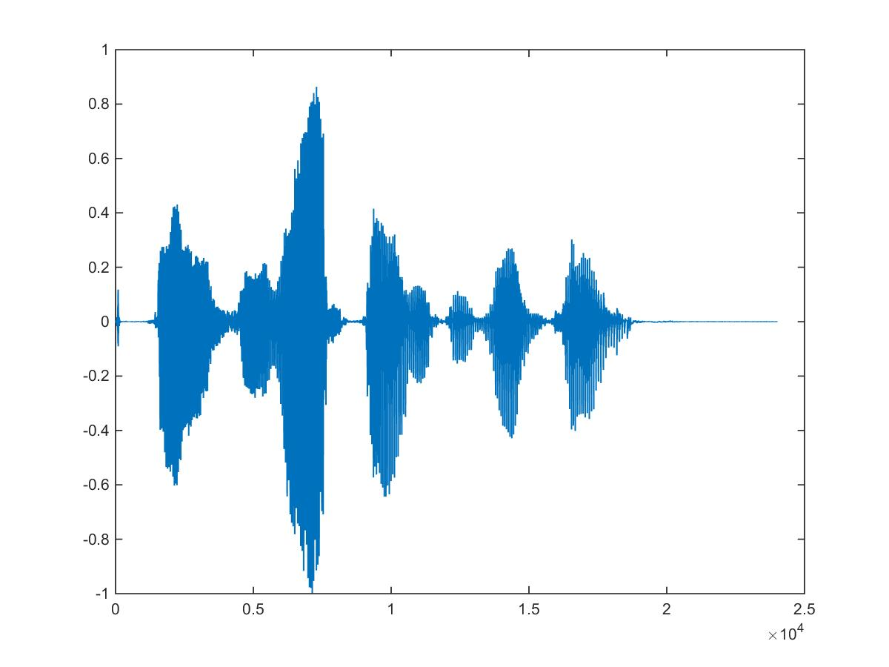

**Nsp1 Filtered Waveform**

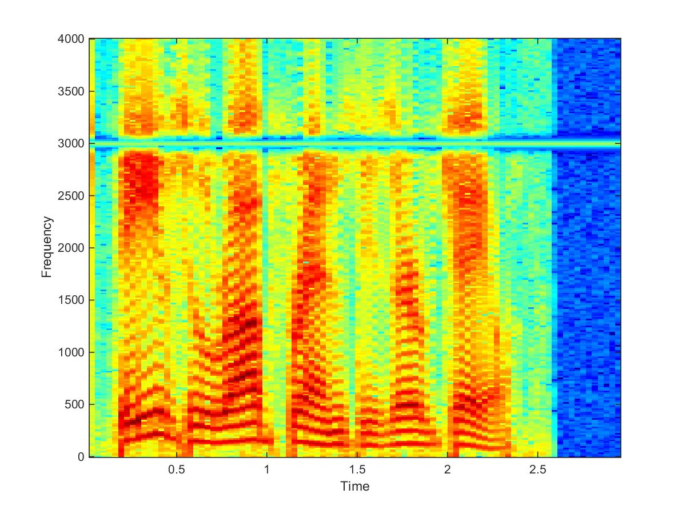

**Nsp1 Filtered Waveform**

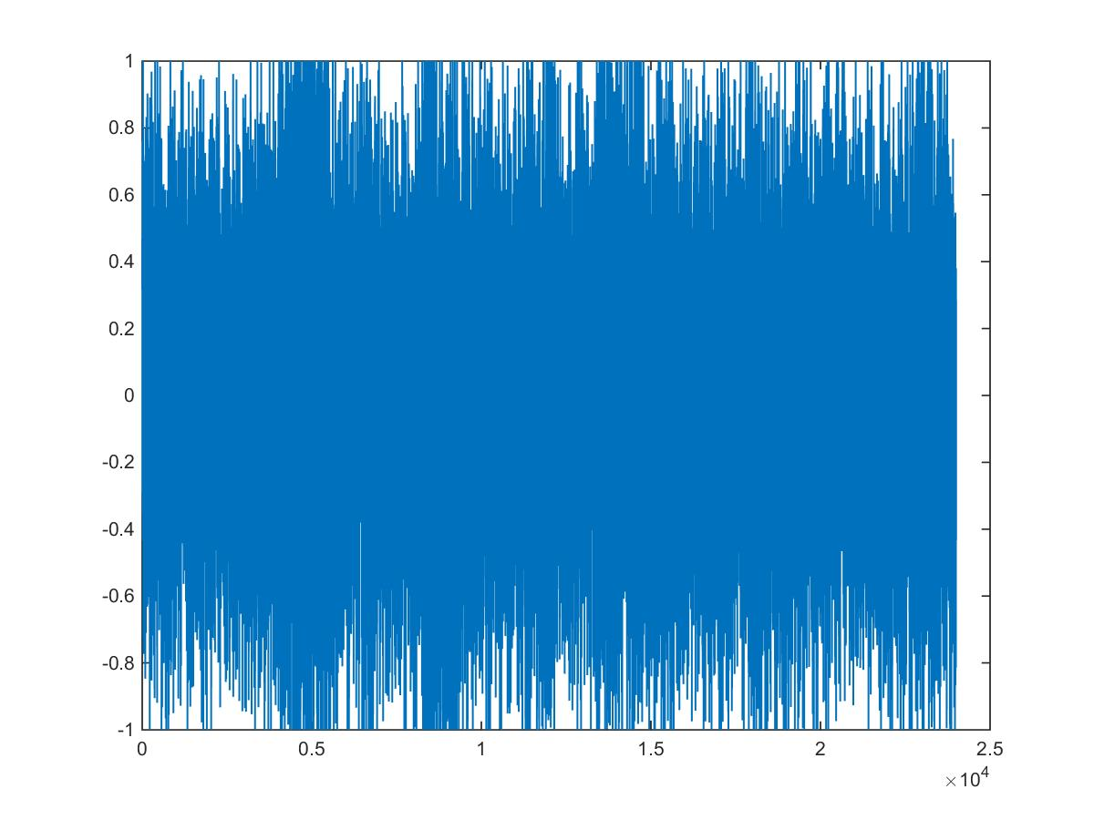

**Nsp2 Unfiltered Waveform**

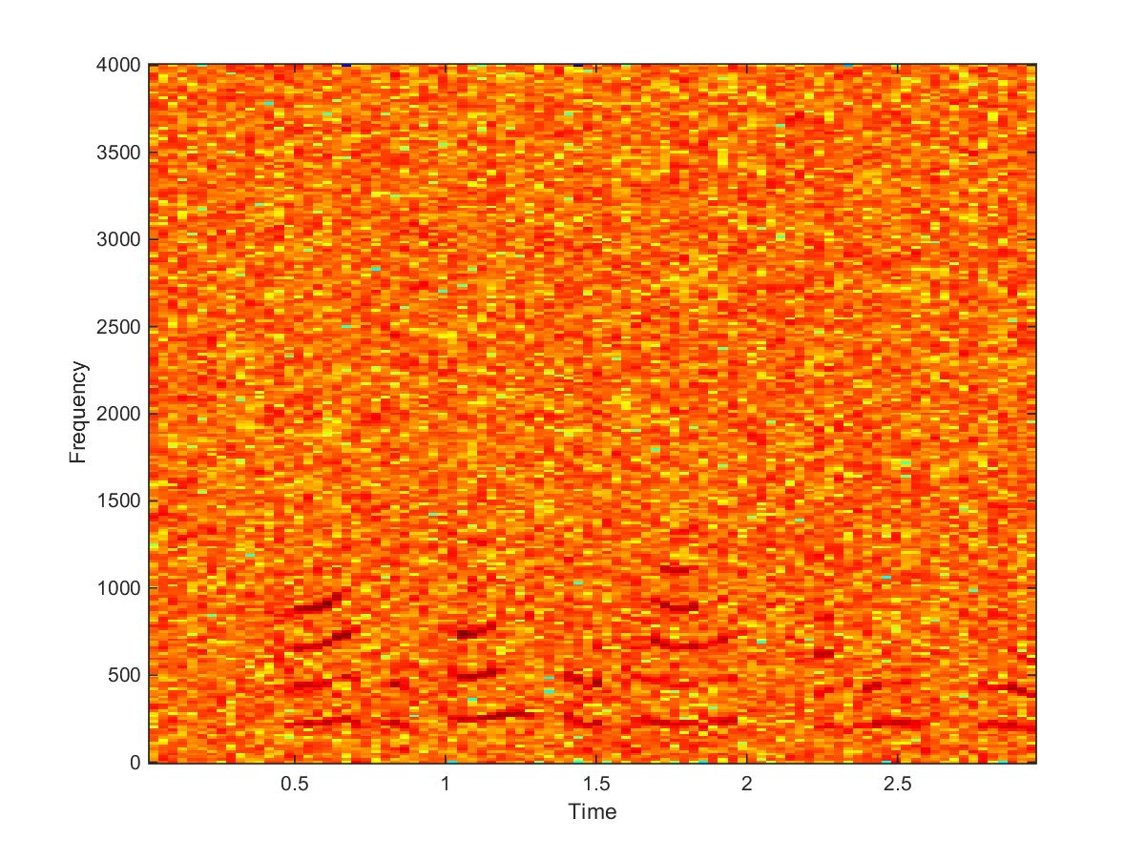

**Nsp2 Unfiltered Spectrogram**

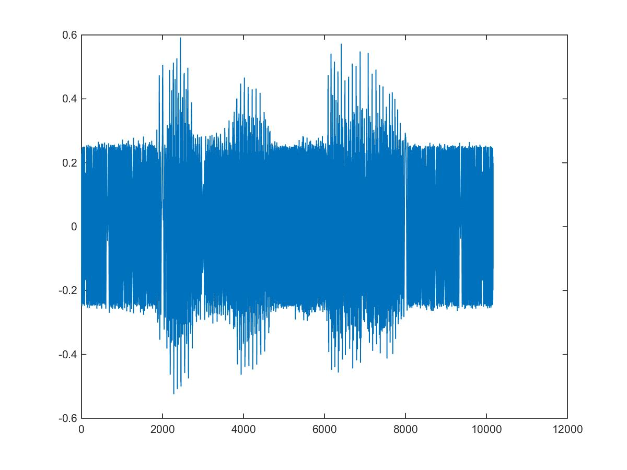

**Nsp3 Unfiltered Waveform**

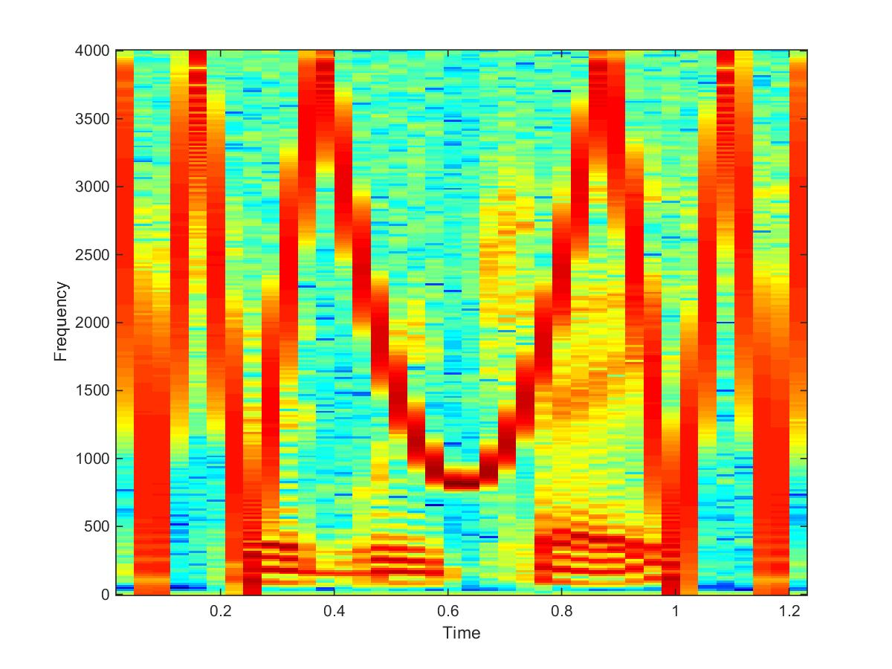

**Nsp3 Unfiltered Spectrogram**

# Discussion

Discuss the meaning of the results here…

# Conclusion

Having leveraged the MATLAB environment, a realization of the \Bach Fugue #2" classical…

# References

List any references used…

# Appendix

Include source code listings here…