CIS GILEAD IDEATHON 2026
AIOps THEME · INTERACTIVE PROTOTYPE SUBMISSION
AURA
THE L0 AGENT
Agentic Unified Resolution & Assistance
PROTOTYPE - TECHNICAL WALKTHROUGH & ARCHITECTURE DOCUMENTATION
A live, interactive product experience demonstrating the L0 Autonomous Support Layer
Live Demo: https://aura-l0-agent.onrender.com/
Source Repository: github.com/ryantusi/AURA-L0-Agent
PREPARED BY  Ryan Ahmed Tusi  Analyst Trainee – L1 IT Support  Employee ID: 2485906 | ORGANIZATION  Cognizant Technology Solutions  CIS Line - Gilead Sciences Account | DOCUMENT  Prototype Technical Documentation  July 2026

Table of Contents
1. Executive Summary 3
2. System Overview & Design Philosophy 4
3. Technical Architecture 5
4. Project Structure 7
5. Engineering Deep Dive - The Voice Biometric Engine 8
6. AI Reasoning Layer - Gemini Integration & Simulated Fallback 10
7. Voice I/O Layer - ElevenLabs TTS & STT 11
8. API Reference 12
9. Feature Walkthrough - Mode by Mode 13
10. Deployment Architecture 14
11. Local Development Setup Guide 15
12. Frequently Asked Questions 16
13. Closing Notes 17

1. Executive Summary
AURA, The L0 Agent has moved from concept to a fully functional, publicly deployed interactive prototype. This document is the technical companion to the AURA Whitepaper: where the whitepaper argues why the L0 support layer should exist, this document explains how the prototype proves that it can.
The prototype is live and accessible at
https://aura-l0-agent.onrender.com/
It is a single-page application built on React 18, TypeScript, and Vite, served by an Express backend, and hosted on Render. The prototype is organized as an immersive walkthrough of AURA's four operating modes, each demonstrating a distinct facet of the L0 concept, plus a voice-gated landing portal that performs genuine audio signal processing - not a simulated effect, but a real Fast Fourier Transform and pitch-tracking pipeline written from first principles.
The purpose of this document is to walk through exactly what was built, how it works under the hood, and how a reader - technical or non-technical - can navigate, run, and evaluate it.
What This Document Covers
- The overall architecture and technology choices, and why each was made
- A full explanation of the voice biometric authentication engine, including the actual signal-processing algorithms implemented
- How the AI voice layer (ElevenLabs) are integrated, including graceful fallback behavior
- A complete reference of every backend API endpoint
- A guided walkthrough of all four modes as experienced by a judge or user
- Deployment details and a step-by-step local setup guide

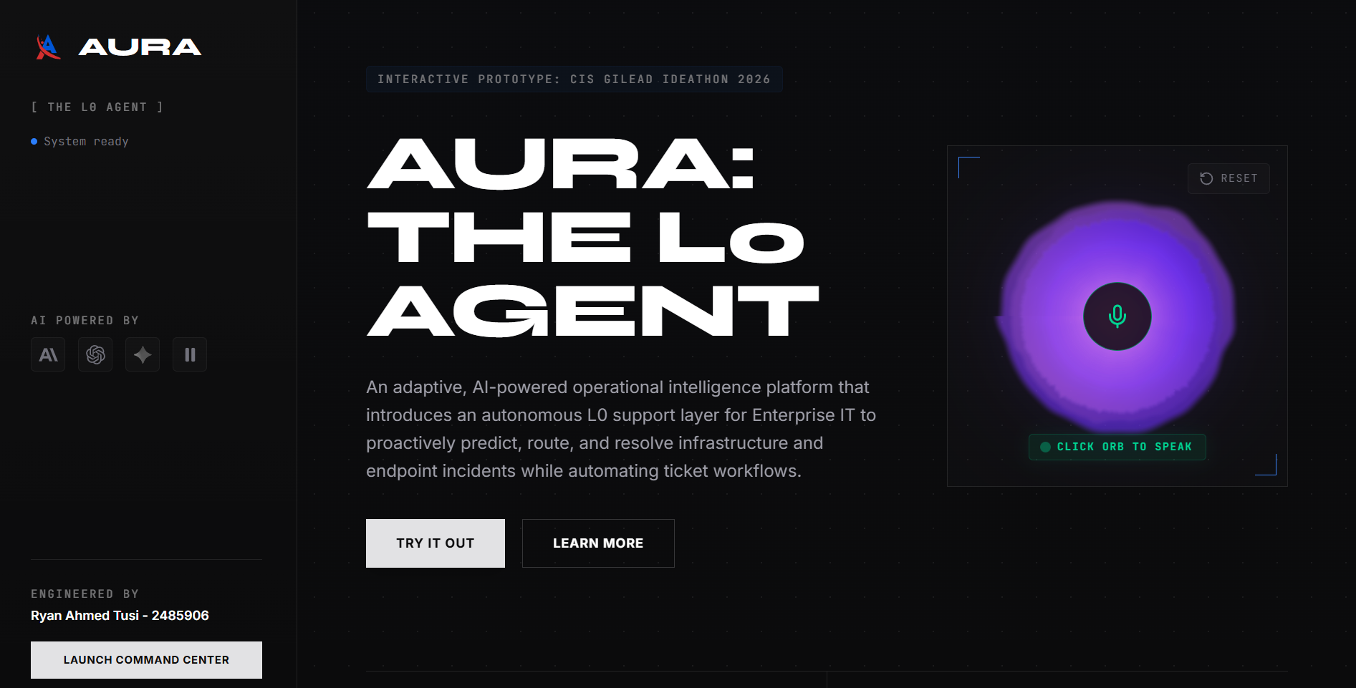

2. System Overview & Design Philosophy
AURA is an adaptive, AI-powered voice and non-voice operational intelligence platform that introduces the L0 Autonomous Support Layer for enterprise IT, a tier positioned before L1 that resolves incidents at first contact, remediates endpoint issues, eliminates manual documentation, routes complex cases intelligently, supports human agents, and predicts incidents before they escalate.
The prototype was designed around one guiding principle established from the outset of this project: judges should not just read about AURA, they should step inside it. Every mode is therefore built as an interactive, first-person experience rather than a passive slideshow, the user registers their voice, initiates simulated calls, watches escalation packages assemble live, and triggers remote remediation actions themselves.
Design Goals
- Immersive over illustrative: every mode is something the user does, not something they watch
- Real engineering where it counts: the voice biometric layer is genuine DSP, not a mocked animation
- Graceful degradation: every AI-dependent feature has a dignified simulated fallback so the app never breaks if a key is missing or a quota is hit
- Single deployable unit: one Express server serves both the API and the compiled frontend, simplifying hosting to a single Render service

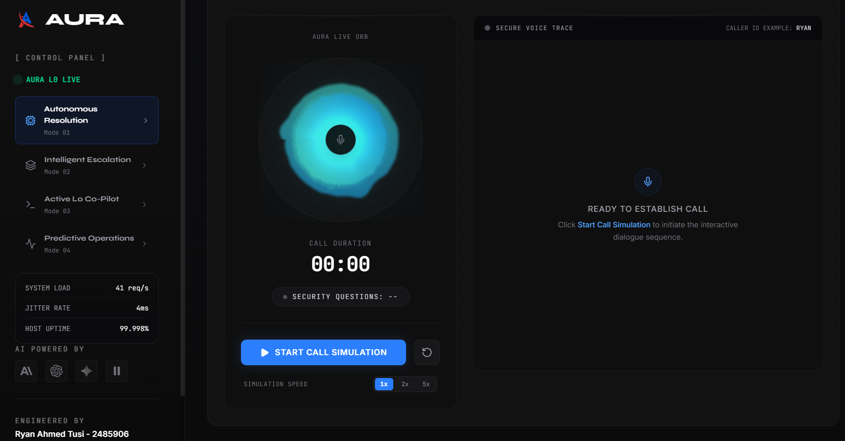

3. Technical Architecture
The entire prototype, frontend and backend, is written in a single language: TypeScript. This was a deliberate simplification. Rather than splitting the system across a TypeScript frontend and a separate Python backend, one language runs the whole stack, which keeps the codebase small, coherent, and fast to iterate on for a solo build.
Technology Stack
Layer | Technology
Frontend Framework | React 18 + TypeScript (.tsx)
Build Tool | Vite (dev server middleware + production bundler)
Styling | Tailwind CSS
Backend Runtime | Node.js + Express (TypeScript)
File Uploads | Multer (in-memory storage for audio blobs)
Voice Synthesis & Transcription | ElevenLabs TTS (eleven_v3) and STT (scribe_v1)
Signal Processing | Custom-built FFT and pitch-detection algorithms (no external DSP library)
Hosting | Render (Node.js web service)
Table 1 - Full technology stack used across the prototype
Architectural Pattern: Dual-Mode Express Server
A distinctive engineering decision in this build is that the same Express server file (server.ts) operates differently depending on environment. In development, it mounts Vite's Hot Module Replacement middleware directly, so any code change reflects instantly in the browser without a manual rebuild. In production, it instead serves the pre-compiled static bundle from the dist/ directory and falls back every unmatched route to index.html, which is what allows the React Router-driven single-page app to handle client-side routing correctly once deployed.
async function setupViteOrStatic() {
if (process.env.NODE_ENV !== "production") {
const vite = await createViteServer({
server: { middlewareMode: true },
appType: "spa",
});
app.use(vite.middlewares);
} else {
const distPath = path.join(process.cwd(), "dist");
app.use(express.static(distPath));
app.get("*", (req, res) => {
res.sendFile(path.join(distPath, "index.html"));
});
}
app.listen(PORT, "0.0.0.0", () => {
console.log(`[AURA Server] Operating at http://localhost:${PORT}`);
});
}
Excerpt from server.ts - the dual-mode bootstrap function
This single decision is what allows the exact same codebase to be run with npm run dev on a laptop for active development, and npm run build && npm start to produce the identical optimized artifact that is deployed on Render, no separate deployment configuration or build pipeline branching is required.

4. Project Structure
The repository is organized into a clear separation between presentation, orchestration, and data.
├── assets/ # Whitepaper, presentation, workbook, logo SVGs
├── dist/ # Compiled production build (generated on build)
├── src/
│ ├── components/
│ │ ├── AuraLogo.tsx # Canvas-based pulsing energy orb
│ │ ├── AutonomousMode.tsx # Mode 1 - voice call simulation & transcripts
│ │ ├── CopilotMode.tsx # Mode 3 - call logging & chat helper panel
│ │ ├── EscalationMode.tsx # Mode 2 - multi-agent routing & ticketing
│ │ ├── LandingPage.tsx # Gateway, voice enrollment, documentation
│ │ ├── MicVisualizer.tsx # Particle animation for active recording
│ │ ├── PredictiveMode.tsx # Mode 4 - remote remediation & monitoring
│ │ ├── Sidebar.tsx # Dark-themed navigation rail
│ │ └── TutorialWalkthrough.tsx # Step-by-step onboarding overlays
│ ├── App.tsx # App shell, global state, voice recorder orchestration
│ ├── data.ts # Simulated dialogues, rosters, metrics, evidence models
│ ├── index.css # Global styles and font configuration
│ ├── main.tsx # React DOM mount point
│ ├── types.ts # Shared TypeScript interfaces & enums
│ └── utils.ts # Tailwind class-merge utilities
├── .env.example # Required environment variable blueprint
├── server.ts # Express backend - DSP engine + all API routes
├── vite.config.ts # Bundler configuration
└── package.json # Scripts and dependencies
Figure 1 - Repository structure
Two files anchor the whole application conceptually: server.ts, which holds every piece of real backend intelligence - the DSP engine, the Gemini bridge, the ElevenLabs bridge - and App.tsx, which owns the global client-side state that every mode component reads from and writes back to (recording state, enrollment status, active mode, transcript history).

5. Engineering Deep Dive - The Voice Biometric Engine
The single most technically distinctive part of this prototype is the voice gateway on the landing page. Rather than simulating voice verification with a canned animation, the Express backend implements a genuine, from-scratch digital signal processing pipeline that extracts real acoustic features from a user's recorded voice and mathematically compares them against a previously enrolled profile.
This was a deliberate choice: any enterprise pitching an autonomous voice agent should be able to show it understands voice as a signal, not just as text. The entire pipeline below runs locally in the Node process - no third-party biometric API is used for the comparison itself.
5.1 - WAV Parsing
Recorded audio arrives from the browser as a WebM stream, which the client converts into a clean 16kHz WAV file before upload. The server's parseWav function reads the RIFF/WAVE container directly at the byte level - walking the chunk headers to locate the fmt and data sections, then decoding sample data for 8-bit, 16-bit, or 32-bit depth, and downmixing stereo channels to mono by averaging left and right samples.
5.2 - Radix-2 Cooley-Tukey FFT
To analyze the frequency content of a voice sample, the server implements the Cooley-Tukey Fast Fourier Transform from first principles - a classic divide-and-conquer algorithm that converts a time-domain signal into its frequency-domain spectrum in O(n log n) time rather than the O(n²) of a naive Discrete Fourier Transform.
function runFFT(re: Float32Array, im: Float32Array) {
const n = re.length;
let j = 0;
for (let i = 0; i < n; i++) {
if (i < j) { /* bit-reversal swap */ }
let m = n >> 1;
while (m >= 1 && j >= m) { j -= m; m >>= 1; }
j += m;
}
for (let len = 2; len <= n; len <<= 1) {
const angle = -2 * Math.PI / len;
// ...butterfly combination step across each stage
}
}
Excerpt from server.ts - bit-reversal permutation and butterfly stage of the FFT
This is applied to overlapping 1024-sample frames (Hamming-windowed to reduce spectral leakage) across the recording, at a hop size of 512 samples, giving 50% frame overlap for smoother feature averaging.
5.3 - Autocorrelation Pitch Tracking
Separately from the FFT-based spectral analysis, the server runs a YIN-inspired autocorrelation pitch tracker to estimate the fundamental frequency (pitch) of the speaker's voice, scanning lag values corresponding to the human vocal range of 50Hz–400Hz. Frames with insufficient energy (RMS below a fixed threshold) are treated as silence or whisper and skipped, so background noise does not corrupt the pitch estimate.
const minLag = Math.floor(sampleRate / 400); // 400Hz max pitch
const maxLag = Math.floor(sampleRate / 50); // 50Hz min pitch
for (let lag = minLag; lag <= maxLag; lag++) {
// normalized autocorrelation at this lag
const r = sum / (Math.sqrt(norm1 * norm2) || 1.0);
if (r > bestR) { bestR = r; bestLag = lag; }
}
Excerpt from server.ts - lag search inside the autocorrelation pitch tracker
Across all voiced frames, the server computes both the average pitch and the pitch standard deviation - the latter capturing intonation variability, i.e., how much a speaker's pitch naturally rises and falls, which is itself a distinguishing vocal trait.
5.4 - Spectral Feature Extraction (Timbre Fingerprint)
In parallel, the server derives a 16-band log-spectral energy vector per recording - effectively a coarse timbre fingerprint. Frequencies between 100Hz and 4000Hz are divided into 16 logarithmically-spaced bands (matching how the human ear perceives pitch), and the FFT magnitude falling into each band is accumulated, log-compressed, averaged across all voiced frames, and finally L2-normalized into a unit vector.
5.5 - Speaker Comparison & Confidence Scoring
When a user later attempts to verify their voice, the same three features (spectral vector, average pitch, pitch standard deviation) are extracted from the new recording and compared against the enrolled profile using a weighted similarity formula:
Feature | Weight | Method
Timbre Cosine Similarity | 45% | Dot product of L2-normalized 16-band spectral vectors
Pitch Similarity | 45% | 1 − (|Δ pitch| ÷ max pitch)
Intonation Similarity | 10% | 1 − (|Δ pitch SD| ÷ max pitch SD)
Table 2 - Weighted composition of the final voice-match confidence score
A strict penalty is additionally applied when the ratio between the two pitches exceeds 1.25× - a deliberate safeguard against two clearly different speakers (e.g., different genders or ages) being scored as a false match purely on timbre similarity. The final similarity score is converted into a confidence percentage, and a match is confirmed only when confidence reaches or exceeds the 75% threshold.
The entire enrolled profile is held in server memory for the duration of the session, deliberately not persisted to disk or a database, since this is a demonstration of the mechanism rather than a production identity system.

6. AI Reasoning Layer - Gemini Integration & Simulated Fallback (Not Implemented)
AURA's conversational intelligence in the prototype is powered by Google's Gemini model (gemini-3.5-flash) through the official @google/genai SDK. The backend exposes a single /api/chat endpoint that accepts a message history and forwards it to Gemini under a carefully written system instruction that shapes AURA's persona.
systemInstruction: `You are AURA, an ultra-advanced, enterprise-grade
AI-native L0 IT Support Operator. Your personality is
professional, hyper-focused, cinematic, and direct...
Always use markdown formatting. Include CLI examples or
code blocks where appropriate. Keep responses concise
(max 180 words)...`
Excerpt from server.ts - the system prompt shaping AURA's operator persona
Graceful Simulated Fallback
A key resilience decision in this build is that the chat feature never hard-fails. If no GEMINI_API_KEY is configured - for example, when a user runs the prototype locally without setting up their own key - the backend transparently falls back to a rule-based simulated response engine (getSimulatedAuraResponse), which pattern-matches on keywords like status, memory, latency, or reboot and returns a pre-written, cinematically-formatted diagnostic report in AURA's voice. The response payload includes an isSimulated flag so the frontend can indicate this distinction if needed.
This means the prototype is fully clickable and presentable even with zero API keys configured - a deliberate design choice for a live demo environment where network access or key availability cannot always be guaranteed.

7. Voice I/O Layer - ElevenLabs TTS & STT
Where Gemini provides reasoning, ElevenLabs provides voice - both synthesis and transcription - through two dedicated endpoints.
Text-to-Speech (/api/tts)
Given a text string, the server calls ElevenLabs' text-to-speech endpoint using the eleven_v3 model against a fixed voice ID, requests MP3 output at 44.1kHz/128kbps, and streams the resulting audio buffer directly back to the browser as an audio/mpeg response - this is what voices AURA's dialogue in Mode 1's simulated calls and the landing page's enrollment prompts.
Speech-to-Text (/api/stt)
The reverse path accepts an uploaded audio file (handled in-memory via Multer), wraps it into a multipart form request to ElevenLabs' speech-to-text endpoint using the scribe_v1 model - chosen specifically for its fast transcription turnaround - and returns the transcribed text as JSON.
Both endpoints are also used internally by the voice enrollment and verification routes described in Section 5, where transcription is captured alongside the acoustic feature extraction so that both what was said and how it was said are recorded against a voice profile.

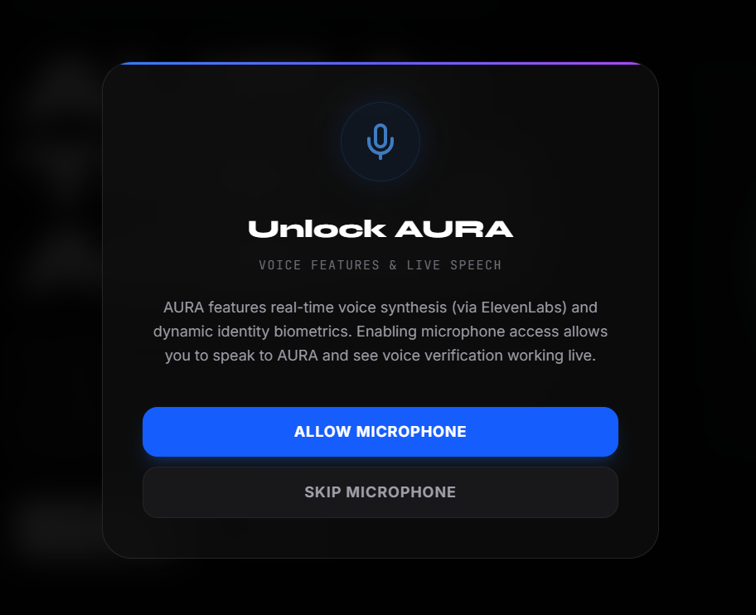

8. API Reference
The following is the complete set of backend endpoints exposed by server.ts.
Method | Route | Purpose
GET | /api/health | Simple liveness check returning server status and timestamp
GET | /api/download/:fileName | Securely serves the Whitepaper, Presentation, Ticket Workbook, or Prototype doc from an allow-listed set of filenames
POST | /api/chat | Sends a message history to Gemini (gemini-3.5-flash) with AURA's system persona; falls back to a simulated response engine if no key is configured
POST | /api/tts | Converts input text to speech via ElevenLabs (eleven_v3) and returns an MP3 audio buffer
POST | /api/stt | Transcribes an uploaded audio file via ElevenLabs (scribe_v1) and returns the text
POST | /api/voice/enroll | Extracts spectral vector, average pitch, and pitch SD from an uploaded recording and stores it in-memory as the enrolled voice profile
POST | /api/voice/verify | Extracts the same features from a new recording, compares against the enrolled profile using the weighted similarity formula, and returns a confidence score and match boolean
POST | /api/voice/reset | Clears the currently enrolled voice profile from server memory
Table 3 - Full backend API surface

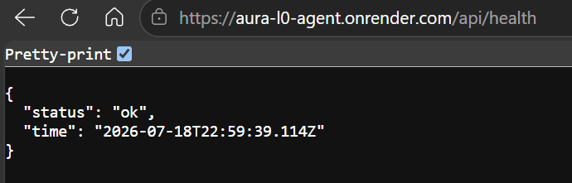

9. Feature Walkthrough - Mode by Mode
The live prototype is structured as a guided, first-person experience. Below is what a judge or user encounters, mode by mode.

AURA’s Live Voice Orb (Landing Portal)
The entry point to the experience. A central interactive cool energy orb (AuraLogo.tsx, rendered on an HTML canvas) invites the user to register their voice. Clicking it prompts a 10-second recording, which the browser converts to a clean 16kHz WAV file and uploads for enrollment. Clicking the orb again initiates verification: the same acoustic pipeline runs again, and access is granted only when the computed confidence exceeds the 75% threshold described in Section 5.5. ElevenLabs-generated speech guides the user through each step of enrollment and confirmation.

Mode 1 - Autonomous Resolution
Simulates a fully automated support call where AURA interacts directly with an end-user. Two scripted paths are available: a Validated Case, where AURA's self-healing troubleshooting resolves the issue outright, and a Failed Case, where AURA correctly identifies a complex issue it cannot resolve and prepares it for escalation. Dialogue is voiced in real time via ElevenLabs TTS, with the visual transcript advancing in sync with the audio.

Mode 2 - Intelligent Escalation
Demonstrates what happens when L0 self-healing cannot resolve an issue. AURA compiles a rich incident log - combining simulated ServiceNow notes, terminal output, and chat history - then actively scans a Tier-1 roster to identify the optimal available assignee (for example, Mohammed Fawaz), generates a ticket, and produces a full handoff briefing before the human agent ever picks up the case.

Mode 3 - Active L0 Co-Pilot
Shows AURA supporting a human agent through three operational sub-modes: L1 Outbound, where AURA proactively reaches out to the customer; L2 Warm Transfer, where full telemetry and context are handed to a senior agent without loss; and the Three-Strike Rule, where a non-responsive ticket automatically progresses toward a compliant closure. Real-time sentiment ratings, timelines, action items, and live call transcripts are tracked side-by-side.

Mode 4 - Predictive Operations
Monitors simulated active client lockouts and latency incidents on a live dashboard. Clicking Push Nexthink Remote Action triggers a self-healing simulation in real time - progress bars resolve high-utilization memory processes, flush CDN nodes, and dynamically generate a ServiceNow ticket, with simultaneous notifications rendered for both the affected user and the IT team.

10. Deployment Architecture
The prototype is deployed as a single Node.js web service on Render, accessible at https://aura-l0-agent.onrender.com/. Because the Express server handles both API routing and static file serving (see Section 3), no separate frontend hosting or reverse proxy configuration is required - Render simply runs npm run build followed by npm start, exactly as it would locally.
Environment Variables in Production
- ELEVEN_LABS_API_KEY - enables real TTS/STT and voice biometric enrollment/verification
- NODE_ENV - production
Because both AI integrations degrade gracefully to simulated behavior in their absence (Sections 6 and 7), the deployed prototype remains fully functional and demonstrable even in the event of an expired key or rate limit during a live judging session.

11. Local Development Setup Guide
The following steps allow anyone with Node.js installed to run the prototype on their own machine using VS Code.
Prerequisites
- Node.js version 18 or higher - download from nodejs.org
- VS Code (recommended editor)
Step 1 - Install Dependencies
Open the project folder in VS Code, open a terminal, and run:
npm install
Step 2 - Configure Environment Variables
Duplicate .env.example as .env in the project root, then populate it:
APP_URL="http://localhost:3000"
ELEVEN_LABS_API_KEY="your_actual_eleven_labs_api_key_here"
Step 3 - Run in Development Mode
npm run dev
This launches the backend with Vite's hot-reload middleware. Navigate to http://localhost:3000 to view the app.
Step 4 - Run in Production Mode
npm run build
npm start
This compiles the frontend and bundles the backend into an optimized single deployable, identical to what runs on Render.

12. Frequently Asked Questions
What happens if I don't configure an ElevenLabs API key?
The voice gateway falls back to standard mock responses and browser-based delays, allowing the full interface to be clicked through and presented even without an active internet connection or API key.
Can this be hosted elsewhere besides Render?
Yes. Since the architecture is a standard Express + Vite full-stack Node.js application, it can be deployed to any container-based host that supports Node.js, including Heroku or Google Cloud Run.

13. Closing Notes
This prototype was built to prove a single point: that the L0 concept described in the AURA Whitepaper is not just an argument on paper, but a system that can be experienced, clicked through, and reasoned about end-to-end - including a genuinely engineered voice biometric layer built without relying on a third-party black box.
Together with the Whitepaper, the Presentation, and the Ticket Analysis Master workbook, this prototype completes the full evidentiary and technical picture of AURA as a submission for the CIS Gilead Ideathon 2026.

We are not building a bot to replace the desk.
We can build the layer that finally lets the desk breathe.

Ryan Ahmed Tusi | 2485906 | Cognizant Technology Solutions
CIS Gilead Ideathon 2026 - AIOps Theme

