Table Counts
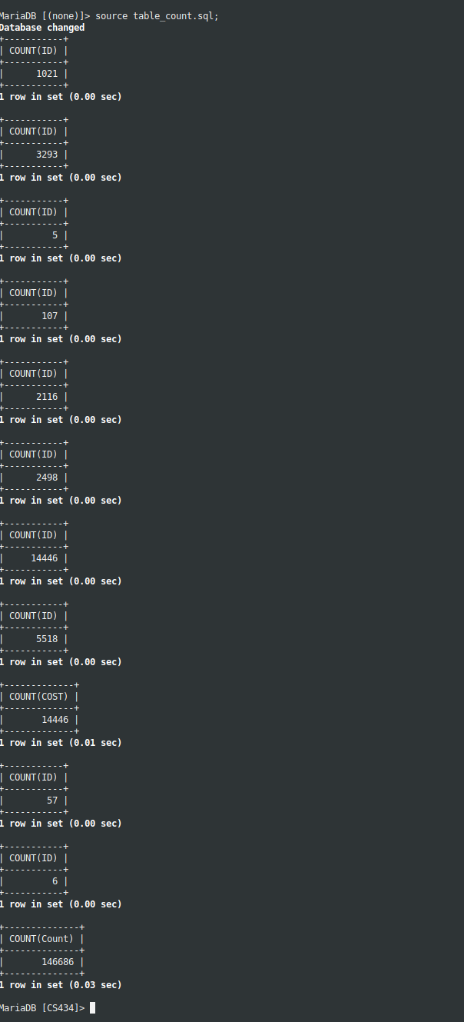

Program Code is in generator.py
*NOTE: Both mysqlclient-python and PcPartPicker-API are required (See program header comments for links)
*NOTE: Program requires a significant amount of time to complete. For the above screenshot I paused the insertion to show current counts.

Large Database is in huge_db.sql (NOTE* Does not contain all data, I just stopped the insertion)

Small Sample Database is in small_db.sql (NOTE* Does not use same data as Huge DB)

