Discussion of Predictive Models’ Performance
The Data.
Before doing anything else, I want to review the data to determine whether or not any ‘cleaning up’ is necessary. Our models’ accuracy will likely suffer otherwise.

DatetimeIndex: 1660 entries, 2017-10-21 13:45:00 to 2017-11-10 06:30:00
Data columns (total 21 columns):
# Column Non-Null Count Dtype
--- ------ -------------- -----
0 q_cms 1660 non-null float64
1 NO3_mgNL 1660 non-null float64
2 SRP_mgPL 1660 non-null float64
3 DO_mgL 1660 non-null float64
4 DO_sat 1660 non-null float64
5 fDOM 1660 non-null float64
6 pH 1660 non-null float64
7 spCond 1660 non-null float64
8 temp 1660 non-null float64
9 turb 1660 non-null float64
10 precip_mm 1660 non-null float64
11 temp_C 1660 non-null float64
12 atm_mbar 1660 non-null float64
13 PAR_uE 1660 non-null int64
14 windSpeed 1660 non-null float64
15 gustSpeed 1660 non-null float64
16 solarRad_wm2 1660 non-null int64
17 windDir 1660 non-null int64
18 Rh 1660 non-null float64
19 dewPoint 1660 non-null float64
20 Basic_Threshold 1660 non-null int64
dtypes: float64(17), int64(4)
memory usage: 285.3 KB

A cursory glance at the data tells us that there are no null values in the set—which means we won’t have to worry about substituting any values—and all of the data is already in a float/integer data type, which we’ll need for our analysis.
Extreme Outliers. We’ll also take a look to see if there’s any outliers in the data-set that may require attention. We’ll do this by calculating the interquartile range and deeming any values over three ranges above or below the 75th or 25th percentile, respectively, as extreme. For brevity’s sake, we’ll truncate the output here, but the full picture and relevant code is available in the repository.

count mean std ... 75% max outliers
SRP_mgPL 1660.0 0.002986 0.002071 ... 0.004041 0.012995 True
turb 1660.0 1.126657 3.389062 ... 0.752667 62.535333 True
precip_mm 1660.0 0.089277 0.338782 ... 0.000000 6.800000 True
PAR_uE 1660.0 65.742169 140.811254 ... 69.000000 1024.000000 True
windSpeed 1660.0 0.313855 0.482035 ... 0.500000 2.500000 True
solarRad_wm2 1660.0 32.778313 71.155572 ... 32.000000 539.000000 True

Luckily, only a handful of features contain extreme outliers. And to their credit, outliers are to be expected for features such as ‘precip_mm’, ‘windSpeed’, and ‘turb’. The other features’ relevance to our purposes is questionable. ‘SRP_mgPL’, ‘PAR_uE’, and ‘solarRad_wm2’ are related to soil phosphorus, photosynthetically active radiation, and solar radiation, respectively. We will keep this in mind as we continue.
Selecting Features. To determine the features we want to use for our model, we’ll calculate the Pearson correlation coefficient to determine if there’s any linear relationship present between our chosen dependent variable (we’ll be focusing on temperature, so ‘temp’) and the other available features.

temp
DO_mgL -0.972560
NO3_mgNL -0.897186
DO_sat -0.778274
atm_mbar -0.435633
Basic_Threshold -0.217459
solarRad_wm2 -0.077421
windDir -0.073441
PAR_uE -0.073142
fDOM -0.011512
q_cms 0.068921
gustSpeed 0.074531
windSpeed 0.106290
precip_mm 0.148349
turb 0.149258
Rh 0.184314
SRP_mgPL 0.480550
pH 0.487443
spCond 0.584501
temp_C 0.807261
dewPoint 0.879371
temp 1.000000

We can immediately see that there are a few features which have a very strong correlation with temperature. To reduce our dimensionality and avoid over-fitting, we’ll be dropping anything with the absolute value of its correlation coefficient less than 0.6, with some leniency. We’ll also be ignoring ‘temp_C’ for this, because of course it would correlate with the temperature.

Building our First Model.
We’ll start by creating and showcasing a basic Linear Regression model, then working to fine-tune it as we see fit. Taking a look at figure 1, we can make the assumption that the model is already performing pretty well. At a glance, each individual predicted data point looks relatively close to the reference point. Our cross validation scores for this model are as such:

Linear Regression CV scores: [0.973774 0.97384273 0.9733014 0.9791383 0.97699208 0.97677576
0.97534507 0.97139934 0.97565612 0.97812507 0.97770152 0.97290375
0.97579989 0.97488845 0.97643929 0.97675226 0.97295155 0.97607742
0.97564382 0.97628453 0.97331081 0.98004867 0.97491826 0.97739194
0.97145104]
Linear Regression mean CV score: 0.9754765230782917
Linear Regression RMSE score: [-0.41915445 -0.42043031 -0.41376851 -0.3896308 -0.40650833 -0.40534977
-0.40450367 -0.43200947 -0.41533659 -0.39168104 -0.39296341 -0.42544872
-0.41542788 -0.4149 -0.39853042 -0.41626476 -0.41237813 -0.40337366
-0.42721415 -0.38661692 -0.4107594 -0.39263735 -0.41738333 -0.38726028
-0.43882382]
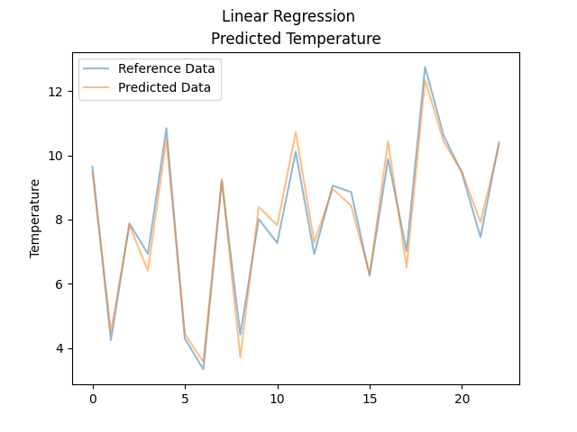
Linear Regression mean RMSE score: -0.40953420724025824

A 0.97 mean coefficient of determination score is pretty good, and it doesn’t seem like we are suffering from over-fitting or anything of the like, but perhaps we can do better. Let’s try applying L1 and L2 regularization techniques to our model to see if we can achieve an even higher score.
Lasso Regression. Without tuning any hyper-parameters, our L1 regularized (Lasso) model performs pretty poorly. Our cross-validation coefficient of determination scores land at about 0.34, which is greatly reduced from our previous score. However, after tuning the alpha of our model using a grid search cross-validation method, we achieve a much improved performance:

Lasso alpha: 0.01
Lasso CV scores: [0.97105222 0.9744032 0.97238348 0.97561909 0.97606406 0.97448862
0.9756176 0.97135871 0.97203314 0.9767279 0.97538476 0.96977016
0.97558316 0.97346465 0.97637744 0.97648632 0.9721784 0.97432618
0.97331603 0.9743595 0.97284687 0.98019524 0.97354809 0.97606219
0.96740902]
Lasso mean CV score: 0.9740422408723972
Lasso RMSE score: [-0.44036794 -0.4159017 -0.42082131 -0.42121455 -0.41462549 -0.42484074
-0.4022618 -0.43231621 -0.44517127 -0.40399597 -0.4128731 -0.44937672
-0.41728399 -0.42650003 -0.39905318 -0.41863892 -0.41823025 -0.41787734
-0.44716341 -0.40200198 -0.4143141 -0.39119241 -0.42863223 -0.39848646
-0.46886063]
Lasso mean RMSE score: -0.4212800689605406

Of course, both our coefficient of determination and RMSE scores are slightly worse than our original Linear Regression model. Let’s try L2 regularization.
Ridge Regression. Before tuning, our L2, or Ridge, regularized model is already performing very well with a mean coefficient of determination score of 0.97—identical to our original Linear Regression model. After tuning, however, the model actually performs slightly worse than it did before tuning.

Ridge alpha: 0.16
Ridge CV scores: [0.94804887 0.95928663 0.95787035 0.9519628 0.95879109 0.95085835
0.95671135 0.95503086 0.95271006 0.96010627 0.95754687 0.94941844
0.95725592 0.95488764 0.95636269 0.95882116 0.95265286 0.9541259
0.95583881 0.95412692 0.9577411 0.96287171 0.95000596 0.95869283
0.94609312]
Ridge mean CV score: 0.9551127425063535
Ridge RMSE score: [-0.58993685 -0.52452518 -0.51976514 -0.59124473 -0.5440344 -0.58963607
-0.5359911 -0.54170453 -0.57888152 -0.5289463 -0.54221232 -0.58128451
-0.55210917 -0.55610197 -0.54237078 -0.55400841 -0.54559612 -0.55858247
-0.57525636 -0.53770482 -0.51686708 -0.53562165 -0.58927149 -0.52346068
-0.60299979]
Ridge mean RMSE score: -0.5543245374946888

Conclusion of Model 1. Though the basic Linear Regression model and the Lasso regularized model performed very similarly, the basic Linear Regression model consistently pulled ever-so-slightly ahead of the Lasso model, while the Ridge model performed worse in every test. This is likely due to the features being carefully chosen before-hand to ensure strong linear relationships between the independent and dependent variables. As there was no over-fitting or extreme outliers present initially, the regularization seems to have only harmed our model’s performance.

Building our Second Model.
For our second model, we’ll be building and training a Random Forest regression model. We won’t need to do anything special with the data this time around, as we’ll just use the cleaned-up data we gathered for the Linear Regression model.
There’s not a whole lot to talk about in the way of building the model, as Sci-Kit Learn’s RandomForestRegressor class doesn’t require a lot of setup outside of the initial data cleanup we’ve already done. I will say, however, that I’ve chosen 10 trees for this model.
The Results. Our Random Forest regression model performs amazingly well, with a mean coefficient of determination score of 0.99 and a mean RMSE score of 0.11 without any further tuning or modifications to the model.

Random Forest Regressor CV scores: [0.99795757 0.99852792 0.9978382 0.99834483 0.99794952 0.99614701
0.99817261 0.99855333 0.99817593 0.99714033 0.99874002 0.99648785
0.99882956 0.9981917 0.99810364 0.99838899 0.99776892 0.99838035
0.99696107 0.99721153 0.99778069 0.99843841 0.99820378 0.99842965
0.99736115]
Random Forest Regressor mean CV score: 0.9979233818870747
Random Forest Regressor RMSE score: [-0.11697186 -0.09973854 -0.11773918 -0.10974864 -0.12135511 -0.16510426
-0.11012512 -0.09716063 -0.11369107 -0.14161748 -0.09341069 -0.15317188
-0.0913613 -0.11133776 -0.113065 -0.10957914 -0.11843543 -0.10495772
-0.15090427 -0.13257075 -0.1184484 -0.1098474 -0.11169571 -0.10206344
-0.1334143 ]
Random Forest Regressor mean RMSE score: -0.11790060316698799
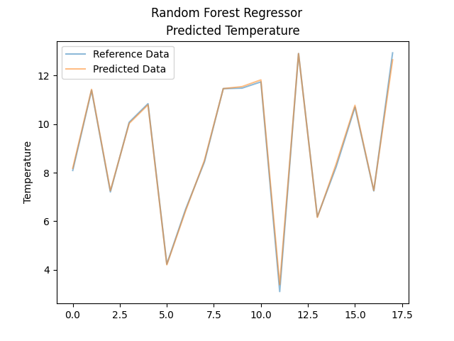
Conclusion. There’s not much to say here. The random forest regression model vastly outperformed all three of our linear regression models with a fraction of the effort. That’s not to say that will always be the case, as it greatly depends on the data and the user’s expected results. In this case, however, our random forest is the obvious choice.

