Theory and Applications of Sparsity for
Radar Sensing of Ionospheric Plasma

Ryan Volz
Department of Aeronautics & Astronautics
Advisor: Sigrid Close
Wednesday, March 19, 2014, 9:00 AM
Durand 450 - refreshments served at 8:45 AM

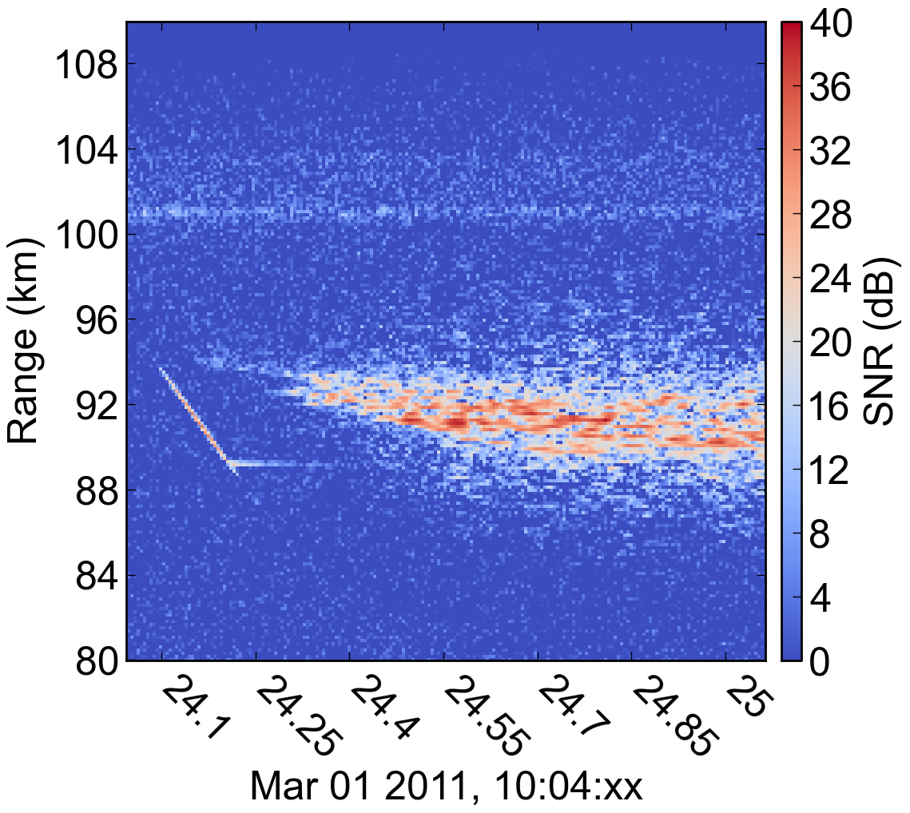Waveform Inversion
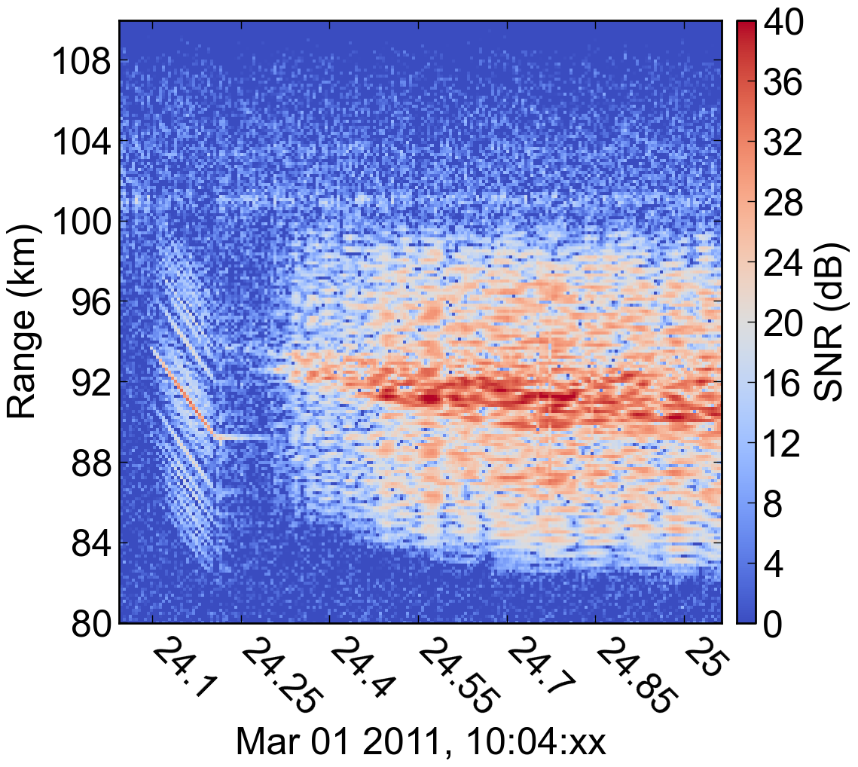Standard Matched Filter
The ionosphere plays an important role in the geospace system, perturbing and disrupting radio signals that pass through it (e.g. GPS) and coupling the Earth with its space environment. Of particular note to spacecraft designers and operators are the small meteoroids that routinely impact spacecraft and are observable due to their passage through the ionosphere. Mechanical and electrical damage due to hypervelocity impacts with meteoroids pose a significant threat to spacecraft, and to fully characterize the threat it is necessary to observe the sporadic meteoroids through the meteor plasma that they create in the ionosphere. These observations, in addition to those of ionospheric plasmas that disrupt communications, can be made with high-power large-aperture radars located across the globe. Unfortunately, current radar techniques are not sufficient for elucidating the details of these plasmas due to inherent signal processing artifacts.

A sparsity-based radar waveform inversion technique was formulated and found to significantly improve observations of ionospheric plasma. Taking direction from the theory of compressed sensing, sparsity or compressibility of the radar target scene is employed as prior knowledge to remove processing artifacts caused by the standard matched filter approach. The result is cleaner data that limits self-interference of range-spread targets and enables differentiation in crowded and variable environments. Though the approach has been applied to ionospheric radar, it is generally applicable and especially relevant for radar target scenes with multiple or distributed scatterers.

In order to enable flexible high-resolution measurements of ionospheric plasma phenomena, including interfering and range-spread targets, a discrete radar model was developed that captures signal sparsity in a delay-frequency basis. This model was discovered to have a strong connection to existing techniques, resulting in an intuitive interpretation of the inversion technique as an iterative-thresholding matched filter. An explicit formulation of how the discrete model represents arbitrary distributed scatterers was derived and analyzed to show that sparsity is reasonably preserved in the discrete representation. Building on top of the model, waveform inversion was implemented using modern convex optimization techniques tailored for efficient computation and quick convergence. Finally, the real-world flexibility and effectiveness of the inversion technique was demonstrated by the removal of filtering artifacts from meteor observations made with a variety of standard radar waveforms.

