Project: Part 2

24-677 Special Topics: Modern Control - Theory and Design

Ryan Wu (ID: weihuanw)

**Due: Nov 9, 2023, 11:59 pm.**

# P2: Problems

**Exercise 1.1**

Given equation:

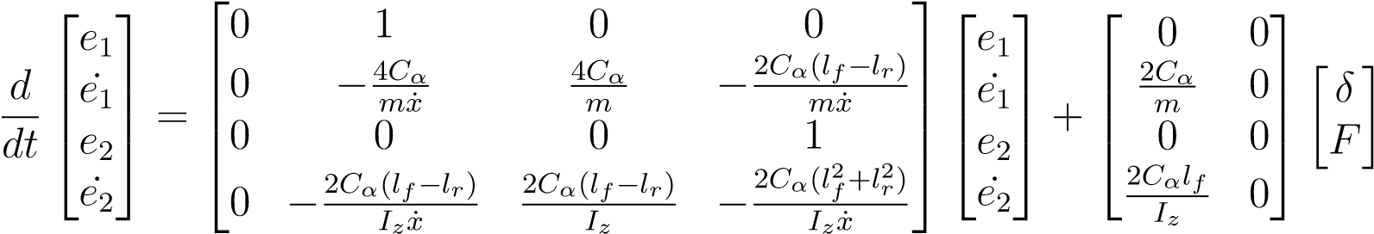

Equations for evaluation:

A = $\left[\begin{matrix}0 & 1 & 0 & 0 \\ 0 & -\frac{8000}{1888.6\dot{x}} & 0 & -\dot{x}-\frac{6400}{1888.6\dot{x}} \\ 0 & 0 & 0 & 1 \\ 0 & -\frac{6400}{25854\dot{x}} & 0 & -\frac{173384}{25854\dot{x}}\end{matrix}\right]$

B = $\left[\begin{matrix}0 \\ \frac{40000}{1888.6} \\ 0 \\ \frac{62000}{25854}\end{matrix}\right]$

C = $\left[\begin{matrix}1 & 0 & 0 & 0 \\ 0 & 1 & 0 & 0 \\ 0 & 0 & 1 & 0 \\ 0 & 0 & 0 & 1\end{matrix}\right]$

Controllability matrix P = [$\begin{matrix}B & AB & A^{2}B & A^{3}B\end{matrix}$]

Observability matrix Q = $\left[\begin{matrix}C \\ CA \\ {CA}^{2} \\ {CA}^{3}\end{matrix}\right]$

We use rank(P), rank(Q) and the size of matrix A (n=4) to determine the controllability and observability of the given system at the following longitudinal velocities: 2 m/s, 5 m/s and 8 m/s and given variable values. The process was done with Python and the terminal outputs are shown below.

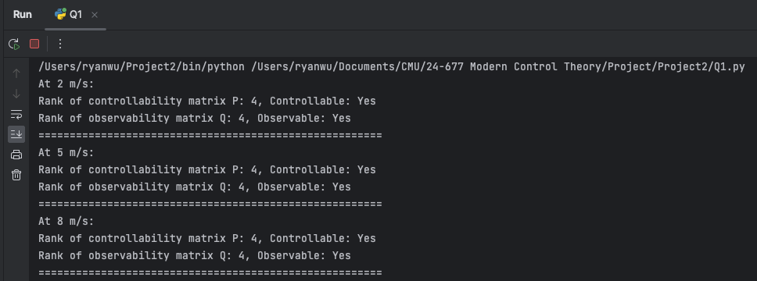

Figure . The controllability and observability at each given velocity values.

**Exercise 1.2**

**(a)**

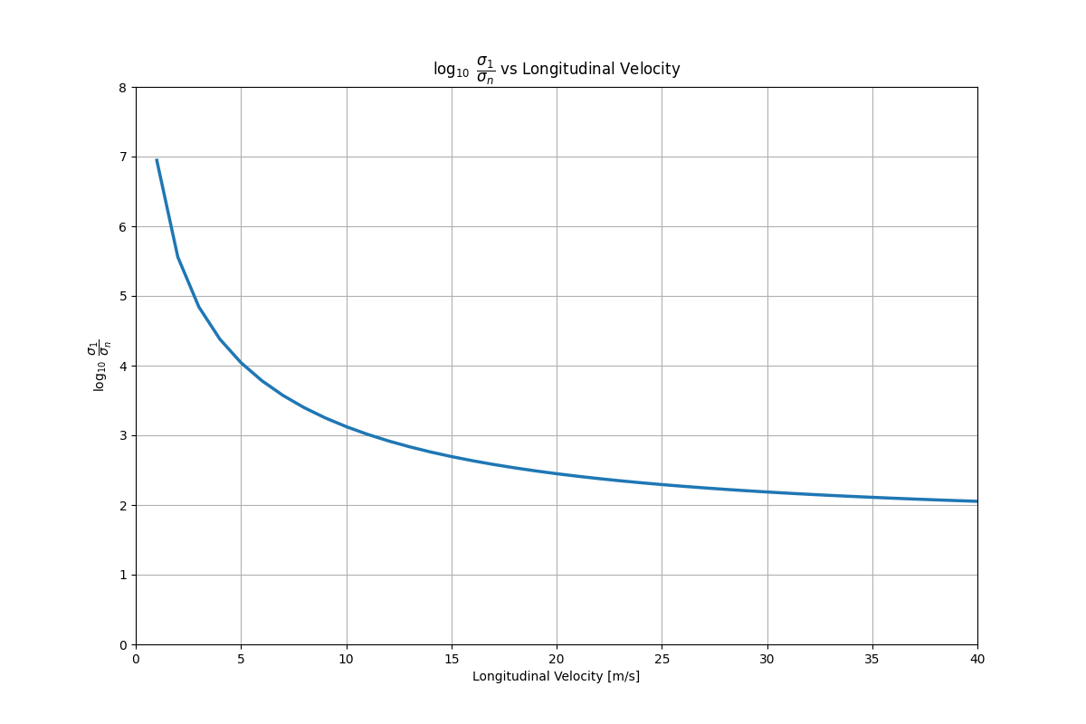

Figure . The plot for $\log_{10}\frac{σ_{1}}{σ_{n}}$ versus the desired longitudinal velocity range.

**(b)**

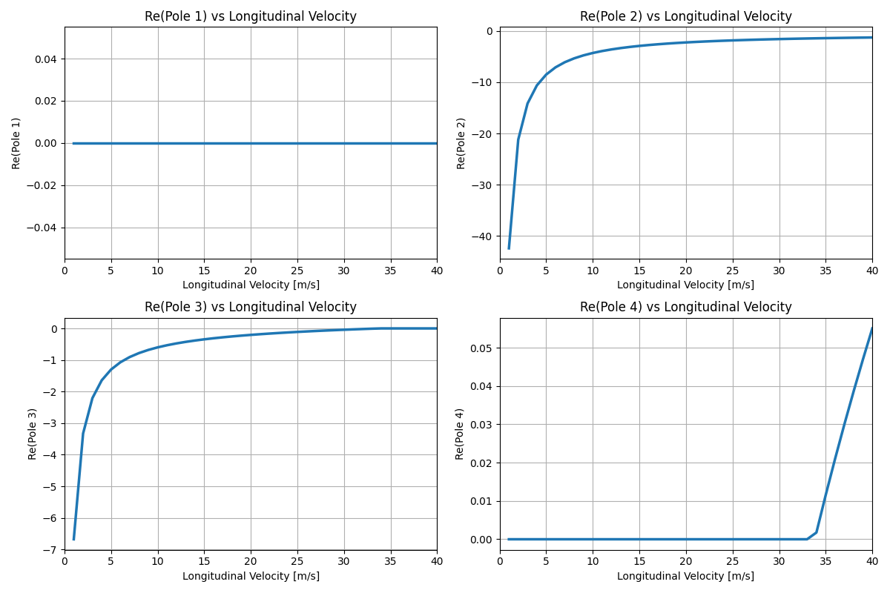

Figure . The plots for $Re(p_{i})$ versus the desired longitudinal velocity range.

From Figure 2, we can observe that the value of the logarithm of the greatest singular value divided by the smallest converges to a smaller value, which means the system is less likely to be defected and becoming more and more controllable. However, from Figure 3, we can observe as the velocity increased, the poles became less and less negative, which means the overall system is becoming less and less stable.

**Exercise 2**

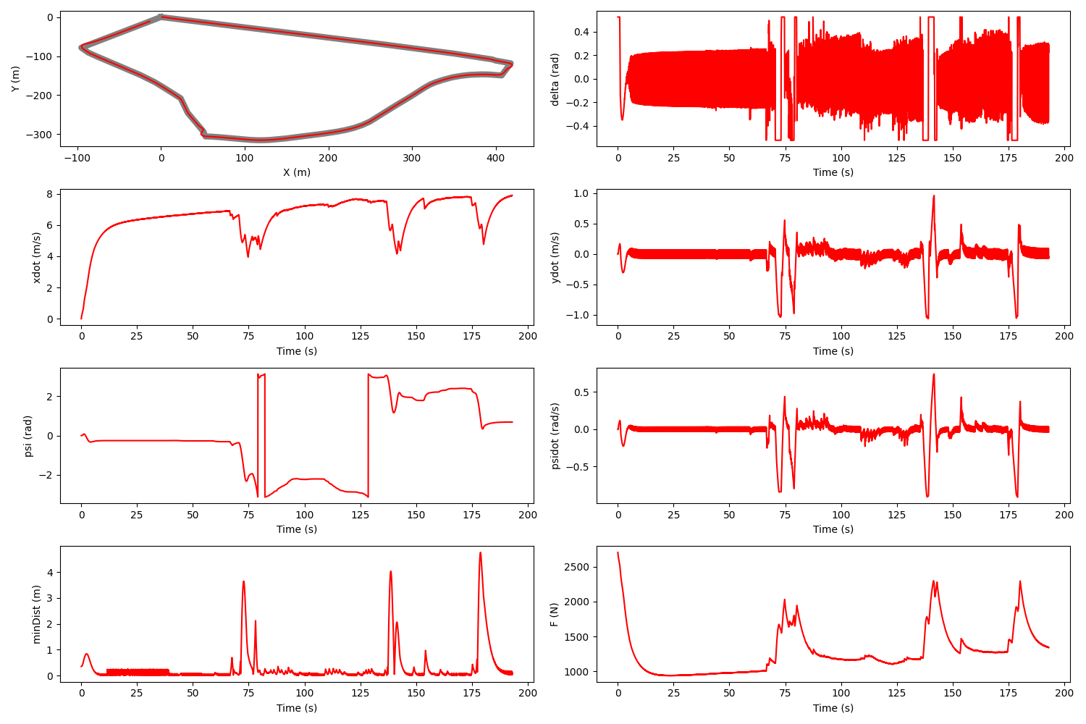

Figure . The final completion plot using poles: [-4, -1, -3, -2].

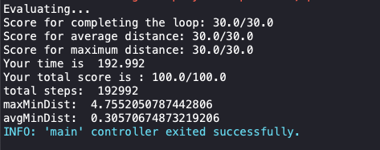

Figure . The final completion score using poles: [-4, -1, -3, -2].