Project: Part 3

24-677 Special Topics: Modern Control - Theory and Design

Ryan Wu (ID: weihuanw)

**Due: Nov 16, 2023, 11:59 pm.**

# P3: Problems

**Exercise 1**

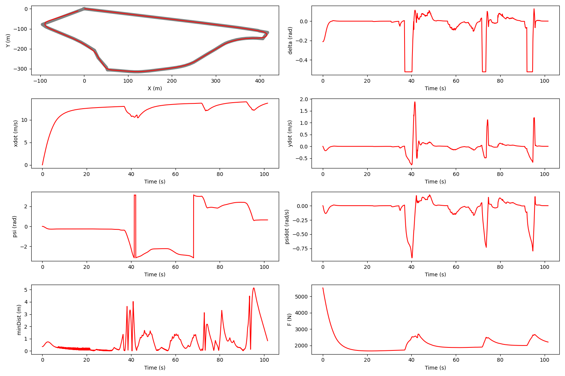

Figure . The final completion plot using my LQR controller.

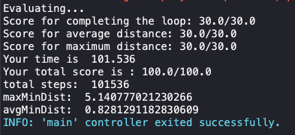

Figure . The final score message from Webots simulation using my LQR controller.

**Exercise 2**

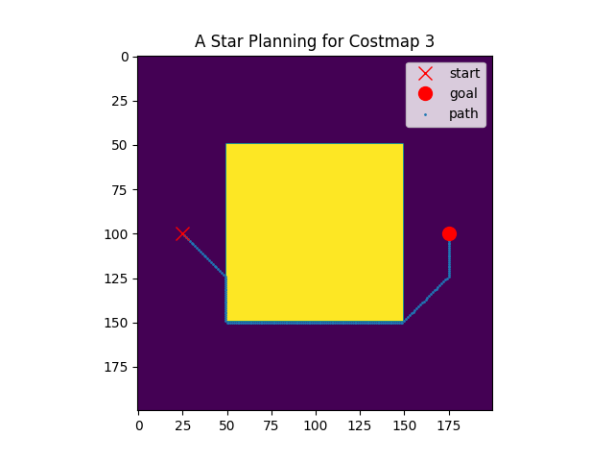

Figure . The path planning results from my Astar_script.py.

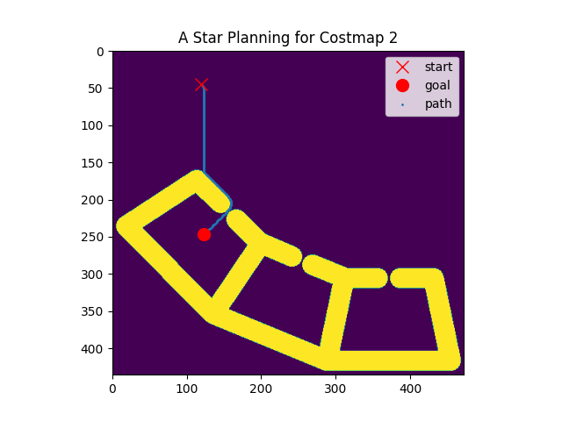

Figure . The path planning results from my Astar_script.py.

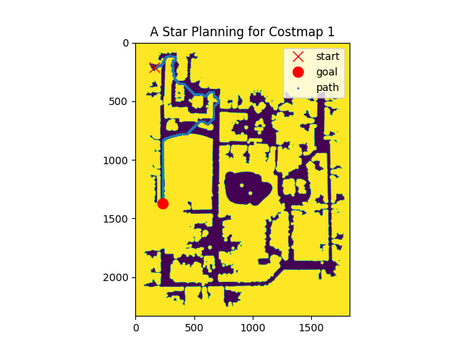

Figure . The path planning results from my Astar_script.py.

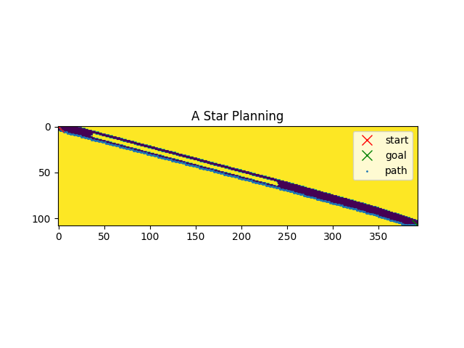

Figure . The path planning results from my Astar.py.

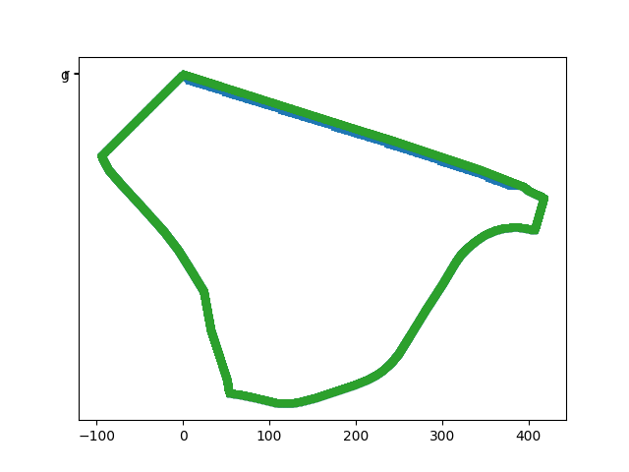

Figure . The path planning results from my Astar.py.

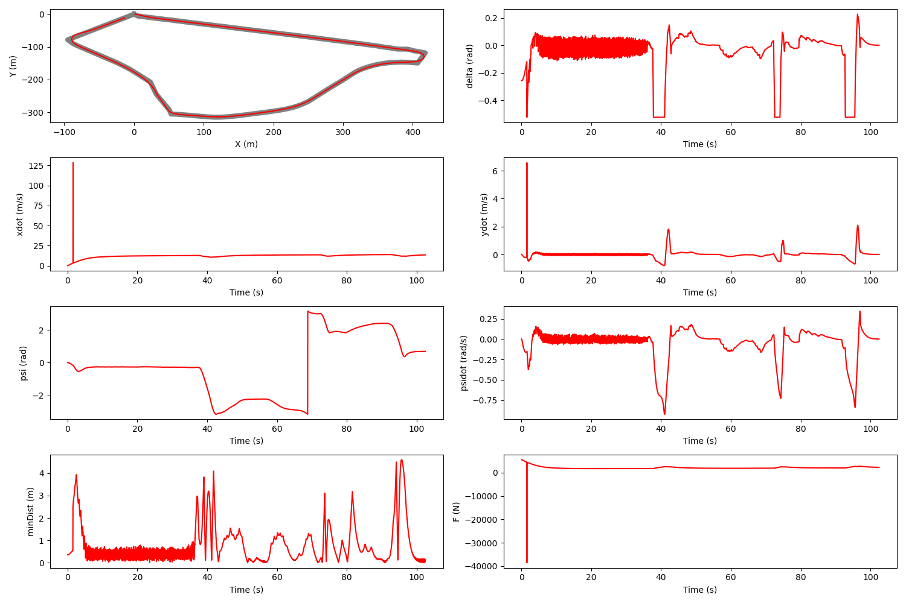

Figure . The final completion plot using my A* algorithm & my LQR controller.

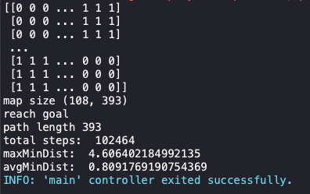

Figure . The final score message from Webots simulation using my A* algorithm & my LQR controller