Project: Part 4

24-677 Special Topics: Modern Control - Theory and Design

Ryan Wu (ID: weihuanw)

**Due: Nov 28, 2023, 11:59 pm**

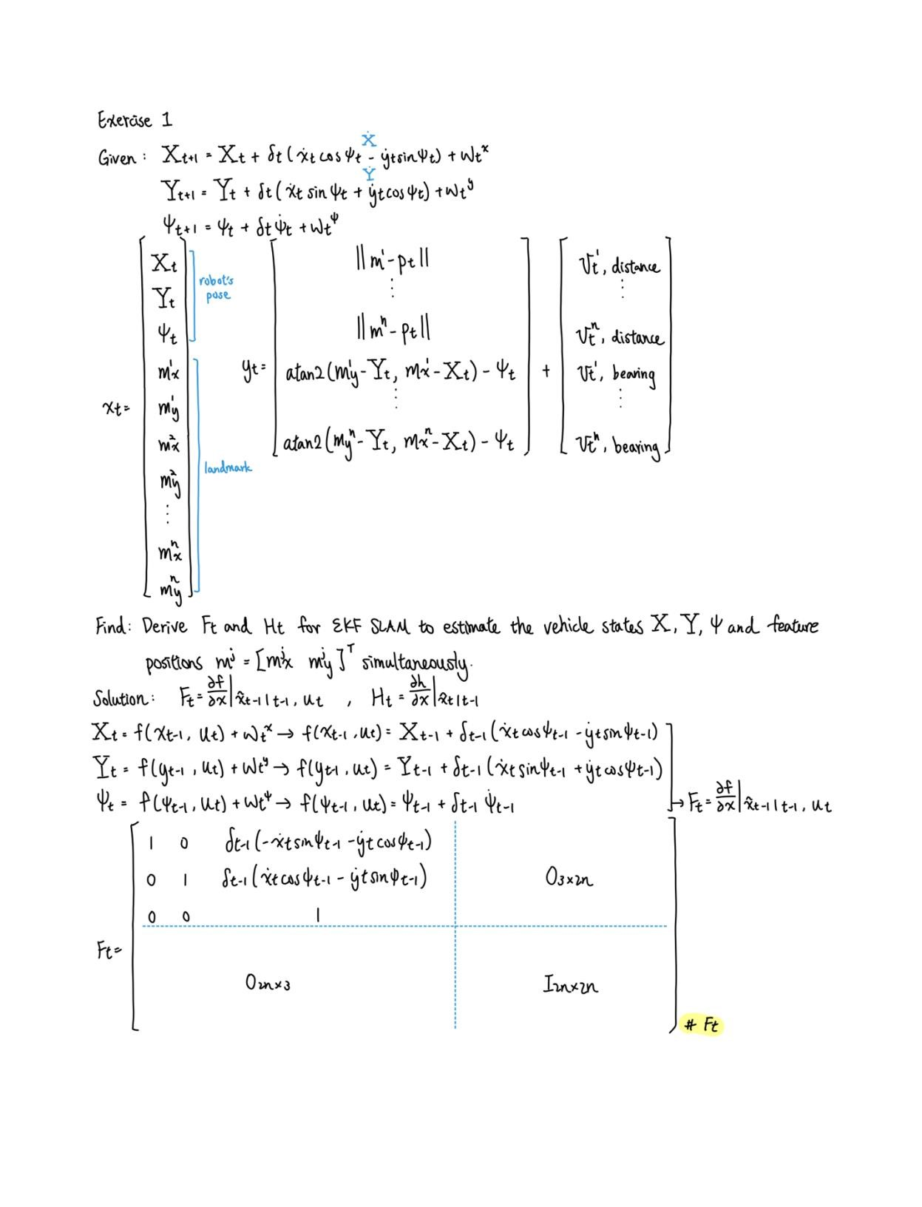

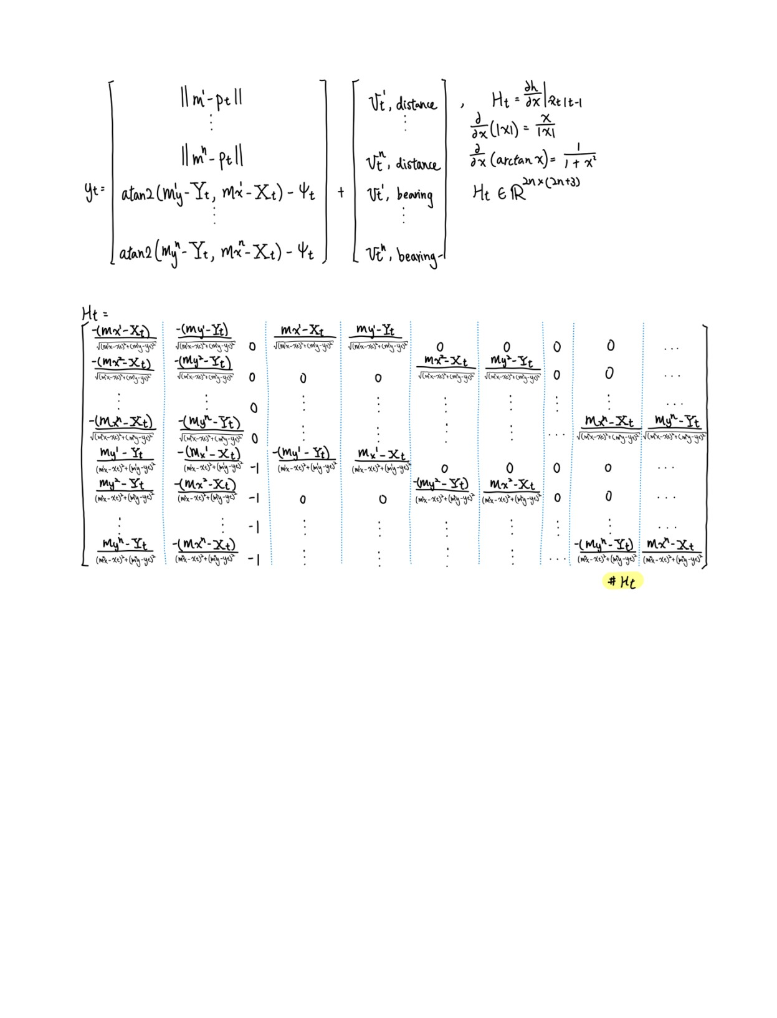

**Exercise 2.**

*Figure*

*1*

*. The final completion plots.*

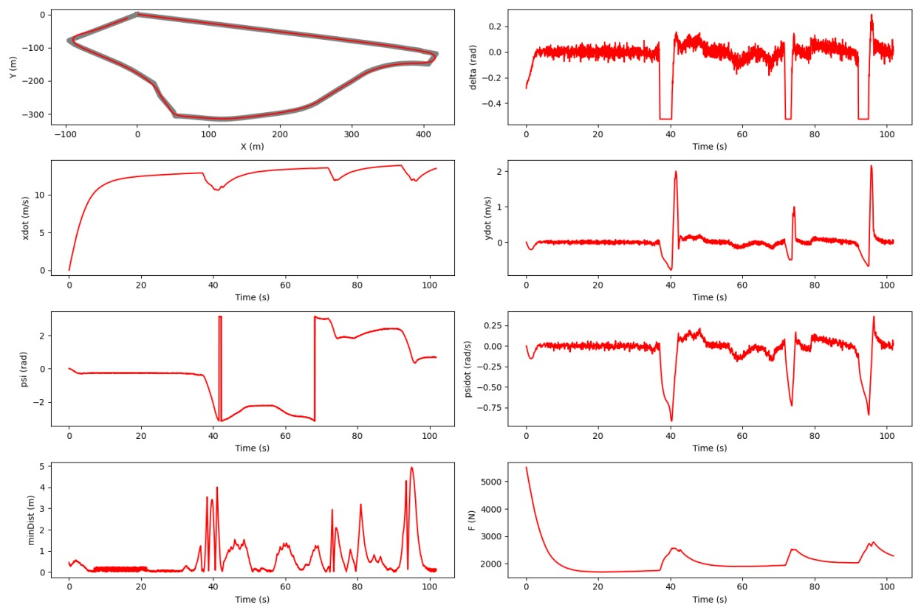

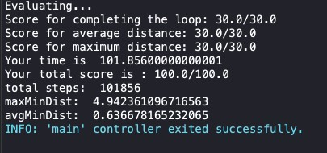

*Figure 2. The Webots terminal output for completion time.*

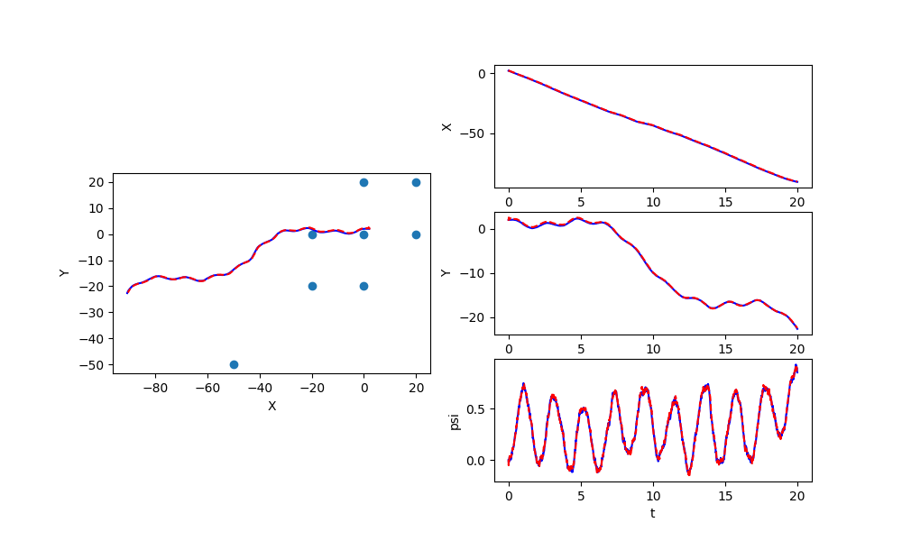

*Figure 3. Plots from the efk_slam.py test script.*

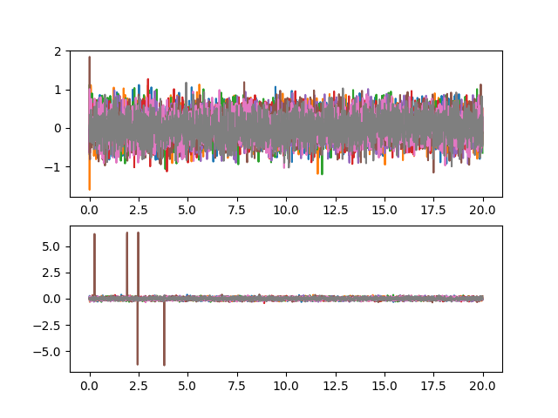

*Figure 4. Plots from the efk_slam.py test script.*