Project: Part 5

24-677 Special Topics: Modern Control - Theory and Design

Ryan Wu (ID: weihuanw)

**Due: Dec 8, 2023, 11:59 pm**

**Exercise 1.**

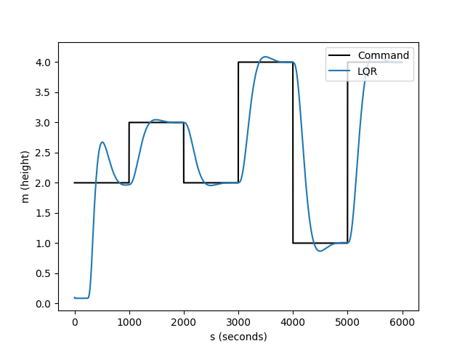

Figure 1. The completed simulation plot showing a stable system.

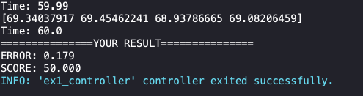

Figure 2. The Webots terminal output for error (0.179) and score (50).

**Exercise 2.**

Exercise 2.1 (50% loss of thrust in one motor)

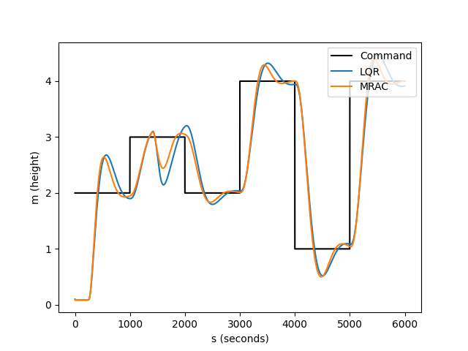

Figure 3. The LQR and MRAC result plot with 50% loss of motor thrust.

Exercise 2.2 (67% loss of thrust in one motor, LQR - failed, MRAC - maintained tracking)

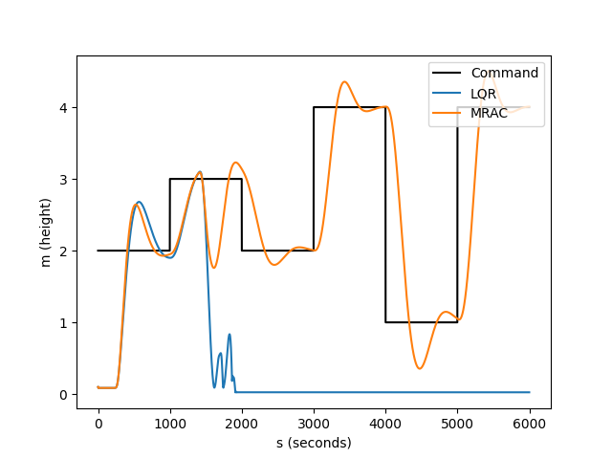

Figure 4. The LQR and MRAC result plot with 67% loss of motor thrust.