24-787: Machine Learning and Artificial Intelligence for Engineers

Ryan Wu

ID: weihuanw

Homework 6

Due: Mar 2 2024

**Concept Questions:**

Problem 1

B) Standardized and C) Normalized.

Problem 2

Log Transformation.

Problem 3

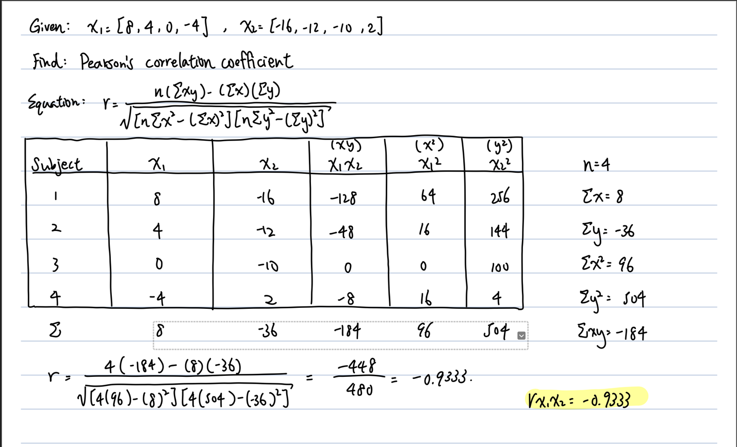

Problem 4

X2.