24-787: Machine Learning and Artificial Intelligence for Engineers

Ryan Wu

ID: weihuanw

Homework 7

Due: Mar 16, 2024

**Concept Questions:**

Problem 1

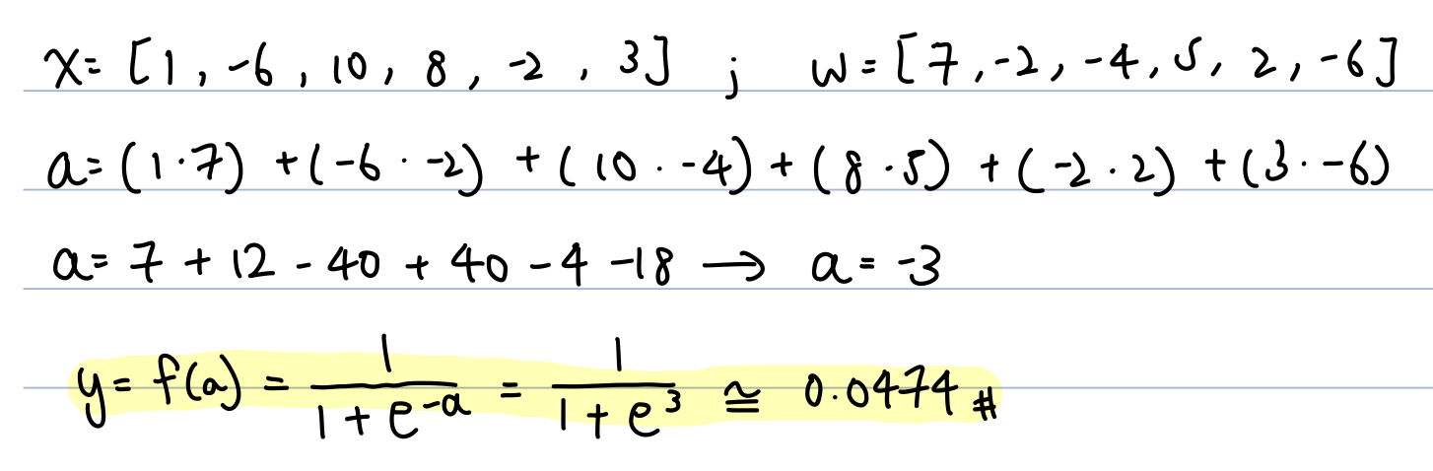

Problem 2

Problem 3

The softmax activation function is used in the output layer for multi-class classification  
problems to produce a probability distribution over multiple classes.

Problem 4

All of the above.