24-787: Machine Learning and Artificial Intelligence for Engineers

Ryan Wu

ID: weihuanw

Homework 9

Due: Mar 30, 2024

**Concept Questions:**

Problem 1

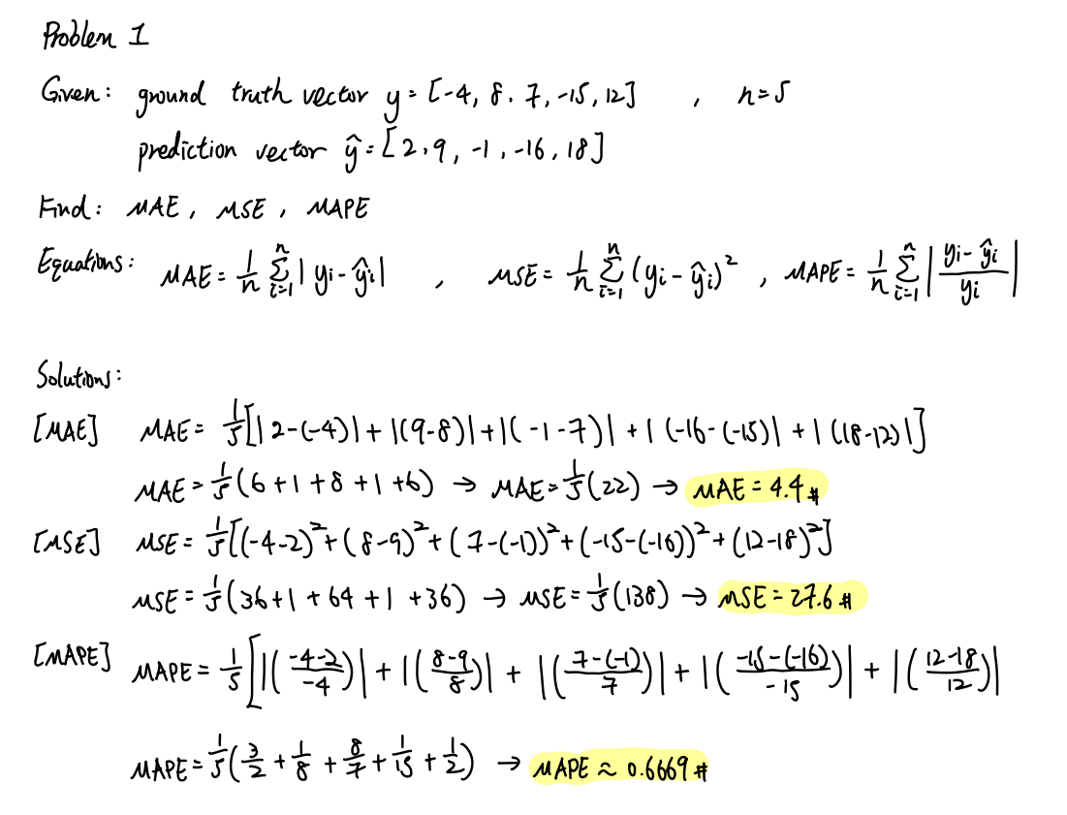

Problem 2

Matrix 3.

Problem 3

4. (8, 10, 0, 2, 0.8, 1.0, 0.889)