Persistence and Change in Requested AI Functions in WildChat Conversations
Tianmai Ryan Xiao
Dr. Chen Hu
Beijing Zhongguancun Academy

Abstract
Conversational AI supports many functions, but users may continue requesting familiar forms of assistance. We analyzed 500 English-language GPT-3.5-turbo conversations from WildChat, containing 1,589 follow-ups. LLM-assisted annotation measured tasks, delegated discretion, actions, content development, and inferred satisfaction. Users commonly retained their initial task categories (69.7%) and discretion category (77.2%). Persistence also predominated when a relevant alternative function was available (63.2%, 95% CI [54.1%, 72.1%]). Planning involved more judgment than information requests, although their coding definitions overlapped. Pursuing current work was more frequent than updating specifications or redirecting work. Satisfaction associations differed across actions and depended on behavioral cues included in the measure. Joint content development was associated with subsequent specification updates. These exploratory findings describe continuity in requested AI functions without establishing functional fixedness. Unvalidated model annotations, post-result coding changes, and overlapping measures limit interpretation.
Keywords: conversational AI, functional fixedness, WildChat, delegated judgment

Persistence and Change in Requested AI Functions in WildChat Conversations
Tools help organize attention and support cognition by shaping what people notice and how they act. Constant et al. (2024) examine this relationship through cognitive archaeology. Expanding tool functions can be understood as part of intellectual development: new uses open possibilities for thinking, while familiar uses shape which possibilities people recognize.
Large language models bring this relationship into everyday information seeking. Search engines help users locate sources; systems such as ChatGPT also synthesize information, develop alternatives, and recommend actions. This expands both requested assistance and delegated judgment. How do people adapt when familiar activities become available through tools with broader functions?
Functional fixedness offers one way to approach this question. Familiar expectations may constrain which functions users recognize or request. Liu et al. (2025) linked prior experience with search engines, virtual assistants, and ChatGPT to expectations and prompting behavior; unmet expectations also prompted adaptation. Together, these accounts motivate examining expanded functions alongside established usage.
We examined naturalistic user–ChatGPT conversations in WildChat (Zhao et al., 2024). The records lack direct reports of expectations, feelings, alternative awareness, or prior transitions from search engines. We therefore could not directly examine that transition's psychology or establish functional fixedness. Instead, we measured observable continuity and change in requested functions. Persistence may reflect fixedness, but it may also reflect appropriate task sequencing or user preferences.
We distinguished task categories from delegated discretion: Execution, Judgment, or Mixed. H1 predicted that users would retain their initial task categories (H1a) and discretion (H1b) more often than change them. H2 predicted more judgment in Planning than Information requests. H3 predicted persistence in both dimensions more often than change, even when an alternative function could advance the same goal. Exploratory analyses examined actions, inferred satisfaction, and content development.

Methods

Sample and Annotation
We sampled 500 English-language GPT-3.5-turbo conversations containing 1,589 follow-ups from an archived WildChat release (revision f66566c; AllenAI, n.d.). Eligible conversations contained at least two user messages and sufficient assistant context. Duplicate identifiers and identical transcripts were grouped before randomized screening. The initial 300-conversation sample was extended by continuing the saved random order. A separate 30-conversation pilot informed coding.
GPT-6.1 Sol annotated requests using codebook v0.9 and only dialogue through each target message. Automated checks verified coverage, supporting quotations, and consistency. Task labels covered Information, Writing, Transformation, Technical, Analytical, Planning, Roleplay, Open Inquiry, and Other; distinct tasks could receive multiple labels.
Execution indicated specified operations or factual assistance; Judgment indicated substantive selection, evaluation, recommendation, or development; Mixed combined distinct components of both. Unclear and nonrequest cases remained separate. The original 300 conversations were recoded after codebook clarification, when earlier results were known. The study was exploratory, not preregistered or independently human-validated.

Measures
H1 compared each eligible follow-up with the initial request, requiring exact task-set or discretion-category equality. H2 compared Planning without Information against Information without Planning; any Judgment included Mixed.
H3 opportunities were coded before viewing the assessed follow-up. Qualification required an identifiable goal and active function, a visible unmet need, and a specific alternative function that could plausibly advance the same goal. Opportunity labels were locked before outcome linkage. Joint persistence required unchanged task categories and discretion relative to the active request, restricted to assessable same-goal responses.
Actions included Pursue current work, Update the specification, Redirect the work, Respond to the contribution, and Unclassified. Labels could overlap. Local discretion transitions used the preceding substantive request. Content measures recorded development versus new directions and overlapping user-established, AI-introduced, or joint origins. Eligible source messages were linked to the next stored follow-up.
Inferred satisfaction adapted Lin et al.'s (2024) 20-item rubric, subtracting negative from positive indicator intensities (absent = 0; present = 1–10). The long-interaction item was inapplicable to individual follow-ups. A reduced score removed overlapping behavioral proxies, retaining direct evaluation and response-mismatch cues. Neither score was validated for this sample.

Statistical Analysis
Primary estimates gave each contributing conversation equal weight. Intervals used 5,000 whole-conversation bootstrap samples: Bonferroni-adjusted intervals for H1a, H1b, and H2, and 95% intervals for H3. Figure notes identify moment-weighted descriptive percentages.
Exploratory linear probability models adjusted for baseline task, discretion, and log2 follow-up position, using conversation weights and clustered standard errors. Satisfaction coefficients represent percentage points per 10 score units. Holm corrections covered separate satisfaction, additional-analysis, and deeper-analysis families, with a supporting cumulative 67-test correction. Bootstrap intervals were pointwise; corrected p values governed significance claims.
Sensitivity checks varied weighting, shared-prefix inclusion, opportunity criteria, and score definitions. Additional analyses decomposed score–Pursue covariance and tested action order using 9,999 within-conversation shuffles. Intervals condition on recorded annotations, not coding uncertainty or verified independent users.

Results

Function Persistence
Users generally retained their initial tasks (69.7%, adjusted CI [64.8%, 74.5%]; 1,271 comparisons, 417 conversations) and discretion (77.2%, adjusted CI [72.7%, 81.6%]; 1,266 comparisons, 415 conversations), supporting H1.
Unchanged task sets predominated; most changes involved replacement or reconfiguration rather than expansion or narrowing (Figure 1A). Execution and Judgment also commonly persisted (70.6% and 80.5% within starting categories; Figure 1B). Figure 1C provides counts and denominators.
Planning involved more judgment than Information (97.3% vs. 11.4%; difference = 85.8 percentage points, adjusted CI [78.8, 92.0]), supporting H2 within the coding framework. The categories' overlapping definitions limit independent interpretation.
Figure 1
Persistence and Change Across Requests
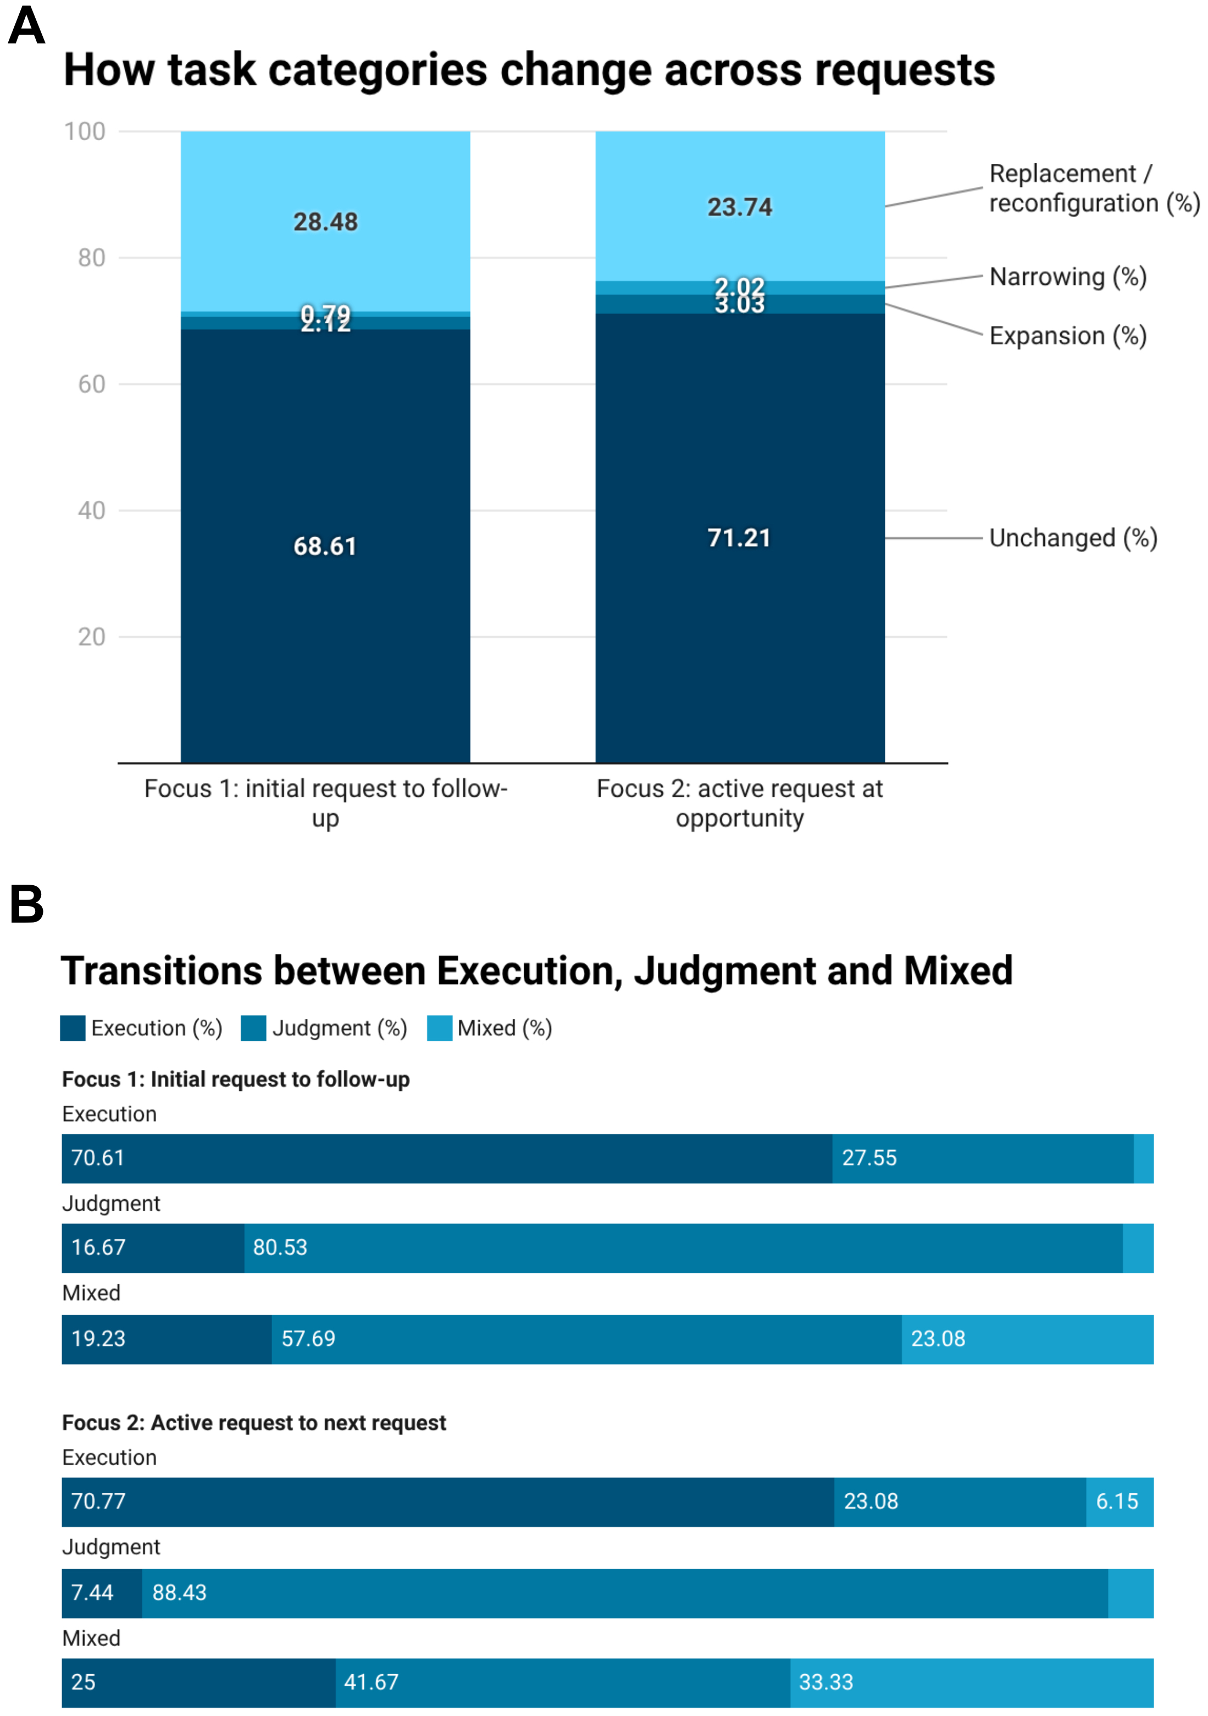
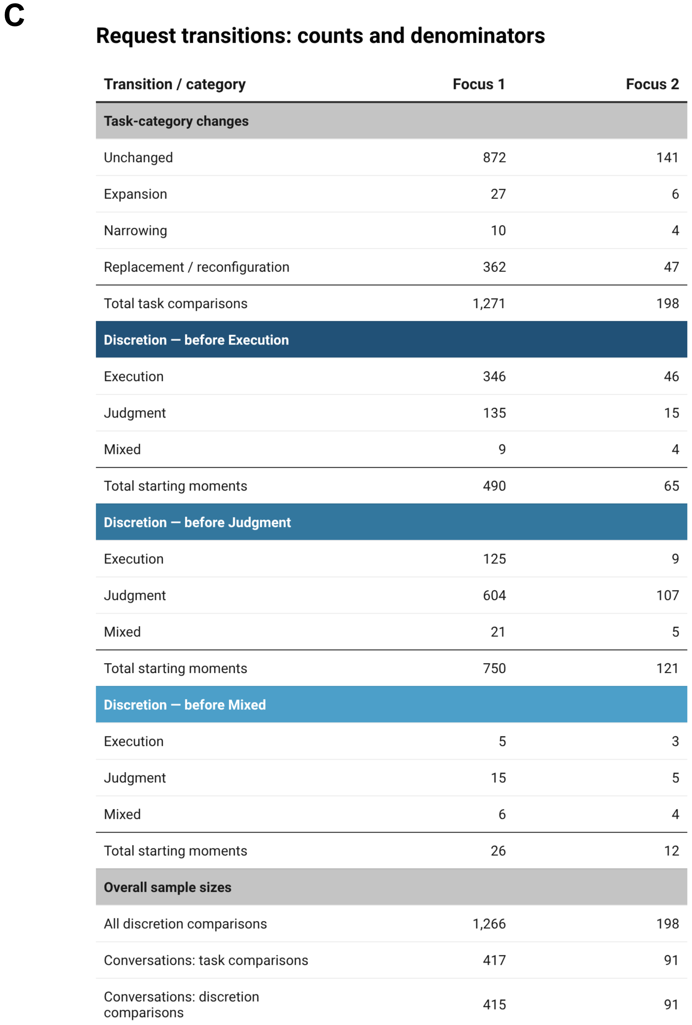
Note. A: Moment-weighted task transitions. B: Discretion destinations within starting categories. Focus 1 compares follow-ups with initial requests; Focus 2 compares assessable same-goal responses with active requests at qualifying opportunities. Percentages differ from conversation-weighted hypothesis estimates. C: Counts underlying A–B. Focus 1 includes 1,271 task comparisons in 417 conversations and 1,266 discretion comparisons in 415. Focus 2 includes 198 comparisons in 91 conversations. Mixed starting groups are small.

Alternative Functions
Qualifying alternatives appeared in 252 windows; 198 had assessable same-goal responses across 91 conversations. Joint persistence exceeded 50% (63.2%, 95% CI [54.1%, 72.1%]), supporting H3. Stricter criteria and first-opportunity checks gave similar estimates (62.3% and 60.9%). At the moment level, task-only retention exceeded joint retention (71.2% vs. 65.7%; Figure 1A).
Opportunities appeared most often during Planning, followed by Technical work and Transformation (27.7%, 21.6%, and 20.9%; Figure 2A). Among explicit assistant offers, continuing without addressing the alternative was common (44.6%); adoption was uncommon (7.9%), but many responses were unclear (37.4%; Figure 2B). These 139 offers formed a separate denominator from H3.
Conditional persistence varied descriptively across task groups (46.6%–59.8%) and discretion groups (Judgment, 66.0%; Execution, 56.8%; Figure 2C). Intervals overlapped; no pairwise subgroup tests were conducted.
Figure 2
Persistence in Qualifying Opportunities
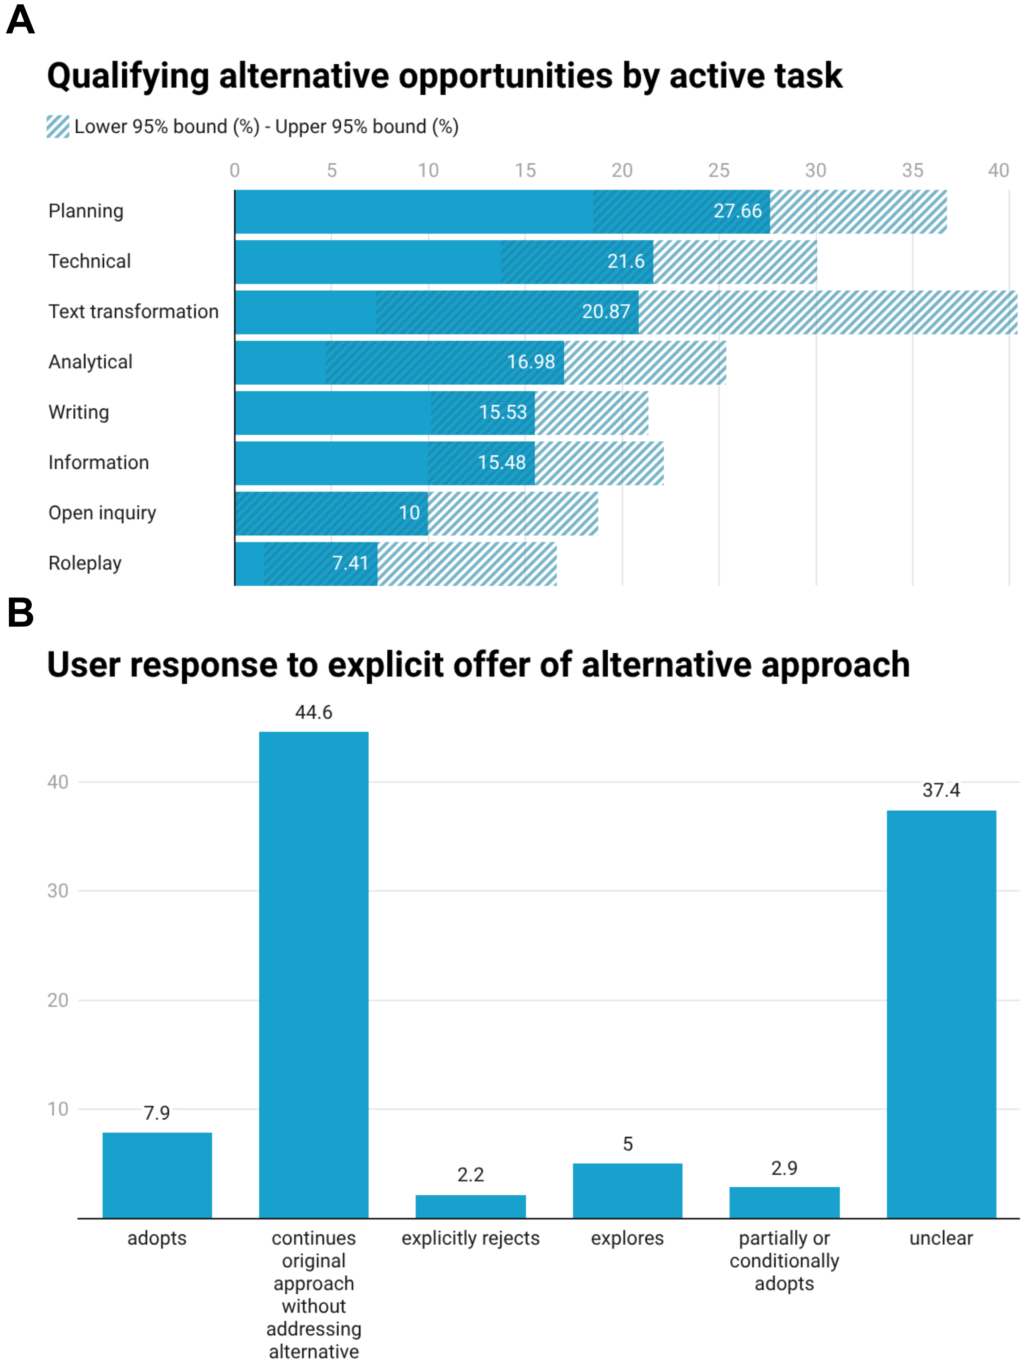
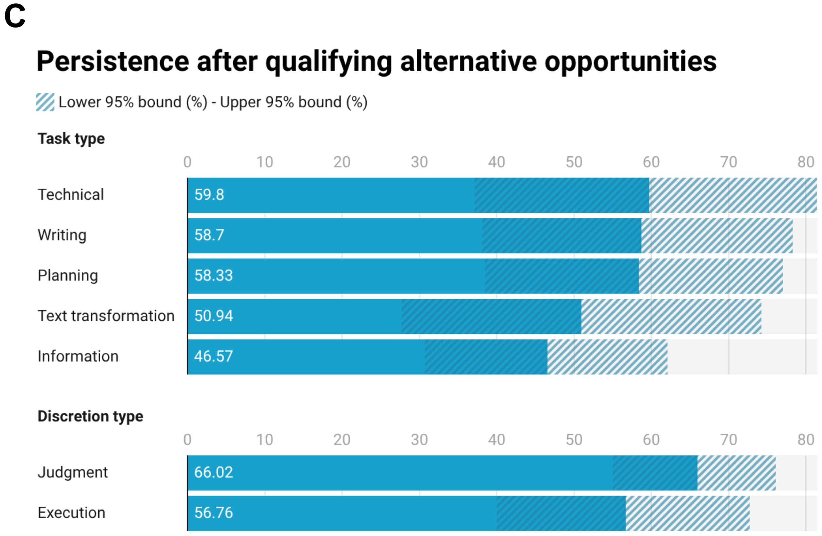
Note. A: Opportunities divided by clear opportunity/no-opportunity decisions within overlapping task groups; hatching indicates 95% intervals. B: Responses to 139 explicit offers in 72 conversations. Unaddressed offers are not explicit rejection. Transformation's full interval is 7.3%–40.4%, extending beyond the axis. C: Conversation-weighted joint persistence among 198 eligible moments in 91 conversations. Hatching indicates pointwise 95% intervals. Task groups overlap. Technical work's full interval is 37.2%–81.5%, extending beyond the axis. Subgroups were not tested pairwise.

Actions and Discretion Changes
Pursue was more frequent than Update and Redirect (50.0%, 38.9%, and 26.6%; Figure 3A). Paired differences supported both comparisons (+11.1 points, 95% CI [5.4, 16.8], adjusted p = .004; +23.5 points, CI [17.6, 29.5], adjusted p = .001; Figure 3D). Pursue did not clearly exceed a 50% majority (p = .986).
Local transitions favored movement from Execution toward Judgment over the reverse (33.7% vs. 18.9% including Mixed; difference = 14.8 points, CI [8.2, 21.6], cumulative-adjusted p = .001). The pure-state comparison showed the same direction (29.3% vs. 17.8%; difference = 11.4 points, CI [4.9, 18.1], adjusted p = .035; Figure 3B–C).
Separate shuffled-order tests found no corrected evidence of additional Pursue or Update repetition beyond conversation-level action composition.
Figure 3
User Redirection
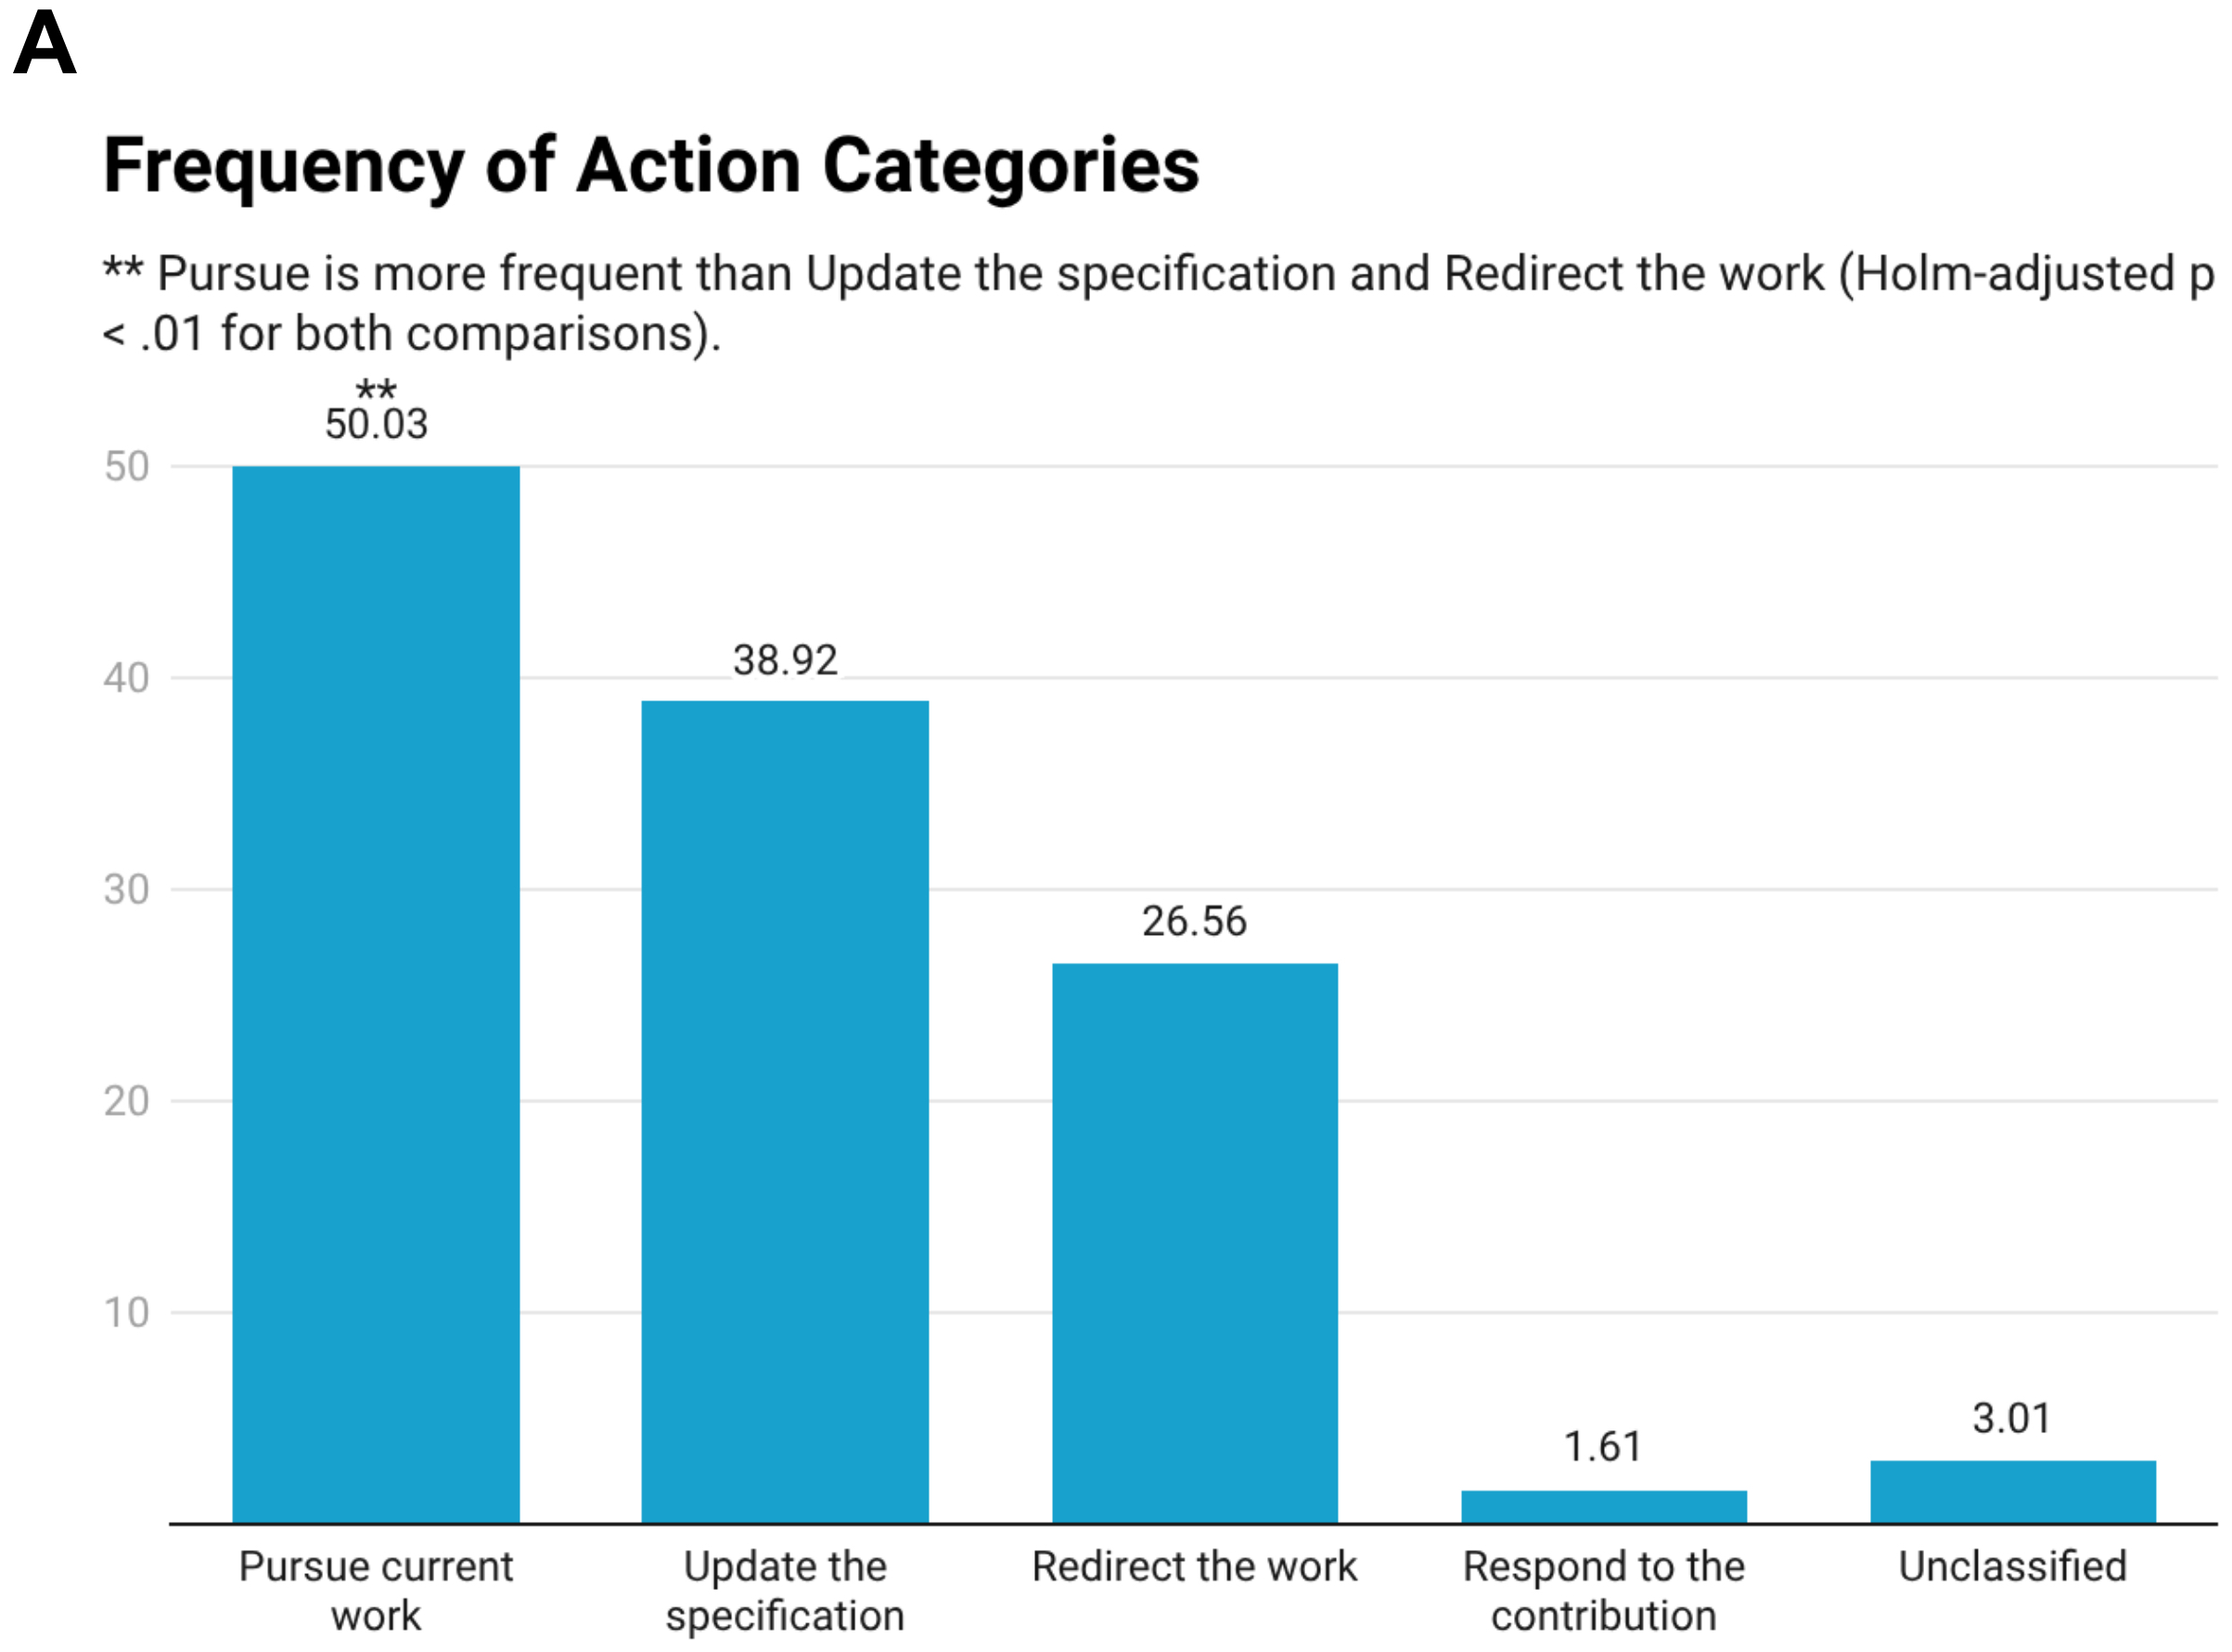
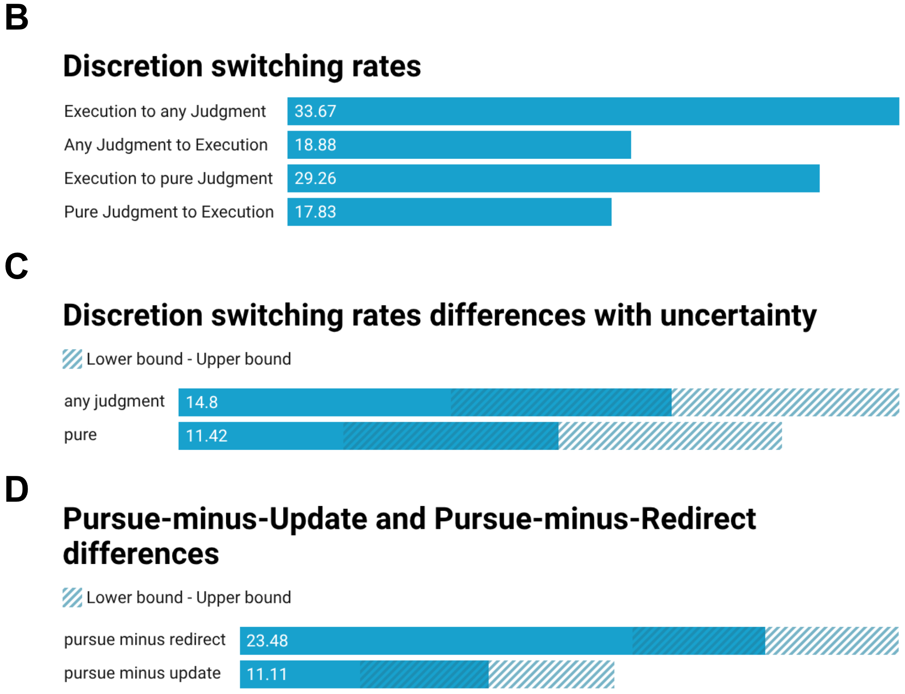
Note. A: Conversation-weighted prevalence across 1,589 follow-ups in 500 conversations. Actions overlap. Significance markers compare Pursue with Update and Redirect, not with a 50% threshold. B–C: Local transitions from preceding substantive requests, weighted equally within each starting-state conversation pool. Any Judgment includes Mixed. C–D: Percentage-point differences with pointwise 95% intervals. D compares paired action prevalences.

Inferred Satisfaction
Higher satisfaction scores were associated with less repetition and more extension under both score definitions (full-score coefficients: −17.9 and +20.1 points; reduced: −22.3 and +24.0; Figure 4). Both patterns survived cumulative correction. Clarification was negatively associated under both scores. Explanation was positively associated only under the full score, and rule changes negatively associated only under the reduced score. Approach changes were inconclusive after correction.
The aggregate Pursue association weakened after overlapping cues were removed (full: +12.4 points, CI [7.6, 17.3]; reduced: +2.4, CI [−6.8, 11.6]; Figure 5A–B). Neither score supported an association with initial task or discretion retention. Under the reduced score, Update decreased and Redirect increased (−28.6 and +27.0 points); however, most reduced scores were zero (1,130/1,589).
Continuation and request cues accounted for most of the signed adjusted score–Pursue covariance numerator (93.3%; Figure 5C). Removing them reduced the slope to +1.2 points, indicating substantial measurement sensitivity.
Figure 4
User Satisfaction Ratings to Actions
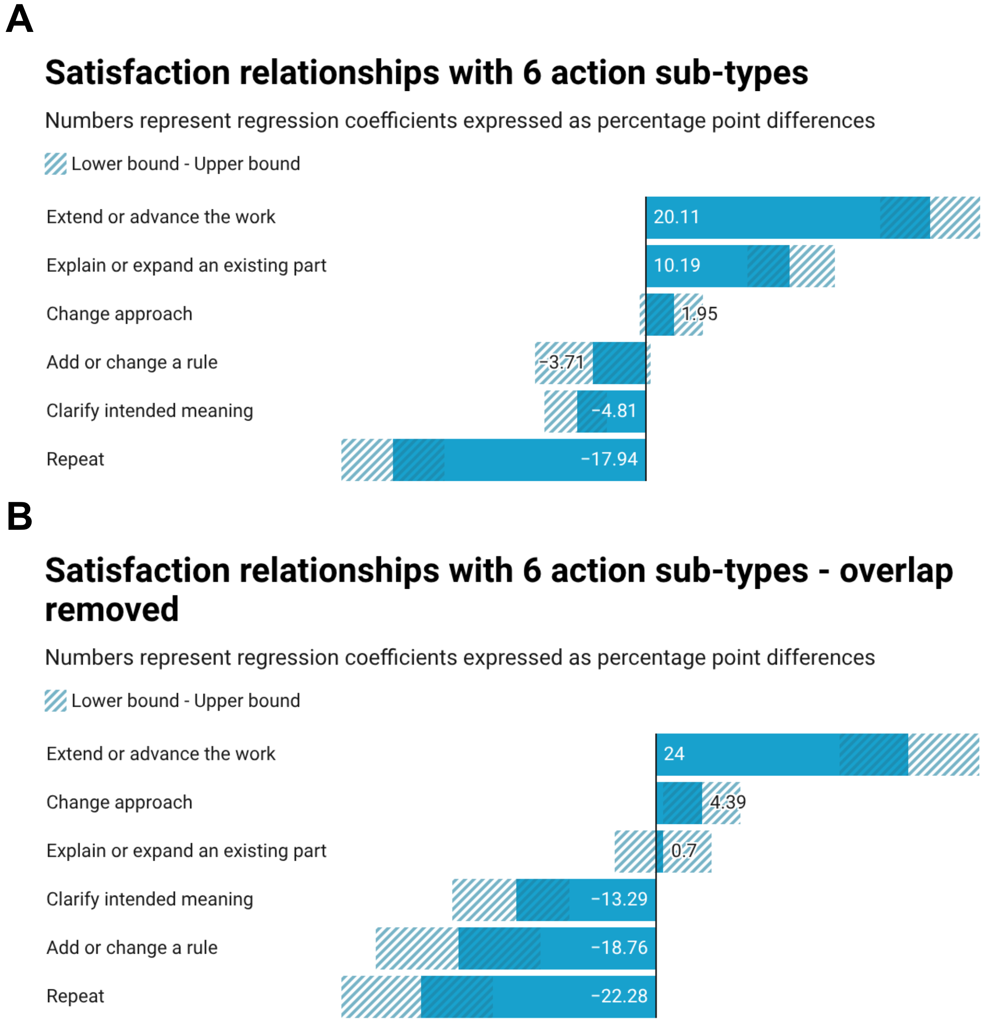
Note. A–B: Adjusted percentage-point coefficients per 10 full or reduced rubric units. Hatching indicates pointwise 95% intervals. Most outcomes use 1,589 follow-ups in 500 conversations; same-goal approach changes use 1,136 in 404. Reduced overlap does not validate satisfaction.
Figure 5
Satisfaction Ratings to Task Approach
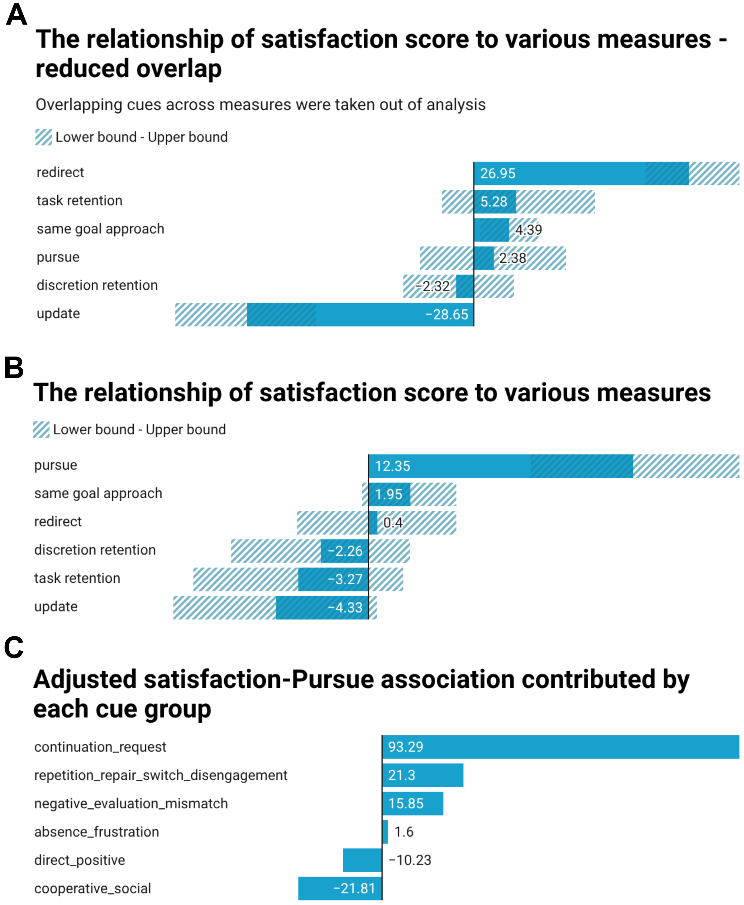
Note. A–B: Adjusted coefficients per 10 reduced or full score units, with pointwise 95% intervals. The scales differ. C: Signed shares of the adjusted covariance numerator, not percentages of users or variance explained; negative shares are possible.

Content Development
Follow-ups usually developed existing content rather than introducing new directions (72.6% vs. 21.9%; Figure 6A). Developed targets were more often user-established than AI-introduced or jointly developed (72.9%, 16.4%, and 12.9%; Figure 6B).
AI-introduced content had no corrected significant association with subsequent retention or actions (Figure 6C). Joint development was associated with subsequent Update (+22.2 points, CI [8.0, 34.1], adjusted p = .023; Figure 6D), although equal pair weighting reduced the estimate (+12.5 points). Its negative Pursue association did not survive the 29-test correction (adjusted p = .066).
Figure 6
User Content Development
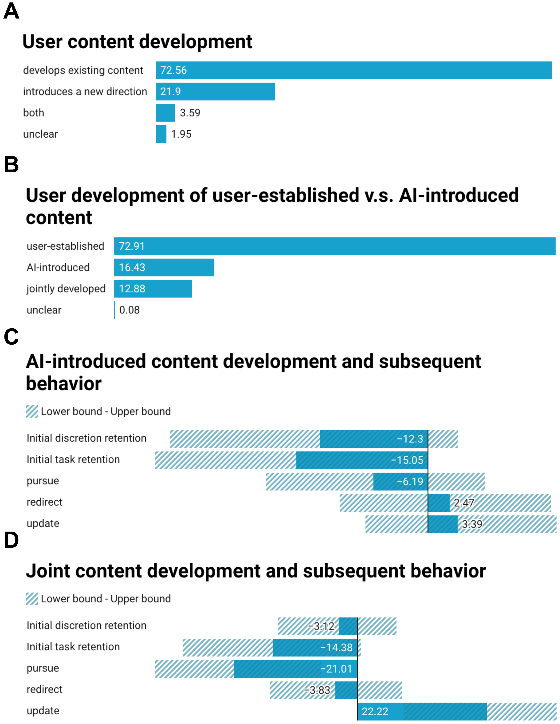
Note. A: All 1,589 follow-ups. B: Overlapping origins among 1,211 developed-target follow-ups. C–D: Adjusted percentage-point associations with the next follow-up (829 pairs, 258 conversations; retention: 672 pairs, 211 conversations). Hatching indicates pointwise 95% intervals; corrected p values determine significance.

Discussion
Requested functions commonly persisted, including when another function could advance the same goal. This complements evidence that expectations shape AI interaction (Liu et al., 2025), but does not establish functional fixedness. Users may prefer continuity or not recognize a researcher-identified alternative. Direct measures of expectations and alternative awareness are needed to distinguish these explanations.
Continuation also concealed different behaviors. Repetition and extension had opposite satisfaction associations, while the aggregate Pursue association depended heavily on continuation cues within the satisfaction score. Behavioral continuity should therefore not be treated as evidence of satisfaction. Joint development's association with later specification updates may reflect collaborative refinement, but was sensitive to weighting.
The main limitations concern measurement. Annotations lacked independent human validation, and confidence intervals exclude coding error. Planning and Judgment overlap by definition; the judgment gap also changed substantially across coding versions (61.1 to 85.8 points). Post-result harmonization and exploratory testing limit confirmation. Broad task categories may miss meaningful changes within a category, while different comparison anchors measure different forms of continuity.
Generalization is limited to the sampled English-language GPT-3.5-turbo conversations. Conversations were not verified independent users, and missing later messages constrained sequence analyses. Future studies should validate coding and satisfaction measures, collect user reports, and experimentally test recognition and adoption of relevant alternatives.

References
AllenAI. (n.d.). WildChat (Revision f66566c) [Data set]. Hugging Face. https://huggingface.co/datasets/allenai/WildChat/tree/f66566ceaaeb619dd98ffb0f3bf3ce1f86775ac4
Constant, A., Di Paolo, L. D., Guénin-Carlut, A., Martinez, L. M., Criado-Boado, F., Müeller, J., & Clark, A. (2024). A computational approach to selective attention in embodied approaches to cognitive archaeology. Journal of the Royal Society Interface, 21(219), Article 20240508. https://doi.org/10.1098/rsif.2024.0508
Lin, Y.-C., Neville, J., Stokes, J., Yang, L., Safavi, T., Wan, M., Counts, S., Suri, S., Andersen, R., Xu, X., Gupta, D., Jauhar, S. K., Song, X., Buscher, G., Tiwary, S., Hecht, B., & Teevan, J. (2024). Interpretable user satisfaction estimation for conversational systems with large language models. In L.-W. Ku, A. Martins, & V. Srikumar (Eds.), Proceedings of the 62nd Annual Meeting of the Association for Computational Linguistics (Volume 1: Long Papers) (pp. 11100–11115). Association for Computational Linguistics. https://doi.org/10.18653/v1/2024.acl-long.598
Liu, J., Karimnazarov, J., & White, R. W. (2025). Trapped by expectations: Functional fixedness in LLM-enabled chat search (Version 1) [Preprint]. arXiv. https://arxiv.org/abs/2504.02074v1
Zhao, W., Ren, X., Hessel, J., Cardie, C., Choi, Y., & Deng, Y. (2024). WildChat: 1M ChatGPT interaction logs in the wild. The Twelfth International Conference on Learning Representations. https://openreview.net/forum?id=Bl8u7ZRlbM

