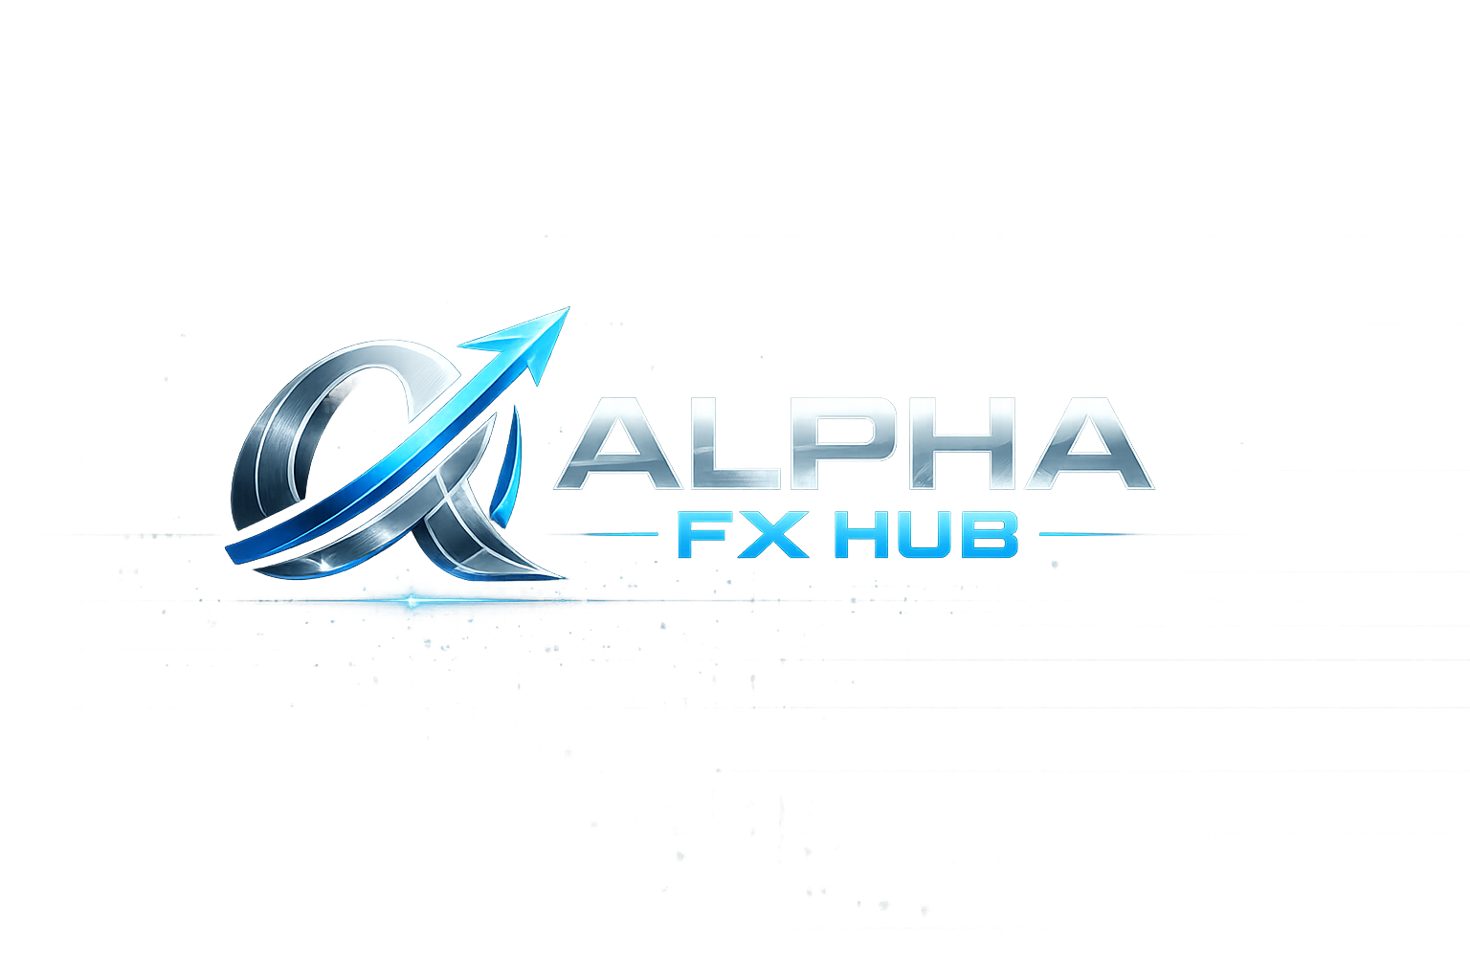

COMPLETE SETUP GUIDE
Step-by-Step Instructions to Launch Your Gold Trading Platform
Version 1.0 | April 2026
CONFIDENTIAL — For Internal Use Only

Your Current API Status
I checked your existing projects. Here is what you already have and what you still need:

SERVICE | STATUS | ACTION
Twelve Data (Price Feed) | READY | No action needed
Telegram Bot | READY | No action needed
MetaAPI (MT5) | READY | No action needed
Trading Economics | MISSING | Action required
Supabase (Auth) | OPTIONAL | Action required
FP Markets Referral | READY | No action needed

Your .env file has been pre-configured with all existing keys. Only Trading Economics needs setup.

STEP 1: Install Python Dependencies
Open your terminal, navigate to the alpha_fx_hub folder, and install the required packages:
cd /path/to/forex_calculator/alpha_fx_hub
pip install -r requirements.txt

This installs: Streamlit, Pandas, NumPy, Plotly, python-dotenv, requests, and supabase.
If you get permission errors, add --user flag:
pip install -r requirements.txt --user

STEP 2: Get Trading Economics API Key (Free)
This powers the Economic Calendar page with gold-impact event filtering.

1. Go to https://tradingeconomics.com/analytics/api.aspx
2. Click on the free tier (500 requests/month — enough for our cached approach)
3. Create an account and get your API key
4. Open the .env file in the alpha_fx_hub folder
5. Find the line TE_API_KEY= and paste your key after the equals sign
TE_API_KEY=your_key_here

Note: The app works without this key — it just shows demo calendar data instead of live events. You can add it later if you want to launch quickly.

STEP 3: Test Launch the Dashboard
Run this command to start Alpha FX Hub locally:
cd /path/to/forex_calculator/alpha_fx_hub
streamlit run app.py

Your browser should automatically open to http://localhost:8501
You should see the Alpha FX Hub home page with your logo, live gold price, market bias, and the 6 feature cards.

What to Check on First Launch
⬜ Logo displays correctly in sidebar and home page
⬜ Gold price shows a number (even if demo data)
⬜ Signal Dashboard page loads with BUY/SELL scores
⬜ Trading Academy shows 12 lessons in 3 levels
⬜ Risk Calculator computes lot sizes correctly
⬜ Economic Calendar shows events (demo or live)
⬜ TP strategy selector works in sidebar (Equal 10% vs 15/10 Split)

STEP 4: Configure Telegram Bot for Signal Delivery
Your bot token is already configured. Now set up the channel and permissions:

1. Open Telegram and find your bot (@BotFather gave you the token)
2. Create a channel for signals (e.g., @alphafxhub_signals)
3. Add your bot as an ADMIN of the channel (must have posting rights)
4. Get the channel ID: forward a message from the channel to @userinfobot
5. Update TELEGRAM_CHANNEL_ID in .env if different from current value

How Telegram Alerts Work
Once running, users receive these notification types:

ALERT | TRIGGER | WHAT IT DOES
RED | H1 CHoCH detected | Structure broken on H1 against your trade. Tighten SL or consider exit.
YELLOW | M15 CHoCH detected | Early warning on M15. H1 may still be intact. Monitor closely.
GREEN | TP level reached | Partial close executed. Shows lot closed, remaining, profit, and new SL position.
BLUE | FVG retest zone | Institutional displacement left a FVG. Price approaching retest zone for sniper LIMIT entry.

STEP 5: Deploy to Streamlit Cloud (Go Live)
This makes your dashboard accessible to users online 24/7 for free.

1. Push your alpha_fx_hub folder to a GitHub repository
cd forex_calculator
git add alpha_fx_hub/
git commit -m "Add Alpha FX Hub v1.0"
git push origin main

2. Go to https://share.streamlit.io and sign in with your GitHub account
3. Click “New app”
4. Select your repository and set:
• Main file path: alpha_fx_hub/app.py
• Python version: 3.10+

5. Add your secrets (API keys) in the Streamlit Cloud dashboard:
Go to Settings → Secrets and paste your .env contents

6. Click Deploy — your app will be live at https://yourapp.streamlit.app

Important: Make sure your .env file is in .gitignore so your API keys don’t get pushed to GitHub!
echo ".env" >> alpha_fx_hub/.gitignore

STEP 6: Set Up User Onboarding Flow
When users message your Telegram bot with /start, the onboarding flow activates:

1. Bot asks how much capital they plan to deposit
2. If less than $500 → rejected (minimum requirement)
3. Bot asks trading experience level (data collection)
4. Bot sends FP Markets referral link and registration steps
5. User sends screenshot proof of registration
6. You receive admin notification — reply /approve or /reject
7. Approved users get access to signal channel + manual

Admin Commands (Your Telegram)
/approve <user_id> - Approve a pending user
/reject <user_id> - Reject with reason
/users - Show user statistics
/stats - Dashboard link

STEP 7: Optional: Set Up Supabase for User Authentication
Supabase adds multi-user login to your dashboard (each user sees their own trades).

1. Go to https://supabase.com and create a free project
2. Copy your Project URL and anon key
3. Add them to .env:
SUPABASE_URL=https://your-project.supabase.co
SUPABASE_KEY=your_anon_key

This is optional for launch. The app works fine without it — it just won’t have user login.

Quick Reference: File Structure

alpha_fx_hub/
app.py ← Main app (run this)
config.py ← All settings in one place
.env ← Your API keys (DO NOT share)
logo.png ← Your brand logo
engine/
gold_engine.py ← 17-module scoring (the brain)
indicators.py ← RSI, MACD, BB, ATR, FVG
levels.py ← SL/TP + trailing logic
signal_scanner.py ← Scalp + Swing scanner
data.py ← Price data fetching
trading/
trade_manager.py ← 10-TP system + strategies
risk_manager.py ← Account risk controls
telegram/
bot.py ← Onboarding + admin cmds
notifications.py ← RED/YELLOW/GREEN/BLUE alerts
academy/
lessons.py ← 12 lessons + signal manual
calendar.py ← Trading Economics API

Launch Checklist

⬜ Step 1: pip install -r requirements.txt
⬜ Step 2: Get Trading Economics API key (optional)
⬜ Step 3: streamlit run app.py (test locally)
⬜ Step 4: Set up Telegram channel + bot permissions
⬜ Step 5: Push to GitHub + deploy on Streamlit Cloud
⬜ Step 6: Test onboarding flow with /start
⬜ Step 7: (Optional) Set up Supabase auth

You are ready to launch Alpha FX Hub.

