

**System Requirements v1.0**

Group 4: Autonomous Foosball Table

|  |  |
| --- | --- |
| Ryan Ma | 1147335 |
| Chenhe Li | 1158035 |
| Taha Hussain | 1200349 |
| Viktor Smirnov | 1154392 |
| Roland Zhou | 1216063 |
| Alvin Li | 0957972 |

# **1 REVISIONS**

|  |  |  |  |
| --- | --- | --- | --- |
| Version | Date | Author | Description |
| 0 | October 26, 2015 | Ryan Ma,  Chenhe Li,  Taha Hussain,  Viktor Smirnov,  Roland Zhou,  Alvin Li | Initial version |
| 0.1 | February 17, 2016 | Chenhe Li | Updating Non-Functional Requirements |
| 0.2 | February 18, 2016 | Chenhe Li | Correcting system response time  Updating Non-Functional Requirements |
| 0.3 | February 27, 2016 | Chenhe Li | Adding reference and Voltage Input  correcting system cost |
| 0.4 | Februray 28, 2016 | Roland Zhou | Added List of Tables and List of Figures |
| 1.0 | February 29, 2016 | Ryan Ma,  Chenhe Li,  Taha Hussain,  Roland Zhou | Updated format |

# **2 TABLE OF CONTENTS**

|  |  |
| --- | --- |
| 1 REVISIONS | 1 |
| 2 TABLE OF CONTENTS | 2 |
| 3 LIST OF FIGURES | 5 |
| 4 LIST OF TABLES | 6 |
| 5 INTRODUCTION | 7 |
| 5.1 Purpose | 7 |
| 5.2 Scope of Work | 7 |
| 5.3 Definitions and Abbreviations | 8 |
| 5.4 References | 8 |
| 6 NORMAL OPERATION | 9 |
| 6.1 Description | 9 |
| 6.2 Normal Use Cases | 9 |
| 6.2.1 Game is requested | 9 |
| 6.2.2 Goal is scored | 9 |
| 6.2.3 Game is finished | 9 |
| 6.2.4 Difficult level setting | 10 |
| 7 SYSTEM DESCRIPTION | 11 |
| 7.1 System Diagram | 11 |
| 7.2 System Context Diagram | 13 |
| 7.3 Functional Decomposition | 14 |
| 7.4 System Variables | 15 |
| 7.4.1 Monitored Variables | 15 |
| 7.4.2 Controlled Variables | 16 |
| 7.4.3 Constants | 17 |
| 8 REQUIREMENTS | 18 |
| 8.1 Functional Requirements | 18 |
| 8.1.1 Mode Selection | 18 |
| 8.1.2 Gameplay mode detection | 19 |
| 8.1.3 Player selection | 19 |
| 8.1.4 Offense | 19 |
| 8.1.5 Defense | 20 |
| 8.1.6 Ball path prediction | 20 |
| 8.1.7 Emergency | 20 |
| 8.1.8 Waiting | 20 |
| 8.2 Non-Functional Requirements | 21 |
| 8.2.1 System response time | 21 |
| 8.2.2 Linear motion accuracy | 21 |
| 8.2.3 Maximum Linear motion speed | 22 |
| 8.2.4 Angular motion accuracy | 22 |
| 8.2.5 Maximum ball kicking speed | 23 |
| 8.2.6 Ball detection accuracy | 23 |
| 8.2.7 Foosman Angular position detection accuracy | 24 |
| 8.2.8 Foosman linear position detection accuracy | 24 |
| 8.2.9 Ball position detecting successful rate | 25 |
| 8.2.10 Ball blocking rate | 25 |
| 8.2.11 Unopposed goal score rate | 26 |
| 8.2.12 Total system cost | 26 |
| 8.2.13 Voltage input | 27 |
| 9 UNDESIRED SCENARIO HANDLING | 28 |
| 10 REQUIREMENT CHANGES | 29 |
| 11 STABLE REQUIREMENTS | 30 |

# **3 LIST OF FIGURES**

Figure 1. Foosball table overview

Figure 2. Foosman and ball overview

Figure 3. Context Diagram

Figure 4. Functional Decomposition

# **4 LIST OF TABLES**

Table 1. Definitions and Abbreviations

Table 2. Monitored Variables

Table 3. Controlled Variables

Table 4. Constants

Table 5. Mode Selection

Table 6. Gameplay Mode

Table 7. Requirements Changes

Table 8. Stable Requirements

# **5 INTRODUCTION**

## **5.1 Purpose**

The purpose of this document is to define the requirement and organization of the autonomous foosball system. This document should be used as the reference throughout the development cycle and a guide for validation and verification. It will also act as a guide for understanding the overall system.

## **5.2 Scope of Work**

This project is constructing a retrofit/extension of a mini foosball table by employing software, electronic and mechanical methods. The entire design and implementation of mini foosball table is not within the scope of the project.

The system includes the following functionalities:

* Awareness of game start event
* Defence (blocking) against high-speed foosball
* Offence (foosball handling and shooting) where possible
* Pausing or stopping the game based on user input
* Edge case detection and handling
* Human Machine Interface

The following functionalities are deemed to be out of scope:

* Resetting the foosball after goal
* Resetting the foosball after dead ball (the foosball has completely stopped its motion and is not within reach of any player figure)
* Resetting the foosball stuck on user foosball men reachable area
* Detecting user spinning the rod
* Detecting a goal

## **5.3 Definitions and Abbreviations**

|  |  |
| --- | --- |
| Term | Definition |
| foosball table | The autonomous mini foosball table |
| foosman | The players in the foosball table |
| ball | The foosball used in the table |
| user | The user playing the autonomous foosball table |
| row1 | System controlled foosball man nearest to user side on offense side rod |
| row2 | System controlled foosball man nearest to user side on defense side rod |
| enemy1 | User controlled foosball man nearest to user side on offense side rod |
| enemy2 | User controlled foosball man nearest to user side on defense side rod |

**Table 1. Definitions and Abbreviations**

## **5.4 References**

[1] “Foosball Rules” Internet: <http://www.foosball.com/learn/rules/>, Apr. 02, 2009 [Otc. 19, 2015]

[2] Michael Aeberhard, Shane Connelly, Evan Tarr, and Nardis Walker. fall 2007. Single Player Foosball Table with an Autonomous Opponent. Available: <http://www.eskibars.com/projects/foosball_robot/final_rpt.pdf>

[3] “Real-Time Foosball Game State Tracking”, Sven Bambach and Stefan Lee. [Otc. 19, 2015]

Available:<http://iu.svenbambach.de/foosball-tracking.pdf>\

[4] “Country Household Voltages and Plug Styles” <http://www.powerstream.com/cv.htm>

# **6 NORMAL OPERATION**

## **6.1 Description**

The system shall capture the position of the ball, predict the trajectory of the ball and use suitable strategies to arrange the positions and rotary velocity of the controlled foosman. The system also shall be able to deliver the ball to the player’s goal as well as preventing the ball from entering its own goal.

## **6.2 Normal Use Cases**

### **6.2.1 Game is requested**

The game shall be manually enabled by the user, either to start a new game or resume after a goal is scored. The system will first go to waiting mode and wait for only the foosball to show in the foosball field before initiating normal game behavior.

### **6.2.2 Goal is scored**

Each time the ball entering the goal is counted as a point. After a goal is scored, the system goes to waiting mode and waits for the user to retrieve the ball and put it in the field. The score has to be incremented manually by the user.

### **6.2.3 Game is finished**

The system shall detect completion of the game, move the foosball player to the default position and go to waiting mode.

### **6.2.4 Difficult level setting**

The system has three difficulty levels (“easy”,”normal”,”advanced”) and the default difficulty level setting is “normal”. User can change the difficult level of the system when the system is in waiting mode.

**6.2.5 Emergency stop**

The system shall halt within 200ms and go to wait mode when unknown objects are present in the foosball playfield.

# **7 SYSTEM DESCRIPTION**

## **7.1 System Diagram**

Figure 1 illustrates that constant variable on the top view of foosball table; there is coordinate axis sign which demonstrate the positive direction of x and y axis. Contained constant variables: k_length_field, k_goal_length, k_row2_x_max, k_row2_x_min, k_max_linear_range, k_row1_x_max, k_row1_x_min, k_width_field. (For detail about variables values see Table 4. Constant Table).

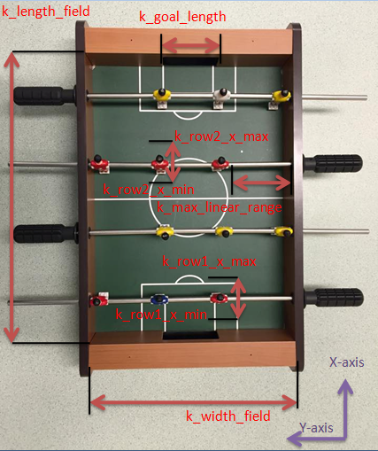

**Figure 1. Foosball table overview**

Figure 2 below demonstrates constant variables about each player and ball, contained variables are k_foosman_height, k_foosman_width, k_ball_diameter(For detail about variables values see Table 4. Constant Table).

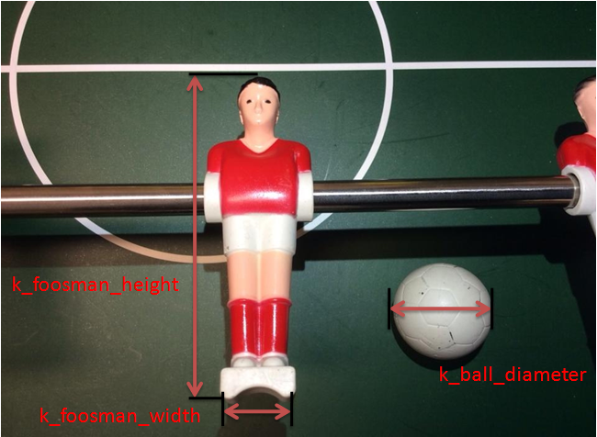

**Figure 2. Foosman and ball overview**

## **7.2 System Context Diagram**

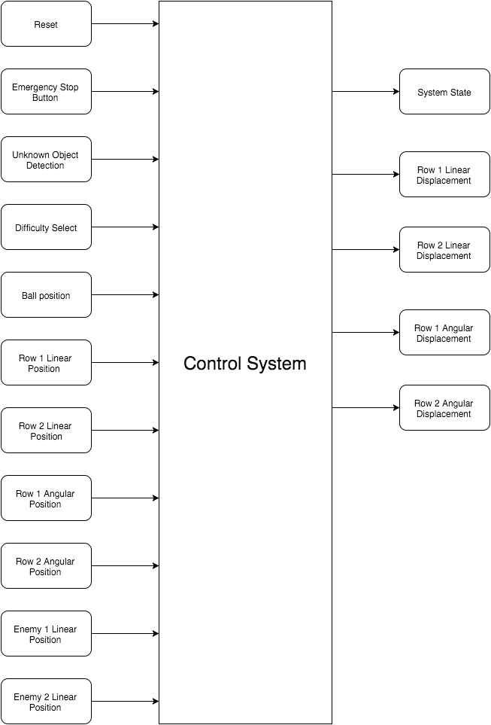

**Figure 3. Context Diagram**

## **7.3 Functional Decomposition**

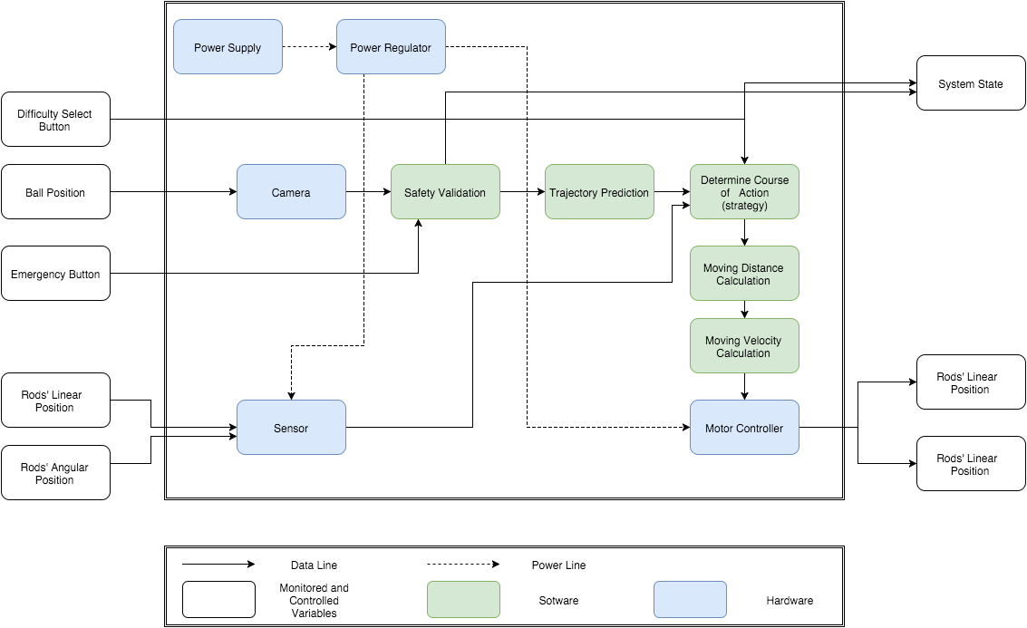

**Figure 4. Functional Decomposition**

## **7.4 System Variables**

The variable names, descriptions/values and units are shown in the tables below. Variables names with “row1”, “row2”, “enemy1” or “enemy2” can be referred from “Table 1. Definitions and Abbreviations” in section 3.3 of this document.

### **7.4.1 Monitored Variables**

|  |  |  |
| --- | --- | --- |
| Variable | Units | Description |
| m_unknown_object | Boolean | Other objects (e.g. human hand) show in the foosball table |
| m_ball_x | mm | Position of the foosball in the x-axis |
| m_ball_y | mm | Position of the foosball in the y-axis |
| m_ball_in_field | Boolean | Ball is in play field |
| m_row1_lp | mm | Linear position of row 1 |
| m_row2_lp | mm | Linear position of row 2 |
| m_enemy1_lp | mm | Linear position of enemy 1 |
| m_enemy2_lp | mm | Linear position of enemy 2 |
| m_row1_ap | degree | Angular position of row 1 |
| m_row2_ap | degree | Angular position of row 2 |
| m_safety | Boolean | Safety shutdown button |
| m_reset | Boolean | Reset button |
| m_difficulty_select | N/A | User requests difficulty level |
| m_ball_speed | m/s | Speed of the foosball |

**Table 2. Monitored Variables**

### **7.4.2 Controlled Variables**

|  |  |  |
| --- | --- | --- |
| Variable | Units | Description |
| c_row1_lp | mm | Linear position of row 1 |
| c_row2_lp | mm | Linear position of row 2 |
| c_row1_ap | degree | Angular position of row 1 |
| c_row2_ap | degree | Angular position of row 2 |
| c_mode | N/A | System mode |
| c_gameplay | N/A | gameplay mode |

**Table 3. Controlled Variables**

### **7.4.3 Constants**

|  |  |  |  |
| --- | --- | --- | --- |
| Constant | Value | Units | Description |
| k_field_length | 400 | mm | Length of the foosball field |
| k_field_width | 288 | mm | Width of the foosball field |
| k_ball_diameter | 25 | mm | Diameter of the foosball |
| k_max_linear_range | 95 | mm | Linear movement range of the row |
| k_goal_width | 85 | mm | Length of the goal |
| k_foosman_height | 75 | mm | Height of the foosman |
| k_foosman_width | 13 | mm | Width of the bottom part of the foosman |
| k_bp_tol | 2 | mm | Ball position tolerance |
| k_rlp_tol | 2 | mm | Linear position tolerance of each row |
| k_rap_tol | 2 | deg | Angular position tolerance of each row |
| k_row1_x_min | 12 | mm | Minimum x position row1 can reach in its workspace |
| k_row1_x_max | 110 | mm | Maximum x position row1 can reach in its workspace |
| k_row2_x_min | 212 | mm | Minimum x position row2 can reach in its workspace |
| k_row2_x_max | 310 | mm | Maximum x position row2 can reach in its workspace |

**Table 4. Constants**

# **8 REQUIREMENTS**

## **8.1 Functional Requirements**

### **8.1.1 Mode Selection**

**Natural Language Description:** Determining the mode of the system. When the emergency button is pressed the system goes to emergency mode. When the ball is not on the foosball table, the system goes to waiting mode. When the ball shows in the table, the system goes to gameplay mode.

**Monitored Variables:** m_ball_in_field, m_reset, m_safety, m_unknown_object

**Control Variables :** c_mode

**Constants :** k_field_length, k_field_width

|  |  |
| --- | --- |
| condition | c_mode |
| m_safety | Emergency |
| ¬m_safety⋀(m_reset⋁m_unkonwn_object) | Waiting |
| ¬m_safety∧¬(m_reset⋁m_unkonwn_object)∧(m_ball_in_field) | Gameplay |
| ¬m_safety∧¬(m_reset⋁m_unkonwn_object)∧¬(m_ball_in_field) | Waiting |

**Table 5. Mode Selection**

### **8.1.2 Gameplay mode detection**

**Natural Language Description:** Determining the gameplay mode. When the ball is low speed in reachable area of system controlled foosmen, the gameplay is in offensive mode.

**Monitored Variables:** m_ball_x, m_ball_y, m_ball_speed

**Control Variables :** c_gameplay

**Constants :** k_row1_x_min, k_row1_x_max, k_row2_x_min, k_row2_x_max, k_row1_y_min, k_row1_y_max, k_row2_y_min, k_row2_y_max

**Derived variables:** Boolean ball_in_kick_range= ((k_row1_x_minm_ball_x)∧(m_ball_x

k_row1_x_max)) ⋁((k_row2_x_min m_ball_x)∧(m_ball_x k_row2_x_max))

|  |  |
| --- | --- |
| condition | c_gameplay |
| ¬ball_in_kick_range | Defensive |
| (m_ball_speed 0.2m/s)∧ball_in_kick_range | Offensive |
| (m_ball_speed 0.2m/s)∧ball_in_kick_range | Defensive |

**Table 6. Gameplay Mode**

### **8.1.3 Player selection**

For a particular offense or defense play the correct foosman has to be selected. Each foosman has its own workspace.A foosman is selected based on the trajectory of the ball and when its predicted path crosses with one of the friendly rows. The region of where this intersection takes place will decide which foosman will be chosen for defense. For offense whatever region the ball is in will lead to the selection of a foosman.During offense it is possible that the ball drifts out of one foosman's region, in that case the current offense play will end and a new one will begin with the payer whose region the ball drifts into.

### **8.1.4 Offense**

**Monitored Variables:** m_ball_x, m_ball_y, m_row1_lp, m_row1_lp, m_row2_lp, m_enemy1_lp,m_enemy2_lp

**Control Variables :** c_row1_lp, c_row2_lp, c_row1_ap, c_row2_ap

**Constants :** All

The offense requirements are divided in several levels. This has been done as we are still not completely sure what reaction time we will be able to obtain for the system.For these offense requirements we assume that:

* The system is in gameplay offense mode
* initialization has has been completed
* A player has been selected to perform the offense action

### **8.1.5 Defense**

**Monitored Variables:** m_ball_x, m_ball_y, m_row1_lp, m_row1_lp, m_row2_lp, m_enemy1_lp,m_enemy2_lp

**Control Variables :** c_row1_lp, c_row2_lp, c_row1_ap, c_row2_ap

**Constants :** All

Theses defense requirements apply for the system in its defense mode. Like the offense requirements, the defense requirements are also divided into different level and have the following assumptions:

* The system is in gameplay mode
* Initialization process is completed
* Gameplay is in defense mode
* There is a foosman selected to perform the defense actions intended

### **8.1.6 Ball path prediction**

Path prediction should predict the path from the ball to one of the ends of the field. The intersection of the path of the ball with the friendly rods should be given as coordinate values for use with defense strategy and offense strategy. The path prediction should also predict deflections off the wall.

### **8.1.7 Emergency**

The system shall stop all its mechanical and electrical operations within 200ms.

### **8.1.8 Waiting**

The system shall immediately hold all mechanical and electrical operations.

## **8.2 Non-Functional Requirements**

Note that for the sections below, importance is represented by numbers from 0 to 5 where 0 is least important and 5 is most important.

### 

### **8.2.1 System response time**

|  |  |
| --- | --- |
| *Description:* | System response time is the amount of time the system takes to respond to user kicking the ball including image processing time to locate the ball and linear motion required to align the foosman with the ball. |
| *Rationale:* | The value chosen for system response time is based on average human reaction time which is 250 ms. Therefore, system response time shall faster than average mankind response time. |
| *Importance:* | 5 |
| *Unit:* | milliseconds (ms) |
| *Marginal Val:* | ≤250 |
| *Ideal Val:* | ≤150 |

### **8.2.2 Linear motion accuracy**

|  |  |
| --- | --- |
| *Description:* | The accuracy of moving the rod linearly to a desired position |
| *Rationale:* | The value is determined by the accuracy of the motors as well as the mechanical structure of the system. This is essential for blocking or kicking the ball. |
| *Importance:* | 3 |
| *Unit:* | millimeters (mm) |
| *Marginal Val:* | ±0.5 |
| *Ideal Val:* | ±0.1 |

### **8.2.3 Maximum Linear motion speed**

|  |  |
| --- | --- |
| *Description:* | The maximum linear speed of the system controlled rod |
| *Rationale:* | The value is determined by the motors,linear motion range and affects the response time significantly. This value is essential for blocking or kicking the ball. |
| *Importance:* | 4 |
| *Unit:* | meter/second (m/s) |
| *Marginal Val:* | ≥0.5 |
| *Ideal Val:* | ≥2 |

### **8.2.4 Angular motion accuracy**

|  |  |
| --- | --- |
| *Description:* | The accuracy of rotating the rod to a desired position |
| *Rationale:* | The value is determined by the accuracy of the motors as well as the mechanical structure of the system. This is essential for kicking the ball |
| *Importance:* | 3 |
| *Unit:* | degree |
| *Marginal Val:* | ±2 |
| *Ideal Val:* | ±0.5 |

### 

### 

### **8.2.5 Maximum ball kicking speed**

|  |  |
| --- | --- |
| *Description:* | The maximum speed the ball can reach after system kicked the ball |
| *Rationale:* | The value is based on an estimated shot speed and reaction time of an average adult player[2], mass of the ball and dimensions of the foosball field. |
| *Importance:* | 4 |
| *Unit:* | meter/second (m/s) |
| *Marginal Val:* | ≥0.3 |
| *Ideal Val:* | ≥1 |

### **8.2.6 Ball detection accuracy**

|  |  |
| --- | --- |
| *Description:* | The accuracy of detecting the position of the ball |
| *Rationale:* | This is essential for ball path prediction and decision making which determines the ball blocking rate and goal score rate of the system |
| *Importance:* | 4 |
| *Unit:* | millimeters (mm) |
| *Marginal Val:* | ±3.0 |
| *Ideal Val:* | ±1.0 |

### 

### 

### **8.2.7 Foosman Angular position detection accuracy**

|  |  |
| --- | --- |
| *Description:* | The accuracy of detecting the angular position of the foosman |
| *Rationale:* | This is essential for making accurate blocks and shots. Foosman need to be at a specific angle to block the ball. |
| *Importance:* | 4 |
| *Unit:* | degree |
| *Marginal Val:* | ±2 |
| *Ideal Val:* | ±0.5 |

### **8.2.8 Foosman linear position detection accuracy**

|  |  |
| --- | --- |
| *Description:* | The accuracy of detecting the linear position of the foosman |
| *Rationale:* | This is essential for making accurate shots. |
| *Importance:* | 4 |
| *Unit:* | millimeters (mm) |
| *Marginal Val:* | ±1.5 |
| *Ideal Val:* | ±0.3 |

### 

### 

### **8.2.9 Ball position detecting successful rate**

|  |  |
| --- | --- |
| *Description:* | The ability of the system to detect the position of the ball when the ball is in the foosball table |
| *Rationale:* | This is essential for blocking ball and predicting ball path, in order to make system well-functionable, the ball detecting shall reach high percentage. The value is based on visible field area from top viewing. |
| *Importance:* | 4 |
| *Unit:* | percentage (%) |
| *Marginal Val:* | >85 |
| *Ideal Val:* | >98 |

### **8.2.10 Ball blocking rate**

|  |  |
| --- | --- |
| *Description:* | The ability of the system to block human shots to prevent goal being scored |
| *Rationale:* | This value is based on adults blocking rate, the system shall has higher percentage blocking rate than adult |
| *Importance:* | 4 |
| *Unit:* | percentage (%) |
| *Marginal Val:* | >70 |
| *Ideal Val:* | >85 |

### 

### 

### **8.2.11 Unopposed goal score rate**

|  |  |
| --- | --- |
| *Description:* | The ability of the system to score in the opponent’s goal when the goal is unopposed |
| *Rationale:* | This value is based on an adult goal score rate without opposite, the system shall has higher percentage score rate than adult |
| *Importance:* | 3 |
| *Unit:* | percentage (%) |
| *Marginal Val:* | >50 |
| *Ideal Val:* | >70 |

### **8.2.12 Total system cost**

|  |  |
| --- | --- |
| *Description:* | The cost of all parts and technologies needed to build this system |
| *Rationale:* | This value is based on researches on current available prototype of this system and parts needed for building such system |
| *Importance:* | 4 |
| *Unit:* | CAD ($) |
| *Marginal Val:* | 600 |
| *Ideal Val:* | 400 |

### 

### 

### **8.2.13 Voltage input**

|  |  |
| --- | --- |
| *Description:* | The input voltage to power supply |
| *Rationale:* | This value is based on Residential voltage in North America and residential voltage around the world.[4] |
| *Importance:* | 3 |
| *Unit:* | VAC |
| *Marginal Val:* | 110 |
| *Ideal Val:* | 220-240 and 100-120 |

# **9 UNDESIRED SCENARIO HANDLING**

1. **Foosball not moving in foosmen reachable area**

* Electrical components failure
* mechanical parts are stuck
* ball is stuck

The system will detect the event and stop all the actuators and goes to emergency mode. User will be notified by an error message when a fault occurs.

1. **Foosball not moving in user reachable area**

* ball is stuck
* user is away

The system will stay in gameplay mode.

1. **Ball jumps over the foosmen**

* strong shot from user
* strong shot from robot

The system will go to waiting mode and reset foosmen to default position.

1. **Linear/Angular actuator malfunctions**

* user pulling or pushing the system controlled rods
* electrical components fail
* actuator internal components fail

If the the actuator malfunctions, the system will automatically go to emergency mode and a signal will notify the user that an error has occurred.

# 

# 

# **10 REQUIREMENT CHANGES**

Since the detailed design are not completed yet, most of the performance related nonfunctional requirements are likely to change in the future. Below is the table of requirements that are likely to change.

|  |  |
| --- | --- |
| Requirements likely to change | Description |
| System response time | The desired values of these requirements are determined based on the processor we are currently using. However, in a production environment, processor might be changed to improve performance. |
| Ball detection accuracy |
| Ball blocking rate |
| Unopposed goal score rate |

**Table 7. Requirement That Are Likely to Change**

# **11 STABLE REQUIREMENTS**

Among the list of functional and nonfunctional requirements , most of the functional requirements are associated with the layout and behaviours of the system. We want to keep these requirements stable and stay away from changing these requirements in the future.

The nonfunctional requirements that are not likely to change are mostly restricted by the constraints so there are not much space for changes in the future. The table below contains the detailed lists of requirements that are not likely to change.

|  |  |
| --- | --- |
| Requirements not likely to change | Description |
| Mode Selection requirements | These are functional requirements that describe the basic layout of system. |
| Emergency Stop requirements | These are safety related requirements that should not be changed. |
| Maximum linear motion speed | This is restricted by the performance of the motors. It cannot be slower than 0.5m/s |
| Ball detection successful rate | 85% successful rate is the minimum acceptable performance |
| Total system cost | The budget needs to be kept under 600 CAD. |

**Table 8. Requirements That Are Not Likely to Change**