Ryan Young

CSE 3500

10/17/2019

The Zombie Apocalypse

Overall Design:

The overall design of this project was started off the basic idea of wanting to import the data from the original txt file that was provided to me from the HuskyCT course site. This led me to develop a custom function called txt_to_list which allows the program to take in a file path as a string and return two lists, one for the vertices and one for the edges of the graph. Next, I implemented by own queue class, and undirected graph class to model the graph and work in the Dijkstra’s algorithm respectively. This allows the program to only require a path to a text file that is of the same format as the one given to us from HuskyCT and it will run.

How it Works:

This script has four parts the main function + format function, the txt_to_list function, the queue class and the undirected graph class. Logically in the script it starts with the txt_to_list function that will pull data from a txt file and return two lists, one for the vertices, and one for the edges that has the format of a list containing [start, end, weight]. The queue class is thus next, and this is a fairly simply class that models a simply queue with four methods: empty, get, put and size. These four methods allow it to be used in the Dijkstra’s algorithm and particularly allows the bredth first search methodology of the algorithm.

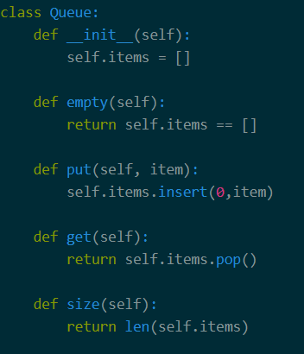

Moving on the undirected graph class is next in the script and this will take a list of vertices and a list of edges. The graph will then create an adjacency list where the first element in each list is the vertex and the remaining elements in that list are the neighbors for that vertex. This class has a few methods: return_neighbors, print_neighbors, distance_between, get_num_vertex, get_vertices and finally dijkstra.

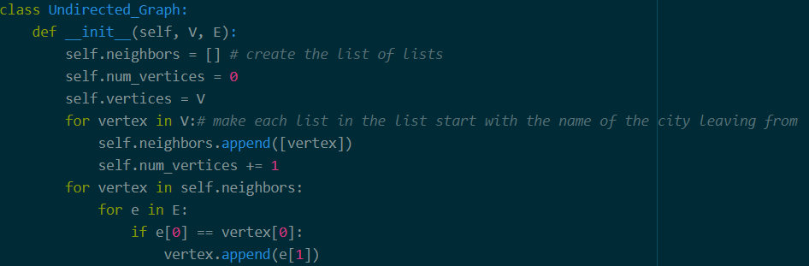

Return_neighbors is a method of the graph that will take in a vertex and return a list of its neighbors. Print_neighbors take in a vertex and will print the neighbors of that vertex. Distance_between is a method that will take in the edges of the graph, a starting node, and an ending node and then it will return the integer value of the distance between the two nodes. Get_num_vertex will return the number of vertices in the graph, no input is necessary. Get_vertices will return the list of vertices in the graph.

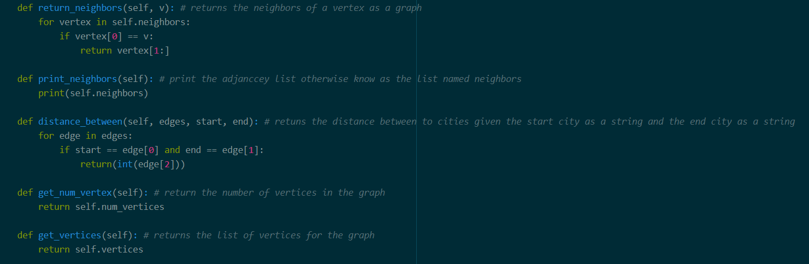

And finally, Dijkstra which takes in the list of edges and a source node as a string and will return a list of each destination and the distance (in an integer) from the source to the destination.

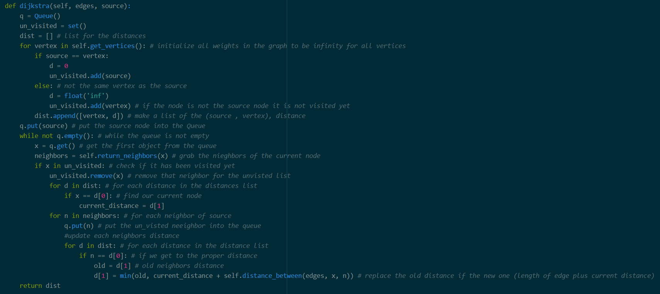

Moreover, the format function takes in that list that is outputted from the dijkstra method and will sort the list alphabetically and finish with printing the desired output showing the time it takes in days and hours for the zombies to reach all other cities.

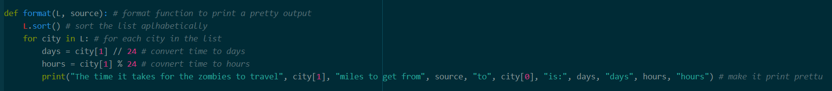

Finally, the main function will run all the functions of the script and use the classes in order to run Dijkstra’s algorithm based off the input txt file and the desired starting city in our case this is the string Phoenix.

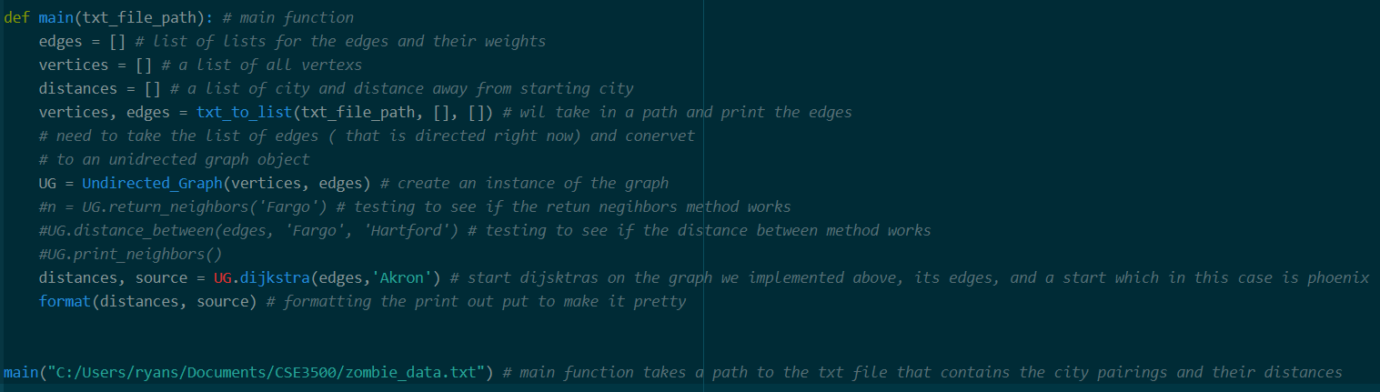

Possible Improvements:

There are a few possible improvements that I would make given more time to work on this project, the first being the time it takes to run. My current implementation of the undirected graph using a list of a list and this caused a longer run time due to the need to use for loops in order to get values. I know a lot of my friends used dictionaries and I think that might decrease the run time of my program in the future. The second thing I would change or improve about my script would be I want to be able to have the user chose which txt file they want to import the data from. I could do this using the built in input function and as long as the user formats it the same way as the example one given from the HuskyCT website it should be able to handle it. One finally improvement I would make given more time would be to have the output written to an excel file. This would allow the script to be able to make graphs and show the time to get to each city from the source as a bar graph which would be easier for the user to compare times.

Test Cases:

My first test case is a simple one taking the txt file as the input to the script and choosing ‘Phoenix’ to be the source city for the algorithm. The base case here would be ‘Phoenix’ to ‘Phoenix’ so this should take 0 days and 0 hours to get there because the zombies do not have to travel any distance. Which as you can see here is: “The time it takes for the zombies to travel 0 miles to get from Phoenix to Phoenix is: 0 days 0 hours”. Then to verify that the graph is indeed unidirectional I will change the source city to ‘Akron’ and the distance to get to ‘Phoenix’ should be exactly the same as 86 days and 7 hours. The output from this reverse test case is: “The time it takes for the zombies to travel 2071 miles to get from Akron to Phoenix is: 86 days 7 hours” Another test case that I preformed was having the input source be ‘Hartford’. This also produced the same time it takes to travel to ‘Phoenix’. (Full output below ‘Phoenix’ output)

“Phoenix” as the Source Output:

The time it takes for the zombies to travel 2071 miles to get from Phoenix to Akron is: 86 days 7 hours

The time it takes for the zombies to travel 2784 miles to get from Phoenix to Albany is: 116 days 0 hours

The time it takes for the zombies to travel 1708 miles to get from Phoenix to Albert_Lea is: 71 days 4 hours

The time it takes for the zombies to travel 470 miles to get from Phoenix to Albuquerque is: 19 days 14 hours

The time it takes for the zombies to travel 1923 miles to get from Phoenix to Angola is: 80 days 3 hours

The time it takes for the zombies to travel 930 miles to get from Phoenix to Arvada is: 38 days 18 hours

The time it takes for the zombies to travel 1995 miles to get from Phoenix to Asheville is: 83 days 3 hours

The time it takes for the zombies to travel 1956 miles to get from Phoenix to Atlanta is: 81 days 12 hours

The time it takes for the zombies to travel 2407 miles to get from Phoenix to Baltimore is: 100 days 7 hours

The time it takes for the zombies to travel 3024 miles to get from Phoenix to Bangor is: 126 days 0 hours

The time it takes for the zombies to travel 415 miles to get from Phoenix to Barstow is: 17 days 7 hours

The time it takes for the zombies to travel 1671 miles to get from Phoenix to Baton_Rouge is: 69 days 15 hours

The time it takes for the zombies to travel 2241 miles to get from Phoenix to Bedford is: 93 days 9 hours

The time it takes for the zombies to travel 2336 miles to get from Phoenix to Bellefonte is: 97 days 8 hours

The time it takes for the zombies to travel 1840 miles to get from Phoenix to Beloit is: 76 days 16 hours

The time it takes for the zombies to travel 2282 miles to get from Phoenix to Benson is: 95 days 2 hours

The time it takes for the zombies to travel 1126 miles to get from Phoenix to Big_Springs is: 46 days 22 hours

The time it takes for the zombies to travel 1637 miles to get from Phoenix to Billings is: 68 days 5 hours

The time it takes for the zombies to travel 2506 miles to get from Phoenix to Binghamton is: 104 days 10 hours

The time it takes for the zombies to travel 1863 miles to get from Phoenix to Birmingham is: 77 days 15 hours

The time it takes for the zombies to travel 2770 miles to get from Phoenix to Boston is: 115 days 10 hours

The time it takes for the zombies to travel 2226 miles to get from Phoenix to Bowman is: 92 days 18 hours

The time it takes for the zombies to travel 1595 miles to get from Phoenix to Buffalo is: 66 days 11 hours

The time it takes for the zombies to travel 1409 miles to get from Phoenix to Butte is: 58 days 17 hours

The time it takes for the zombies to travel 2023 miles to get from Phoenix to Cambridge is: 84 days 7 hours

The time it takes for the zombies to travel 2781 miles to get from Phoenix to Canton is: 115 days 21 hours

The time it takes for the zombies to travel 2330 miles to get from Phoenix to Carlisle is: 97 days 2 hours

The time it takes for the zombies to travel 48 miles to get from Phoenix to Casa_Grande is: 2 days 0 hours

The time it takes for the zombies to travel 1694 miles to get from Phoenix to Champaign is: 70 days 14 hours

The time it takes for the zombies to travel 2029 miles to get from Phoenix to Charleston is: 84 days 13 hours

The time it takes for the zombies to travel 2138 miles to get from Phoenix to Charlotte is: 89 days 2 hours

The time it takes for the zombies to travel 1838 miles to get from Phoenix to Chattanooga is: 76 days 14 hours

The time it takes for the zombies to travel 1020 miles to get from Phoenix to Cheyenne is: 42 days 12 hours

The time it takes for the zombies to travel 1824 miles to get from Phoenix to Chicago is: 76 days 0 hours

The time it takes for the zombies to travel 1868 miles to get from Phoenix to Cincinnati is: 77 days 20 hours

The time it takes for the zombies to travel 2093 miles to get from Phoenix to Cleveland is: 87 days 5 hours

The time it takes for the zombies to travel 2157 miles to get from Phoenix to Columbia is: 89 days 21 hours

The time it takes for the zombies to travel 1943 miles to get from Phoenix to Columbus is: 80 days 23 hours

The time it takes for the zombies to travel 1805 miles to get from Phoenix to Country_Club_Hills is: 75 days 5 hours

The time it takes for the zombies to travel 816 miles to get from Phoenix to Cove_Fort is: 34 days 0 hours

The time it takes for the zombies to travel 1218 miles to get from Phoenix to Dallas is: 50 days 18 hours

The time it takes for the zombies to travel 1912 miles to get from Phoenix to Dandridge is: 79 days 16 hours

The time it takes for the zombies to travel 1727 miles to get from Phoenix to Davenport is: 71 days 23 hours

The time it takes for the zombies to travel 1872 miles to get from Phoenix to Dayton is: 78 days 0 hours

The time it takes for the zombies to travel 2374 miles to get from Phoenix to Daytona_Beach is: 98 days 22 hours

The time it takes for the zombies to travel 1167 miles to get from Phoenix to Declo is: 48 days 15 hours

The time it takes for the zombies to travel 919 miles to get from Phoenix to Denver is: 38 days 7 hours

The time it takes for the zombies to travel 1559 miles to get from Phoenix to Des_Moines is: 64 days 23 hours

The time it takes for the zombies to travel 2066 miles to get from Phoenix to Detroit is: 86 days 2 hours

The time it takes for the zombies to travel 1957 miles to get from Phoenix to Duluth is: 81 days 13 hours

The time it takes for the zombies to travel 2483 miles to get from Phoenix to Dunmore is: 103 days 11 hours

The time it takes for the zombies to travel 1042 miles to get from Phoenix to Echo is: 43 days 10 hours

The time it takes for the zombies to travel 1614 miles to get from Phoenix to Effingham is: 67 days 6 hours

The time it takes for the zombies to travel 1617 miles to get from Phoenix to Ellensburg is: 67 days 9 hours

The time it takes for the zombies to travel 2195 miles to get from Phoenix to Erie is: 91 days 11 hours

The time it takes for the zombies to travel 1946 miles to get from Phoenix to Fargo is: 81 days 2 hours

The time it takes for the zombies to travel 145 miles to get from Phoenix to Flagstaff is: 6 days 1 hours

The time it takes for the zombies to travel 2072 miles to get from Phoenix to Flint is: 86 days 8 hours

The time it takes for the zombies to travel 2254 miles to get from Phoenix to Florence is: 93 days 22 hours

The time it takes for the zombies to travel 813 miles to get from Phoenix to Ft_Davis is: 33 days 21 hours

The time it takes for the zombies to travel 1441 miles to get from Phoenix to Galveston is: 60 days 1 hours

The time it takes for the zombies to travel 1834 miles to get from Phoenix to Gary is: 76 days 10 hours

The time it takes for the zombies to travel 1633 miles to get from Phoenix to Goreville is: 68 days 1 hours

The time it takes for the zombies to travel 2174 miles to get from Phoenix to Green_Bay is: 90 days 14 hours

The time it takes for the zombies to travel 2173 miles to get from Phoenix to Greensboro is: 90 days 13 hours

The time it takes for the zombies to travel 1716 miles to get from Phoenix to Hammond is: 71 days 12 hours

The time it takes for the zombies to travel 2285 miles to get from Phoenix to Hancock is: 95 days 5 hours

The time it takes for the zombies to travel 2485 miles to get from Phoenix to Harrisburg is: 103 days 13 hours

The time it takes for the zombies to travel 2671 miles to get from Phoenix to Hartford is: 111 days 7 hours

The time it takes for the zombies to travel 2435 miles to get from Phoenix to Hazleton is: 101 days 11 hours

The time it takes for the zombies to travel 1521 miles to get from Phoenix to Hermiston is: 63 days 9 hours

The time it takes for the zombies to travel 1395 miles to get from Phoenix to Houston is: 58 days 3 hours

The time it takes for the zombies to travel 1756 miles to get from Phoenix to Indianapolis is: 73 days 4 hours

The time it takes for the zombies to travel 1623 miles to get from Phoenix to Jackson is: 67 days 15 hours

The time it takes for the zombies to travel 2285 miles to get from Phoenix to Jacksonville is: 95 days 5 hours

The time it takes for the zombies to travel 1779 miles to get from Phoenix to Joliet is: 74 days 3 hours

The time it takes for the zombies to travel 2498 miles to get from Phoenix to Jonestown is: 104 days 2 hours

The time it takes for the zombies to travel 1229 miles to get from Phoenix to Joplin is: 51 days 5 hours

The time it takes for the zombies to travel 1365 miles to get from Phoenix to Kansas_City is: 56 days 21 hours

The time it takes for the zombies to travel 1985 miles to get from Phoenix to Kingsport is: 82 days 17 hours

The time it takes for the zombies to travel 1880 miles to get from Phoenix to Knoxville is: 78 days 8 hours

The time it takes for the zombies to travel 1727 miles to get from Phoenix to LaPlace is: 71 days 23 hours

The time it takes for the zombies to travel 1746 miles to get from Phoenix to LaSalle is: 72 days 18 hours

The time it takes for the zombies to travel 1612 miles to get from Phoenix to Lafayette is: 67 days 4 hours

The time it takes for the zombies to travel 2224 miles to get from Phoenix to Lake_City is: 92 days 16 hours

The time it takes for the zombies to travel 2016 miles to get from Phoenix to Lansing is: 84 days 0 hours

The time it takes for the zombies to travel 1355 miles to get from Phoenix to Laredo is: 56 days 11 hours

The time it takes for the zombies to travel 394 miles to get from Phoenix to Las_Cruces is: 16 days 10 hours

The time it takes for the zombies to travel 1853 miles to get from Phoenix to Lexington is: 77 days 5 hours

The time it takes for the zombies to travel 1351 miles to get from Phoenix to Little_Rock is: 56 days 7 hours

The time it takes for the zombies to travel 373 miles to get from Phoenix to Los_Angeles is: 15 days 13 hours

The time it takes for the zombies to travel 1774 miles to get from Phoenix to Louisville is: 73 days 22 hours

The time it takes for the zombies to travel 2040 miles to get from Phoenix to Macon is: 85 days 0 hours

The time it takes for the zombies to travel 1971 miles to get from Phoenix to Madison is: 82 days 3 hours

The time it takes for the zombies to travel 1970 miles to get from Phoenix to Marshall is: 82 days 2 hours

The time it takes for the zombies to travel 1488 miles to get from Phoenix to Memphis is: 62 days 0 hours

The time it takes for the zombies to travel 2176 miles to get from Phoenix to Mercer is: 90 days 16 hours

The time it takes for the zombies to travel 1716 miles to get from Phoenix to Meridian is: 71 days 12 hours

The time it takes for the zombies to travel 2635 miles to get from Phoenix to Miami is: 109 days 19 hours

The time it takes for the zombies to travel 2337 miles to get from Phoenix to Middletown is: 97 days 9 hours

The time it takes for the zombies to travel 1945 miles to get from Phoenix to Milwaukee is: 81 days 1 hours

The time it takes for the zombies to travel 1629 miles to get from Phoenix to Miner is: 67 days 21 hours

The time it takes for the zombies to travel 1805 miles to get from Phoenix to Minneapolis is: 75 days 5 hours

The time it takes for the zombies to travel 1879 miles to get from Phoenix to Mobile is: 78 days 7 hours

The time it takes for the zombies to travel 1956 miles to get from Phoenix to Montgomery is: 81 days 12 hours

The time it takes for the zombies to travel 2186 miles to get from Phoenix to Morgantown is: 91 days 2 hours

The time it takes for the zombies to travel 1592 miles to get from Phoenix to Mt_Vernon is: 66 days 8 hours

The time it takes for the zombies to travel 1700 miles to get from Phoenix to Nashville is: 70 days 20 hours

The time it takes for the zombies to travel 2653 miles to get from Phoenix to New_Haven is: 110 days 13 hours

The time it takes for the zombies to travel 2572 miles to get from Phoenix to New_York is: 107 days 4 hours

The time it takes for the zombies to travel 2572 miles to get from Phoenix to Newark is: 107 days 4 hours

The time it takes for the zombies to travel 2573 miles to get from Phoenix to Newburgh is: 107 days 5 hours

The time it takes for the zombies to travel 1683 miles to get from Phoenix to Normal is: 70 days 3 hours

The time it takes for the zombies to travel 2117 miles to get from Phoenix to North_Jackson is: 88 days 5 hours

The time it takes for the zombies to travel 1084 miles to get from Phoenix to Ogden is: 45 days 4 hours

The time it takes for the zombies to travel 1011 miles to get from Phoenix to Oklahoma_City is: 42 days 3 hours

The time it takes for the zombies to travel 1517 miles to get from Phoenix to Omaha is: 63 days 5 hours

The time it takes for the zombies to travel 336 miles to get from Phoenix to Ontario is: 14 days 0 hours

The time it takes for the zombies to travel 2352 miles to get from Phoenix to Petersburg is: 98 days 0 hours

The time it takes for the zombies to travel 2513 miles to get from Phoenix to Philadelphia is: 104 days 17 hours

The time it takes for the zombies to travel 0 miles to get from Phoenix to Phoenix is: 0 days 0 hours

The time it takes for the zombies to travel 2131 miles to get from Phoenix to Pittsburg is: 88 days 19 hours

The time it takes for the zombies to travel 1239 miles to get from Phoenix to Pocatello is: 51 days 15 hours

The time it takes for the zombies to travel 1337 miles to get from Phoenix to Portland is: 55 days 17 hours

The time it takes for the zombies to travel 2797 miles to get from Phoenix to Reading is: 116 days 13 hours

The time it takes for the zombies to travel 2090 miles to get from Phoenix to Richfield is: 87 days 2 hours

The time it takes for the zombies to travel 2352 miles to get from Phoenix to Richmond is: 98 days 0 hours

The time it takes for the zombies to travel 1794 miles to get from Phoenix to Rochelle is: 74 days 18 hours

The time it takes for the zombies to travel 757 miles to get from Phoenix to Sacramento is: 31 days 13 hours

The time it takes for the zombies to travel 992 miles to get from Phoenix to Salt_Lake_City is: 41 days 8 hours

The time it takes for the zombies to travel 1198 miles to get from Phoenix to San_Antonio is: 49 days 22 hours

The time it takes for the zombies to travel 394 miles to get from Phoenix to San_Diego is: 16 days 10 hours

The time it takes for the zombies to travel 843 miles to get from Phoenix to San_Francisco is: 35 days 3 hours

The time it takes for the zombies to travel 2206 miles to get from Phoenix to Savannah is: 91 days 22 hours

The time it takes for the zombies to travel 2561 miles to get from Phoenix to Schenectady is: 106 days 17 hours

The time it takes for the zombies to travel 2804 miles to get from Phoenix to Schenetady is: 116 days 20 hours

The time it takes for the zombies to travel 1510 miles to get from Phoenix to Seattle is: 62 days 22 hours

The time it takes for the zombies to travel 2048 miles to get from Phoenix to Seville is: 85 days 8 hours

The time it takes for the zombies to travel 1406 miles to get from Phoenix to Shreveport is: 58 days 14 hours

The time it takes for the zombies to travel 1739 miles to get from Phoenix to Silvis is: 72 days 11 hours

The time it takes for the zombies to travel 1702 miles to get from Phoenix to Sioux_Falls is: 70 days 22 hours

The time it takes for the zombies to travel 1764 miles to get from Phoenix to Slidell is: 73 days 12 hours

The time it takes for the zombies to travel 2064 miles to get from Phoenix to Spartanburg is: 86 days 0 hours

The time it takes for the zombies to travel 1609 miles to get from Phoenix to Springfield is: 67 days 1 hours

The time it takes for the zombies to travel 2698 miles to get from Phoenix to Springfield_MA is: 112 days 10 hours

The time it takes for the zombies to travel 2747 miles to get from Phoenix to Springfield_Ma is: 114 days 11 hours

The time it takes for the zombies to travel 1513 miles to get from Phoenix to St_Louis is: 63 days 1 hours

The time it takes for the zombies to travel 2098 miles to get from Phoenix to Statesville is: 87 days 10 hours

The time it takes for the zombies to travel 2228 miles to get from Phoenix to Staunton is: 92 days 20 hours

The time it takes for the zombies to travel 2073 miles to get from Phoenix to Strongsville is: 86 days 9 hours

The time it takes for the zombies to travel 2714 miles to get from Phoenix to Sturbridge is: 113 days 2 hours

The time it takes for the zombies to travel 2433 miles to get from Phoenix to Syracuse is: 101 days 9 hours

The time it takes for the zombies to travel 2396 miles to get from Phoenix to Tampa is: 99 days 20 hours

The time it takes for the zombies to travel 2554 miles to get from Phoenix to Teaneck is: 106 days 10 hours

The time it takes for the zombies to travel 2007 miles to get from Phoenix to Toledo is: 83 days 15 hours

The time it takes for the zombies to travel 1871 miles to get from Phoenix to Tomah is: 77 days 23 hours

The time it takes for the zombies to travel 1065 miles to get from Phoenix to Tremonton is: 44 days 9 hours

The time it takes for the zombies to travel 2414 miles to get from Phoenix to Washington is: 100 days 14 hours

The time it takes for the zombies to travel 940 miles to get from Phoenix to Welby is: 39 days 4 hours

The time it takes for the zombies to travel 2759 miles to get from Phoenix to Weston is: 114 days 23 hours

The time it takes for the zombies to travel 1826 miles to get from Phoenix to Wildwood is: 76 days 2 hours

The time it takes for the zombies to travel 2144 miles to get from Phoenix to Winston-Salem is: 89 days 8 hours

The time it takes for the zombies to travel 2076 miles to get from Phoenix to Wytheville is: 86 days 12 hours

‘Hartford’ as the Source Output:

The time it takes for the zombies to travel 580 miles to get from Hartford to Akron is: 24 days 4 hours

The time it takes for the zombies to travel 113 miles to get from Hartford to Albany is: 4 days 17 hours

The time it takes for the zombies to travel 1440 miles to get from Hartford to Albert_Lea is: 60 days 0 hours

The time it takes for the zombies to travel 2213 miles to get from Hartford to Albuquerque is: 92 days 5 hours

The time it takes for the zombies to travel 860 miles to get from Hartford to Angola is: 35 days 20 hours

The time it takes for the zombies to travel 2033 miles to get from Hartford to Arvada is: 84 days 17 hours

The time it takes for the zombies to travel 854 miles to get from Hartford to Asheville is: 35 days 14 hours

The time it takes for the zombies to travel 1017 miles to get from Hartford to Atlanta is: 42 days 9 hours

The time it takes for the zombies to travel 324 miles to get from Hartford to Baltimore is: 13 days 12 hours

The time it takes for the zombies to travel 353 miles to get from Hartford to Bangor is: 14 days 17 hours

The time it takes for the zombies to travel 2890 miles to get from Hartford to Barstow is: 120 days 10 hours

The time it takes for the zombies to travel 1553 miles to get from Hartford to Baton_Rouge is: 64 days 17 hours

The time it takes for the zombies to travel 402 miles to get from Hartford to Bedford is: 16 days 18 hours

The time it takes for the zombies to travel 335 miles to get from Hartford to Bellefonte is: 13 days 23 hours

The time it takes for the zombies to travel 1123 miles to get from Hartford to Beloit is: 46 days 19 hours

The time it takes for the zombies to travel 652 miles to get from Hartford to Benson is: 27 days 4 hours

The time it takes for the zombies to travel 1889 miles to get from Hartford to Big_Springs is: 78 days 17 hours

The time it takes for the zombies to travel 2293 miles to get from Hartford to Billings is: 95 days 13 hours

The time it takes for the zombies to travel 249 miles to get from Hartford to Binghamton is: 10 days 9 hours

The time it takes for the zombies to travel 1163 miles to get from Hartford to Birmingham is: 48 days 11 hours

The time it takes for the zombies to travel 99 miles to get from Hartford to Boston is: 4 days 3 hours

The time it takes for the zombies to travel 856 miles to get from Hartford to Bowman is: 35 days 16 hours

The time it takes for the zombies to travel 2172 miles to get from Hartford to Buffalo is: 90 days 12 hours

The time it takes for the zombies to travel 2521 miles to get from Hartford to Butte is: 105 days 1 hours

The time it takes for the zombies to travel 648 miles to get from Hartford to Cambridge is: 27 days 0 hours

The time it takes for the zombies to travel 110 miles to get from Hartford to Canton is: 4 days 14 hours

The time it takes for the zombies to travel 313 miles to get from Hartford to Carlisle is: 13 days 1 hours

The time it takes for the zombies to travel 2731 miles to get from Hartford to Casa_Grande is: 113 days 19 hours

The time it takes for the zombies to travel 1048 miles to get from Hartford to Champaign is: 43 days 16 hours

The time it takes for the zombies to travel 702 miles to get from Hartford to Charleston is: 29 days 6 hours

The time it takes for the zombies to travel 768 miles to get from Hartford to Charlotte is: 32 days 0 hours

The time it takes for the zombies to travel 1135 miles to get from Hartford to Chattanooga is: 47 days 7 hours

The time it takes for the zombies to travel 2040 miles to get from Hartford to Cheyenne is: 85 days 0 hours

The time it takes for the zombies to travel 1027 miles to get from Hartford to Chicago is: 42 days 19 hours

The time it takes for the zombies to travel 815 miles to get from Hartford to Cincinnati is: 33 days 23 hours

The time it takes for the zombies to travel 601 miles to get from Hartford to Cleveland is: 25 days 1 hours

The time it takes for the zombies to travel 850 miles to get from Hartford to Columbia is: 35 days 10 hours

The time it takes for the zombies to travel 708 miles to get from Hartford to Columbus is: 29 days 12 hours

The time it takes for the zombies to travel 1026 miles to get from Hartford to Country_Club_Hills is: 42 days 18 hours

The time it takes for the zombies to travel 2535 miles to get from Hartford to Cove_Fort is: 105 days 15 hours

The time it takes for the zombies to travel 1758 miles to get from Hartford to Dallas is: 73 days 6 hours

The time it takes for the zombies to travel 846 miles to get from Hartford to Dandridge is: 35 days 6 hours

The time it takes for the zombies to travel 1182 miles to get from Hartford to Davenport is: 49 days 6 hours

The time it takes for the zombies to travel 779 miles to get from Hartford to Dayton is: 32 days 11 hours

The time it takes for the zombies to travel 1186 miles to get from Hartford to Daytona_Beach is: 49 days 10 hours

The time it takes for the zombies to travel 2615 miles to get from Hartford to Declo is: 108 days 23 hours

The time it takes for the zombies to travel 2022 miles to get from Hartford to Denver is: 84 days 6 hours

The time it takes for the zombies to travel 1404 miles to get from Hartford to Des_Moines is: 58 days 12 hours

The time it takes for the zombies to travel 835 miles to get from Hartford to Detroit is: 34 days 19 hours

The time it takes for the zombies to travel 1601 miles to get from Hartford to Duluth is: 66 days 17 hours

The time it takes for the zombies to travel 188 miles to get from Hartford to Dunmore is: 7 days 20 hours

The time it takes for the zombies to travel 2432 miles to get from Hartford to Echo is: 101 days 8 hours

The time it takes for the zombies to travel 1069 miles to get from Hartford to Effingham is: 44 days 13 hours

The time it takes for the zombies to travel 3007 miles to get from Hartford to Ellensburg is: 125 days 7 hours

The time it takes for the zombies to travel 545 miles to get from Hartford to Erie is: 22 days 17 hours

The time it takes for the zombies to travel 1684 miles to get from Hartford to Fargo is: 70 days 4 hours

The time it takes for the zombies to travel 2538 miles to get from Hartford to Flagstaff is: 105 days 18 hours

The time it takes for the zombies to travel 903 miles to get from Hartford to Flint is: 37 days 15 hours

The time it takes for the zombies to travel 767 miles to get from Hartford to Florence is: 31 days 23 hours

The time it takes for the zombies to travel 2227 miles to get from Hartford to Ft_Davis is: 92 days 19 hours

The time it takes for the zombies to travel 2043 miles to get from Hartford to Galveston is: 85 days 3 hours

The time it takes for the zombies to travel 997 miles to get from Hartford to Gary is: 41 days 13 hours

The time it takes for the zombies to travel 1137 miles to get from Hartford to Goreville is: 47 days 9 hours

The time it takes for the zombies to travel 1272 miles to get from Hartford to Green_Bay is: 53 days 0 hours

The time it takes for the zombies to travel 676 miles to get from Hartford to Greensboro is: 28 days 4 hours

The time it takes for the zombies to travel 1508 miles to get from Hartford to Hammond is: 62 days 20 hours

The time it takes for the zombies to travel 425 miles to get from Hartford to Hancock is: 17 days 17 hours

The time it takes for the zombies to travel 288 miles to get from Hartford to Harrisburg is: 12 days 0 hours

The time it takes for the zombies to travel 0 miles to get from Hartford to Hartford is: 0 days 0 hours

The time it takes for the zombies to travel 236 miles to get from Hartford to Hazleton is: 9 days 20 hours

The time it takes for the zombies to travel 3030 miles to get from Hartford to Hermiston is: 126 days 6 hours

The time it takes for the zombies to travel 1829 miles to get from Hartford to Houston is: 76 days 5 hours

The time it takes for the zombies to travel 927 miles to get from Hartford to Indianapolis is: 38 days 15 hours

The time it takes for the zombies to travel 1512 miles to get from Hartford to Jackson is: 63 days 0 hours

The time it takes for the zombies to travel 1097 miles to get from Hartford to Jacksonville is: 45 days 17 hours

The time it takes for the zombies to travel 1052 miles to get from Hartford to Joliet is: 43 days 20 hours

The time it takes for the zombies to travel 264 miles to get from Hartford to Jonestown is: 11 days 0 hours

The time it takes for the zombies to travel 1454 miles to get from Hartford to Joplin is: 60 days 14 hours

The time it takes for the zombies to travel 1418 miles to get from Hartford to Kansas_City is: 59 days 2 hours

The time it takes for the zombies to travel 773 miles to get from Hartford to Kingsport is: 32 days 5 hours

The time it takes for the zombies to travel 878 miles to get from Hartford to Knoxville is: 36 days 14 hours

The time it takes for the zombies to travel 1518 miles to get from Hartford to LaPlace is: 63 days 6 hours

The time it takes for the zombies to travel 1100 miles to get from Hartford to LaSalle is: 45 days 20 hours

The time it takes for the zombies to travel 1612 miles to get from Hartford to Lafayette is: 67 days 4 hours

The time it takes for the zombies to travel 1158 miles to get from Hartford to Lake_City is: 48 days 6 hours

The time it takes for the zombies to travel 926 miles to get from Hartford to Lansing is: 38 days 14 hours

The time it takes for the zombies to travel 2189 miles to get from Hartford to Laredo is: 91 days 5 hours

The time it takes for the zombies to travel 2437 miles to get from Hartford to Las_Cruces is: 101 days 13 hours

The time it takes for the zombies to travel 878 miles to get from Hartford to Lexington is: 36 days 14 hours

The time it takes for the zombies to travel 1439 miles to get from Hartford to Little_Rock is: 59 days 23 hours

The time it takes for the zombies to travel 3006 miles to get from Hartford to Los_Angeles is: 125 days 6 hours

The time it takes for the zombies to travel 914 miles to get from Hartford to Louisville is: 38 days 2 hours

The time it takes for the zombies to travel 1101 miles to get from Hartford to Macon is: 45 days 21 hours

The time it takes for the zombies to travel 1177 miles to get from Hartford to Madison is: 49 days 1 hours

The time it takes for the zombies to travel 907 miles to get from Hartford to Marshall is: 37 days 19 hours

The time it takes for the zombies to travel 1302 miles to get from Hartford to Memphis is: 54 days 6 hours

The time it takes for the zombies to travel 475 miles to get from Hartford to Mercer is: 19 days 19 hours

The time it takes for the zombies to travel 1430 miles to get from Hartford to Meridian is: 59 days 14 hours

The time it takes for the zombies to travel 1447 miles to get from Hartford to Miami is: 60 days 7 hours

The time it takes for the zombies to travel 436 miles to get from Hartford to Middletown is: 18 days 4 hours

The time it takes for the zombies to travel 1148 miles to get from Hartford to Milwaukee is: 47 days 20 hours

The time it takes for the zombies to travel 1196 miles to get from Hartford to Miner is: 49 days 20 hours

The time it takes for the zombies to travel 1449 miles to get from Hartford to Minneapolis is: 60 days 9 hours

The time it takes for the zombies to travel 1345 miles to get from Hartford to Mobile is: 56 days 1 hours

The time it takes for the zombies to travel 1177 miles to get from Hartford to Montgomery is: 49 days 1 hours

The time it takes for the zombies to travel 545 miles to get from Hartford to Morgantown is: 22 days 17 hours

The time it takes for the zombies to travel 1096 miles to get from Hartford to Mt_Vernon is: 45 days 16 hours

The time it takes for the zombies to travel 1090 miles to get from Hartford to Nashville is: 45 days 10 hours

The time it takes for the zombies to travel 39 miles to get from Hartford to New_Haven is: 1 days 15 hours

The time it takes for the zombies to travel 120 miles to get from Hartford to New_York is: 5 days 0 hours

The time it takes for the zombies to travel 130 miles to get from Hartford to Newark is: 5 days 10 hours

The time it takes for the zombies to travel 98 miles to get from Hartford to Newburgh is: 4 days 2 hours

The time it takes for the zombies to travel 1101 miles to get from Hartford to Normal is: 45 days 21 hours

The time it takes for the zombies to travel 534 miles to get from Hartford to North_Jackson is: 22 days 6 hours

The time it takes for the zombies to travel 2474 miles to get from Hartford to Ogden is: 103 days 2 hours

The time it takes for the zombies to travel 1672 miles to get from Hartford to Oklahoma_City is: 69 days 16 hours

The time it takes for the zombies to travel 1543 miles to get from Hartford to Omaha is: 64 days 7 hours

The time it takes for the zombies to travel 2969 miles to get from Hartford to Ontario is: 123 days 17 hours

The time it takes for the zombies to travel 497 miles to get from Hartford to Petersburg is: 20 days 17 hours

The time it takes for the zombies to travel 218 miles to get from Hartford to Philadelphia is: 9 days 2 hours

The time it takes for the zombies to travel 2683 miles to get from Hartford to Phoenix is: 111 days 19 hours

The time it takes for the zombies to travel 512 miles to get from Hartford to Pittsburg is: 21 days 8 hours

The time it takes for the zombies to travel 2687 miles to get from Hartford to Pocatello is: 111 days 23 hours

The time it takes for the zombies to travel 3214 miles to get from Hartford to Portland is: 133 days 22 hours

The time it takes for the zombies to travel 126 miles to get from Hartford to Reading is: 5 days 6 hours

The time it takes for the zombies to travel 580 miles to get from Hartford to Richfield is: 24 days 4 hours

The time it takes for the zombies to travel 473 miles to get from Hartford to Richmond is: 19 days 17 hours

The time it takes for the zombies to travel 1148 miles to get from Hartford to Rochelle is: 47 days 20 hours

The time it takes for the zombies to travel 3131 miles to get from Hartford to Sacramento is: 130 days 11 hours

The time it takes for the zombies to travel 2482 miles to get from Hartford to Salt_Lake_City is: 103 days 10 hours

The time it takes for the zombies to travel 2032 miles to get from Hartford to San_Antonio is: 84 days 16 hours

The time it takes for the zombies to travel 3082 miles to get from Hartford to San_Diego is: 128 days 10 hours

The time it takes for the zombies to travel 3217 miles to get from Hartford to San_Francisco is: 134 days 1 hours

The time it takes for the zombies to travel 958 miles to get from Hartford to Savannah is: 39 days 22 hours

The time it takes for the zombies to travel 450 miles to get from Hartford to Schenectady is: 18 days 18 hours

The time it takes for the zombies to travel 133 miles to get from Hartford to Schenetady is: 5 days 13 hours

The time it takes for the zombies to travel 3114 miles to get from Hartford to Seattle is: 129 days 18 hours

The time it takes for the zombies to travel 603 miles to get from Hartford to Seville is: 25 days 3 hours

The time it takes for the zombies to travel 1729 miles to get from Hartford to Shreveport is: 72 days 1 hours

The time it takes for the zombies to travel 1170 miles to get from Hartford to Silvis is: 48 days 18 hours

The time it takes for the zombies to travel 1617 miles to get from Hartford to Sioux_Falls is: 67 days 9 hours

The time it takes for the zombies to travel 1460 miles to get from Hartford to Slidell is: 60 days 20 hours

The time it takes for the zombies to travel 842 miles to get from Hartford to Spartanburg is: 35 days 2 hours

The time it takes for the zombies to travel 1134 miles to get from Hartford to Springfield is: 47 days 6 hours

The time it takes for the zombies to travel 27 miles to get from Hartford to Springfield_MA is: 1 days 3 hours

The time it takes for the zombies to travel 76 miles to get from Hartford to Springfield_Ma is: 3 days 4 hours

The time it takes for the zombies to travel 1170 miles to get from Hartford to St_Louis is: 48 days 18 hours

The time it takes for the zombies to travel 751 miles to get from Hartford to Statesville is: 31 days 7 hours

The time it takes for the zombies to travel 530 miles to get from Hartford to Staunton is: 22 days 2 hours

The time it takes for the zombies to travel 597 miles to get from Hartford to Strongsville is: 24 days 21 hours

The time it takes for the zombies to travel 43 miles to get from Hartford to Sturbridge is: 1 days 19 hours

The time it takes for the zombies to travel 322 miles to get from Hartford to Syracuse is: 13 days 10 hours

The time it takes for the zombies to travel 1324 miles to get from Hartford to Tampa is: 55 days 4 hours

The time it takes for the zombies to travel 138 miles to get from Hartford to Teaneck is: 5 days 18 hours

The time it takes for the zombies to travel 776 miles to get from Hartford to Toledo is: 32 days 8 hours

The time it takes for the zombies to travel 1277 miles to get from Hartford to Tomah is: 53 days 5 hours

The time it takes for the zombies to travel 2513 miles to get from Hartford to Tremonton is: 104 days 17 hours

The time it takes for the zombies to travel 363 miles to get from Hartford to Washington is: 15 days 3 hours

The time it takes for the zombies to travel 2043 miles to get from Hartford to Welby is: 85 days 3 hours

The time it takes for the zombies to travel 88 miles to get from Hartford to Weston is: 3 days 16 hours

The time it takes for the zombies to travel 1174 miles to get from Hartford to Wildwood is: 48 days 22 hours

The time it takes for the zombies to travel 705 miles to get from Hartford to Winston-Salem is: 29 days 9 hours

The time it takes for the zombies to travel 682 miles to get from Hartford to Wytheville is: 28 days 10 hours