Ryan Young

CSE 4071 Databases

2/18/2020

Project 1 Part 1

Course Table:

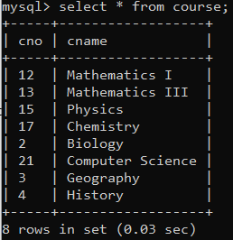

Result Table:

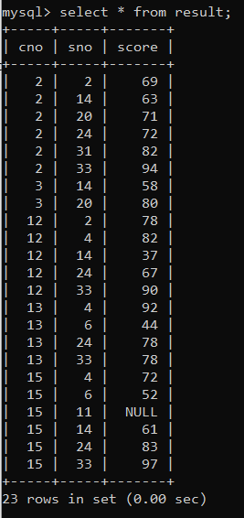

Student table:

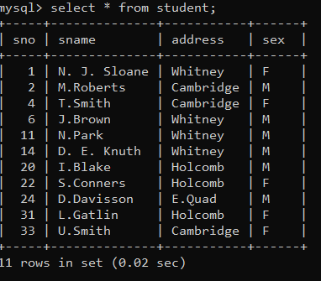

Proving that the Primary Keys are set properly:

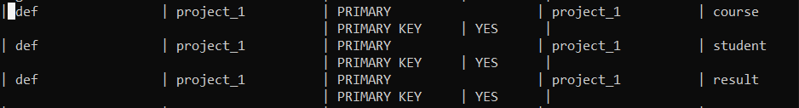

This screen shot was taking from querying the information schema.

Adding Foreign Keys to Result Table:

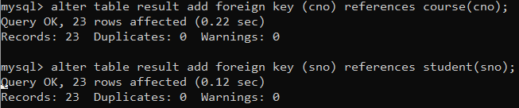

Proving that Foreign Keys are set properly:

