A Software Design Document:
a Brief Template
Timothy A. Gonsalves
Professor, School of Computing & Electrical Engineering
Indian Institute of Technology Mandi
E-mail: tag@iitmandi.ac.in
October 2011
This generic template is intended as a guide for preparation of a brief software design document. The team leader may modify the template to improve the clarity of presentation, or to cater to peculiarities of your product or project.
In the template, we use an example of a hotel reservation system. Text in italics explains the purpose of each sub-section. Text in normal font is the example. Retain the Section headings and replace all the text in each section with your own material.
Use OpenOffice v3 or LibreOffice v3 to edit this document.
This document describes a fictitious software product purely for academic purposes. It is not related in any way to a particular existing or proposed real product. It should not be used for any purpose except as a template of a document. It may be freely used for this purpose.
The BookIt Hotel Reservation System
Design Document
Revision History
Add a row to the table below every time you release a new version of this document. The filename should correspond to the version e.g. Design_Brief_Template_v1_0.odt for the initial version of this document.
Version | Date | Author(s) | Description
v1.0 | 29/10/11 | TAG | Initial version

Table of Contents
1Introduction 1
1.1Design Overview 1
1.2Intended Audience 2
1.3References 2
2Detailed Design 2
2.1Architecture 2
Components 3
Interfaces 3
2.2Algorithms and Data Structures 3
2.3External Data 3
Databases 3
Files 3
2.4Performance 4
2.5Test Scripts 4
2.6Miscellaneous 4
3Appendix A 4
After editing the file, to update the Table of Contents, right-click on the Table of Contents and select “Update Index/Table”.

Introduction
This Section gives a high-level overview of the design of your product or project. It includes an overview of this document.
This document should largely describe your intellectual work. If your work builds on an existing open-source or other platform or product, you are not expected to give the design of that software, except to the extent that it is necessary to explain your work.

Design Overview
Describe the overall design philosophy. Eg, that the product is based on an OSS platform, or that it uses an RDBMS to efficiently handle large amounts of data.
The BookIt system is based on the Apache OFBiz ERP platform (Ref. [2]). OFBiz has no license fee. It is an enterprise-grade, full-fledged ERP and hence will cater to most future requirements of BookIt. OFBiz has a service-oriented architecture (SOA) so can be customised with minimal programming. It has an easy-to-use Web interface for all users, including the hotel staff and the travelling public.

Intended Audience
Who is expected to read this document? When writing, ensure that it will be understandable by the intended audience.
This document is intended for software managers, coders and testers.

References
List documents, papers, books, URLs, etc that are useful for the reader to understand this document in depth. The SRS of this product must be one of the references.
For all references, give the author (if applicable), the title, publisher or source, pages, date. For a URL, give the date on which you last accessed it, as the contents of the URL may be different on other dates. Follow the format given below, or that used in standard professional documents such as CACM, IEEE Computer, etc.
The references should be cited in the text of the subsequent sections using the style (Ref. [3]).
[1] T.A. Gonsalves, The BookIt Hotel Reservation System Requirements Document, IIT Mandi, 26/10/2011.
[2] What is Apache OFBiz?, http://ofbiz.apache.org/, accessed on 29/10/2011.
[3] Wong & Howell, Apache OFBiz Development: The Beginner's Tutorial, Packt Publishing, 2008.
[4] Aaron M. Tenenbaum, Data Structures Using C, Prentice-Hall, 1989

Detailed Design
In Section 2, give a detailed, precise description of how you plan to satisfy the requirements listed in your SRS document. Use diagrams liberally.
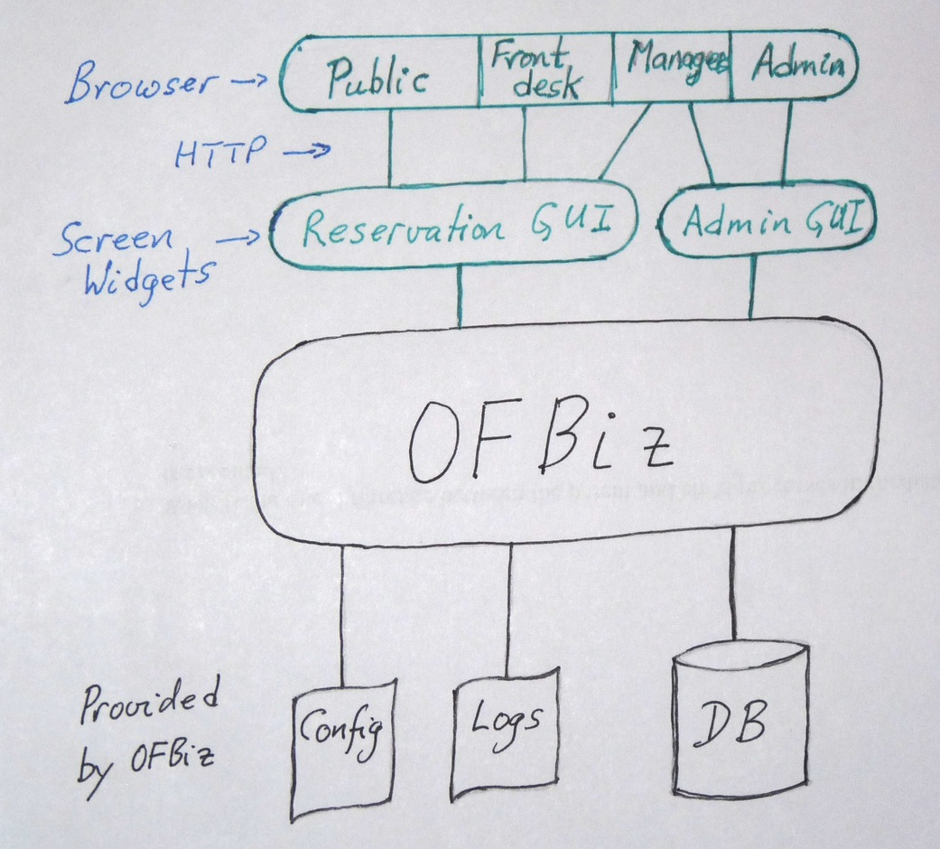
Fig. 1: BookIt Architecture
For rapid implementation and future expansion, the Apache OFBiz ERP is used as the platform for BookIt (Ref. [2]).

Architecture
Draw a block diagram or other pictorial representation of the major components of your project.
The BookIt architecture (Fig. 1) conforms to the multi-tier, service-oriented architecture (SOA) of OFBiz (Ref. [3]). The blocks in black are the pre-existing OSS software. Green blocks are developed as part of this project.

Components
Describe each component. For components designed by you, include salient features such as the programming language, design strategy, etc.
The OFBiz platform is used as-is. Any additional tables are created using the built-in OFBiz entity facility.
The Reservation and Admin GUIs are written as OFBiz Screen Widgets (Ref. [3], Chap. 3). Extensive data validation is done in the Widgets to minimize mistakes made by novice users.
The various categories of users access BookIt through a browser. Authentication is done by OFBiz via username and password for each internal user and for travel agents. The external users (travelling public) access as guests without password. HTTPS is used for security.

Interfaces
Explain the interfaces between the components. Eg, the interface between two components may be messages over TCP, function calls, system calls, XML over HTTP, via a file, etc.
The interface between the brower and the Reservation and Admin GUIs is XML over HTTP. The internal interfaces are as defined by OFBiz.

Algorithms and Data Structures
Describe the important algorithms and data structures used by you. For well-known algorithms, eg Quicksort, refer to a textbook or technical paper. For you own algorithms, give the pseudo-code.
You need not describe internal algorithms and data structures of the underlying OSS platform or product, unless that is necessary to explain your work.
There are no significant algorithms developed for this product. The only important data structure is a hash table used to hold reservation information during data entry (Ref. [4]).

External Data

Databases
This Section is optional. If your product uses a database, describe the schema and the important tables.
BookIt does not directly use any database tables. It creates OFBiz entities. OFBiz automatically creates and maintains the necessary tables for storing these entities.

Files
This Section is optional. List important files for input and output, for configuration, logging, etc. For each file, give a brief description of its purpose and the format of the data in the file.
BookIt uses the configuration and log files of OFBiz. It does not create any additional files.

Performance
Explain how your design is expected to achieve the performance targets set in Section 3.2 of the SRS.
The product will be benchmarked on different entry-level and server-class PCs. This will result in a table giving the PC configuration required for each size of hotel (i.e., number of rooms).

Test Scripts
To test your product/project, you may need to populate tables and files with a large amount of data, to generate input requests, to check whether the output is as expected. As it is tedious to do this manually, it is adviseable to write a number of scripts (Perl, shell, etc) or programmes in C, Java, etc. to automate these tasks. Describe each of these test scripts and programmes here.
The following scripts will be used. To maintain consistency, all scripts access BookIt through HTTP, mimicking a user's browser. All scripts are written in Perl, unless otherwise noted.
SetupHotel.pl: populate the database for a hotel of specified size etc. This also creates the user ids for the front-desk staff, managers and admin staff.
RoomQuery.pl: generates room query requests at a specified rate for a specified duration.
ReserveIt.pl: generates a sequence of reservation and cancellation requests.
CheckIt.pl: verifies the consistency of the database.

Miscellaneous
Anything that is relevant, but does not fit into the above sections. In many cases, this section is omitted.

Appendix A
This is optional. Use for bulky material that is useful for understanding the document, which would interfere with the flow of the document if put in the main body, and is not readily available in some other document. Eg., lists of all the classes, functions and files in the product; list of all fields in messages in an interface; database schema.

