|  |  |  |
| --- | --- | --- |
| **LAB221 Assignment** | **Type:** | **Long Assignment** |
| **Code:** | **J2.L.P0025** |
| **LOC:** | **300** |
| **Slot(s):** | **10** |

**Title: Caro game**

**Background**

Caro (or Gomoku) is an abstract strategy board game and is also called Five in a row. It is traditionally played with go pieces (black and white stones) on a go board (19x19 intersections). This game is known in several countries under different names. In this game, there are two symbols: O and X. Players alternate in placing their symbols on empty intersections. The winner is the first player to get unbroken row of five cells horizontally, vertically, or diagonally.

**Program Specifications and Features**

Caro is a small game that allows two players play over the network. Each player should join the Caro game room with a name. After joining the room, a player can invite the other to play with. The inviting can give a preferred board size (NxN). The invited player should accept the inviting. At the first time, the game will randomly choose who is the X -player right after the invited accepts the inviting. When a game finished, a new game is started with the X-player is set to the player who was O-player in the previous game.

***Expectation of User interface:***

Invite a player

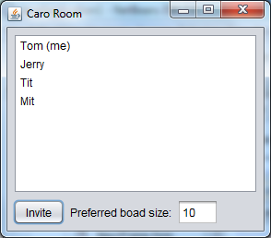

Accept an invitation (Jerry screen)

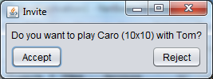

X-player 1st turn screen

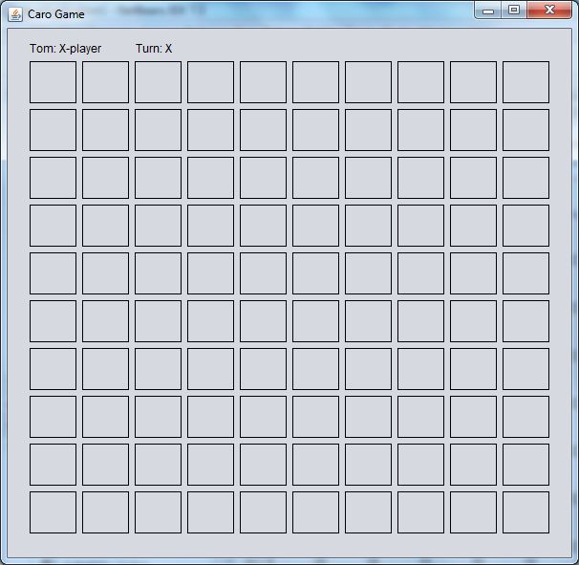

O-player 1st turn screen

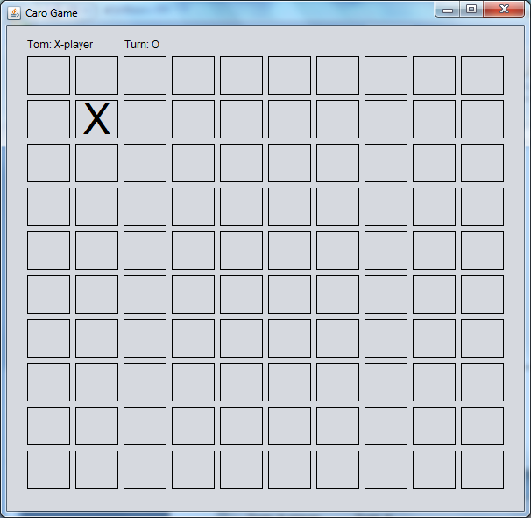

X-player 2nd turn screen

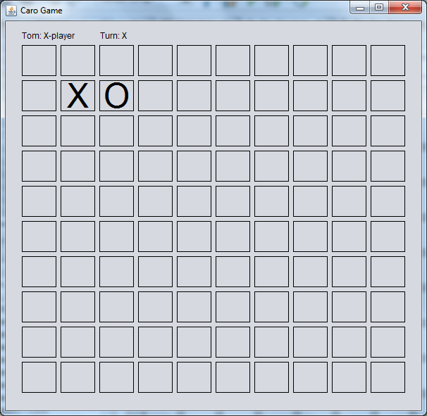

**Guidelines**

-Use ServerSocket, Socket classes

-Use JLabel with border to create a grid of cells, change the font size of labels.