ALY6015: Intermediate Analytics

Northeastern University
VLADIMIR SHAPIRO
Team Project: Draft Report

INTRODUCTION
In this project, our primary focus is on sports analytics, specifically in the context of predicting player wages and analyzing the factors that significantly impact a player’s overall rating. By understanding these aspects, we can gain valuable insights into player valuation and performance evaluation in the sports industry.
Q1: Predicting a player’s wage based on their attributes and personal data To answer this question, we aim to develop a predictive model that can estimate a player’s wage using their attributes and personal data. The attributes may include factors such as age, overall rating, market value, nationality, position, and other relevant information. M1: Our chosen method for this analysis is Ridge Regression. Ridge Regression is a suitable technique as it addresses the issue of overfitting by adding a penalty term to the loss function. By incorporating the attributes into the model, we can train it to accurately predict a player’s wage. The dataset will be divided into training and testing sets, and cross-validation techniques will be applied to optimize the model’s performance. Tuning the regularization parameter (alpha) will help strike a balance between bias and variance, resulting in a more robust and accurate wage prediction model.
Q2: Analyzing factors that have the most significant impact on a player’s overall rating To answer this question, we aim to identify the factors that have the most significant influence on a player’s overall rating. This analysis will help us understand the key contributors to a player’s performance evaluation. M1: For this task, we will employ the Generalized Linear Model (GLM) analysis. GLM allows us to analyze the relationship between a player’s overall rating and various factors, including age, nationality, position, and specific attributes like pace, shooting, passing, and more. By examining these factors and their coefficients, we can determine the relative importance and significance of each factor in determining a player’s overall rating.
Through these analyses, we can provide valuable insights to sports organizations, agents, and talent scouts, enabling them to make informed decisions regarding player wages and performance evaluation.
ANALYSIS

Exploratory Data Analysis (EDA)
#Import the data
players_22 <- read_csv(
"/Users/mia/Downloads/players_22.csv"
)

# Specify the variables we want to keep
selected_vars <- c(
"wage_eur"
,
"age"
,
"short_name"
,
"value_eur"
,
"overall"
,
"nationality_name"
,
"player_positions"
,
"shooting"
)
# Create a new dataset with only the selected variables
selected_data <- players_22[, selected_vars]
# Remove rows with any missing values
data_complete <- na.omit(selected_data)

sorted_table <- data_complete %>%
arrange(desc(wage_eur))
sorted_table %>%
kbl(caption =
"Table1.Summary of the players with their attributes"
)
%>%
kable_classic(full_width =
F
, html_font =
"Cambria"
)
%>%
scroll_box(height =
"300px"
)
Table1.Summary of the players with their attributes
wage_eur
age
short_name
value_eur
overall
nationality_name
player_positions
shooting
350000 30 K. De Bruyne 125500000 91 Belgium CM, CAM 86
350000 | 33 K. Benzema 66000000 89 France CF, ST 86
320000 | 34 L. Messi 78000000 93 Argentina RW, ST, CF 92
310000 | 29 Casemiro 88000000 89 Brazil CDM 73
310000 | 31 T. Kroos 75000000 88 Germany CM 81
290000 | 26 R. Sterling 107500000 88 England LW, RW 82
270000 | 32 R. Lewandowski 119500000 92 Poland ST 92
270000 | 36 Cristiano Ronaldo 45000000 91 Portugal ST, LW 94
270000 | 29 Neymar Jr 129000000 91 Brazil LW, CAM 83
270000 | 29 S. Mané 101000000 89 Senegal LW 83
270000 | 29 M. Salah 101000000 89 Egypt RW 87
260000 28 R. Lukaku 93500000 88 Belgium ST 87
summary(data_complete)

## wage_eur age short_name value_eur
## Min. : 500 Min. :16.00 Length:17041 Min. : 15000
## 1st Qu.: 1000 1st Qu.:21.00 Class :character 1st Qu.: 525000
## Median : 3000 Median :25.00 Mode :character Median : 1000000
## Mean : 9355 Mean :25.07 Mean : 2965082
## 3rd Qu.: 9000 3rd Qu.:28.00 3rd Qu.: 2100000
## Max. :350000 Max. :39.00 Max. :194000000
## overall nationality_name player_positions shooting
## Min. :47.00 Length:17041 Length:17041 Min. :18.00
## 1st Qu.:62.00 Class :character Class :character 1st Qu.:42.00
## Median :66.00 Mode :character Mode :character Median :54.00
## Mean :65.93 Mean :52.33
## 3rd Qu.:70.00 3rd Qu.:63.00
## Max. :93.00 Max. :94.00
Obsversations:
The table titled “Summary of the players with their attributes” provides valuable insights into the attributes of various players. The wage distribution among the players showcases a range from 270,000 EUR to 350,000 EUR, reflecting the diversity in their earnings. Additionally, the age of the players spans from 26 to 36 years old, indicating a mix of experienced and relatively younger individuals. Notable names in the table include K. De Bruyne, K. Benzema, L. Messi, Casemiro, T. Kroos, R. Sterling, R. Lewandowski, Cristiano Ronaldo, Neymar Jr, and S. Mané, each contributing their unique skills and abilities to their respective teams. The market value, represented by the “value_eur” column, showcases a range from 45,000,000 EUR to 129,000,000 EUR, indicating the perceived worth of these players in the market. The overall rating column provides an insight into their overall performance, with ratings ranging from 88 to 93, highlighting their exceptional capabilities. Moreover, the players hail from various nationalities, including Belgium, France, Argentina, Brazil, Germany, England, Poland, and Portugal, showcasing the global diversity of talent.
The “player_positions” column illustrates the diverse roles and positions these players occupy on the field. These positions include CM, CAM, CF, ST, RW, LW, CDM, and CAM, demonstrating their versatility and adaptability. Finally, the “shooting” attribute values range from 73 to 94, suggesting varying levels of expertise in their shooting abilities..

# Set up a nice plot layout
par(mar = c(
5
,
4
,
4
,
6
))

# Adjust margin size
# Create a scatter plot of Wage vs. Age
plot(data_complete$age, data_complete$wage_eur,
xlab =
"Age"
, ylab =
"Wage (EUR)"
, main =
"Figure1. Relationship between age and wage"
,
col =
"red"
, pch =
16
)
legend(
"topright"
, legend = c(
"Outliers"
)
, pch =
20
, col =
"red"
, pt.cex =
1.2
, bty =
"n"
)
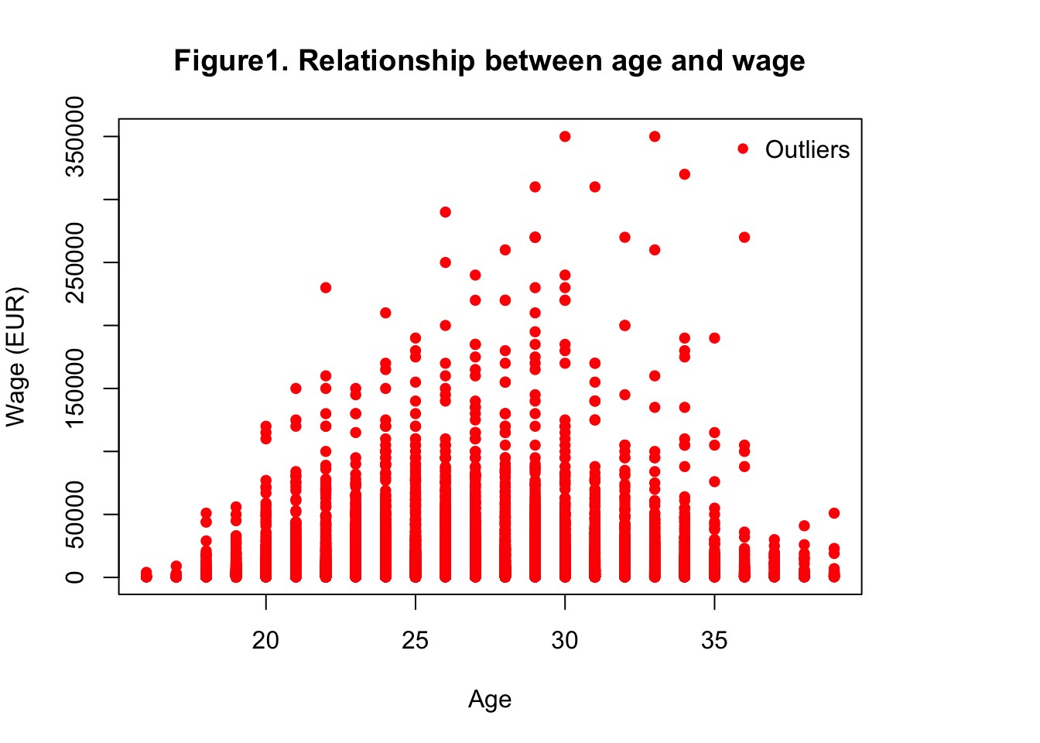
Obsersations:
The scatter plot of Wage vs. Age reveals a general trend where player wages tend to be higher during their late twenties and early thirties. However, as players enter their mid-thirties, there is a slight decrease in wages. The plot also includes outliers representing exceptional cases where players earn significantly higher or lower wages compared to their age group.
Goal (Business Question) #1: Predicting a player’s wage based on their attributes and personal data.
Motivation: The prediction of player wages is crucial for sports organizations, agents, and talent scouts when negotiating contracts and making financial decisions. By accurately estimating a player’s wage based on their attributes and personal data, stakeholders can make informed decisions and ensure fair compensation.
Research and Development: To tackle this business question, we will leverage a machine learning approach called Ridge Regression. Ridge Regression is suitable for predicting a player’s wage as it addresses the issue of overfitting by introducing a penalty term to the loss function. This regularization technique helps in achieving a more robust and accurate model.

# Select only the numeric variables
numeric_vars <- c(
"wage_eur"
,
"age"
,
"value_eur"
,
"overall"
)
numeric_data <- data_complete[, numeric_vars]
# Print the correlation matrix
cor_plot <- ggcorr(numeric_data,
nbreaks =
6
,
label =
TRUE
,
label_size =
3
,
color =
"grey50"
)
cor_plot <- cor_plot + labs(caption =
"Figure2.Correlation Matrix Plot"
)
print(cor_plot)
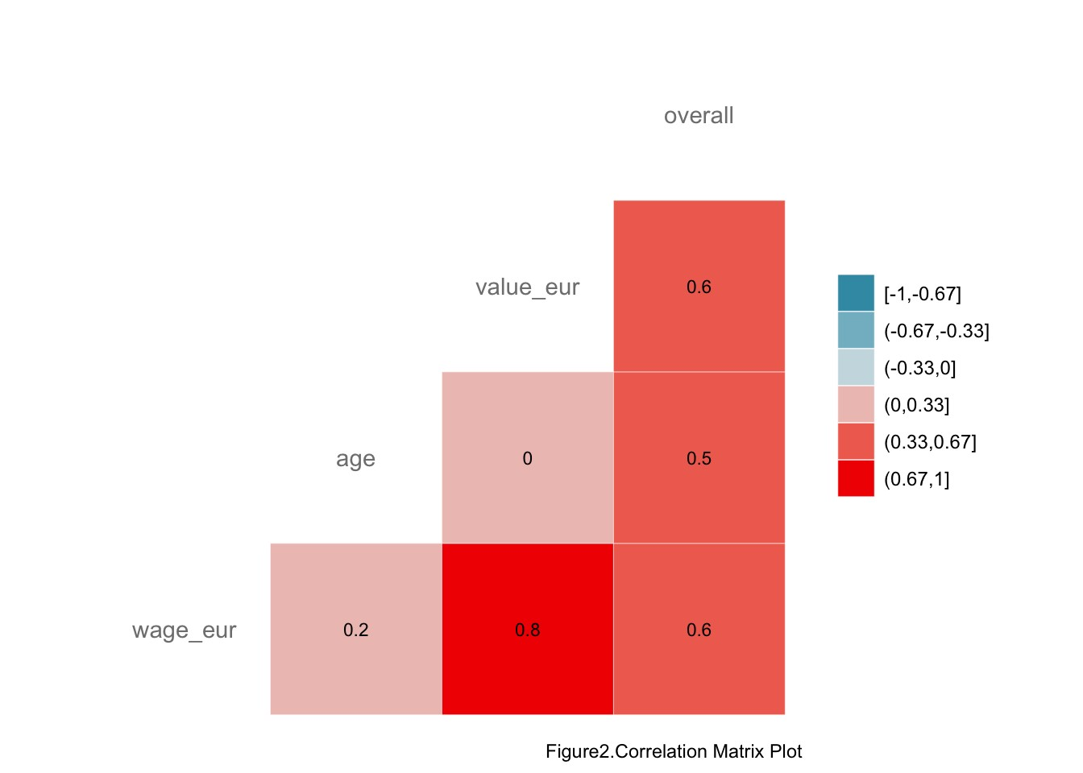
The development process involves the following steps:
Table 2.Model Evaluation Metrics

Metric Value
Mean Squared Error (MSE) | 9.498579e+07
Root Mean Squared Error (RMSE) 9.746065e+03
R-squared | 7.291393e-01

Obsversations

The output provided represents the evaluation metrics for the Ridge Regression model used to predict player wages based on their attributes and personal data.
# Split the dataset into training and testing sets
set.seed(
123
)

# Set a seed for reproducibility
trainIndex <- createDataPartition(data_complete$wage_eur, p =
0.7
, list =
FALSE
)
trainData <- data_complete[trainIndex, ]
testData <- data_complete[-trainIndex, ]
# Perform Ridge Regression
model <- glmnet(x = as.matrix(trainData[, c(
"age"
,
"overall"
,
"value_eur"
)])
,
y = trainData$wage_eur,
alpha =
0
,
# Ridge Regression
standardize =
TRUE
)
# Choose the optimal lambda value using cross-validation
cvModel <- cv.glmnet(x = as.matrix(trainData[, c(
"age"
,
"overall"
,
"value_eur"
)])
,
y = trainData$wage_eur,
alpha =
0
,
# Ridge Regression
standardize =
TRUE
)
# Retrieve the optimal lambda value
optimalLambda <- cvModel$lambda.min
# Train the final model using the optimal lambda value
finalModel <- glmnet(x = as.matrix(trainData[, c(
"age"
,
"overall"
,
"value_eur"
)])
,
y = trainData$wage_eur,
alpha =
0
,
# Ridge Regression
standardize =
TRUE
,
lambda = optimalLambda)
# Make predictions on the testing set
predictions <- predict(finalModel, newx = as.matrix(testData[, c(
"age"
,
"overall"
,
"value_eur"
)])
, s = optimalLambda
)
# Model Evaluation
mse <- mean((predictions - testData$wage_eur)^
2
)
rmse <- sqrt(mse)
r_squared <- cor(predictions, testData$wage_eur)^
2
# Create a table for evaluation metrics
evaluation_table <- data.frame(
Metric = c(
"Mean Squared Error (MSE)"
,
"Root Mean Squared Error (RMSE)"
,
"R-squared"
)
,
Value = c(mse, rmse, r_squared)
)
# Format the table using kable
table_formatted <- kable(evaluation_table, align =
"c"
, caption =
"Table 2.Model Evaluation Metrics"
)
%>%
kable_styling(bootstrap_options = c(
"striped"
,
"hover"
))
table_formatted
- Mean Squared Error (MSE): 9.4985789\times 10^{7}
MSE is a measure of the average squared difference between the predicted and actual wage values. In this case, the MSE value of 94985789 suggests that, on average, the squared difference between the predicted and actual wages is quite large. A lower MSE indicates better model performance.
- Root Mean Squared Error (RMSE): 9746.065
RMSE is the square root of the MSE and provides a measure of the average difference between the predicted and actual wage values. In this case, the RMSE value of 9746.065 indicates that, on average, the predicted wage values deviate by approximately $9746.065 from the actual wage values. A lower RMSE indicates better model performance.
- R-squared: 0.729
R-squared, also known as the coefficient of determination, measures the proportion of the variance in the dependent variable (wage) that can be explained by the independent variables (attributes and personal data). In this case, the R-squared value of 0.7291393 indicates that approximately 72.9% of the variance in the player wages can be explained by the model. A higher R-squared value suggests better predictive power.
Overall, the evaluation metrics provide insights into the performance of the Ridge Regression model. While the model explains a significant portion of the wage variance (as indicated by the R-squared value), there is room for improvement, as evidenced by the relatively high MSE and RMSE values. Fine-tuning the model or considering additional variables may help enhance its performance.
Goal (Business Question) #2: Analyzing factors that have the most significant impact on a player’s overall rating. Q2: Analyzing factors that have the most significant impact on a player’s overall rating To answer this question, we aim to identify the factors that have the most significant influence on a player’s overall rating. This analysis will help us understand the key contributors to a player’s performance evaluation. M1: For this task, we will employ the Generalized Linear Model (GLM) analysis. GLM allows us to analyze the relationship between a player’s overall rating and various factors, including age, nationality, position, and specific attributes like pace, shooting, passing, and more. By examining these factors and their coefficients, we can determine the relative importance and significance of each factor in determining a player’s overall rat
Motivation: Player’s overall rating is the most intuitive display of player’s performance. According to the player’s performance score, it can be clearly concluded that the overall level of each player has changed and which players have more comprehensive skills. In addition, the player’s performance score helps fans and clubs assess the player’s status and value.
Research and Development: To tackle this business question, we will leverage feature selection method to determine an optimal model. Generalized Linear Model (GLM) analysis is suitable for analyze the relationship between a player’s overall rating and various factors as it determine the extent to which each of these factors contributes to the player’s overall rating. The stepwise selection method is considered to be used to get the variables effectively.

# Select variables
selected_vars2 <- c(
"overall"
,
"age"
,
"skill_moves"
,
"international_reputation"
,

"pace"
,
"shooting"
,
"passing"
,

"dribbling"
,
"defending"
,
"physic"
)
# Subset dataframe based on selected_vars
df_selected2 <- players_22[, selected_vars2]
# Remove rows with NA values
vars_selected2 <- na.omit(df_selected2)
# Print the correlation matrix
cor_plot2 <- ggcorr(vars_selected2,
nbreaks =
6
,
label =
TRUE
,
label_size =
3
,
color =
"grey50"
)
cor_plot21 <- cor_plot2 + labs(caption =
"Figure3.Correlation Matrix Plot"
)
print(cor_plot21)

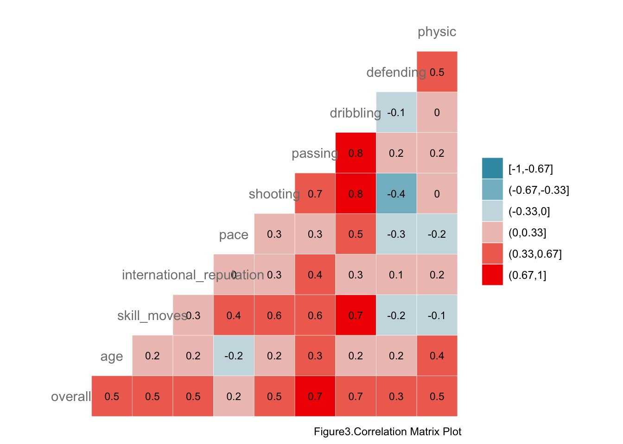
# Split the dataset into training and testing sets
set.seed(
123
)

trainIndex2 <- createDataPartition(vars_selected2$overall, p =
0.7
, list =
FALSE
)
trainData2 <- vars_selected2[ trainIndex2, ]
testData2 <- vars_selected2[-trainIndex2, ]
# perform generalized linear model
full_model <- glm(overall ~ age + skill_moves + international_reputation + pace + shooting + passing + dribbling + defending + physic, data = trainData2, fa
mily = gaussian())
summary(full_model)
The development process involves the following steps:


##
## Call:
## glm(formula = overall ~ age + skill_moves + international_reputation +
## pace + shooting + passing + dribbling + defending + physic,
## family = gaussian(), data = trainData2)
##
## Deviance Residuals:
## Min 1Q Median 3Q Max
## -10.6547 -2.1753 -0.1738 2.0819 14.8390
##
## Coefficients:
## Estimate Std. Error t value Pr(>|t|)
## (Intercept) 12.434352 0.324978 38.262 < 2e-16 ***
## age 0.129137 0.007667 16.843 < 2e-16 ***
## skill_moves 0.875384 0.063732 13.735 < 2e-16 ***
## international_reputation 2.757811 0.085440 32.278 < 2e-16 ***
## pace 0.018268 0.003478 5.253 1.52e-07 ***
## shooting 0.030966 0.004572 6.772 1.33e-11 ***
## passing 0.029149 0.007156 4.073 4.67e-05 ***
## dribbling 0.328585 0.008041 40.862 < 2e-16 ***
## defending 0.093795 0.003391 27.660 < 2e-16 ***
## physic 0.232465 0.004053 57.349 < 2e-16 ***
## ---
## Signif. codes: 0 '***' 0.001 '**' 0.01 '*' 0.05 '.' 0.1 ' ' 1
##
## (Dispersion parameter for gaussian family taken to be 9.978133)
##
## Null deviance: 553215 on 11976 degrees of freedom
## Residual deviance: 119408 on 11967 degrees of freedom
## AIC: 61553
##
## Number of Fisher Scoring iterations: 2
# Perform stepwise regression
step_model <- glm(overall~., data = trainData2) %>% stats::step(direction =
"both"
)


## Start: AIC=61553.09
## overall ~ age + skill_moves + international_reputation + pace +
## shooting + passing + dribbling + defending + physic
##
## Df Deviance AIC
## <none> 119408 61553
## - passing 1 119574 61568
## - pace 1 119684 61579
## - shooting 1 119866 61597
## - skill_moves 1 121291 61738
## - age 1 122239 61832
## - defending 1 127042 62293
## - international_reputation 1 129804 62551
## - dribbling 1 136069 63115
## - physic 1 152226 64459
summary(step_model)


##
## Call:
## glm(formula = overall ~ age + skill_moves + international_reputation +
## pace + shooting + passing + dribbling + defending + physic,
## data = trainData2)
##
## Deviance Residuals:
## Min 1Q Median 3Q Max
## -10.6547 -2.1753 -0.1738 2.0819 14.8390
##
## Coefficients:
## Estimate Std. Error t value Pr(>|t|)
## (Intercept) 12.434352 0.324978 38.262 < 2e-16 ***
## age 0.129137 0.007667 16.843 < 2e-16 ***
## skill_moves 0.875384 0.063732 13.735 < 2e-16 ***
## international_reputation 2.757811 0.085440 32.278 < 2e-16 ***
## pace 0.018268 0.003478 5.253 1.52e-07 ***
## shooting 0.030966 0.004572 6.772 1.33e-11 ***
## passing 0.029149 0.007156 4.073 4.67e-05 ***
## dribbling 0.328585 0.008041 40.862 < 2e-16 ***
## defending 0.093795 0.003391 27.660 < 2e-16 ***
## physic 0.232465 0.004053 57.349 < 2e-16 ***
## ---
## Signif. codes: 0 '***' 0.001 '**' 0.01 '*' 0.05 '.' 0.1 ' ' 1
##
## (Dispersion parameter for gaussian family taken to be 9.978133)
##
## Null deviance: 553215 on 11976 degrees of freedom
## Residual deviance: 119408 on 11967 degrees of freedom
## AIC: 61553
##
## Number of Fisher Scoring iterations: 2
# Predict on the test data using the final model
predictions2 <- predict(step_model, newdata = testData2)
# Model Evaluation
mse2 <- mean((testData2$overall - predictions2)^
2
)
rmse2 <- sqrt(mse2)
r_squared2 <- cor(predictions2, testData2$overall)^
2
# Create a table for evaluation metrics
evaluation_table2 <- data.frame(
Metric = c(
"Mean Squared Error (MSE)"
,
"Root Mean Squared Error (RMSE)"
,
"R-squared"
)
,
Value = c(mse2, rmse2, r_squared2)
)
# Format the table using kable
table_formatted2 <- kable(evaluation_table2, align =
"c"
, caption =
"Table 3.Model Evaluation Metrics"
)
%>%
kable_styling(bootstrap_options = c(
"striped"
,
"hover"
))
table_formatted2
Table 3.Model Evaluation Metrics
Metric Value
Mean Squared Error (MSE) | 9.958295
Root Mean Squared Error (RMSE) 3.155677
R-squared | 0.779160

Obsversations
The output provided represents the evaluation metrics for the generalized linear model used to predict players’ overall score based on their attributes and personal data.
1. Mean Squared Error (MSE): 9.9582948
The MSE is 9.958295, which implies there is a certain level of error in the predictions, although without a benchmark model for comparison, it’s hard to assess whether this is high or low. 2. Root Mean Squared Error (RMSE): 3.16
The RMSE is 3.16 which means that on average, the prediction of the model is about 3.16 scores away from the actual values.
3. R-squared: 0.779
An R-squared of 0.779 indicate that the model has a relatively high explanatory power. An R-squared of 0.779 means that about
77.9% of the variability in the player’s overall score can be explained by the features in the model.
Overall, the use of generalized linear model and stepwise model shows that all selected variables are suitable to predict players’ overall score. According to the R-squared value, the prediction model is convincible. From the RMSE, the results of the prediction is accurate. It can be speculated that add additional variables might enhance the model’s performance.

