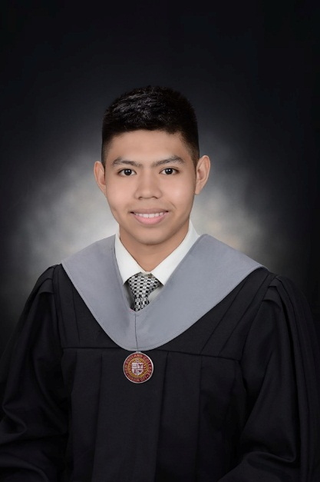

RYAN PHILIP T. HERNANDEZ

**Email:** [ryanphilip0101@gmail.com](mailto:ryanphilip0101@gmail.com)

**Contact No.** 09652363292

**Address:** 12 cattleya street

Barangay Bahay Toro Quezon City

**OBJECTIVE**

A fresh graduate who want to seek for a position in a stable company that could uphold my skills and knowledge, give me the opportunity for growth and development and widen my experience.

**EXPERIENCE**

**Arellano University Mandaluyong Plaridel Campus**

53 New Panaderos Ext, Mandaluyong, 1550 Metro Manila

**INTERN**

* Facilitating in Computer laboratories
* Troubleshooting computers

**Incuventure Partners Corporation (January 2019-May 2019)**

12/F, Unit 1237-07 Times Plaza Building, United Nations Avenue cor. Taft Avenue, Ermita Manila

**INTERN**

* **Design and developed user-friendly website using html, css, javascript and bootstrap for front-end**
* **PHP and MySQL for back-end**

**SKILLS**

|  |  |
| --- | --- |
| * Oriented in HTML5 * Oriented in CSS3 * Oriented in Bootstrap4 * Oriented in WordPress * Oriented in PHP and MySQL * Oriented in JavaScript | Oriented in Microsoft Office such as:   * MS Word * MS Power point * MS Access |
|  |  |

**TRAININGS ATTENDED**

**AMERICAN TESOL INSTITUTE PHILIPPINES**

Certificate of Training to Creative Web Design

Nov 5 – Nov 11, 2018

707 Shaw Blvd. Brgy Kapitolyo, Pasig City

**AMERICAN TESOL INSTITUTE PHILIPPINES**

Certificate of Training to Web Development Level III

Nov 22 – Dec 12, 2018

707 Shaw Blvd. Brgy Kapitolyo, Pasig City

**SEMINAR ATTENDED**

**OVERVIEW OF THE BIG DATA AND BUSINESS ANALYTICS**

March 3, 2018

Held at NEC Computer Lab

**CHALLENGES AND TRENDS IN THE DIGITAL WORLD 2018**

January 30, 2018

Held at Adamson University Theatre

**EDUCATIONAL BACKGROUND**

**Tertiary:** New England College

40 Quezon Ave, Quezon City, 1113 Metro Manila

BS Information Technology

2015 - 2019

**Secondary:** Ernesto Rondon High School

146 Rd 3, Project 6, Quezon City, 1100 Metro Manila

2011 – 2015

**Primary:** Project 6 Elementary School

24 Rd 7, Project 6, Quezon City, Metro Manila

2005 - 2011

**PERSONAL INFORMATION**

Age: 19 years old

Birthday: February 1, 1999

Birthplace: Quezon City

Status: Single

Religion: Catholic