Ryszard Czekaj

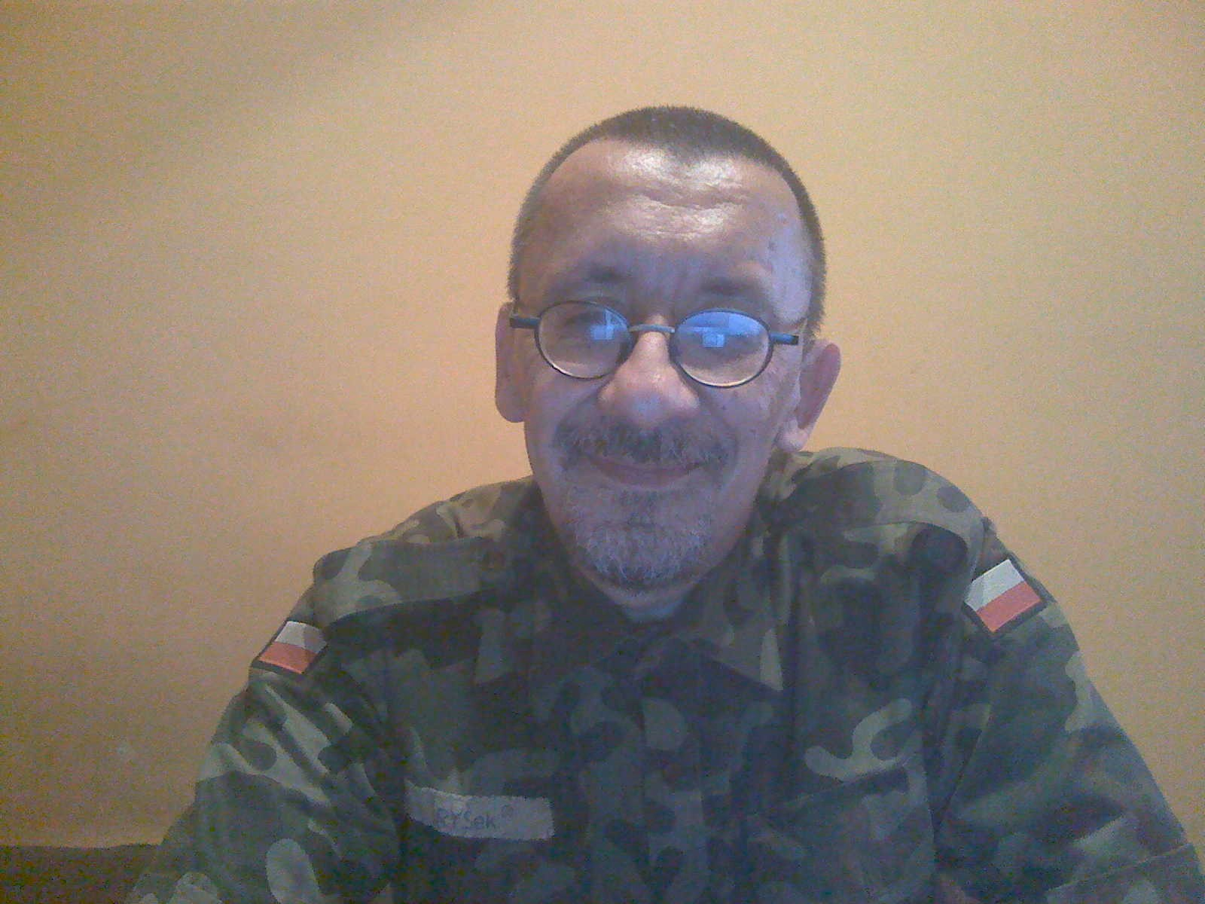

Teacher of engineering, computer scientist, programmer, handyman with passion. Practical knowledge of construction and administration of computer networks supported by gaining concession in 1997 from the Ministry of Communications to provide telecommunications services No 274/97/I. Extensive experience in designing and developing software from separate, specific applications to complex network systems using available libraries, SQL and other solutions in several programming languages. Ability to work in a team in an international environment. Support for electric tools, machinery and equipment, the assembly works as well as of electrical appliances, soldering. Independence, resistance to stress and ready to relocate.

# Experience

10.2010–now DD1Studio Advanced Programming, working remotly

Developing WWW services with PHP language [(http://dd1studio.com/)](http://dd1studio.com/))

07.2009–

12.2009

10.2007–

12.2007

06.2006–

03.2007

SBA Euro & Axell, The Netherlands

Van Happen Containers [(http://www.vanhappencontainers.nl/)](http://www.vanhappencontainers.nl/)), De Rooy [(http://www.deroo](http://www.derooy.com/))y[.com/),](http://www.derooy.com/)) Opstalan, Kaasmakerij de Jong [(http://www.goatcheese.nl/)](http://www.goatcheese.nl/))

World Wide Staffing, The Netherlands, SoFi: 2679.53.185

Elephant Dekker [(http://www.dekkerhout.nl/)](http://www.dekkerhout.nl/))

JobServer, Denmark, CPR: 030270-2683 DanSystem Industri [(http://www.dansy](http://www.dansystemindustri.dk/))s[temindustri.dk/),](http://www.dansystemindustri.dk/)) Frigoscandia [(http://www.frigoscandia.dk/)](http://www.frigoscandia.dk/)), T. Hansen Gruppen [(http://www.thansen.dk/)](http://www.thansen.dk/))

01.2004–now Freelancer

06.2002–

12.2003

IT expert, AKSEL-NET,

44-207 Rybnik, ul. Lipowa 17, Poland

Network administrator, IT systems analyst and developer, dispatcher apps programmer for Kenwood and Motorola radios, webmaster. <http://www.aksel.com.pl/>

09.2000–

08.2001

06.1997–

02.2000

09.1995–

08.1996

Teacher, Zespół Szkół Liceum Ogólnokształcące, 44-280 Rydułtowy, ul. Skalna 1, Poland

Teaching in secondary school. <http://www.zsp1rydultowy.internetdsl.pl/>

Own economic in IT and Internet networking, ”RYCHo Ryszard Czekaj Usługi Informatyczne i Internetowe” ,

40-005 Katowice, Aleja Korfantego 8/145, Poland

Working for DEMO s.c. in Katowice I have created and was directing of internet network section of company: [www.demo.pl,](http://www.demo.pl/) teaching in Private Higher School of IT and Economics ”PPSIE NOVUM”, professional courses. <http://www.demo.pl/>

Teacher, Zespół Szkół Elektronicznych,

41-200 Sosnowiec, ul. Jagiellońska 13, Poland

Teaching in secondary school. <http://elektronik.zse.edu.pl/>

# Driver license

12.07.1988 B 04255/01/2415

# Computer skills

OS Mac OS X, Unix (FreeBSD, Linux), Novell,

Microsoft Windows

programming Assembler, Basic, C/C++,

Pascal (Delphi), PHP

administration Apache, Sendmail, Postfix,

Samba, Bind

scripting Perl, Shell, sed, awk

graphic Corel Draw, Gimp typography LATEX

web design Web 2.0 database MySQL, PostgreSQL, Fi- rebird

# Education

1990–1996 Master of Science in Information Technology,

University of Silesia in Katowice [http://www.us.edu.pl/,](http://www.us.edu.pl/) Department of Engineering Sciences in Sosnowiec <http://www.wiinom.us.edu.pl/>

1985–1990 Secondary school, „1st LO Wodzisław Śląski”,

<http://www.lo1-wodzislaw.net/>

1976–1985 Elementary school, <http://zsp7wodzislawslaski.smarthost.pl/zsp7/>

# Master thesis

title Emulation of printer and plotter in graphic mode („Emulacja dru- karki i plotera w trybie graficznym”) <http://rychoo.freeshell.net/mgr/>

supervisors prof. dr hab. inż. Dariusz Badura and mgr Ireneusz Gościniak

description Study of the complex design of a software emulating printer and plotter with their various languages on the graphic screen made with the first Bor- land 32–bit compiler for MS Windows in C++. In written part description about contemporary devices and study of object method for analysis and interpreting device language with plain text drivers.

# Languages

Polish native

English very good Not perfect but good enough for working in Denmark and

in the Netherlands. A language I’m using reading documentation and surfing Internet.

Russian poor Many journeys in Russian speaking countries.

German elementary Taking classes at the time of study.

# Interests

social skills and competences

I’m an Internet fan, as a technique for connecting computers using TCP/IP, and as a sociocultural phenomena connecting people ([http://www.facebook.com/ryszard.czekaj).](http://www.facebook.com/ryszard.czekaj)) You can say about me ”BSD guru”, I’m using network actively and have its own website where I test my ideas ([http://RYCHoo.TheUnixPlace.com/).](http://RYCHoo.TheUnixPlace.com/)) Work during studies at the radio (part-time): Students’ Radio «ORS Centrum» in Gliwice, Radio

«Rezonans» in Sosnowiec, Radio «Silesia FLASH» in Gliwice, Poland, as broadcast leader and sound engineer. I also helped at those times in organization of the students’ ”juwenalia” as a program manager.

hobby Music and even sometimes playing guitar. In spare time tourism.