Europass Curriculum Vitae

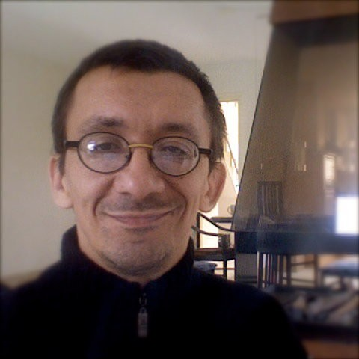

# Personal information

Name / Surname

Address Telephone Personal Email

Nationality Date of birth

Gender

# Czekaj Ryszard

Plac Zwycie˛ stwa, 44-300 Wodzisław S´ la˛ski, Poland (+48) 32 4555 988 mobile: (+48) 882 723907

[rycho@DD1Studio.com](mailto:rycho@DD1Studio.com) Polish

3*th* February 1970 male

# Desired employment/ Occupational field

**Work experience**

Dates Occupation or position held

Main activities and responsibilities Name and address of employer

## WWW

Dates Occupation or position held

Main activities and responsibilities Name and address of employer

## WWW

Dates Occupation or position held

Main activities and responsibilities Name and address of employer

## WWW

Dates Occupation or position held

# Engineering, Information Technology and Telecommunication

2010–now

Developer in PHP language

Various remote works with WWW services

DD1Studio Advanced Programming, Registered in Ireland CRO 391436 <https://DD1Studio.com/>

2009

Workman in The Netherlands: Van Happen Containers [(http://www.vanhappencontainers](http://www.vanhappencontainers.nl/).nl/), De Rooy [(http://www.derooy.com/),](http://www.derooy.com/) Opstalan, Kaasmaker[U+0133] de Jong [(http://www.goatcheese.nl/)](http://www.goatcheese.nl/))

Various positions in jobs as flexible worker

Axell employment, J. Asselbergsweg 70 5026 RR Tilburg <https://workataxell.nl/>

2007

Workman in The Netherlands: Elephant Dekker [(http://www.dekkerhout.nl/)](http://www.dekkerhout.nl/) SoFi: 2679.53.185 woodworks, selecting, sorting and packing beams of timber after machine–tool for Elephant Dekker World Wide Staffing, Schinkeldijkje 2b, 1432 Aalsmeer, The Netherlands

<http://www.wwstaffs.com/> 2006–2007

Workman in Denmark: DanSystem [(http://www.dansystemindustri.dk/),](http://www.dansystemindustri.dk/) Frigoscandia [(http://www.frigoscandia.dk/),](http://www.frigoscandia.dk/) T. Hansen [(http://www.thansen.dk/)](http://www.thansen.dk/) CPR: 030270-2683

Main activities and responsibilities

Name and address of employer

## WWW

Dates Occupation or position held

Main activities and responsibilities Name and address of employer Type of business or sector

## WWW

Dates Occupation or position held Name and address of employer Type of business or sector

## WWW

Dates Occupation or position held

Main activities and responsibilities

Name and address of employer Type of business or sector

## WWW

Dates Occupation or position held Name and address of employer Type of business or sector

WWW

# Education and training

Dates Title of qualification awarded

Master’s thesis Principal subjects/Occupational skills

covered

Name and type of organisation providing education and training

Dates Principal subjects/Occupational skills

covered

Name and type of organisation providing education and training

Dates Title of qualification awarded Principal subjects/Occupational skills

covered

Name and type of organisation providing education and training

assembling steel constructions, mounting equipment of pig–shed, building silo for DanSystem Industri; composing orders on truck in warehouse freezer Frigoscandia; workman in car equipment store, fitting up tires for T. Hansen Gruppen; driver

JobServer ApS, Petersmindevej 2; 5000 ODENSE C, Denmark <http://www.tnspolska.pl/>

2002–2003

IT expert

network administrator, IT systems analyst and developer, programmer, webmaster AKSEL-NET Sp. z o.o., 44-207 Rybnik, ul. Lipowa 17

electronic and telecommunication <http://www.aksel.com.pl/> 2000–2001

IT Teacher

Zespół Szkół Liceum Ogólnokształca˛ce, 44-280 Rydułtowy, ul. Skalna 1 education

<http://www.zsp1rydultowy.internetdsl.pl/> 1997–2000

Own economic in IT and Internet networking (”RYCHo Ryszard Czekaj Usługi Informatyczne i Interne- towe” REGON: 273553687)

installation and administration of Internet network [http://www.demo.pl/,](http://www.demo.pl/) teaching in Private Higher School of IT and Economics ”PPSIE NOVUM”, professional courses

working for Os´rodek Szkolenia Informatycznego DEMO s.c. w Katowicach education and networking

<http://www.demo.pl/> 1995–1996

Teacher

Zespół Szkół Elektronicznych, 41-200 Sosnowiec, ul. Jagiellon´ska 13 education

<http://elektronik.zse.edu.pl/>

1992–1996

Master of Science in University Degree

”Emulation of Printer and Plotter in Graphic Mode” („Emulacja drukarki i plotera w trybie graficznym”)

Engineering Teacher

”Department of Engineering Sciences” in Sosnowiec at ”University of Silesia” Katowice, Poland 1990–1992

Mining Electrification and Automatic Control

”Faculty of Mining and Geology” at ”The Silesian University of Technology” Gliwice 1985–1990

Grammar–school

mathematical and physical class

„I Liceum Ogólnokształca˛ce” in Wodzisław S´ la˛ski

# Personal skills and competences

Mother tongue Other language(s)

*Self-assessment*

*European level*(*)

**English Russian German**

Technical skills and

competences

Driving licence(s)

# Polish

|  |  |  |  |  |
| --- | --- | --- | --- | --- |
| **Understanding** | | **Speaking** | | **Writing** |
| Listening | Reading | Spoken interaction | Spoken production |
| good | good | good | good | good |
| good | good | good | poor | poor |
| poor | poor | poor | poor | poor |

(*) *Common European Framework of Reference* (CEF) level

Strong background as programmer or analyst developing, testing and documenting software. Designed and built of demo.pl network (WAN TCP/IP). Experiences with operating systems (Unix, Mac OS X, Microsoft, Novell), networks and Internet security. Using a great many software fluently (user, LATEX, tools, SQL databases). Good knowledge of wire and wireless telecommunication, computer and network equipment. Skills in teaching and training. Proficient in using electric tools.

category B