D424 – Software Engineering
Task 3
Capstone Proposal Project Name: |   Your Way Vacation Solutions
Student Name: | Ryan Corson

Table of Contents
Contents
Table of Contents 2
Task 3 Design Document 5
Class Design 5
UI Design 6
Unit Test Plan 12
Introduction 12
Purpose 12
Overview 13
Test Plan 14
Items 14
Features 15
Deliverables 15
Tasks 15
Needs 16
Pass/Fail Criteria 16
Specifications 18
Procedures 18
Results 19
Guide for Setting Up and Maintaining Your Way Vacation Solutions Application 21
Introduction 21
Prerequisites 22
Project Setup 23
Executing the Application 27
Maintenance and Future Development 28
Deployment and Hosting Updates 28
User Guide 31
Introduction 31
Installation and Using the Application 31
Your Way Vacation Solutions entry screen 32
Vacations 33
Add a New Vacation 35
Edit a Vacation 37
Delete a Vacation 38
Share and Notify Features for Vacations 40
Excursions 41
Add an Excursion 42
Edit an Excursion 45
Delete an Excursion 46
Share and Notify Features for Excursions 48
Search and Reports 49
Searching for a Vacation 50
Generating a Report 52

Task 3 Design Document

Class Design
The Class Diagram below illustrates the backend data architecture of the Your Way Vacation Solutions application, focusing on the major entities, data access objects, and the repository layer. At the core of the data model are the “Vacation” and “Excursion” entity classes, each representing its own SQLite database table and encapsulating the attributes and accessors for the records it stores. The relationship between the “Vacation” and “Excursion” entities is one-to-many: a single vacation may contain multiple excursions, and each excursion references its parent vacation via the “vacationID” foreign key.
To manage data access, the architecture utilizes Data Access Object (DAO) interfaces, specifically “VacationDAO” and “ExcursionDAO.” These interfaces define the insert, update, and delete SQL operations, as well as custom search queries required to manipulate entity data. Finally, the “Repository” class serves as the single source of truth for the application. Acting as a mediator between the user interface and the database, it processes all user interface data requests and utilizes the DAOs for direct, secure database communication.
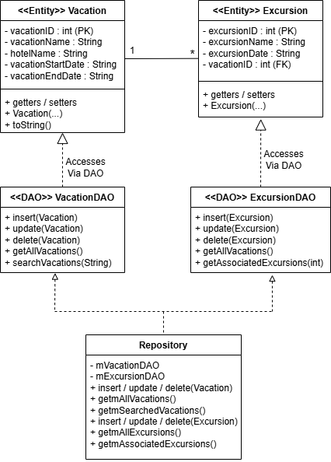
Class Diagram.

UI Design
The following images outline the User Interface (UI) design for the Your Way Vacation Solutions application. Each screen in the application is presented as a comparison between the low-fidelity wireframe and its high-fidelity design counterpart. The low-fidelity wireframes were created in the initial planning phase to establish a structural layout, navigation flow, and placement of interactive elements. The high-fidelity designs highlight the final UI color schemes, interactive forms, and navigation features. The application prioritizes straightforward navigation and a clean layout to reduce clutter, ensuring efficient access to all features and enabling users to plan, manage, and track travel itineraries.
The core functionality is centered on the “Vacation List” dashboard. Upon entering the application, the “Vacation List” screen displays all saved vacations retrieved from the local database. From this page, users can search for specific vacation itineraries using text input or date-range filtering, export search results, and add new vacations. Clicking the “Add Vacation” button directs the user to the “VacationDetails” screen to input new data. Selecting an existing vacation from the list allows the user to view and edit its details or attach an excursion. Clicking the “Add Excursion” button opens the “ExcursionDetails” screen, where individual activities can be created, viewed, edited, or deleted.
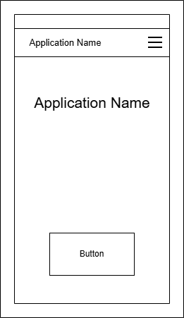
Figure 2.1 Main Activity low-fidelity wireframe.
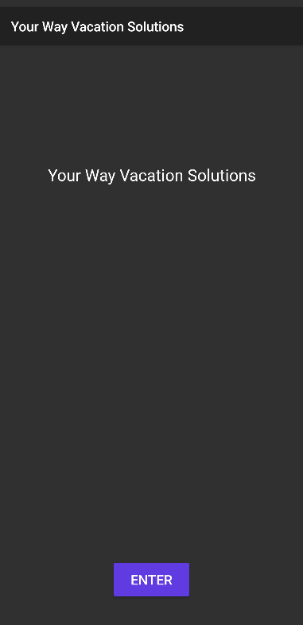
Figure 1.2 Main Activity high-fidelity design.
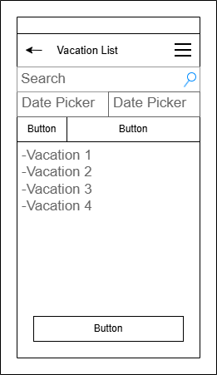
Figure 3.1 Vacation List low-fidelity wireframe.
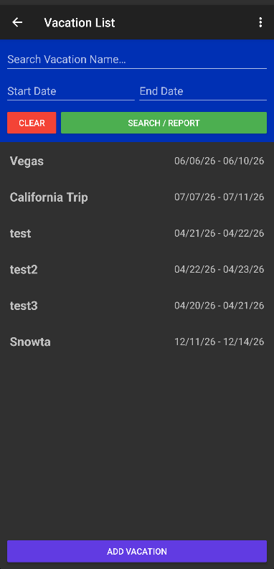
Figure 2.2 Vacation List high-fidelity design.

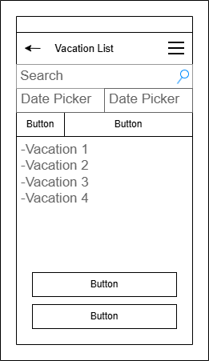
Figure 3.1 Vacation List Search Report low-fidelity wireframe.
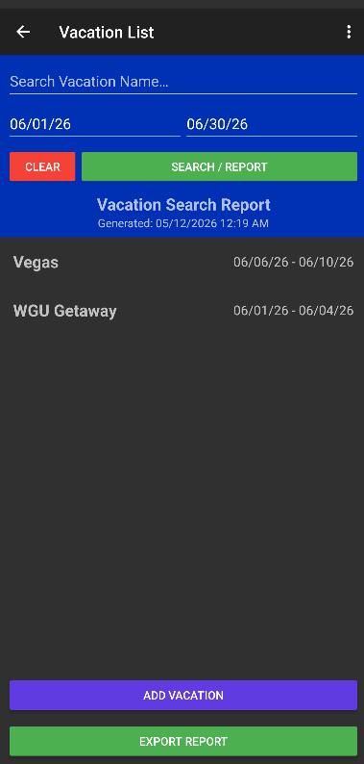
Figure 3.2 Vacation List Search Report high-fidelity design.
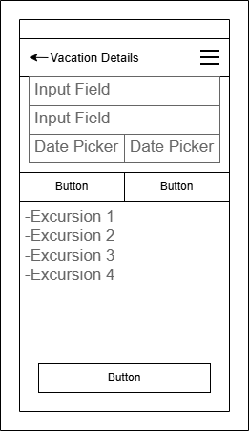
Figure 4.1 Vacation Details low-fidelity wireframe.
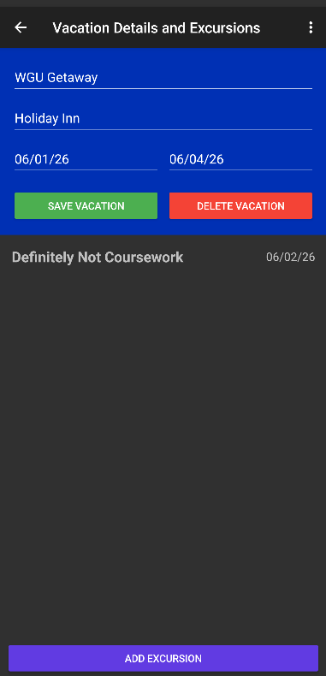
Figure 4.2 Vacation Details high-fidelity design.
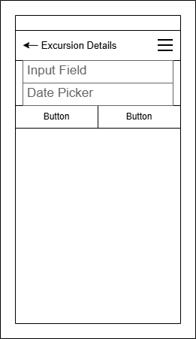
Figure 5.1 Excursion Details low-fidelity wireframe.
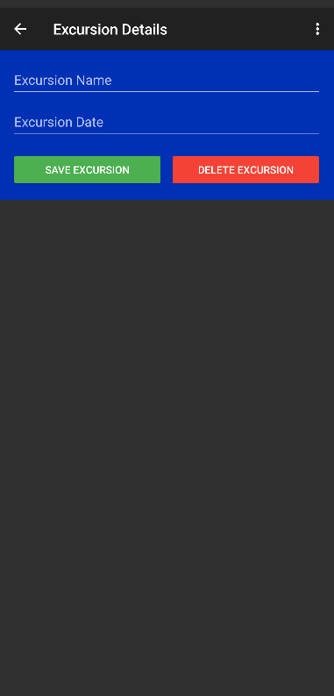
Figure 5.2 Excursion Details high-fidelity design.

Unit Test Plan

Introduction

Purpose
The purpose of the unit test plan is to ensure the integrity and security of the local database for the Your Way Vacation Solutions application. Tests were written using the JUnit framework. Tests were conducted to verify that the application correctly handles invalid date ranges, prevents empty data submissions, and sanitizes user input against special characters. No remediation was required as the validation logic performed as expected across all scenarios. If remediation had been necessary, it would have involved examining the Regular Expression parameters or the date-parsing logic in the main codebase. Once verified, the test suite would be re-executed until the passing criteria are met.

Overview
The unit tests focused specifically on the data-entry validation within the “VacationDetails” activity. The data entered in this activity is accessed and used by every screen in the Your Way Vacation Solutions application. Verifying that this code behaves as expected is critical to ensuring the application functions properly. Using the JUnit framework, individual tests were written with assertions to evaluate potential scenarios when handling user data. Asserting expected outcomes verifies that the validation logic produces expected results. By conducting these tests, the results verify that the application prevents corrupt or logically impossible data from being saved to the SQLite database, thereby ensuring overall application stability.
Date validation for vacations was tested by chronologically evaluating the entered start and end dates. The test simulates what happens when a user presses the “Save Vacation” button; in the “VacationDetails.java” file, the “btnSaveVacation.setOnClickListener(…)” function is run when the button is pressed. To test the date validation, the code contained in the “try/catch” block runs to ensure the start date is set before the end date via the “endDateObject.before(startDateObject)” condition. Assertions within the test verify that an end date set before the entered start date evaluates to “false” and cannot be stored in the database. An additional assertion is evaluated to verify that chronologically consistent dates evaluate to “true,” allowing data to be stored in the database. Expected errors, such as an invalid date range, were handled by confirming that the logic returned a “false” state, which triggers the appropriate user-facing Toast error messages rather than causing a system crash.
Similarly, user input sanitization was tested by verifying the Regular Expression (Regex) logic applied to the vacation name and hotel text fields. Within the same “btnSaveVacation.setOnClickListener(…)” function, the application extracts the user’s input using the “getText().toString().trim()” methods. Before the application even attempts to evaluate the dates, the code runs two conditional checks: an “if (vacationName.isEmpty())” block to catch blank submissions, and an “if (!vacationNameText.matches("^[a-zA-Z0-9 ]+$"))” block to identify invalid special characters. The JUnit tests isolate these specific functions by evaluating assertions written to check conditions like blank input fields, and strings containing special characters (like “@” or “!”), and valid alphanumeric input. Assertions within the test verify that empty values or strings containing special characters evaluate to “false”. In contrast, the live application would block database insertion, execute a “return” statement to stop the save process, and display a user-facing Toast error message. Valid alphanumeric strings are asserted to return “true”, where the live application would store the input in the database. Testing these functions ensures that empty data objects, or malicious code attempting to breach the database, cannot bypass the UI layer. If any of these assertions were to fail, a code review would take place to ensure that the regex parameters and “.isEmpty()” validation logic within “VacationDetails.java” were properly implemented.

Test Plan

Items
Development Environment: Android Studio, with Java installed, was used to test and develop the Your Way Vacation Solutions application.
Source Code: The code can be cloned from the repository. The application’s source code is necessary for testing, specifically the “VacationDetails” class; the test scripts are in the “test [Unit Test]” folder.
Test Framework: JUnit 4 was used to write and run tests. Ensure that imports for “org.junit.Test;” and “org.junit.Assert.*;” are up to date in the “VacationValidationTest” class to utilize the framework and assert statements.

Features
Date Chronology Validation: Test that the user-entered dates are correctly entered by ensuring the start date precedes the end date.
User input sanitization: Test that user input does not contain empty data objects or code containing special characters that could be used in SQL injection attacks.

Deliverables
Test Scripts: The test scripts for the Your Way Vacation Solutions application are located in the source codebase, in the “VacationValidationTest.java” file.
Test Results: The results of the executed test suite are generated by the Android Studio Run Console.
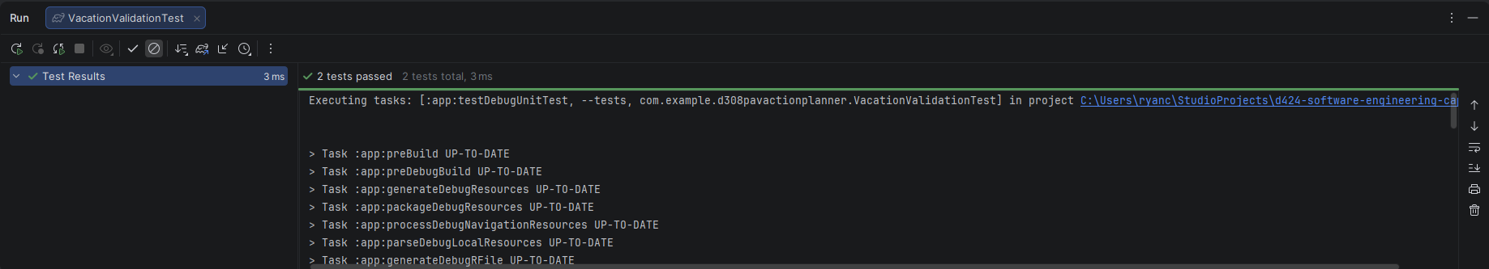
Run Console displaying results for executed tests.

Tasks
List the tasks required to complete the testing and provide the outcomes you identified.
Set up the Android Studio development environment with Java installed.
Clone the source code from the repository as a new project in the Android Studio IDE.
Locate the test scripts in the “test [Unit Test]” folder, and ensure the imports for “org.junit.Test” and “org.junit.Assert.*” are present and valid within the “VacationValidationTest” class.
Execute the test scripts using the JUnit testing framework and monitor the test results.
Analyze the results and identify any unexpected behavior or failed tests.

Needs
Software Requirements: The application is written in Java 25.1 and runs in Android Studio using Panda 4, both of which need to be installed on the device used for testing. The Java Development Kit version 25 and Android Software Development Kit version 36 are required to run the application effectively in the Android Studio development environment.
Testing Tools: JUnit 4.13.2 was used for the testing framework. The JUnit “Test” and “Assert” libraries were imported into the “VacationValidationTest” class.
Source Code and Test Scripts: The source code can be cloned from the Git repository. The test scripts are in the “test [Unit Test]” folder and can be updated as needed during testing.

Pass/Fail Criteria
Date Chronology Validation: The “testDateValidation” test was created to ensure that user-entered dates are properly structured, with the start date preceding the end date. The test uses assertions that return Boolean values when testing function behavior for expected user inputs. The “Pass” criteria are met for the “testDateValidation” test if the assertions perform exactly as expected. Two assertions being evaluated. The first assertion is expected to evaluate to “false”, as the input being tested is a start date that occurs after the entered end date. The second assertion is expected to evaluate to “true” as the entered start date precedes the entered end date. The “Fail” criteria is met when either assertion does not match the intended result, if the logic accepts an invalid date range, or rejects a valid date range.
User Input Sanitization: The “testNameValidation” test was created to ensure that user-entered text fields are properly formatted, rejecting empty strings and special characters. Similar to the “testDateValidation” test, this test uses assertions that return Boolean values based on function behavior. The “Pass” criteria are met if all three assertions perform exactly as expected. The first assertion is expected to evaluate to “false”, as the input contains invalid special characters. The second assertion is also expected to evaluate to “false”, as it tests a blank submission that represents an empty data object. The third assertion is expected to evaluate to “true”, as the input is a valid alphanumeric string. The “Fail” criteria is met if any of these assertions do not match their intended result, meaning the logic erroneously permitted special characters, accepted an empty string, or rejected properly formatted text.
If either test yields a “Fail” result, the test results should be documented and investigated. A support ticket should be created documenting the failed test result. The first step in remediating the issue involves a root cause analysis, which requires examining the Android Studio stack trace and execution logs to identify the point of failure within the “VacationDetails” class. Once the origin of the failure is identified, a code review of the affected validation function is conducted. Following the code review and necessary code remediation, the developer must iteratively rerun the JUnit test suite until all assertions pass before committing any code to the repository. After the fix is implemented, the support ticket should be updated to document that the issue has been addressed and to log the steps taken to address it.

Specifications
Below is a screenshot of the test code for the Your Way Vacation Solutions application.
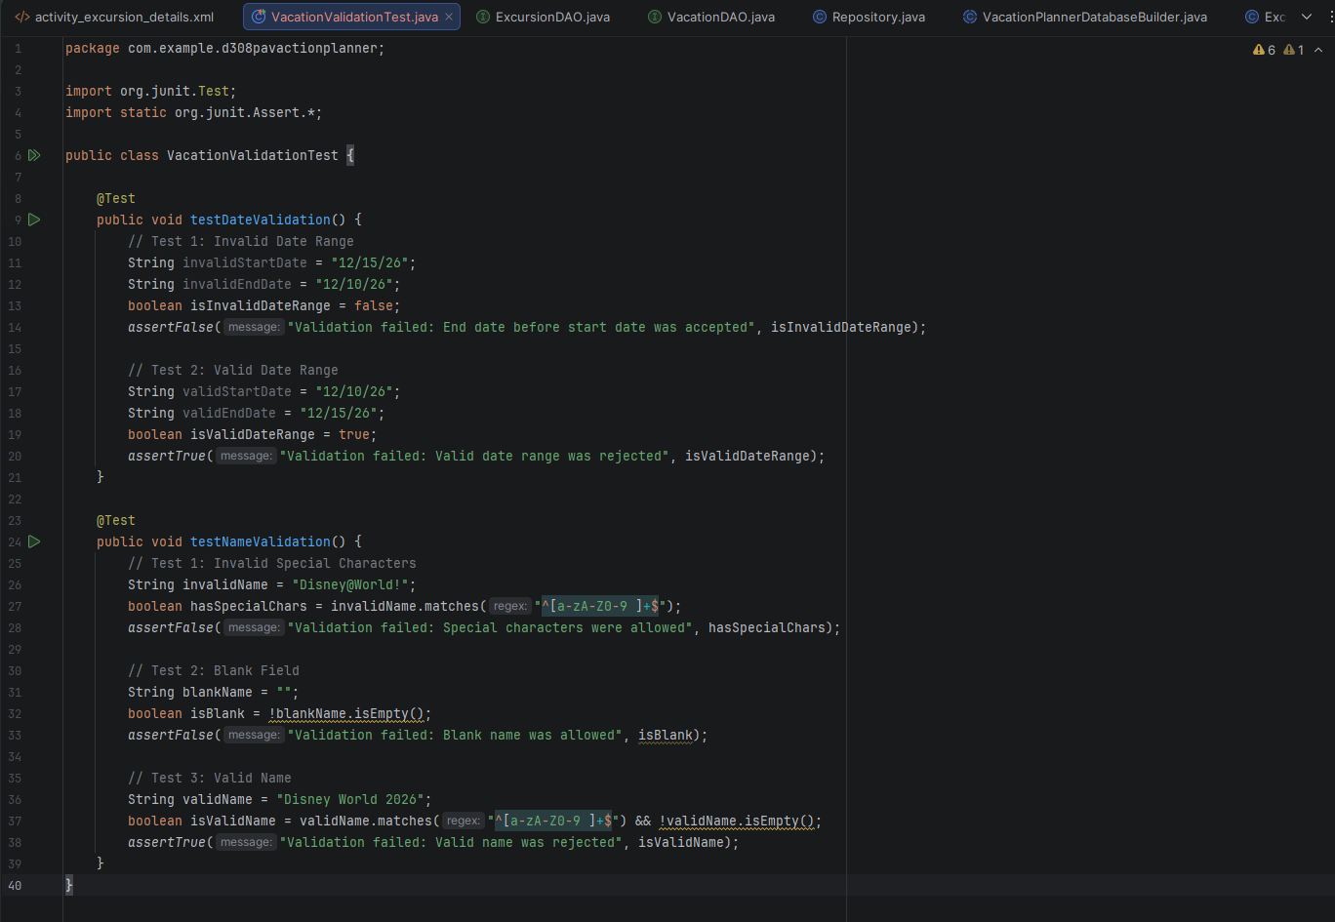
Screenshot showing tests created for the Test Plan.

Procedures
Test Plan Preparation: An analysis of the Your Way Vacation Solutions application was conducted to determine its core functionality. As the vacation details saved in the SQLite database are used to update every screen of the application, potential points of failure in date-range validation and security concerns related to user data input were identified for addressing.
Test environment setup: Within the project for the Your Way Vacation Solutions application created in Android Studio, the “VacationValidationTest” class was created in the “test [Unit Test]” directory. The JUnit library and its associated Assert package were imported into the class.
Test Generation: Test cases for “testDateValidation” and “testNameValidation” were created using the “@Test” annotation. Assertions were written for both tests, simulating multiple scenarios involving valid and invalid user input, ensuring the code in the “VacationDetails” class behaves as expected.
Test Execution: The tests were run using the “Run” command in Android Studio. The test results were displayed within the Run Console window.
Test Results Review: The test results were run to provide immediate Pass/Fail feedback in the console, to ensure the logic was sound before committing the code to the repository. If any tests fail, the failures would be documented, and a root cause analysis would be performed to implement the necessary coding changes and run the test cases iteratively until all tests meet the “Pass” criteria.

Results
The unit testing yielded entirely successful results. The assertions outlined in the “testDateValidation” test confirmed that the application correctly flagged an inverted date range as invalid while accepting a proper chronological date range. The “testNameValidation” test’s assertions confirmed that the regex parameters successfully rejected input containing special characters and blank entries, while valid alphanumeric string input was accepted. Because both tests passed and each assertion was evaluated as intended, no code remediation was required.
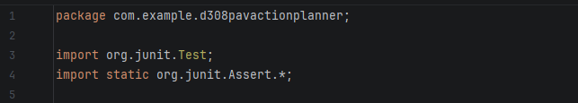
Package for the source code, and imports for JUnit Test and Assert libraries.
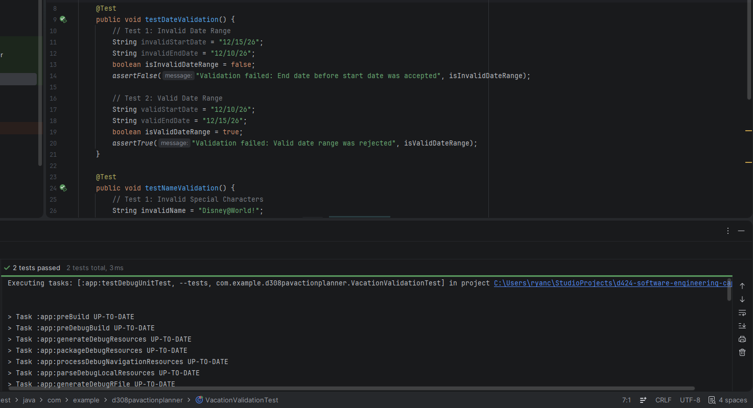
Date Chronology Validation test "testDateValidation" with passing result.
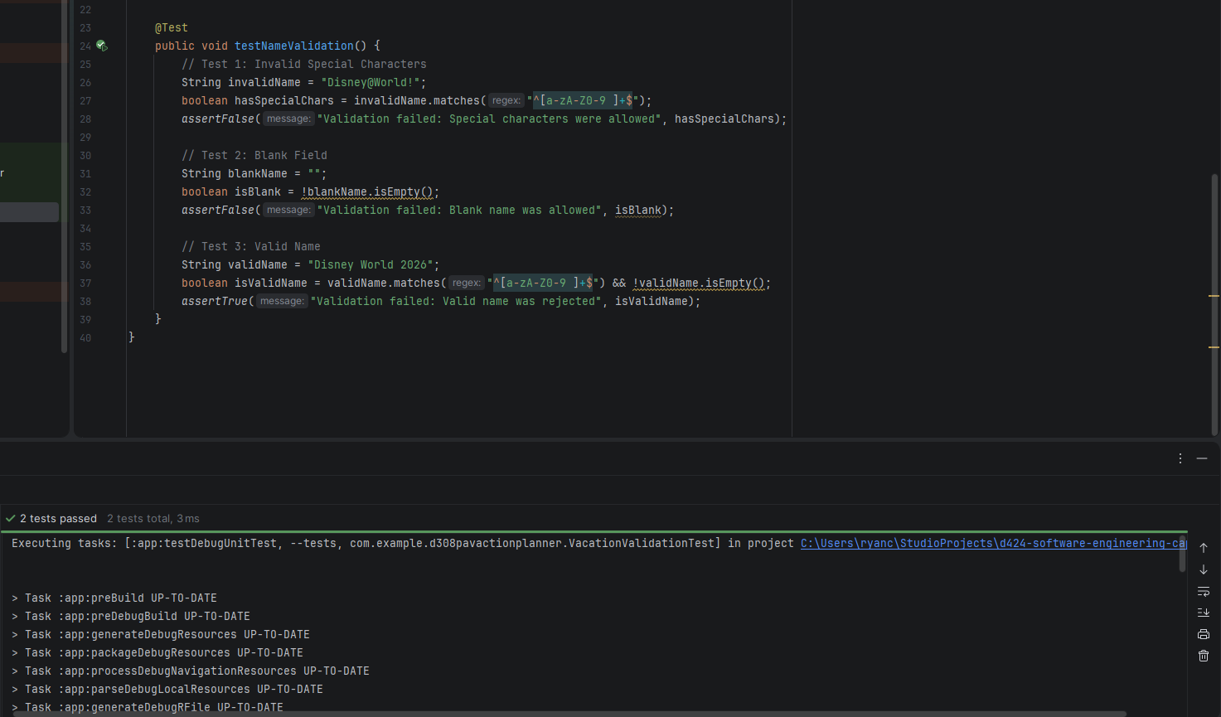
User Input Sanitization test "testNameValidation" with passing result.

Guide for Setting Up and Maintaining Your Way Vacation Solutions Application

Introduction
The following guide outlines the necessary prerequisites, development environment installation, and maintenance protocols for the Your Way Vacation Solutions application. This guide is intended for developers who need to clone the repository, compile the codebase, execute the application within a local development environment, and update the hosted application version for distribution.

Prerequisites
Please ensure that the following software is installed and properly configured on the machine used for development:
Integrated Development Environment (IDE): Android Studio, Panda 4 or newer is recommended. Android Studio is a free development environment. The latest version can be downloaded from the Android developer site. https://developer.android.com/studio
Java Development Kit (JDK): JDK 25.1 or the version specifically configured in the project’s build settings.
Android Software Development Kit (SDK): Android API level 36 was used to develop the Your Way Vacation Solutions application.
Testing Framework: Junit 4.13.2 was used to test the Your Way Vacation Solutions application. The framework is implemented in classes in the test directory; updates may be necessary for future development.
Version Control: Ensure Git is locally installed to clone the repository. The official source code repository can be accessed via GitLab at: https://gitlab.com/wgu-gitlab-environment/student-repos/rcorso6/d424-software-engineering-capstone.git.

Project Setup
- Clone Repository: Open Android Studio, on the welcome screen, click the Clone Repository button.
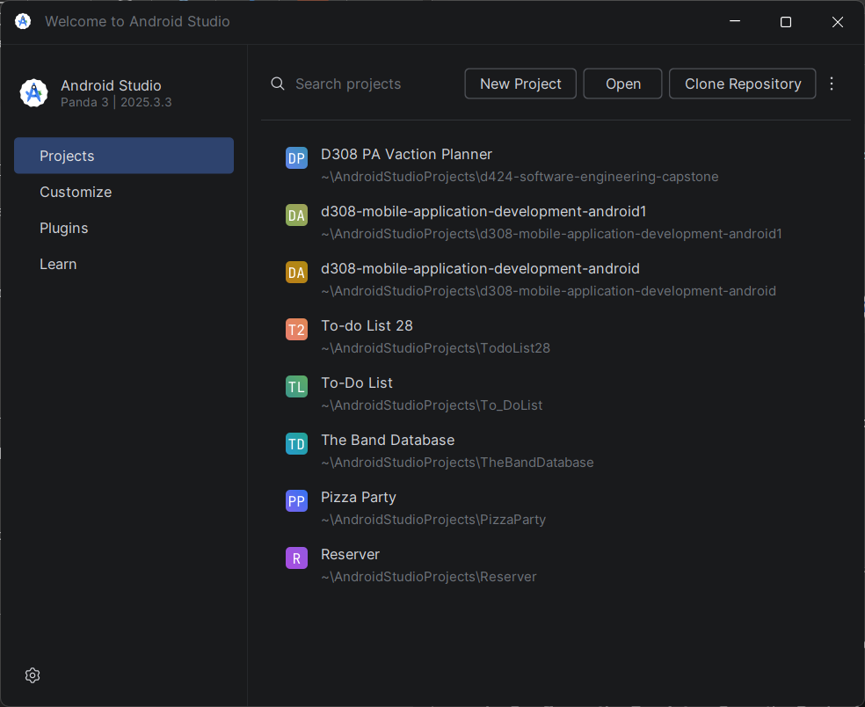
Android Studio Welcome Screen.
From the Clone Repository screen, paste the repository URL in its respective field. The directory will default to the Android Studio Projects folder set up during Android Studio installation. Click Clone to copy the source code into the directory.
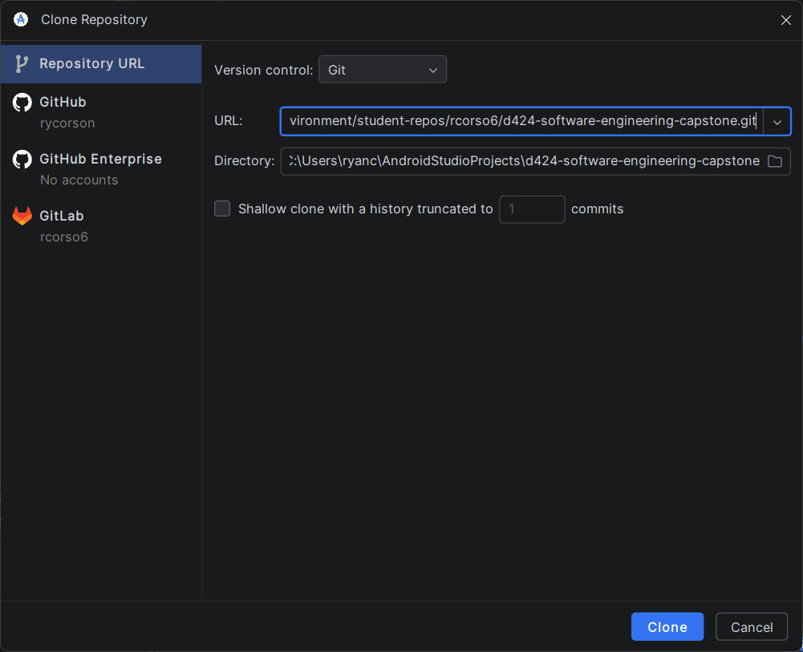
Clone Repository screen, with the URL field filled with the GitLab repository link.
- Open the Project: Launch Android Studio. Open the project by selecting the directory where the repository was cloned. Select the root folder of the project.
- Gradle Synchronization: Upon opening the project, Android Studio will automatically begin syncing the Gradle build files to download the necessary dependencies needed for the project, such as the Room Database libraries and the Junit testing framework. Wait for the “BUILD SUCCESSFUL” message to display in the build console.
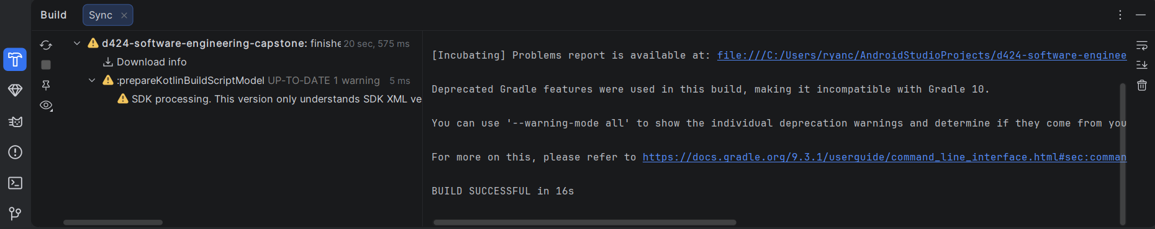
“Build Successful” notification in the build console.
- Configure Device Emulator: Open the Device Manager in Android Studio. Press the “+” button and select Create Virtual Device to create a new Android Virtual Device (AVD) running an API level compatible with the application’s SDK. A standard Pixel device profile is recommended for rendering the project to test the application. A Pixel 8 Pro profile was used in developing the initial Your Way Vacation Solutions application.
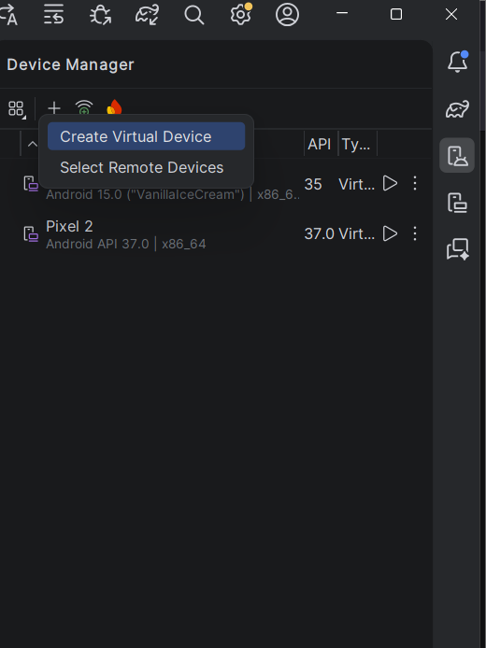
Device Manager with the option to “Create Virtual Device”.
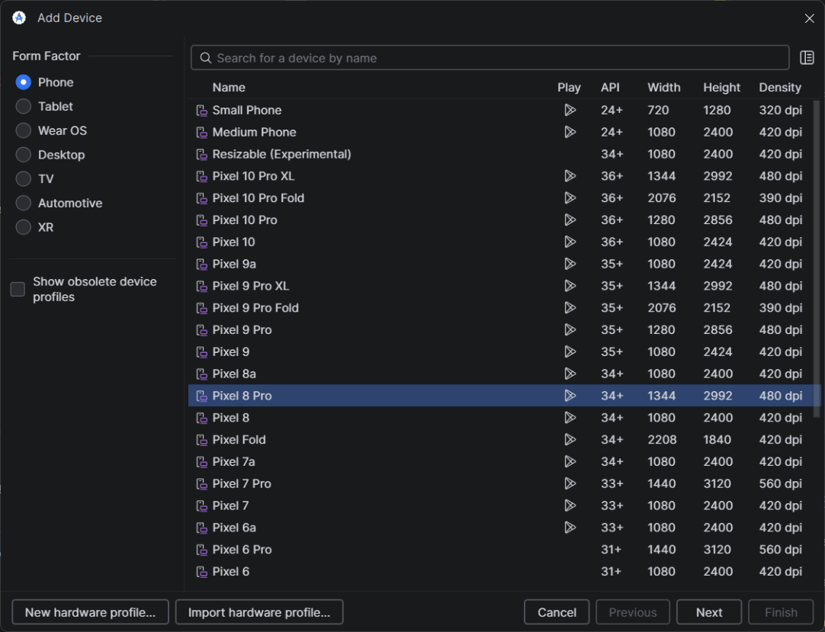
Add Device screen with device profile options.
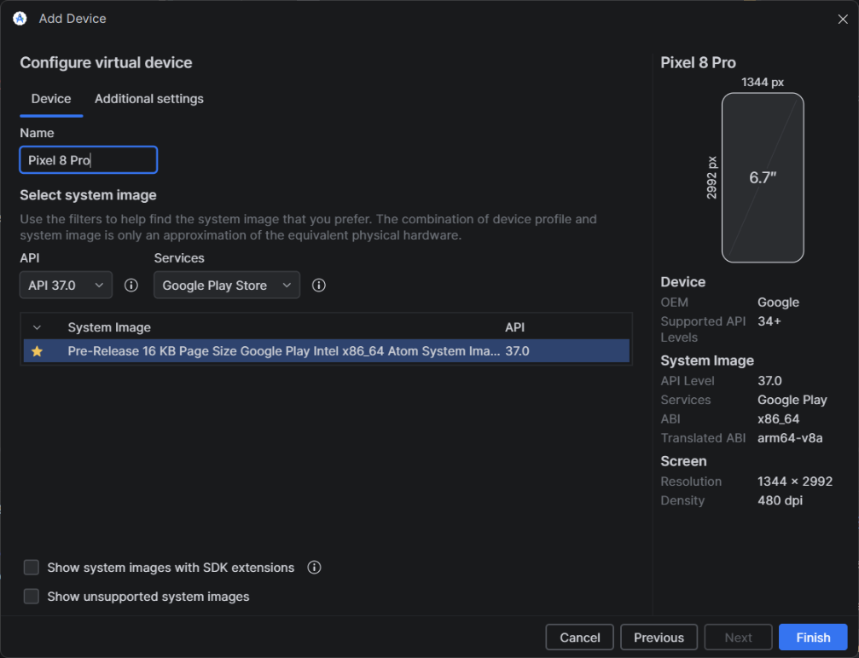
Add Device screen configuration settings for the selected profile.

Executing the Application
- Ensure the newly created Android Virtual Device is selected in the target device dropdown menu at the top of the Android Studio Interface.
- To run the application, click the green arrow “Run ‘app’” button, or press Shift + F10.
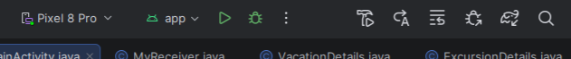
Android Studio toolbar with device selection and run application options.
- Android Studio will compile the codebase, build the APK, and launch the emulator.
- Once the installation is complete, the Your Way Vacation Solutions application will automatically open to the “Main Activity” screen. On application launch, the SQLite database will be initialized on the emulated device, so any changes made while using the emulator will persist throughout development.
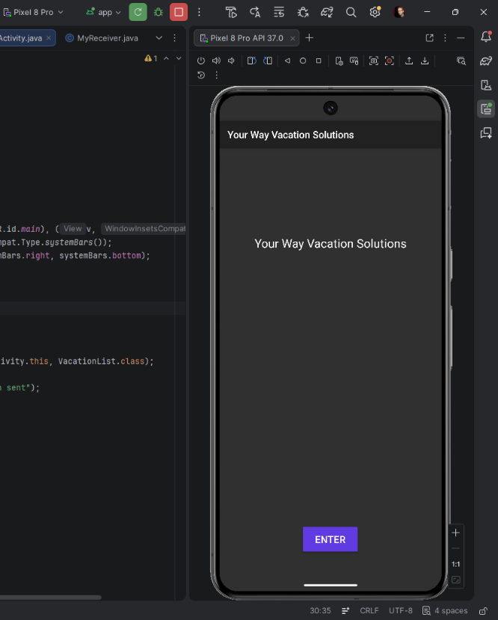
Emulator launched after the application has run in Android Studio.

Maintenance and Future Development
To ensure the long-term stability and security of the application, future developers should adhere to the following maintenance protocols:
Dependency Management: Review the “build.gradle (Module : app)” file. Android Studio will highlight outdated libraries. Update any outdated libraries to their latest stable version to ensure compatibility with newer Android Operating System releases.
Database Schema Updates: The application utilizes the Android Room Persistence Library. If future development requires adding new columns to the “Vacation” or “Excursion” entity classes, the developer must increment the “version” number within the “@Database” annotation of the main database class. To prevent crashes for existing users during an update, a Room Migration strategy must be written to safely alter the SQLite tables without destroying existing user itineraries.
Testing Protocol: Before committing any new features or maintenance updates to the working branch (where production code is written), the developer must execute the “VacationValidationTest” JUnit suite to ensure that the new code has not compromised data validation procedures.

Deployment and Hosting Updates
Once maintenance is complete and all unit tests have been passed, the application must be packaged as a secure, signed release and hosted for users to download. The application is hosted as an APK file in the project’s GitHub repository, accessible at: https://github.com/rycorson/capstone-app-hosting. To update the hosted version, follow these steps:
- Generate a Signed APK: Within Android Studio, navigate to the top toolbar and select “Build > Generate Signed App Bundle or APK…”. Select APK, follow the prompts to choose your Keystore path (or create a new one), enter the required security passwords, and select the “release” build variant. Click Finish, then wait for the Gradle build to complete.
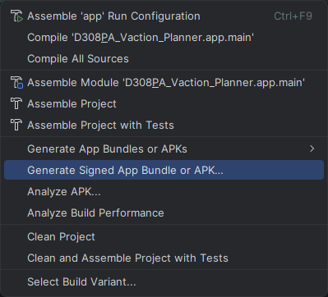
Build menu options with "Generate Signed App Bundle or APK..." highlighted.
- Locate the File: Once the build is successful, click the “locate” link in the Android Studio event log pop-up, or navigate manually to the “app/release/” directory within your local project files to find the newly generated “app-release.apk” file.
- Standardize the Name: Rename the new file to “YourWayCap.apk” so that it exactly matches the file name of the currently hosted version.
- Update the Repository: Open the project’s GitHub repository in a web browser. Click the “Add file” button and select “Upload files”.
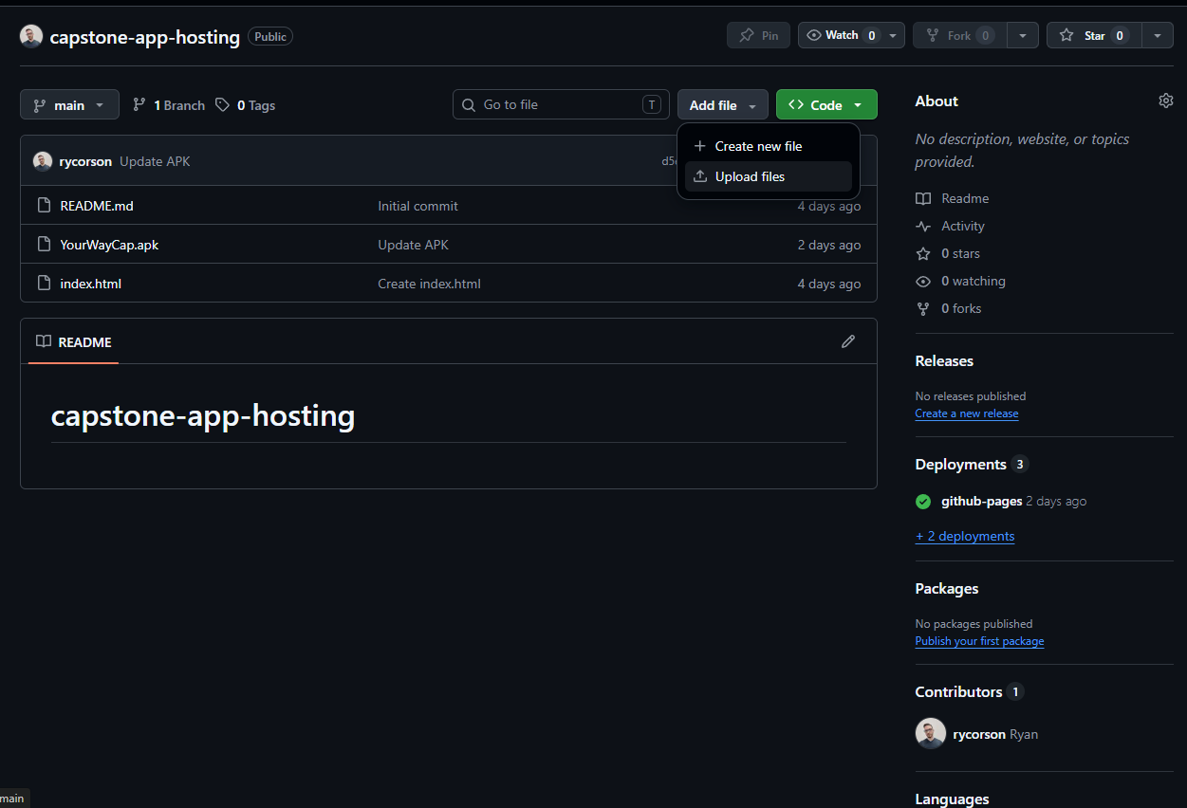
GitHub repository with "Add file > Upload files" selected.
Drag and drop the newly generated APK into the upload field, and commit the changes to the “main” branch.
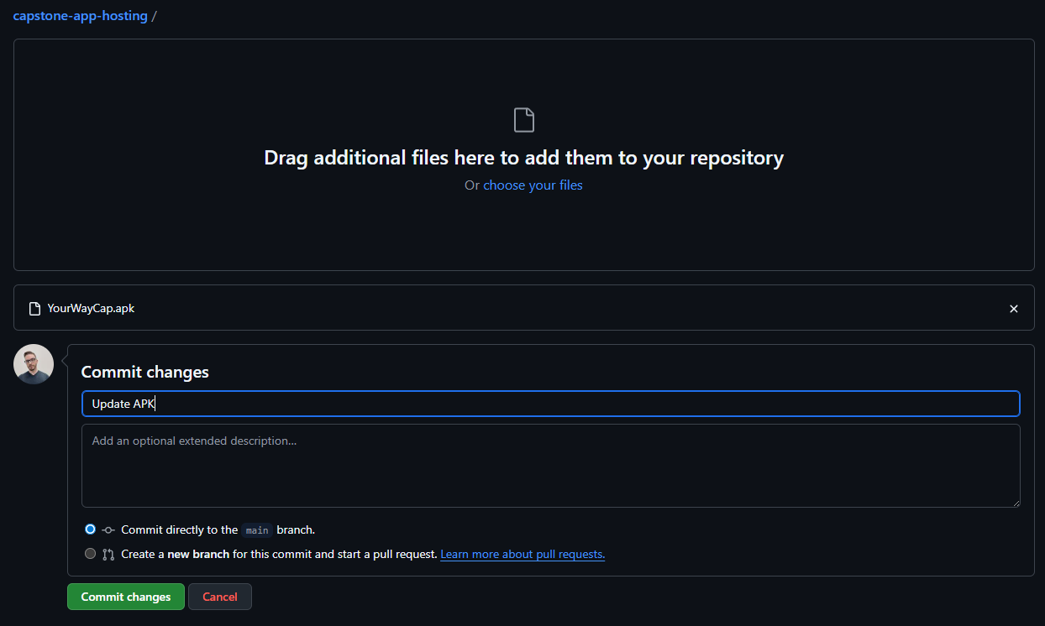
Upload screen with "YourWayCap.apk" uploaded.
This action will seamlessly overwrite the outdated file, ensuring that the existing repository download link automatically provides the most up-to-date version of the application.
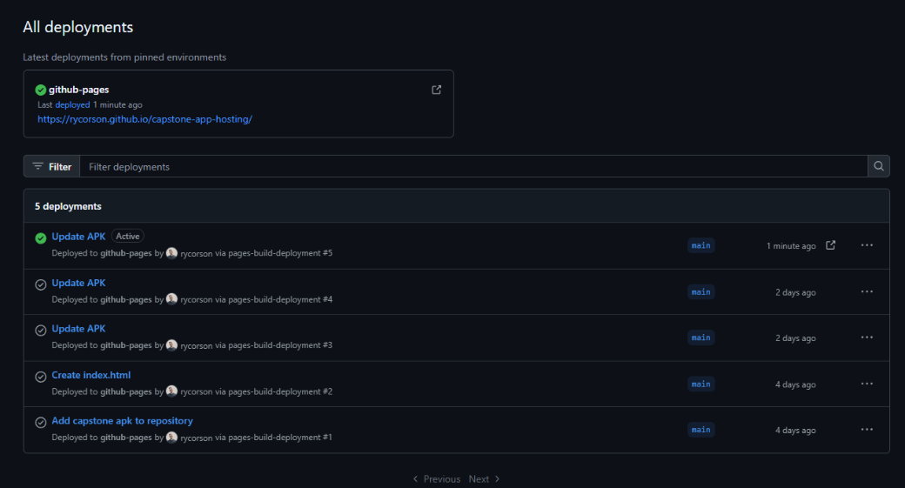
Deployment screen showing that the APK has been updated and deployed to the hosted site.

User Guide

Introduction
This user guide provides step-by-step instructions for installing and navigating the Your Way Vacation Solutions application. The guide covers all core functionalities, including adding, editing, searching, and deleting travel itineraries, managing associated excursions, and generating itinerary reports. The steps outlined below will help you plan and track your travel data effectively.

Installation and Using the Application
To install the application on your personal Android device, please follow these steps:
- Navigate to https://rycorson.github.io/capstone-app-hosting/ on your mobile device’s web browser.
- Download the “YourWayCap.apk” by clicking the “Download APK” button.
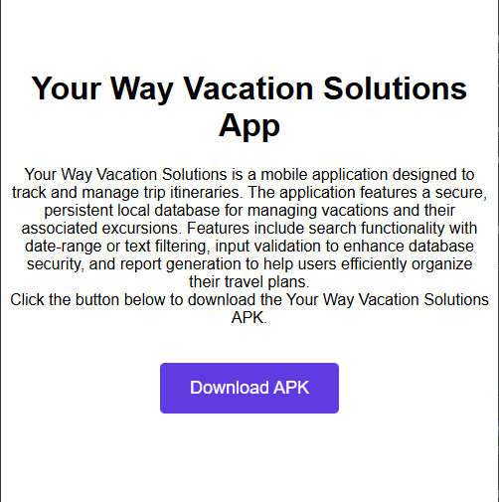
- Open your device’s Downloads folder, tap the APK file, and select “Install”. (Note: You may need to allow “Install from Unknown Sources” in your Android security settings.)
- Once installed, tap the Your Way Vacation Solutions application icon in your applications view to launch the application.

Your Way Vacation Solutions entry screen
When you first launch the application, the Your Way Vacation Solutions entry screen appears. Tap the “Enter” button to access the application.
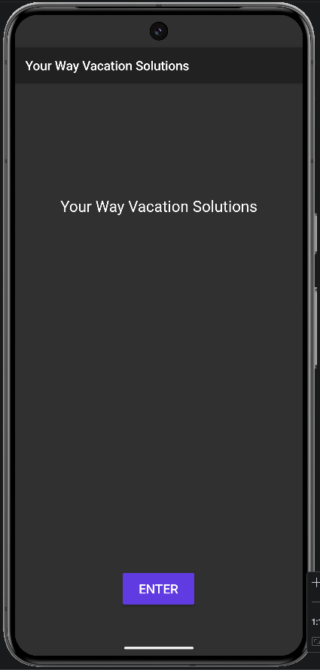

Vacations
Upon entering the application, you will be directed to the Vacation List screen. The screen shows a list of all your currently saved vacations.
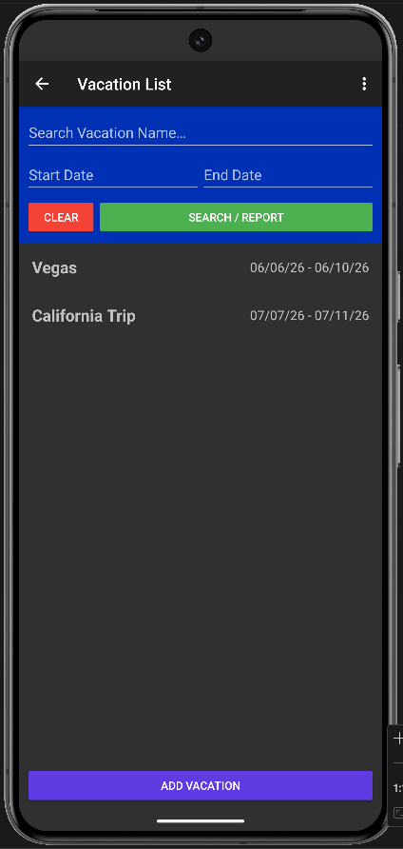
From this screen, you can access Search, generate Reports, add a new vacation, or select an existing vacation to view its details.

Add a New Vacation
- From the Vacation List screen, tap the “Add Vacation” button to be directed to the Vacation Details screen.
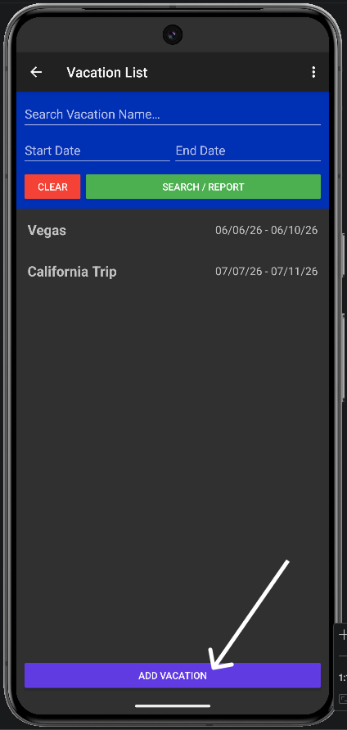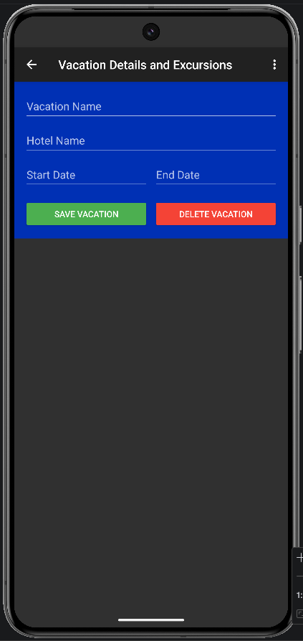
- Tap on the Vacation Name and Hotel text fields to enter your details. (Note: For security and data integrity, these fields only accept standard letters and numbers. Special Characters @#! Etc are not allowed and will prompt an error message.)
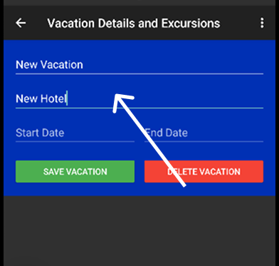
- Tap the Start Date and End Date fields to open the Calendar picker and select your travel dates. The application will verify that your End Date does not occur before your Start Date.
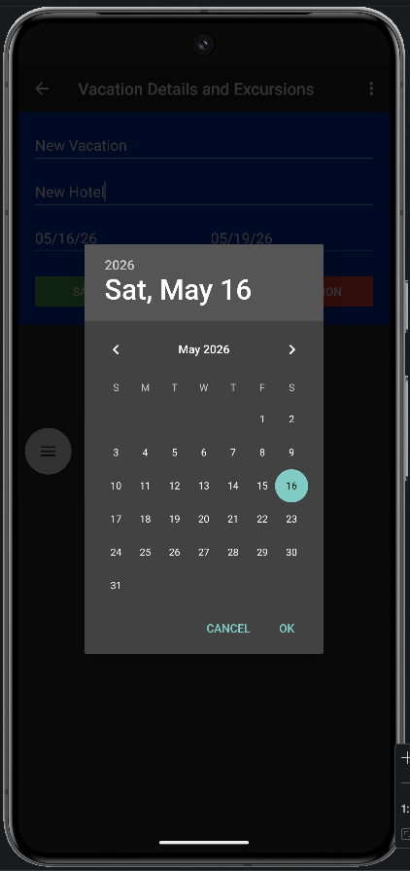
- Once all information is entered correctly, click the “Save Vacation” button. Once the vacation is saved, you will be directed back to the Vacation List screen, and your new vacation will appear in the list.
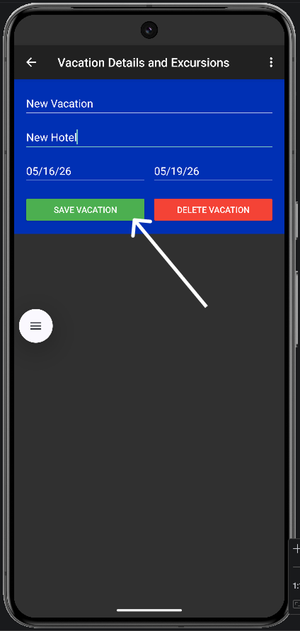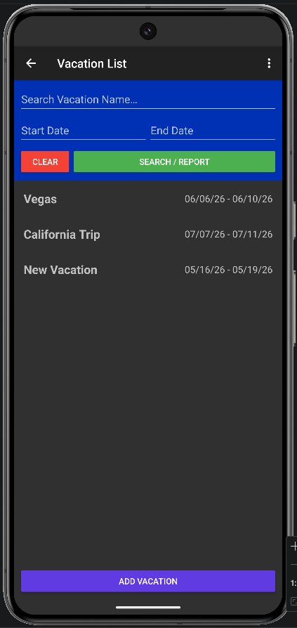

Edit a Vacation
- From the Vacation List, click on any existing vacation in the list that you wish to update.
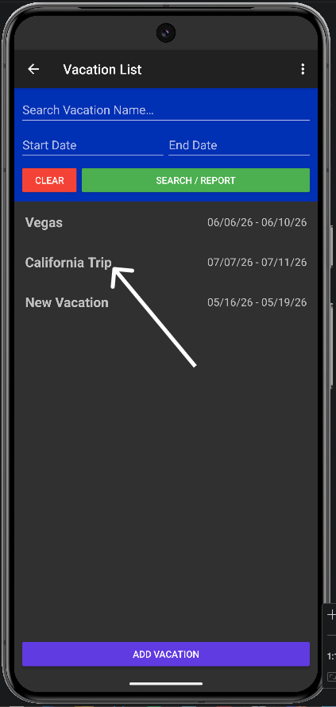
- Make any necessary changes to the text fields or dates.
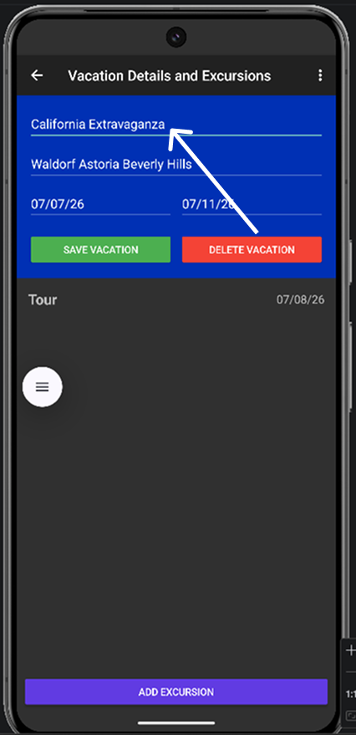
- Click the “Save Vacation” button to apply the updates and return to the Vacation List screen.
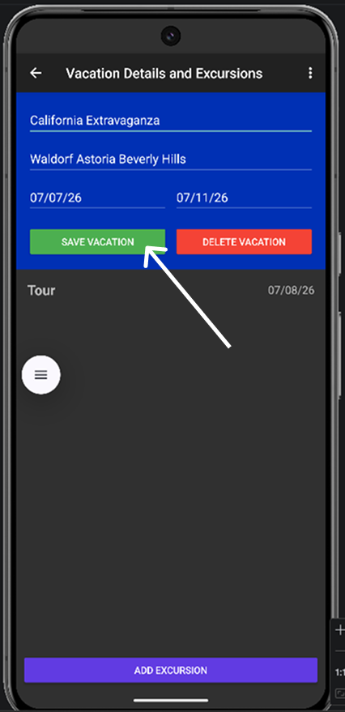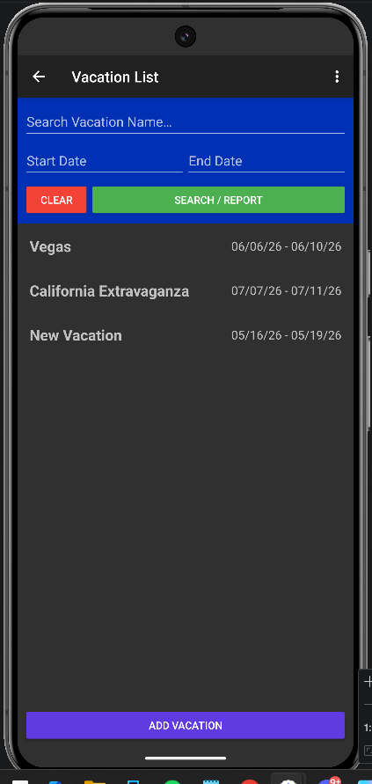

Delete a Vacation
- From the Vacation List screen, click on the vacation you wish to remove.
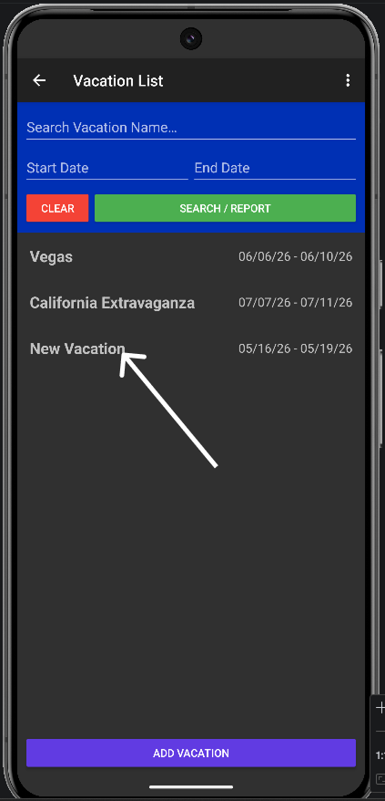
- In the Vacation Details and Excursions screen, tap the “Delete Vacation” button. (Note: To prevent accidental data loss, the application will not allow you to delete a vacation if it currently has excursions attached to it. You must delete the associated excursions first.)
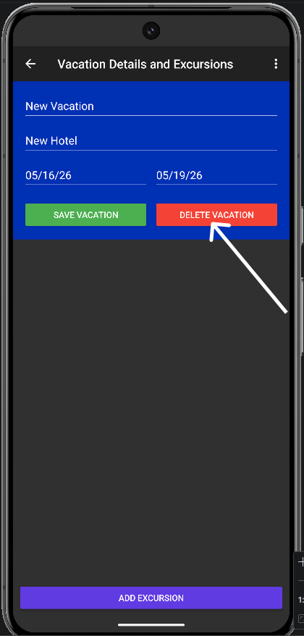
- The vacation will be deleted from the database, and you will be returned to the Vacation List screen.
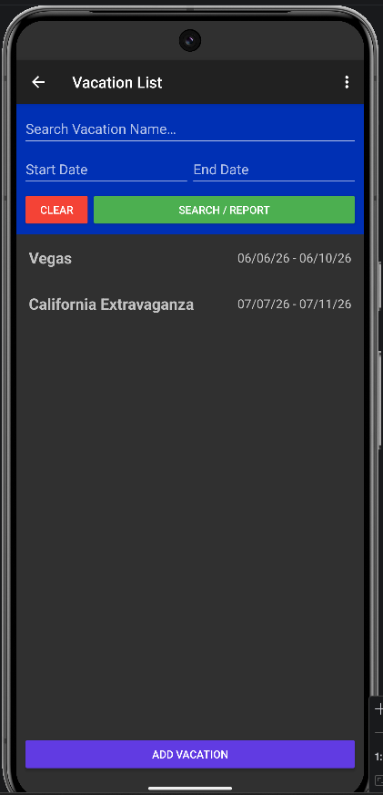

Share and Notify Features for Vacations
While viewing a saved vacation on the Vacation Details and Excursions screen, you have access to additional tools in the top right menu:
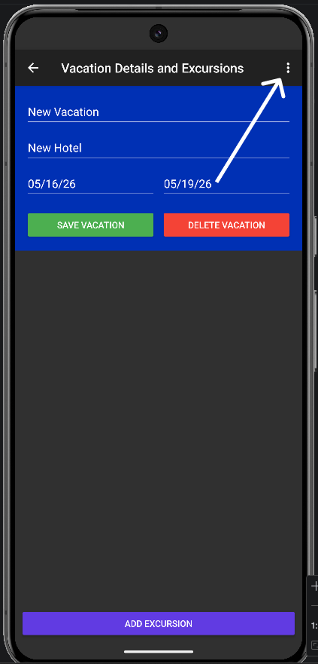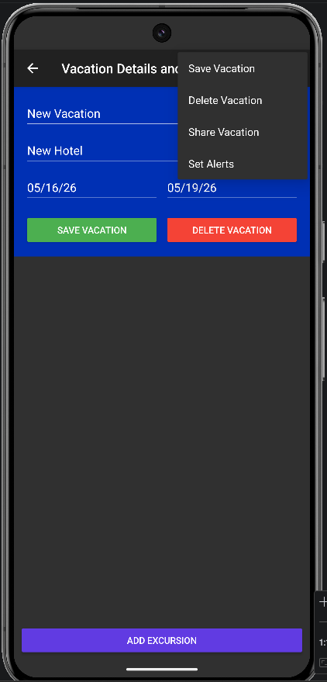
- Share: Tap the “Share Vacation” option to send a text-based summary of your vacation to other apps on your device, such as your email or messaging client.
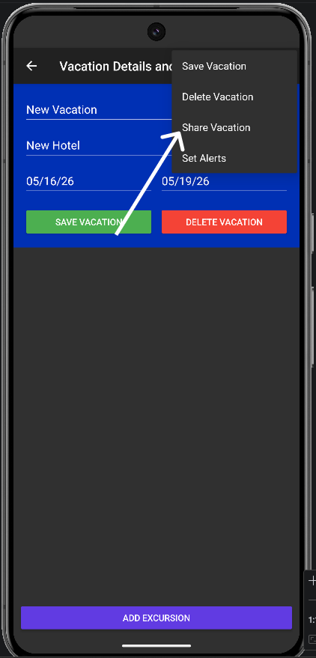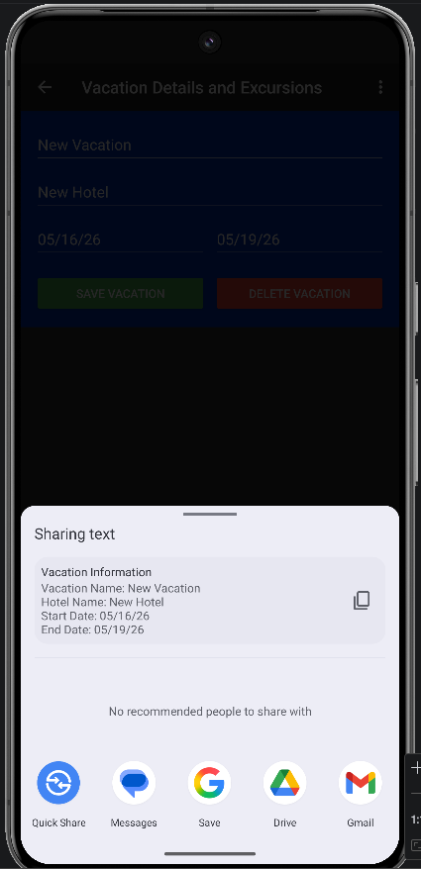
- Alert: Tap the “Set Alerts” option to set system-level notifications. The app will automatically schedule a notification to alert you on the day your vacation starts and ends.
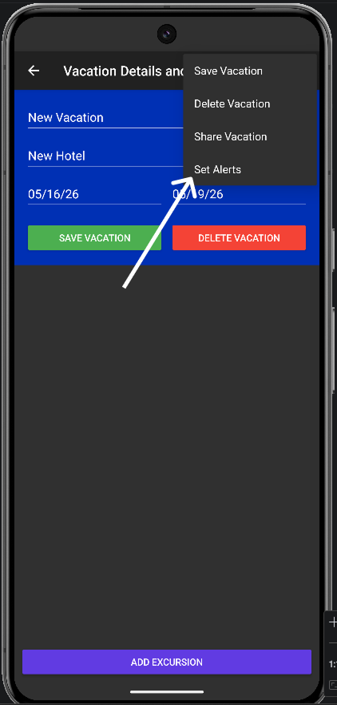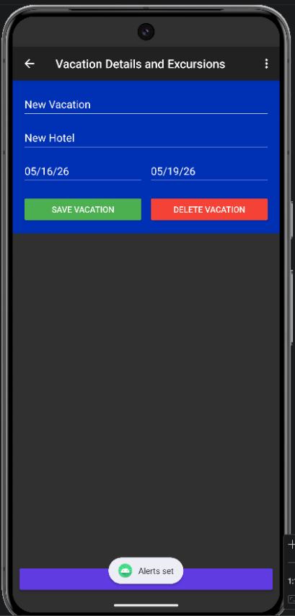

Excursions
Excursions, also known as activities, to take place during a vacation, can be added to vacations that have been successfully saved in the database.

Add an Excursion
- From the Vacation List screen, tap on a saved vacation you wish to add an excursion to.
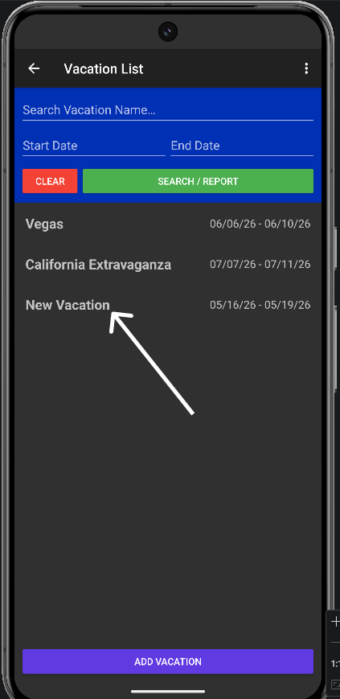
- At the bottom of the Vacation Details and Excursions screen, click the “Add Excursion” button. (Note: This button is only available for saved vacations; excursions can not be added to a vacation that is actively being created.)
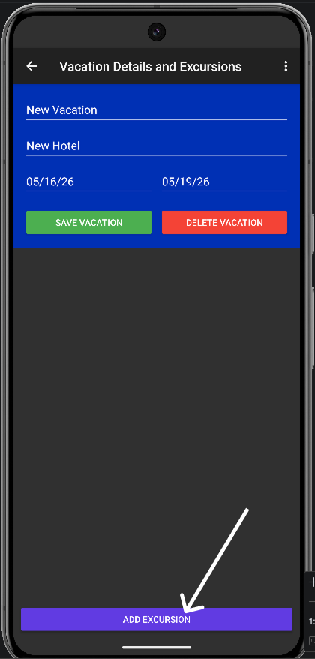
- Tap the Excursion Name field to enter excursion information.
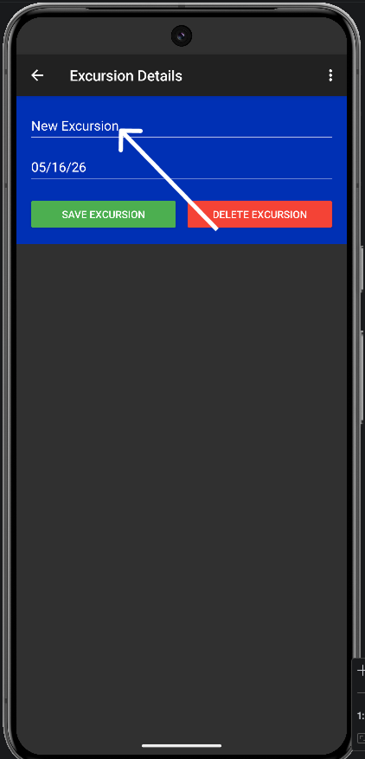
- Tap the Excursion Date field to open the Calendar picker and select the excursion date. (Note: Excursions can only be added if they fall within the date range of the associated vacation.)
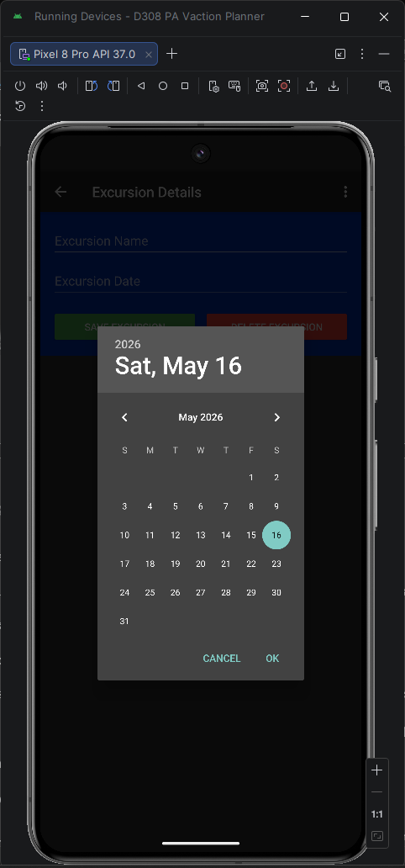
- Tap the “Save Excursion” button to link this excursion to the selected vacation.
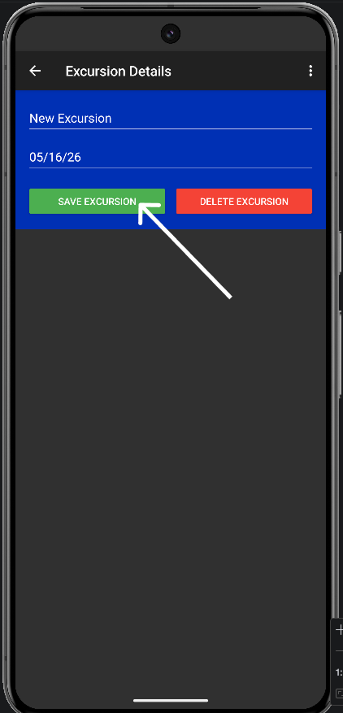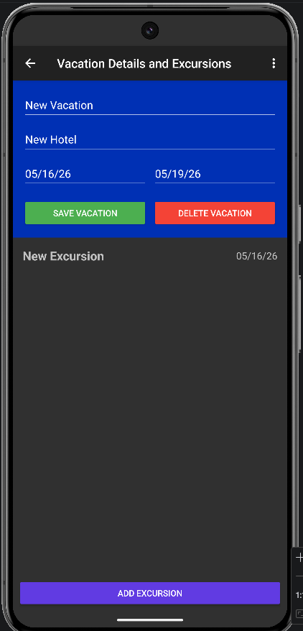

Edit an Excursion
- Select the vacation that contains the excursion to be edited from the Vacation List screen.
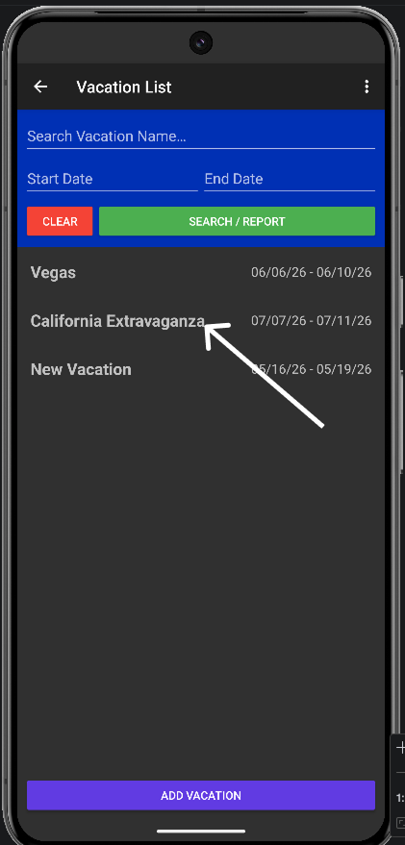
- Select the excursion to be edited from the Vacation Details and Excursions screen.
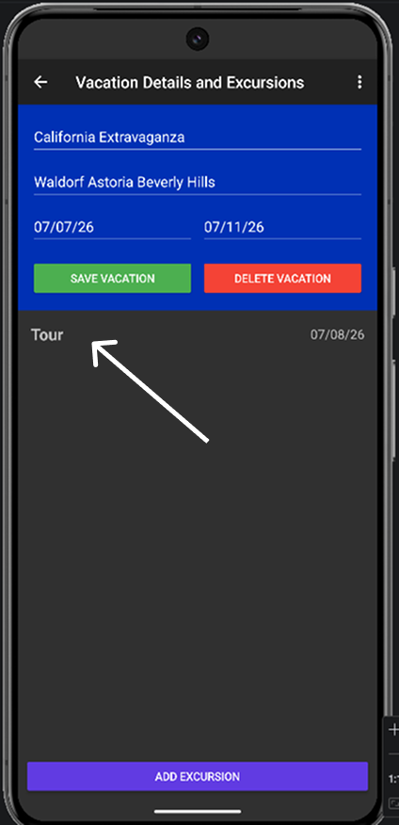
- Edit the name or date of the excursion and tap the “Save Excursion” button. Changes to the excursion will be saved, and you will be returned to the Vacation Details and Excursions screen for the selected vacation.
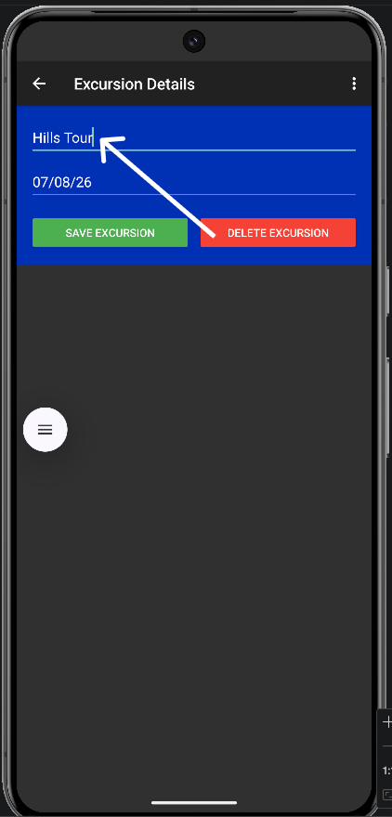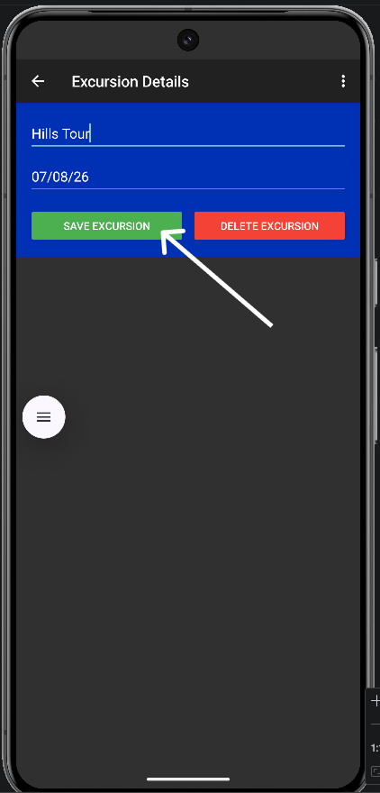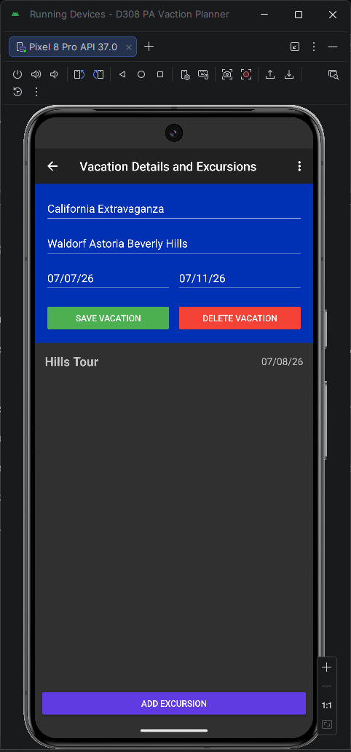

Delete an Excursion
- Select the vacation that contains the excursion to be deleted from the Vacation List screen.
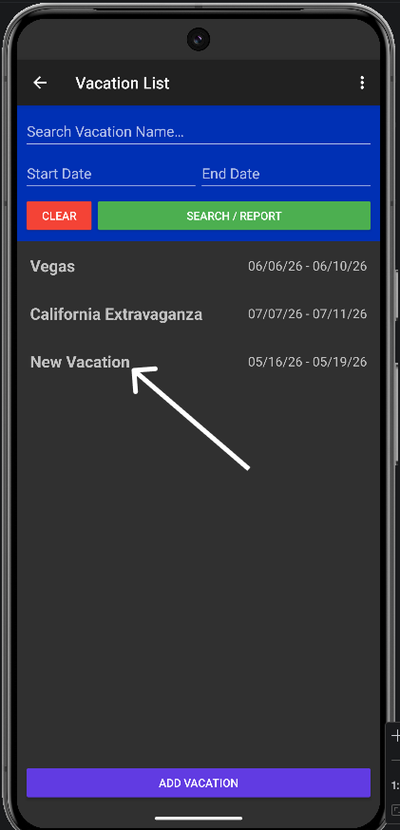
- Select the excursion to be deleted from the Vacation Details and Excursions screen.
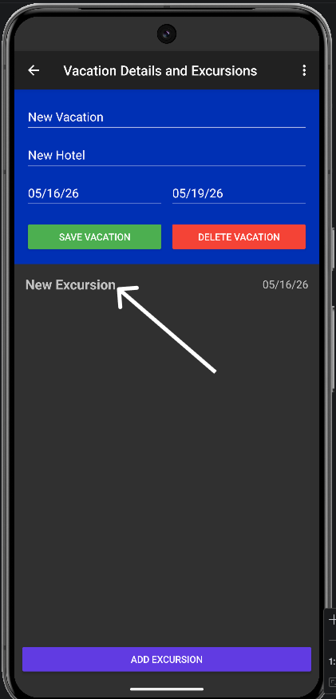
- To delete the selected excursion, tap the “Delete Excursion” button. The excursion will be removed, and you will be returned to the Vacation Details and Excursions screen for the selected vacation.
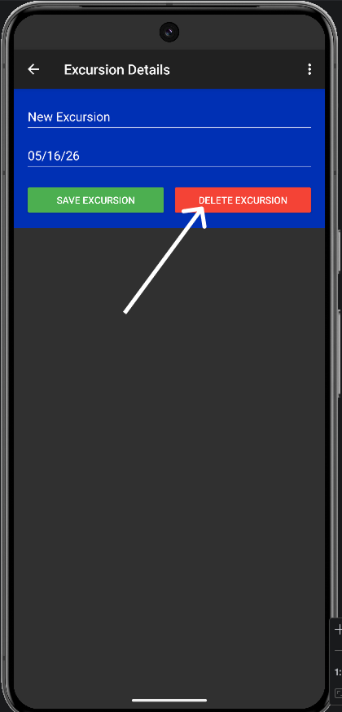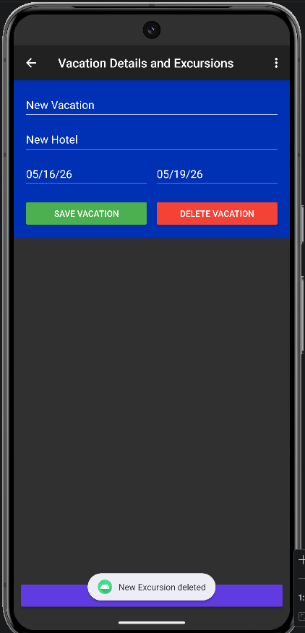

Share and Notify Features for Excursions
While viewing a saved excursion on the Excursion Details screen, you have access to additional tools in the top right menu:
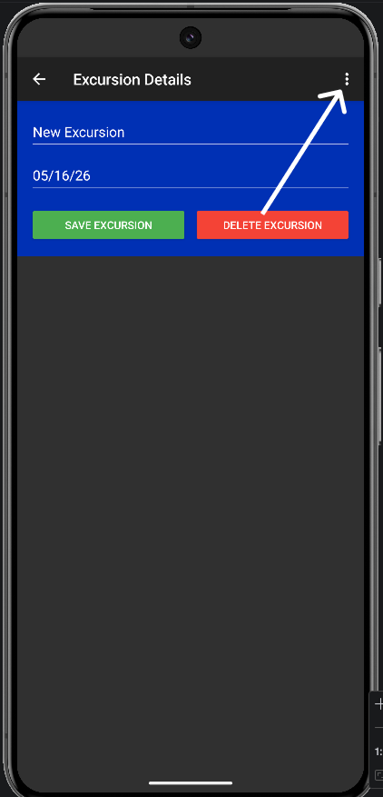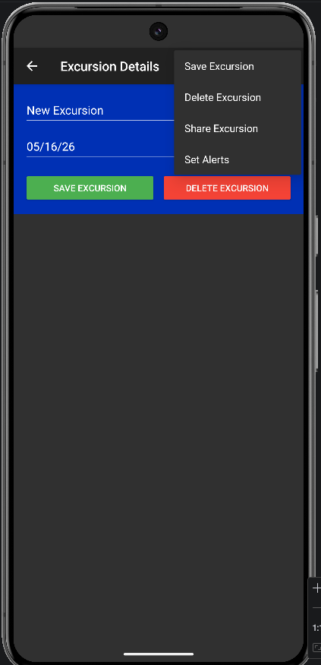
- Share: Tap the “Share Excursion” option to send a text-based summary of your excursion to other apps on your device, such as your email or messaging client.
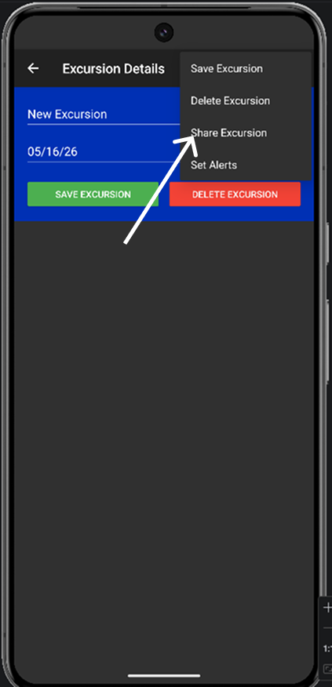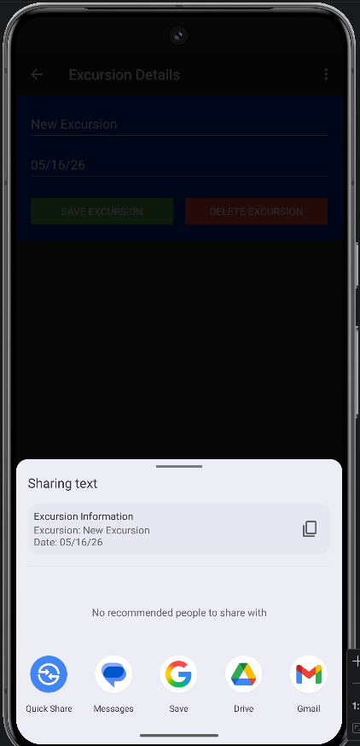
- Alert: Tap the “Set Alerts” option to set system-level notifications. The app will automatically schedule a notification to alert you on the day of your excursion.
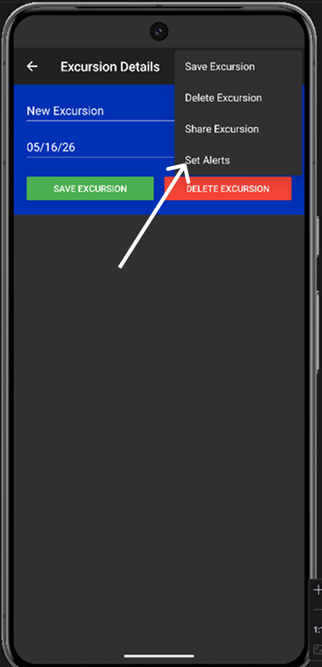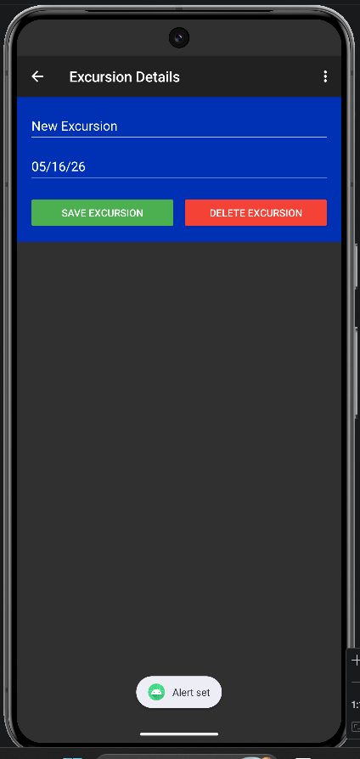

Search and Reports
The search function on the Vacation List screen lets you find vacations by search terms or date ranges. The search function includes a built-in reporting feature that generates a report for the returned search result that can be copied to the Android device’s clipboard to paste into other applications, or exported and sent via messaging applications installed on the device.

Searching for a Vacation
- On the Vacation List screen, locate the Search bar near the top of the screen.
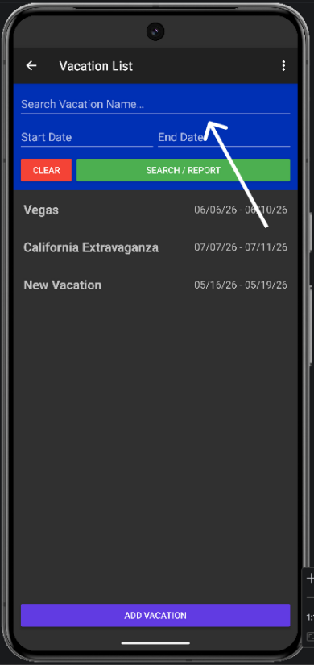
- Type in the name of the vacation you are looking for, or search for vacations that fall within a date range using the Start Date and End Date fields.
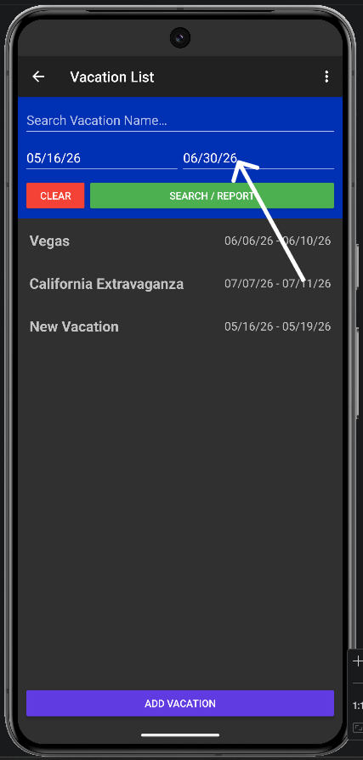
- Click the “Search/Report” button to retrieve search results. (Note: You can clear search input by tapping the “Clear” button next to the “Search/Report” button.)
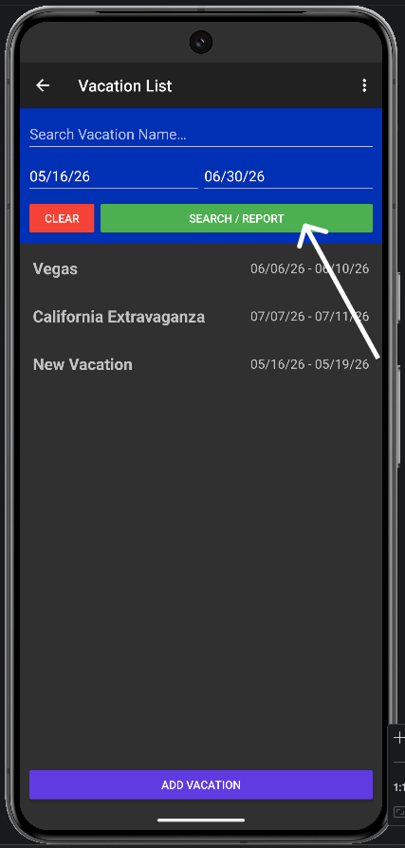
- The Vacation List will automatically filter to display vacations that match your search criteria, making it easy to find specific trips in a large list.
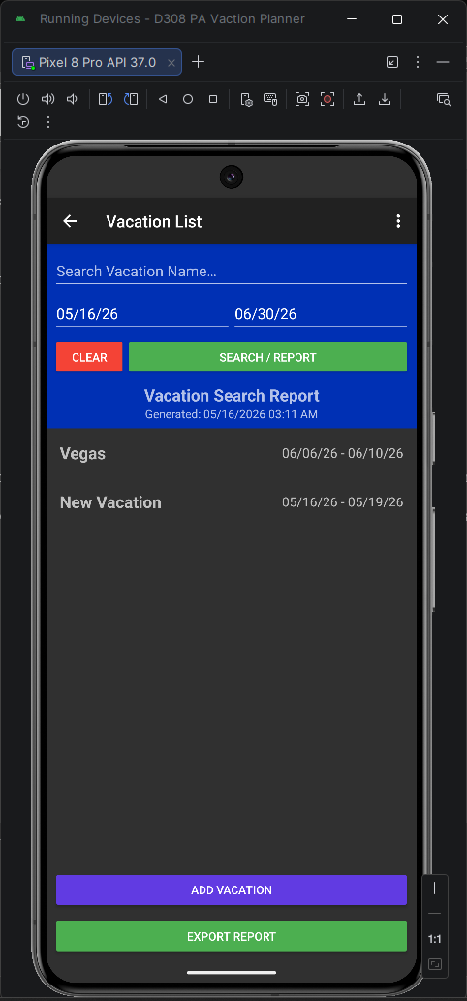

Generating a Report
- On the Vacation List screen, perform a search for vacations you would like to generate a report for.

- Once the search results have been returned, tap the “Export Report” button that appears at the bottom of the screen. A time-stamped report will be generated from your returned search results.
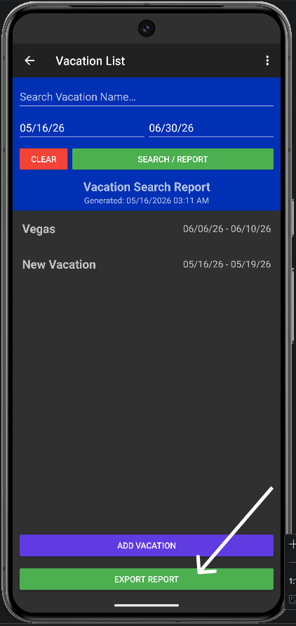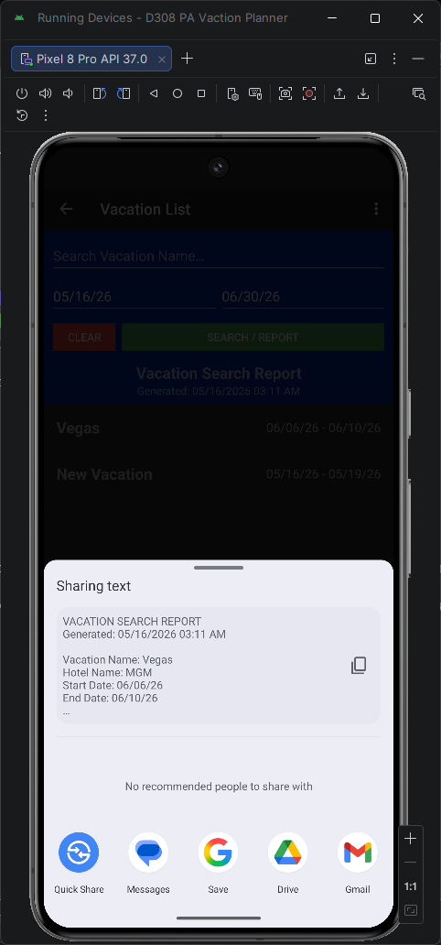
The report will include the following for each vacation in the results:
  - Vacation Name
  - Hotel Name
  - Start Date
  - End Date
- You can copy the generated report to your clipboard to paste into other note applications, or you can send the report to other apps on your device, such as your email or messaging client.
