NDT = Non-Destructive Testing.
It means testing a structure without damaging or destroying the material.
For your bridge project, NDT is basically the technology that lets you look beyond what a camera can see.

Common NDT methods for bridges
Method | What it detects | Your system
📷 Computer vision | Cracks, spalling, rust | iPhone camera + AI
📐 LiDAR | Deformation, displacement, geometry | iPhone LiDAR
🌡️ Thermal imaging | Moisture, delamination, temperature anomalies | Thermal camera
🔊 Ultrasonic testing | Internal cracks, voids, discontinuities | Raspberry Pi + transducers
📡 GPR | Rebar, tendons, voids, internal structure | Future add-on
📳 Vibration/IMU | Changes in dynamic behavior | Raspberry Pi IMU
🎤 Acoustic/impact echo | Delamination, voids, concrete condition | Microphone/sensor

The important distinction
Imagine a concrete bridge girder:
SURFACE
─────────────────────
│ crack
▼
╲ ╱
╲ ╱
│
──────┼──────────────
│
│ ← hidden void
│ ○
│
│ ← rebar/tendon
═══════════════
─────────────────────
A camera might see the surface crack.
LiDAR might see that the girder has deformed.
But neither necessarily tells you what's happening inside the concrete.
That's where NDT comes in.

For your concept
I'd frame the system as three layers:
1. Vision — "What does the surface look like?"
Camera + AI
2. Geometry — "Has the structure moved or deformed?"
LiDAR + GPS + IMU
3. NDT — "What's happening beneath the surface?"
Ultrasound + GPR + thermal/acoustic methods
So your pitch could be:
“Vision sees the surface. LiDAR sees movement. NDT sees what the surface can't.”
One caveat: NDT doesn't mean the system automatically determines whether a bridge is safe. It provides measurements and indications that engineers can use for a more detailed assessment.
Today 12:18 PM
best way to detect strucutral issues of asphalt with rasperrby pi and sensors. build out the programms i need, which LLMs are best, cost structure for a prototype, I hvae 3 days for a competition
For a 3-day competition, I would not try to build a Raspberry Pi system that directly determines the deep structural capacity of asphalt. That is too ambitious.
Instead, build a mobile pavement inspection system that combines RGB vision + 3D geometry + thermal + motion, then uses AI to turn those measurements into a road condition map.
The important distinction is:
Surface distress ≠ structural capacity.
You can reliably demonstrate cracks, potholes, rutting, deformation, roughness, and thermal anomalies. Subsurface structural problems would eventually require GPR, deflection testing, or other professional NDT. Research supports combining visual, 3D, and thermal sensing for pavement inspection; LiDAR is particularly useful for measuring geometry such as rutting and pothole depth, while thermal imaging can reveal additional distress information.

The system I'd build
ROAD INSPECTION VEHICLE
│
┌────────────────┼────────────────┐
↓ ↓ ↓
CAMERA LiDAR THERMAL
│ │ │
Cracks Rutting Temperature
Potholes Potholes anomalies
Raveling Settlement moisture/
Patches Roughness distress
│ │ │
└────────────────┼────────────────┘
↓
IMU
↓
Motion / vibration
│
↓
┌─────────────────┐
│ SENSOR FUSION AI │
└─────────────────┘
↓
ROAD CONDITION MAP
↓
┌──────────────┼──────────────┐
↓ ↓ ↓
LOCATION SEVERITY PRIORITY

The biggest change I'd make to your original idea
Don't make the Raspberry Pi do everything.
Use:

Raspberry Pi
Sensor hub + data logger

iPhone
High-quality camera + LiDAR + GPS + UI

Laptop/cloud
AI inference + processing + dashboard
That gives you much more capability in three days.

1. Your MVP sensors

A. RGB camera — absolutely essential
This detects:
- longitudinal cracks
- transverse cracks
- alligator/fatigue cracking
- potholes
- patches
- raveling
- edge damage
- lane/surface anomalies
A Raspberry Pi Camera Module 3 is inexpensive and supports autofocus/HDR. Current listings are roughly $30–40. Raspberry Pi Camera Module 3
But if you already have an iPhone, I'd use the iPhone camera instead.

Why?
Much better image quality.
Your Pi doesn't need to spend its limited processing power doing computer vision.

2. LiDAR — your best sensor for rutting/deformation
If someone on your team has an iPhone Pro with LiDAR, use it.
You can generate a point cloud:
Normal pavement

───────────────

Rutted pavement

──────\____/──────
↑
rut
You can calculate:
- pothole depth
- pothole volume
- rut depth
- surface elevation
- road roughness
- localized deformation
- settlement
LiDAR-based pavement research specifically emphasizes its ability to produce metric 3D geometry rather than merely classifying visual appearance.
This is probably your strongest differentiator over a simple "AI crack detector."

3. Thermal camera
This is where your Raspberry Pi becomes interesting.
A small MLX90640 provides a 32×24 thermal array and can communicate with Raspberry Pi over I²C.
MLX90640 IR Array Thermal Imaging Camera
$68.14 · RobotShop USA
Current examples are roughly $70–100, although prices vary substantially by vendor. Adafruit MLX90640 IR Thermal Camera Breakout
You aren't going to use it to say:
"The road has a 4.7-inch-deep structural failure."
Instead:
"This region has an abnormal thermal signature relative to surrounding pavement."
Thermal imaging has actually been researched for asphalt distress detection, including cracks and potholes, and multimodal visible + infrared imagery has shown useful performance.

4. IMU
Put an accelerometer/gyroscope on the inspection platform.
Something like:
Adafruit MPU-6050 6-DoF Accelerometer and Gyro Sensor
$12.99 · Micro Center
can provide:
- acceleration
- vibration
- pitch
- roll
- motion
You can create a crude road roughness signal:
vehicle acceleration

/\ /\
/ \ / \
___/ \___/ \____
↑
rough area
You could then correlate:
high vibration + LiDAR deformation
which is more meaningful than either signal alone.

5. GPS
You want every observation tied to a location.
Even if you just use the phone's GPS for the competition:
Crack
Lat: 34.xxxx
Lon: -118.xxxx

Pothole
Lat: 34.xxxx
Lon: -118.xxxx

Rut
Lat: 34.xxxx
Lon: -118.xxxx
Then your dashboard becomes a GIS road-condition map.

What I would NOT build in 3 days
Don't waste your competition time on:
❌ GPR
❌ ultrasonic asphalt testing
❌ professional deflection testing
❌ subsurface tomography
❌ custom LiDAR hardware
❌ training a giant neural network from scratch
❌ trying to determine remaining pavement life
Those are excellent Phase 2/3 technologies.

The software stack
Here's the actual software architecture I'd use.
DATA COLLECTION
│
┌────────────┼────────────┐
↓ ↓ ↓
Camera LiDAR Thermal
│ │ │
└────────────┼────────────┘
↓
Data Fusion
↓
┌──────────────┼──────────────┐
↓ ↓ ↓
Vision Model Point Cloud Thermal
│ Analysis Analysis
↓ ↓ ↓
CRACKS RUTS ANOMALIES
POTHOLES DEPTH
PATCHES ROUGHNESS
│ │
└──────────────┼──────────────┘
↓
RISK ENGINE
↓
DATABASE / GIS
↓
DASHBOARD

Program #1 — Data collector
Python.
Have the Pi record:
timestamp
GPS
temperature
accelerometer
gyroscope
thermal_frame
And the phone records:
RGB frame
LiDAR frame
GPS
timestamp
Critical: synchronize everything using timestamps.
You don't need sophisticated sensor fusion initially.

Program #2 — Crack/pothole detector
This is where I'd use a YOLO-style computer vision model.
Don't ask an LLM to inspect every road image.
Instead:
Image
↓
YOLO
↓
bounding boxes / segmentation
↓
crack
pothole
patch
raveling
For the competition, start with:
3 classes
CRACK
POTHOLE
OTHER_DISTRESS
You can expand later.
Recent pavement research continues to use YOLO-family models for pavement distress and deformation detection.

Program #3 — LiDAR deformation detector
This is potentially your coolest demo.
Take your point cloud:
x
y
z
Create a reference road surface.
Then calculate:
ΔZ = observed elevation - expected elevation
For example:
ROAD

0mm 0mm -2mm -4mm
│ │ │ │
───┴────┴─────┴─────┴──

↓

-38 mm
↓
───\____/───
RUT
Output:
Rut detected: 38 mm
That is much more compelling than simply drawing a box around a pothole.

Program #4 — Thermal anomaly detector
You don't even need AI initially.
Take the thermal image.
Calculate:
local_temperature
-
surrounding_temperature
Then:
if temperature_difference > threshold:
anomaly = True
Create:
NORMAL NORMAL ANOMALY

████████ ████████ ████🔴████
████████ ████████ ███🔴🔴███
████████ ████████ ████🔴████
Then overlay it onto the RGB image.

Program #5 — Sensor fusion
This is where your project becomes much more interesting.
Don't simply say:
AI found a pothole.
Instead:
VISION
Pothole probability = 91%

+

LiDAR
Depth = 42 mm

+

THERMAL
Temperature anomaly = +3.2°C

+

IMU
Vehicle vibration = 2.1σ above baseline

↓

MULTIMODAL EVENT

↓

HIGH-PRIORITY INSPECTION
Now you have a multimodal infrastructure inspection system.

Program #6 — GIS dashboard
I'd build this with Streamlit + Python.
Screen:
┌──────────────────────────────────────────────┐
│ ROAD CONDITION MONITOR │
├──────────────────────────────────────────────┤
│ │
│ MAP │
│ │
│ 🟢🟢🟡🔴🟢🟢 │
│ 🟡 🔴 │
│ │
├──────────────────────────────────────────────┤
│ DETECTED DISTRESS │
│ │
│ 🔴 Pothole 42 mm HIGH │
│ 🟡 Crack 1.8 m MEDIUM │
│ 🟡 Rut 31 mm MEDIUM │
│ 🔴 Thermal +3.2°C HIGH │
│ │
└──────────────────────────────────────────────┘
Clicking the red point opens:
LOCATION #037

Pothole
Depth: 42 mm
Area: 0.31 m²

Thermal anomaly: YES
LiDAR anomaly: YES
IMU anomaly: YES

Confidence: 94%

Recommended:
Targeted pavement engineering inspection

What LLMs should you use?
This is important:
Don't use an LLM as the primary defect detector.
Use specialized computer vision models for that.
Use LLMs as your engineering/coding agents.

My stack
Job | Tool
Coding | GPT-5.6 Luna / ChatGPT
Debugging | GPT-5.6 Luna
Architecture | GPT-5.6 Luna
Computer vision | YOLO + OpenCV
Image segmentation | YOLO segmentation / SAM-style model
Point cloud | Open3D
Data analysis | Python + NumPy/Pandas
Dashboard | Streamlit
Maps | Mapbox/Leaflet/Plotly
Database | SQLite
Thermal processing | NumPy/OpenCV
Sensor interface | Python GPIO/I²C
Documentation | LLM
If you have access to multiple models, you can use one LLM for code generation and another as a reviewer/debugger, but don't spend your three days building a complicated multi-agent architecture.

Hardware budget
You can actually make this relatively cheap.

If you already have an iPhone Pro
Component | Approx.
Raspberry Pi Zero 2 W | ~$15–30
Camera | ~$30–40
MLX90640 | ~$70–100
MPU6050 | ~$5–15
GPS | ~$15–30
MicroSD | ~$10
Battery/power bank | ~$15–25
Wires/breadboard | ~$10
Mount | ~$10–20
Total | ~$180–285
A current Pi Zero 2 W listing I found is around $14–15 from one specialist retailer, while other marketplaces can be dramatically more expensive, so don't pay $90+ for one. Raspberry Pi Zero 2 W
You can also skip the separate Pi camera entirely if the iPhone handles RGB.
That gets you closer to:

~$100–180 incremental hardware
because your iPhone provides the primary camera/LiDAR/GPS.

But here's the version I'd actually build

Hardware
IPHONE PRO
┌────────────────┐
│ RGB CAMERA │
│ LiDAR │
│ GPS │
│ IMU │
└───────┬────────┘
│ WiFi/Bluetooth
↓
RASPBERRY PI ZERO 2 W
┌──────────────────────┐
│ MLX90640 Thermal │
│ MPU6050 IMU │
│ Data Logger │
└──────────┬───────────┘
│
↓
LAPTOP
│
┌──────────┴──────────┐
│ │
AI ENGINE GIS ENGINE
│ │
YOLO/OpenCV Open3D/Map
│ │
└──────────┬──────────┘
↓
DASHBOARD

Your 3-day schedule

DAY 1 — Make sensing work

Morning
Get:
- Pi running
- camera working
- thermal sensor working
- IMU working
- iPhone LiDAR scan working
Don't touch AI yet.

Afternoon
Write one Python collector:
collect.py
which outputs:
/data/
timestamp.csv
thermal/
images/
imu/
lidar/

Evening
Build the basic dashboard.

DAY 2 — AI + geometry
Build:

Vision
image → YOLO → distress

LiDAR
point cloud → road plane → ΔZ → rut/pothole depth

Thermal
thermal → temperature map → anomaly
Get all three working independently.

DAY 3 — The "wow" factor
Don't add more sensors.
Fuse what you already have.
Demo:

Scan #1
Healthy road.
🟢 NORMAL

Modify your test road
Put:
- fake pothole
- crack
- depressed section
- warm/cold material
- patch
Then scan again.
Your system says:
ROAD SEGMENT 014

VISION
🔴 Pothole detected
Confidence: 93%

LiDAR
🔴 Depression: 41 mm

THERMAL
🟡 Temperature anomaly: +2.8°C

IMU
🟡 Vibration anomaly

────────────────────────

MULTIMODAL ANOMALY SCORE

87 / 100

PRIORITIZE INSPECTION
That is your demo.

The really important product insight
I'd actually change your wording from:
"Structural inspection of asphalt."
to:
"Automated pavement condition and deterioration monitoring."
Because your system can legitimately demonstrate:
Surface condition
→ cracks / potholes
Geometric condition
→ rutting / settlement / deformation
Thermal condition
→ anomalies / potential distress
Dynamic condition
→ vibration / roughness
Historical condition
→ how all of those measurements change over time.
The last one is particularly powerful.

Your eventual product
Imagine the same road scanned:
January
Crack = 1.2 m
Rut = 8 mm
April
Crack = 2.1 m
Rut = 13 mm
July
Crack = 4.8 m
Rut = 27 mm
Your system recognizes:
Deterioration accelerating at Segment 143.
Then the city doesn't have to inspect every mile equally.
It can prioritize the specific road segments showing measurable deterioration.
That is a much stronger long-term concept than simply "Raspberry Pi detects potholes."

One more important limitation
For your competition, call the output "inspection priority" or "condition anomaly," not "structural failure." Surface imagery and LiDAR are excellent for screening, but they cannot by themselves establish subsurface pavement structural capacity. Current reviews explicitly distinguish 2D visual, 3D geometric, and subsurface sensing such as GPR for this reason.
If you have exactly 3 days, I'd put roughly 70% of your effort into RGB + LiDAR + dashboard, 20% into thermal/IMU, and 10% into the Raspberry Pi sensor integration. That gives you the highest probability of having a working end-to-end demonstration rather than five half-working sensors.
how can i make this at low input and automated as possible?
Yes. If your goal is low human input + highly automated inspection, I would change the concept from a “sensor that an inspector operates” into a drive-over autonomous pavement monitoring system.
The basic idea:
Mount one sensor box on a car → drive normally → automatically capture road data → AI detects anomalies → GPS maps them → system prioritizes what needs inspection.

The lowest-input architecture
🚗 NORMAL VEHICLE
│
┌────────▼────────┐
│ SENSOR BOX │
│ │
│ Camera │
│ LiDAR │
│ IMU │
│ Thermal │
│ GPS │
└────────┬────────┘
│
ONE BUTTON
│
▼
AUTOMATIC CAPTURE
│
▼
AI PROCESSING
│
┌────────────┼────────────┐
▼ ▼ ▼
SURFACE GEOMETRY MOTION
ISSUES ISSUES ISSUES
│ │ │
└────────────┼────────────┘
▼
SENSOR FUSION
│
▼
GPS ROAD MAP
│
▼
PRIORITY QUEUE
│
▼
🚨 INSPECT THESE
LOCATIONS
The human should ideally only do:
Mount → Start → Drive.
Everything else happens automatically.

1. Don't make the Raspberry Pi the brain
This is probably the biggest architectural change I'd make.
Use:

Raspberry Pi
Sensor controller

Phone
Camera + LiDAR + GPS + user interface

Cloud/laptop
AI + heavy processing
That keeps the physical device cheap and simple.

2. Make the sensor box completely self-contained
Build something like:
┌──────────────────────────┐
│ ROADSCAN BOX │
│ │
│ 📷 Camera │
│ │
│ 🌡️ Thermal │
│ │
│ 📡 LiDAR │
│ │
│ 📳 IMU │
│ │
│ GPS │
│ │
│ Raspberry Pi │
│ │
│ Battery │
└────────────┬─────────────┘
│
Wi-Fi/5G
│
▼
Cloud
Mount it to the roof/front of the vehicle.
You don't want someone holding sensors.

3. Automatic triggering
You don't want:
"Press button every time you see a pothole."
Instead:

Continuous capture
Camera:
30 FPS
LiDAR:
continuous scanning
IMU:
100+ Hz
GPS:
1–10 Hz
Thermal:
several frames/sec
Then software automatically decides which data is worth saving.

4. Use the IMU to trigger higher-resolution inspection
This is a clever way to reduce computing requirements.
Suppose the car normally produces:
Acceleration

───────────────
normal
Then:
──────────╱╲────────
↑
big impact
The Pi recognizes:
Large vertical acceleration detected.
Then automatically tells the camera:
Save high-resolution frames from ±3 seconds around this event.
So you're not processing every frame equally.

5. Automatically detect road anomalies
You can create several independent detectors.

Vision
Camera
↓
YOLO
↓
crack
pothole
patch
raveling

LiDAR
Point cloud
↓
road surface model
↓
elevation deviation
↓
rut / pothole / settlement

IMU
Acceleration
↓
filter noise
↓
detect spikes
↓
roughness event

Thermal
Thermal image
↓
compare neighboring pavement
↓
temperature anomaly

6. Then automatically combine them
This is where I'd make your system much more sophisticated.
Don't have an LLM decide whether something is dangerous.
Create a deterministic condition engine.
For example:
VISION
Pothole: 92%
+
LIDAR
Depth: 43 mm
+
IMU
Impact: 3.1σ
+
THERMAL
Anomaly: YES
↓
CONDITION ENGINE
↓
Priority = HIGH
The AI/LLM can then explain the result:
"A 43 mm depression was detected at this location. Computer vision independently identified a pothole and vehicle acceleration exceeded the local baseline."

7. Automatically create a road "health score"
Break the road into segments.
For example:
every 10 meters.
Road
─────────────────────────────────────────
0 10 20 30 40 50m
🟢 🟢 🟡 🔴 🟢 🟡
Each segment gets:
Segment 30

Cracking 72/100
Potholes 91/100
Rutting 84/100
Roughness 76/100
Thermal 44/100

Overall condition:
HIGH PRIORITY
Now your system can automatically produce a maintenance list.

8. Make the system learn the road's baseline
This is probably the most valuable automation feature.
Don't rely entirely on generic thresholds.
The first time the car drives a road:

Baseline
Segment 100
Elevation = baseline
Acceleration = baseline
Temperature = baseline
Cracking = baseline
Next drive:
Segment 100

Elevation change = -11 mm
Acceleration = +18%
Crack length = +0.8m
The system automatically says:
Deterioration detected.
You don't need an engineer manually comparing two scans.

9. Repeated autonomous monitoring
This is where it becomes a real product.
You could put your device on:
- garbage trucks
- street sweepers
- city maintenance vehicles
- buses
- delivery fleets
- utility vehicles
These vehicles are already driving roads every day.
That means you don't need to send an inspection vehicle everywhere.
Imagine:
CITY FLEET

🚛 Garbage Truck #12
↓
47 miles

🚌 Bus #34
↓
82 miles

🚚 Utility Truck #8
↓
31 miles
All of them continuously collect road-condition data.
Your software merges everything.
CITY ROAD DATABASE

8,421 miles
│
▼
14,231 segments
│
▼
438 anomalies
│
▼
37 high-priority
│
▼
MAINTENANCE QUEUE
That is much more scalable than dedicated inspectors.

10. The automation loop
I'd make your entire product revolve around this:

IDENTIFY
AI automatically detects:
- crack
- pothole
- rut
- deformation
- unusual vibration
- thermal anomaly
↓

LOCATE
GPS automatically assigns:
Lat
Lon
Road
Lane
Segment
↓

VERIFY
Multiple sensors cross-check the anomaly.
↓

PRIORITIZE
System calculates:
severity
+
confidence
+
rate of deterioration
+
traffic exposure
↓

ACTION
Automatically generates:
Maintenance ticket #1842
Location:
Segment 38

Issue:
Pothole

Depth:
43 mm

Detected:
Sept 25

Priority:
High

Evidence:
Camera ✓
LiDAR ✓
IMU ✓

Suggested action:
Targeted pavement inspection

11. You can even automate the maintenance side
This is where your previous infrastructure idea can become much bigger.
Don't stop at:
"We found a pothole."
Build:
Detect → Predict → Prioritize → Dispatch → Verify
ROAD DATA
↓
DETECT
↓
PREDICT
↓
PRIORITIZE
↓
DISPATCH
↓
MAINTENANCE CREW
↓
REPAIR
↓
DRIVE OVER AGAIN
↓
VERIFY
After the crew repairs it:
Before:
🔴 Pothole 43 mm

After:
🟢 Surface restored
Your vehicle becomes the automated verification system.

For your 3-day competition
I would simplify this dramatically.

Build only this:

Hardware
iPhone Pro + Raspberry Pi + MLX90640 + IMU
No custom ultrasonic.
No GPR.
No drone.
No robotics.

Software
Build 5 programs:
1. collector.py
↓
2. vision_detector.py
↓
3. lidar_analyzer.py
↓
4. sensor_fusion.py
↓
5. dashboard.py

One drive
Drive over a controlled test road.
Your system automatically generates:
ROADSCAN REPORT

Distance scanned: 0.8 miles

Segments analyzed: 127

Cracks: 18
Potholes: 7
Rutting events: 4
Thermal anomalies: 3
Vibration anomalies: 9

MULTI-SENSOR CONFIRMED:
5

HIGH PRIORITY:
2

──────────────

LOCATION #47
Pothole
Depth: 41 mm
Camera: 94%
LiDAR: confirmed
IMU: confirmed

→ Maintenance inspection recommended
That would be a very compelling 3-day MVP because the judge sees the entire pipeline rather than a cool sensor sitting on a table.

And your long-term pitch becomes:
“We don't send inspectors to find problems. We turn vehicles already driving the roads into autonomous infrastructure inspectors.”
That's the direction I'd take if your goal is maximum automation with minimum human input.
Absolutely. If you structure the opportunity around the four verbs in the prompt — identify → predict → automate inspection → prioritize — there are a lot of directions beyond “car-mounted crack detector.”
The most interesting ideas use multiple existing data streams so you're solving the problem of too much data + too much manual work, rather than just adding another sensor.

1. AI “Inspector Agent”
Instead of just detecting damage, an AI agent manages the entire inspection workflow.
Data comes in:
- Drone imagery
- Vehicle cameras
- Satellite imagery
- IoT sensors
- Previous inspection reports
- Weather
- Seismic events
- GIS
Then:
AI Agent
→ identifies anomaly
→ checks historical records
→ determines whether anomaly is new
→ estimates severity
→ determines inspection type needed
→ creates work order
→ assigns inspection crew
→ tracks completion
→ updates asset history
The human becomes the exception handler, rather than manually managing every inspection.

2. Autonomous “inspection scheduling”
This is different from damage detection.
The AI constantly asks:
What should we inspect tomorrow?
It considers:
- Asset age
- Condition
- Previous inspection
- Recent deterioration
- Weather
- Earthquakes
- Traffic/load
- Failure consequences
- Inspector availability
- Geographic proximity
Then automatically creates:
Tomorrow's inspection route
For example:
Crew 1
8:00 AM → Bridge A
9:15 AM → Bridge C
10:00 AM → Road D
11:30 AM → Utility Pole F

Reason:
High deterioration + recent seismic activity
This directly attacks the manual planning problem.

3. AI route optimization for inspectors
Take it one step further.
Instead of:
“Which assets need inspection?”
ask:
“What's the most efficient way to inspect everything that needs inspection?”
The system combines:
Risk × location × inspection type × crew skills × traffic × travel time
and generates optimized routes.
This could save substantial field time without requiring better sensors.

4. “Inspection by exception”
This is probably one of the strongest concepts.
Instead of inspecting every asset equally:

Normal
AI sees:
No meaningful change.
→ No inspection required

Uncertain
Something changed.
→ Quick visual inspection

High risk
Multiple independent signals indicate deterioration.
→ Engineer/NDT inspection
So you're turning:
100% manual inspection
into:
AI screening → human inspection only where necessary.

5. Multi-agent infrastructure monitoring
You could have specialized AI agents:

👁️ Vision Agent
Finds visible damage.

📡 Sensor Agent
Analyzes vibration/temperature/acoustic data.

🌎 Geospatial Agent
Analyzes location, terrain, flooding, seismic exposure.

📚 History Agent
Reads inspection reports and maintenance records.

🔮 Prediction Agent
Estimates deterioration.

🚨 Response Agent
Prioritizes and creates work orders.
Then they collaborate:
Vision Agent:
"Crack detected."

Sensor Agent:
"Vibration increased 31%."

Geospatial Agent:
"Earthquake occurred 2.8 miles away."

History Agent:
"Same location had corrosion 14 months ago."

Prediction Agent:
"Deterioration probability increased."

Response Agent:
"Schedule inspection within 72 hours."
That is much more compelling than one generic AI model.

6. Automatically determine what kind of inspection is needed
This is an overlooked problem.
Not every anomaly requires the same response.
AI could classify:
Detection | Recommended inspection
Surface crack | Visual/CV
Suspected delamination | Thermal/ultrasound
Ground movement | LiDAR/GPS
Excessive vibration | Accelerometer
Corrosion | NDT
Possible internal concrete defect | GPR/ultrasound
Bearing anomaly | Specialized structural inspection
So instead of simply:
“Something is wrong.”
the system says:
“Something is potentially wrong, and this is the cheapest appropriate way to investigate it.”

7. Autonomous “second opinion”
Imagine an engineer receives an inspection report.
AI independently analyzes:
- Images
- Measurements
- Previous reports
- Sensor data
and says:
“Three defects in this inspection may warrant additional review.”
This is useful because human inspections themselves can be inconsistent.
You're not replacing the engineer; you're providing quality control.

8. Automatically compare every inspection to every previous inspection
This could be extremely valuable.
Today:
Inspector looks at 2026 photos
and may need to manually compare them with:
2025 photos + 2024 report + 2023 report.
AI does it automatically.
2024
██████

2025
████████

2026
████████████
Then:
Crack length increased ~40% over 24 months.
The key is longitudinal infrastructure intelligence.

9. Automatically detect “silent deterioration”
Some infrastructure problems aren't obvious visually.
You could look for behavioral changes.
For example:
Normal vibration pattern
████████████

Current vibration
██████████████████
The system flags:
Behavior deviates from historical baseline.
Potentially useful for:
- Bridges
- Railways
- Machinery
- Pipelines
- Industrial structures
- Utility infrastructure
This gets you beyond pure computer vision.

10. Crowdsource infrastructure inspection
Turn every smartphone into an inspection device.
Someone records a video while walking/driving.
AI extracts:
- Location
- Images
- Defects
- Road condition
- Infrastructure type
Then automatically merges observations.
If 50 people independently report the same location, confidence increases.
Citizen 1 ─┐
Citizen 2 ─┤
Bus camera ├──→ AI → confirmed anomaly
Drone ─────┤
Satellite ─┘
This creates a distributed infrastructure sensor network.

11. Vehicles as “inspection swarms”
Instead of one inspection vehicle:
100 existing vehicles collect data.
For example:
Bus 17 ─────┐
Bus 23 ─────┤
Delivery 4 ─┤
Taxi 82 ────┤──→ Infrastructure AI
Garbage 11 ──┤
Police 7 ────┘
You don't need dedicated inspection trips.
The system piggybacks on existing mobility.
That's a particularly strong answer to the prompt's emphasis on the unprecedented amount of data.

12. Predict where failures will happen
Instead of predicting:
“Bridge A will fail.”
(which is extremely difficult)
predict:
“These areas have an unusually high deterioration trajectory.”
Use:
Asset characteristics + environmental conditions + historical deterioration + sensor signals + traffic + weather.
Then create a heatmap:
LOW RISK
🟢🟢🟢🟢

MEDIUM
🟡🟡🟡

HIGH
🔴🔴
This is much more realistic.

13. AI maintenance budget allocator
Now you're attacking the prioritize component directly.
Suppose an agency has:
$10M maintenance budget
and:
2,000 assets.
AI produces scenarios:

Scenario A
Fix 8 major assets.

Scenario B
Fix 30 moderate assets.

Scenario C
Preventative maintenance across 100 assets.
Then show:
Expected risk reduction / dollar spent.
This turns infrastructure inspection into a capital allocation problem.

14. “Digital twin that updates itself”
Create a digital representation of the infrastructure.
But instead of a static digital twin:
Every new observation updates it automatically.
BRIDGE 182

Structure
├── Deck
├── Bearings
├── Girders
├── Piers
└── Foundation

Data
├── 2024 inspection
├── 2025 drone scan
├── 2026 vehicle scan
├── Sensor data
└── Seismic events
AI continuously updates the condition of each component.

15. Disaster mode
This is where your everyday system becomes extremely powerful.
Normal day:
Continuously monitor.
Earthquake happens:
SYSTEM SWITCHES TO DISASTER MODE
Immediately:
- Identify affected assets
- Compare before/after imagery
- Analyze sensor anomalies
- Estimate damage
- Rank assets
- Generate inspection routes
- Dispatch crews
- Continuously update the map
So instead of having a separate disaster product:
Your normal infrastructure monitoring system becomes an emergency response system.

16. The really ambitious version: “self-driving inspection”
Eventually:
Autonomous vehicle
↓
Infrastructure scanning
↓
AI detects anomaly
↓
Vehicle automatically slows down
↓
Captures additional imagery
↓
Changes sensor configuration
↓
Uploads evidence
↓
AI determines inspection priority
The vehicle itself decides:
“I saw something unusual. I'm going to collect more data here.”
That's an exciting long-term vision, even if your competition prototype only demonstrates the first pieces.

How I'd organize your competition concept
You could frame the whole platform as:

IDENTIFY → PREDICT → INSPECT → PRIORITIZE

👁️ IDENTIFY
What is wrong?
Camera + thermal + LiDAR + vibration + satellite
↓

🔮 PREDICT
What is getting worse?
Historical observations + environmental data + sensor trends
↓

🤖 AUTOMATE INSPECTION
What needs a human and what doesn't?
AI screening + inspection scheduling + route optimization + work orders
↓

🎯 PRIORITIZE
Where should limited resources go?
Risk × consequence × uncertainty × cost

And your Raspberry Pi fits beautifully
Don't make the Raspberry Pi the product.
Make it your physical-world data collection node.
PHYSICAL WORLD
↓
┌────────────────────────┐
│ MOBILE SENSOR NODE │
│ │
│ Camera │
│ IMU │
│ GPS │
│ Thermal │
│ Optional ultrasonic │
└───────────┬────────────┘
↓
RAW DATA
↓
┌────────────────────────┐
│ AI INFRASTRUCTURE │
│ │
│ Identify │
│ Predict │
│ Compare │
│ Prioritize │
└───────────┬────────────┘
↓
INSPECTION QUEUE
↓
┌────────────────────────┐
│ "GO LOOK HERE FIRST" │
└────────────────────────┘
For the 3-day competition, I'd build the smallest convincing version of that loop: a Pi-mounted camera + IMU + GPS, automated data collection, CV anomaly detection, GPS mapping, and an AI-generated ranked inspection queue. Then present autonomous inspection scheduling, multi-source sensor fusion, and predictive maintenance as the expansion path.
Go.AI, On-Premises AI for Regulated Industries
Private AI On-Prem
Deploy secure AI in your own environment.
Ad
More options
how would this be best for roads (asphalt?) over just dirving over it?
Yes. Roads/asphalt may actually be the easiest place to make the Raspberry Pi vehicle concept work in 3 days, because you can detect several meaningful surface-level problems simply by driving over/along the road.
The key is to distinguish “drive over it and measure it” from “drive over it and somehow see through the asphalt.”

Best road setup
I'd build a mobile road-condition scanner:
CAR
┌──────────────────┐
│ Raspberry Pi │
│ │
│ 📷 Camera ───────┼──→ road ahead
│ │
│ 📡 IMU ──────────┤
│ │
│ 📍 GPS ──────────┤
│ │
│ 🌡 Thermal ──────┤
└──────────────────┘
↓
ASPHALT

The most important sensor isn't ultrasound.
For asphalt, I'd prioritize:
Camera > IMU > GPS > LiDAR/ToF > thermal > ultrasound

1. Camera: detect what's actually visible
Point the camera toward the road.
You can identify:
- Potholes
- Cracks
- Alligator cracking
- Rutting
- Patches
- Faded markings
- Surface deterioration
- Debris
- Standing water
- Manhole abnormalities
For example:
CAMERA

↓
┌─────────────────────┐
│ asphalt │
│ │
│ ╲ ╱ │
│ ╲ crack │
│ ╲ │
│ ○ pothole │
└─────────────────────┘
The important thing is that the AI doesn't just say “pothole.”
It records:
Pothole → location → size → severity → image → time

2. IMU: detect what the car physically experiences
This is where your concept gets much more interesting.
Put an accelerometer/IMU on the vehicle.
When you drive over:

Normal asphalt
acceleration
│
│ ~~~~~~~~
│ ~~~~~~~~~~~~
└──────────────→ time

Pothole
acceleration
│
│ /\
│ / \
│____/ \________
└──────────────────→ time
You can detect:
vertical acceleration spike
and associate it with the GPS location.
So you have two independent signals:
Camera: “I see a pothole.”
IMU: “The vehicle experienced a sharp impact.”
Together → higher confidence.

3. You can actually use the vehicle's suspension as a sensor
This is a really cool angle for the pitch.
You don't necessarily need sophisticated infrastructure sensors.
The car is already interacting with the road.
The road causes:
vertical acceleration + vibration + pitch + roll
Your system can measure those.
You can essentially turn the vehicle into a mobile road profiler.

4. GPS turns measurements into infrastructure intelligence
Every anomaly gets a coordinate.
For example:
08:32:11
34.05281, -118.2432
Acceleration: +3.4g
Camera: pothole 91%
Then:
08:37:42
34.05401, -118.2418
Acceleration: +2.7g
Camera: crack 84%
Put these on a map.
Now you've created:

Road condition heatmap
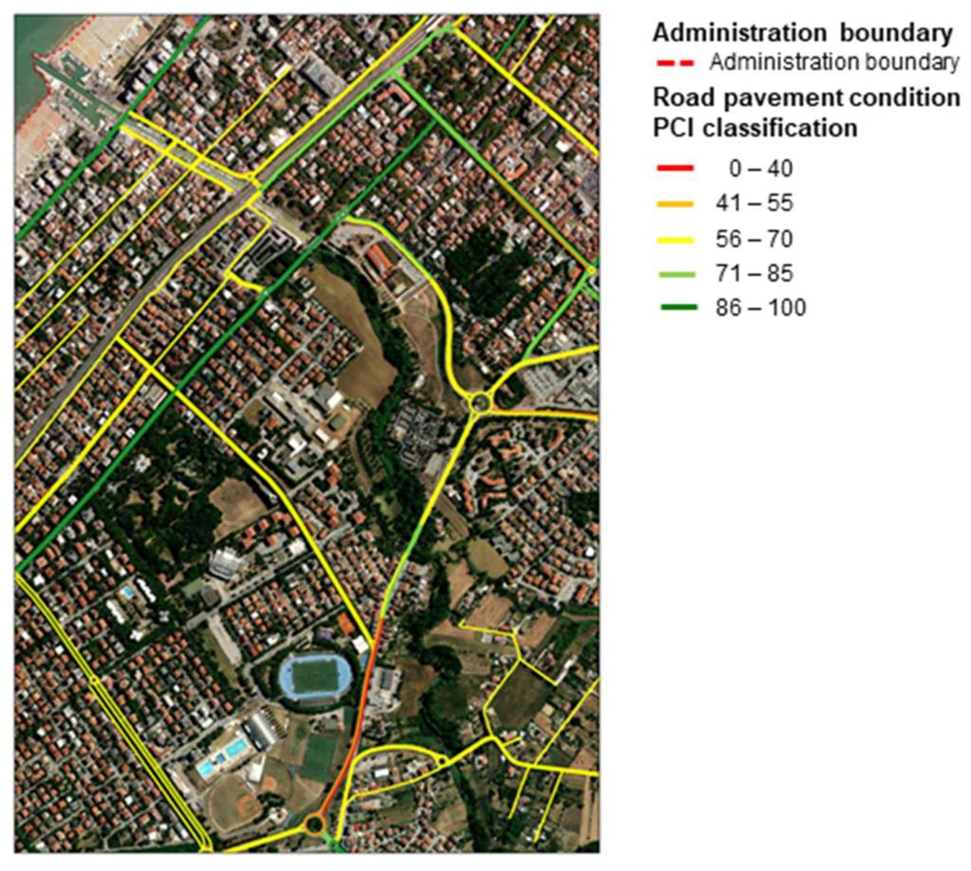
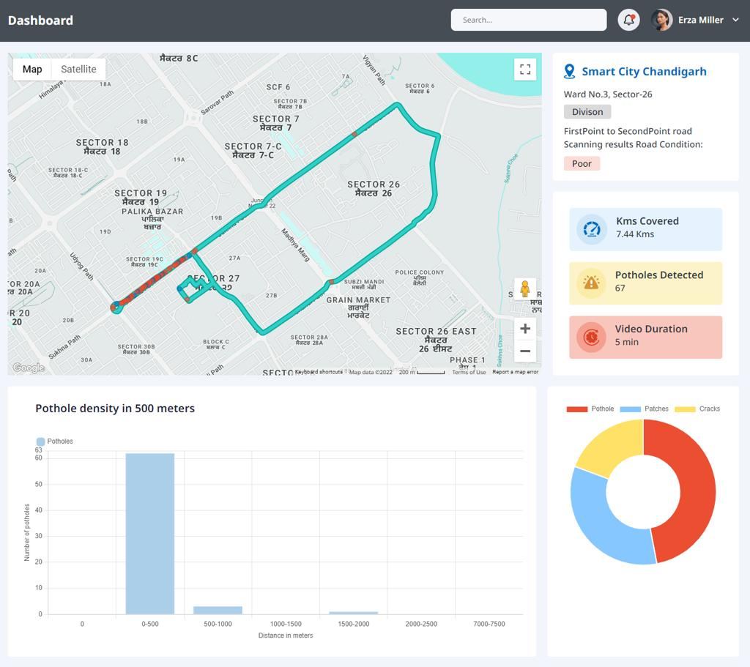
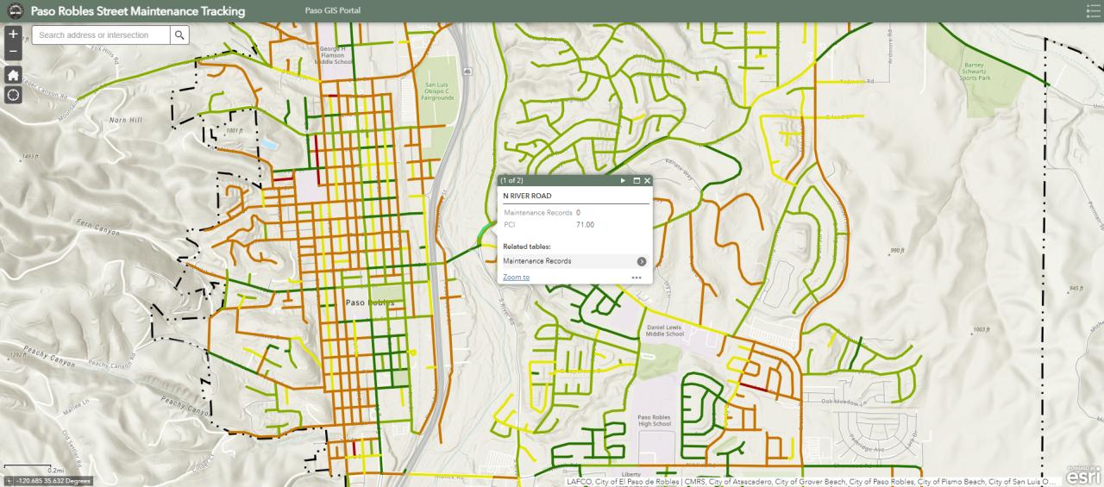
7
🟢 🟢 🟢
🟢 🟡
🔴
🟡
🟢 🔴

5. The really cool part: repeated drives
Suppose a city bus drives the same road every day.

Day 1
Road segment 184
Condition: 82

Day 30
Condition: 75

Day 60
Condition: 61
AI says:
Rapid deterioration detected.
You don't necessarily need to understand the internal mechanics of the asphalt.
You're identifying a changing physical signature.

6. You can detect rutting
Rutting is when the wheel paths become depressed.
This is where a LiDAR/ToF sensor becomes useful.
You could mount one looking down at the road.
Conceptually:
Normal road:

_________
/ \
_____/ \_____

Rutted road:

___________
______/ \____
\___________/
A distance sensor can detect the road profile.
With multiple measurements across the road, you can estimate surface deformation.
For a 3-day prototype, though, I wouldn't make this your primary feature unless you already have the hardware.

7. Thermal is more of a secondary signal
A thermal camera can potentially identify:
- Temperature differences
- Water/moisture-related anomalies
- Different surface materials
- Some pavement deterioration patterns
But don't pitch:
“Thermal camera detects structural failure.”
That's too strong.
Instead:
Thermal data provides another signal that can help identify unusual pavement conditions.

8. Ultrasound is the wrong first move for asphalt
This is important.
A cheap ultrasonic distance sensor:
HC-SR04
basically asks:
“How far away is the surface?”
It doesn't ask:
“What's happening 10 cm beneath the asphalt?”
Professional ultrasonic testing uses very different transducers, frequencies, coupling methods, signal processing, etc.
So for your competition:

Don't spend your 3 days trying to make cheap ultrasound inspect asphalt internally.
Use:
Camera + IMU + GPS.
You can add thermal or distance sensing if you have time.

9. Make the inspection completely automatic
The vehicle doesn't need an inspector sitting there.
You could have:
CAR STARTS
↓
Pi starts recording
↓
GPS continuously records location
↓
Camera continuously records road
↓
IMU continuously records vibration
↓
AI analyzes data
↓
Anomaly detected?
↓
YES
↓
Capture high-resolution image
↓
Save GPS coordinate
↓
Calculate severity
↓
Add to inspection queue
At the end:
“4.2 miles scanned.”
“17 anomalies detected.”
“3 require immediate inspection.”

10. You can make it much smarter than just detecting potholes
Imagine:

Camera
Crack probability: 92%

IMU
Vibration anomaly: 2.8σ

Historical data
Same location flagged 3 times

Weather
Heavy rainfall last 48 hours
AI:
🔴 HIGH PRIORITY
That is much more powerful than:
“I found a pothole.”

11. Your actual product could be “Road Health Score”
Divide the road into segments:
100m segment
and calculate:
Road Health =

surface defects
+ vehicle vibration
+ deterioration trend
+ environmental exposure
+ historical observations
Then:
Road Segment | Health | Action
A | 91 | Monitor
B | 76 | Routine maintenance
C | 43 | Inspect
D | 21 | Immediate inspection
Again, call it a screening/priority score, not an engineering safety certification.

12. The best 3-day prototype
I would not attempt to build a sophisticated sensor array.
Build this:

Hardware
Raspberry Pi
- Pi Camera
- MPU6050/other IMU
- GPS module
- Optional thermal camera

Software
Camera
↓
Computer vision
↓
Crack / pothole detection

IMU
↓
Vibration analysis
↓
Road roughness / impact detection

GPS
↓
Geospatial coordinates

↓

SENSOR FUSION

↓

ROAD CONDITION MAP

↓

PRIORITIZED INSPECTION LIST

Demo
Drive over:
- Normal asphalt
- Crack
- Pothole/bump
- Rough pavement
And show your dashboard automatically change:
SCANNING...

████████████████ 100%

4.1 miles scanned
1,823 observations
23 anomalies

🔴 3 HIGH PRIORITY
🟡 7 MEDIUM
🟢 13 LOW
Then click one:
Road Segment 43
📍 GPS location
📷 Pothole detected — 93% confidence
📈 Vehicle impact — 3.2σ above baseline
📅 Previously flagged 21 days ago
📉 Condition deteriorating
Recommendation: Dispatch maintenance crew
That is a very compelling competition prototype because you're demonstrating the entire loop:
drive → automatically collect → identify → corroborate → geolocate → detect deterioration → prioritize → dispatch.
ideas to provide automated inspections and how to take action with automated maintencance and recovery resources within the 3 days competition
Yes. For a 3-day competition, I would shift the prototype from “AI detects road damage” to “AI autonomously turns detection into a maintenance action.”
The impressive part of the demo should be:
Something gets detected → the system decides what inspection is needed → creates the work order → assigns the right resource → optimizes the route → closes the loop.
You don't need actual autonomous road repair. You need to automate the decision and dispatch workflow.

1. Automated inspection-on-demand
Instead of a fixed inspection schedule:
Vehicle detects anomaly
→ AI checks confidence
→ checks whether it has been seen before
→ determines severity
→ automatically creates inspection request.
Example:
🔴 Road Segment #143
Pothole detected: 91%
Vehicle impact: 3.4σ
Previously detected: No
Traffic volume: High
Action: Create inspection work order.
Then the system generates:
Inspection #4821
- Location: GPS coordinate
- Issue: Suspected pavement failure
- Required equipment: Camera + measurement
- Priority: High
- Deadline: 24 hours
This is very achievable in 3 days.

2. AI decides whether a human inspection is even necessary
This is an important automation layer.
DETECTED
↓
AI CONFIDENCE
↓
┌───────────┴───────────┐
↓ ↓
HIGH CONFIDENCE UNCERTAIN
↓ ↓
Automated action Human inspection
↓
Maintenance
For example:

Small crack
Monitor automatically.

Large pothole
Create maintenance request.

Major anomaly + abnormal vibration
Send inspector.

Multiple signals + critical road
Escalate immediately.
You're automating triage.

3. Automated inspection route generation
This could be one of the easiest impressive features.
Suppose your system finds:
17 anomalies
Instead of giving an engineer a list, it creates:
Today's inspection route
DEPOT
↓
🔴 #17
↓
🔴 #4
↓
🟡 #11
↓
🔴 #2
↓
🟡 #9
↓
DEPOT
Optimize based on:
- Severity
- Distance
- Traffic
- Crew availability
- Required equipment
- Estimated inspection duration
You can implement this with a basic routing algorithm/API.

4. Automated crew assignment
Now add a resource layer.
Imagine you have:
Crew | Capability | Location
Crew A | Pavement | 2 mi
Crew B | Structural | 8 mi
Crew C | Electrical | 4 mi
AI determines:
Crew A → Road #17
rather than simply notifying everyone.
For bridges:
Structural Crew B → Bridge #4
For a power line:
Electrical Crew C → Pole #82
This directly addresses “rapidly prioritize recovery.”

5. Automated maintenance work orders
Once an anomaly passes a threshold:
AI
↓
Maintenance required
↓
Generate work order
Your prototype dashboard could show:

WORK ORDER #1847
Asset: Road Segment 43
Problem: Pothole
Severity: High
Coordinates: 34.x, -118.x
Evidence: Image + IMU
Recommended action: Patch pavement
Estimated duration: 45 min
Assigned crew: Crew A
ETA: 18 min
Then have a button:
DISPATCH
You don't actually need to connect to a city's maintenance system. Your prototype can simulate the downstream action.

6. Automated maintenance recommendation
Don't just detect the problem.
Recommend what to do.
For example:
Detection | AI Recommendation
Small crack | Monitor
Large crack | Seal
Pothole | Patch
Extensive cracking | Resurface
Severe deformation | Engineer inspection
Possible subsurface issue | NDT inspection
Flood damage | Drainage assessment
The system can use a simple rules engine for the competition.
You can honestly describe this as:
AI-assisted maintenance decisioning
rather than pretending your model has engineering authority.

7. Automated recovery prioritization
This is where the disaster component comes in.
Imagine an earthquake occurs.
Your system receives:
Earthquake location
↓
Automatically identifies infrastructure within the affected radius.
EARTHQUAKE
↓
Affected assets
↓
AI damage screening
↓
Risk ranking
Then:

Recovery Queue
1 🔴 Bridge A
Critical route
Suspected damage: 86%

2 🔴 Road B
Hospital access
Damage probability: 74%

3 🟡 Road C
Moderate traffic
Damage probability: 51%

4 🟢 Road D
Low traffic
Damage probability: 12%
Now you aren't just detecting damage.
You're answering:
“Where should the first recovery crew go?”

8. Add criticality to your prioritization
This makes the system much more realistic.
A pothole on a quiet residential street isn't equivalent to one on an emergency route.
Your score could be:
Priority =
Damage likelihood × severity × infrastructure criticality × traffic × uncertainty
For example:
Pothole A
Damage: 80
Traffic: 20
Criticality: 20

→ Medium priority

Pothole B
Damage: 70
Traffic: 95
Criticality: 90

→ HIGH priority
That is a much better story than simply ranking by damage severity.

9. Automated “what if?” resource allocation
This could be a killer dashboard feature.
Suppose the city has:
5 crews
and:
37 damaged locations.
Your system determines:
If we dispatch these five crews first, we address 68% of estimated infrastructure risk.
Then the user can change:
Available crews: 5 → 2
and the system recalculates.
Or:
Budget: $100k → $50k
and it generates a different maintenance plan.
You're effectively creating an infrastructure recovery optimizer.

10. Automatic escalation
You can create different levels:

🟢 Monitor
No action.

🟡 Maintenance queue
Routine repair.

🟠 Inspection
Human/technical inspection required.

🔴 Emergency
Immediate response.
Then your system automatically moves assets between levels.
Example:
Monday
🟢 Crack

↓

Wednesday
🟡 Crack worsening

↓

Friday
🟠 Significant deterioration

↓

After earthquake
🔴 Emergency inspection
This demonstrates continuous infrastructure monitoring.

11. Close the loop automatically
This is something I'd definitely include.
Most systems stop at:
“We found a problem.”
Your system should go:
Detect
↓
Inspect
↓
Repair
↓
Verify
↓
Learn
For example:

Before
AI detects pothole.

Action
Crew patches it.

Verification
Next vehicle drives over the same location.
AI sees:
Road anomaly disappeared.

System
Work order automatically verified as complete.
That is an extremely strong automation story.

12. “Proof of repair”
Your inspection vehicle can automatically verify maintenance.
Before:
🔴 Pothole
After repair:
🟢 Normal surface
The system can compare:
Before image vs. after image
and:
Before IMU vs. after IMU
Then:
Repair successful — automatically verified.
This reduces another manual process.

13. Have the vehicle automatically trigger a second inspection
This is another clever feature you can build quickly.
Suppose the first pass isn't conclusive:
CV confidence = 61%
Instead of asking an employee to decide what to do:
61% confidence
↓
AI requests additional scan
↓
Vehicle slows down
↓
Captures 10 additional images
↓
Reanalyzes
Now your inspection process is adaptive.

14. Build a “human-in-the-loop” approval system
This is probably the most credible version.
Don't have AI autonomously authorize major repairs.
Instead:
AI
↓
Detect
↓
Prioritize
↓
Recommend action
↓
Human approves
↓
Automatic dispatch
↓
AI verifies completion
For low-risk maintenance, you could allow automatic work orders.
For major infrastructure:
Engineer approval required.
That gives you a very defensible safety architecture.

What I would actually build in 3 days
Don't attempt all 14 ideas.
Build one complete automated workflow.

Your demo:

🚗 1. Drive
Raspberry Pi collects:
Camera + IMU + GPS
↓

🤖 2. Identify
AI detects:
pothole/crack
↓

📍 3. Locate
GPS associates defect with:
Road Segment #43
↓

📊 4. Prioritize
AI calculates:
HIGH PRIORITY
because:
- severe defect
- high traffic
- repeated detection
↓

🔧 5. Automate inspection
System creates:
Inspection Work Order #1847
↓

👷 6. Assign
AI chooses:
Crew A
↓

🗺️ 7. Route
System generates:
optimal inspection route
↓

🛠️ 8. Maintenance recommendation
Patch pavement
↓

📷 9. Verify
Second vehicle pass:
Defect no longer detected.
↓

✅ 10. Close
Work order automatically completed.

Your dashboard could literally have these 4 columns

IDENTIFY
23 anomalies detected

PREDICT
7 showing deterioration

INSPECT
4 inspections automatically scheduled

ACT
2 crews dispatched
That's a very clean response to the competition prompt.
And the killer differentiator is:
We're not building another infrastructure inspection camera. We're building an autonomous workflow that turns continuously collected physical-world data into maintenance and recovery actions.
For a 3-day competition, I'd spend roughly 30% of your time on the Raspberry Pi/sensor, 40% on the AI + prioritization logic, and 30% on the dashboard/work-order automation. The last two are what will make the prototype feel like a real company rather than a science project.

For building automated inspection and action workflows, an AI app builder may help.

Replit inc
An AI Assistant for One Task
Tell Replit the goal and get a focused assistant for a useful result.
Ad
More options
Sponsored options
Ad
Sponsored options
Ad
Today 9:58 AM
Hosseini, Amin MOR531_Lean_Canvas_Template (3).xlsx
Spreadsheet
fill out each table with detail, ideas and alternatives
I filled out every Lean Canvas section with detailed ideas, alternatives, positioning options, customer segments, AI/technology differentiation, GTM, metrics, costs, and revenue models.
I also kept the recommendations centered around the strongest concept we discussed: continuous infrastructure intelligence using vehicle-based sensor fusion, while giving you alternatives so you can decide how narrow or ambitious to make the startup.
Download the completed Lean Canvas
Infrastructure_AI_Lean_Canvas_Filled.xlsxSpreadsheetOpen file
would there be a way to adjust this for deep structural issues using sensors and geospatial tech?
Yes. In fact, I think deep structural monitoring could make the concept substantially more differentiated than a standard pothole/road-inspection platform.
The important adjustment is that you don't position the system as a camera that can magically "see through concrete." Instead, build a multi-layer structural health monitoring system that combines inexpensive continuous sensing with targeted geospatial and non-destructive-testing data.

The revised concept
Instead of:
Detect visible infrastructure damage
move toward:
Continuously identify structural anomalies, track how infrastructure is changing spatially and over time, and automatically direct expensive inspections to the assets most likely to have deeper problems.
Think:
Continuous low-cost monitoring → anomaly detection → geospatial analysis → targeted deep inspection → structural health model

1. The sensor stack
You could have several layers.
Sensor | What it measures | Potential structural insight
RGB camera | Cracks, spalling, corrosion, deformation | Visible symptoms
IMU / accelerometer | Vibration, acceleration, impacts | Abnormal dynamic response
GPS/GNSS | Position | Exact asset/location tracking
RTK-GNSS | Centimeter-level positioning | Settlement/deformation monitoring
LiDAR | 3D geometry | Deflection, deformation, clearance, geometry changes
Thermal camera | Temperature patterns | Moisture/delamination indicators
Ultrasonic | Internal material response | Cracks, voids, delamination in suitable materials
GPR | Subsurface electromagnetic response | Voids, layers, embedded features/anomalies
Acoustic sensors | Structural sound/vibration | Potential cracking/material changes
Strain sensors | Structural deformation | Load/stress changes
Tilt sensors | Angular displacement | Settlement/leaning
Satellite InSAR | Surface movement | Millimeter-scale ground/structure displacement over time
The key is not putting every sensor on every vehicle.

2. Create a tiered inspection architecture
This is where I think the idea becomes really compelling.

Tier 1 — Continuous monitoring
Cheap sensors on existing vehicles:
Camera + IMU + GPS
Your vehicles continuously collect observations.
Cost:
Low
Coverage:
Huge
Purpose:
Find anomalies.

Tier 2 — Geospatial monitoring
When something looks suspicious, combine it with:
- historical imagery
- LiDAR
- satellite data
- RTK-GPS
- elevation models
- road geometry
- flood zones
- soil/geology
- previous inspection data
Now you're asking:
Is this isolated surface damage or part of a larger structural/geotechnical pattern?

Tier 3 — Specialized inspection
Only suspicious locations receive expensive inspection:
Thermal → LiDAR → ultrasonic → GPR → drone → engineering inspection
This is important economically.
Instead of:
Inspect everything deeply.
You do:
Continuously screen everything → deeply inspect the anomalies.

3. Geospatial technology could be a major differentiator
This is probably the most interesting addition to your current concept.
Imagine you detect a crack at:
Latitude X / Longitude Y
Your system doesn't just create a pin.
It asks:

What else is happening around this location?
For example:
CRACK DETECTED
↓
GPS / GIS
↓
Historical imagery
↓
Elevation model
↓
Soil/geology
↓
Drainage
↓
Flood history
↓
Satellite deformation
↓
Traffic/loading
↓
Previous inspections
↓
Structural risk model
Now you might discover:
Crack growth + 12 mm surface movement + drainage problem + repeated heavy-vehicle loading.
That's much more meaningful than:
"Crack detected."

4. Use geospatial time series
This could become one of your strongest features.
Suppose a bridge approaches a slope or embankment.
Your system tracks:
2026
Elevation change: 0 mm
2027
+4 mm
2028
+9 mm
2029
+17 mm
The system identifies:
Accelerating displacement
That's a very different type of infrastructure intelligence.
You're no longer just doing computer vision.
You're monitoring physical change over time.

5. Satellite InSAR is particularly interesting
For certain applications, satellite radar interferometry can measure very small changes in the Earth's surface over time.
That could potentially help identify:
- ground settlement
- subsidence
- landslide movement
- deformation around infrastructure
- structural displacement patterns
You could combine:
Satellite
"This region is moving."
with
Vehicle
"This bridge/road has developing cracks."
with
LiDAR
"Geometry has changed."
with
IMU
"Dynamic response is abnormal."
Now you have multiple independent signals pointing toward the same problem.

6. Build a "Structural Anomaly Score"
Instead of pretending the AI can directly diagnose structural failure, create an anomaly/risk score.
For example:

Bridge 017
Signal | Observation
Surface cracking | ↑ 24%
Crack width | ↑ 18%
LiDAR geometry | 11 mm change
Ground movement | 8 mm/year
Vibration | 1.7× baseline
Thermal anomaly | Detected
Traffic loading | High
Historical condition | Deteriorating

Result
Structural anomaly: HIGH
Recommend targeted engineering inspection
This is much more defensible than:
"Bridge has a 78% chance of failing."

7. The AI architecture changes
Your original system was essentially:
Vision AI → defect
I'd evolve it into:
PHYSICAL ASSET
│
┌───────────────┼────────────────┐
↓ ↓ ↓
CAMERA IMU GPS
│ │ │
└───────────────┼────────────────┘
↓
SENSOR FUSION
│
┌────────┴────────┐
↓ ↓
VISUAL DAMAGE DYNAMIC RESPONSE
│ │
└────────┬────────┘
↓
GEOINT LAYER
│
┌───────────────┼───────────────┐
↓ ↓ ↓
SATELLITE LiDAR GIS
│ │ │
└───────────────┼───────────────┘
↓
TEMPORAL ANALYSIS
↓
STRUCTURAL ANOMALY
↓
PRIORITY ENGINE
↓
┌───────────────┴──────────────┐
↓ ↓
ROUTINE MAINTENANCE DEEP INSPECTION
↓
NDT / ENGINEER
That is a much more interesting architecture.

8. You can make the system adaptive
This is where the platform could get really smart.
Suppose your system sees:
Bridge A
Minor surface cracking.
But:
Bridge B
Minor surface cracking + increasing vibration + ground movement.
The system shouldn't treat them equally.
It could say:

Bridge A
Low anomaly
Continue monitoring.

Bridge B
High anomaly
Deploy:
LiDAR + thermal + ultrasonic inspection.
So the AI isn't just detecting damage.
It is deciding what level of inspection is justified.

9. This gives you a strong economic argument
Specialized structural inspections can be expensive.
You don't necessarily want to compete with them.
Instead:
Use inexpensive continuous sensing to determine where expensive inspection resources should be deployed.
That's a much clearer ROI story.

Current model
Inspect 1,000 assets
↓
Expensive engineering inspection
↓
Find 40 problematic assets

Your model
Monitor 1,000 assets continuously
↓
AI identifies 80 anomalies
↓
Specialized inspection of 80
↓
Engineers focus on highest-risk assets
The exact economics would need customer validation, but the business thesis is compelling.

10. Your moat becomes much stronger
Your original moat:
Computer vision + fleet data
New moat:
Longitudinal multimodal infrastructure dataset
For every asset you could eventually store:
ASSET #38291

Location
│
├── Images
├── Video
├── IMU
├── GPS
├── LiDAR
├── Thermal
├── Satellite history
├── Ground movement
├── Weather
├── Traffic
├── Inspection reports
├── Repairs
└── Structural history
Then you can learn:
What does infrastructure deterioration actually look like before a serious failure?
That dataset could be extremely valuable.

11. Where I would focus first
I wouldn't try to detect every type of structural failure for the competition.
I'd choose one asset where the sensor combination makes intuitive sense.

Option A — Bridges
Probably the strongest demonstration.
Camera
→ cracks/corrosion
IMU
→ vibration
LiDAR
→ geometry
GPS
→ location
Satellite
→ surrounding deformation
AI
→ structural anomaly

Option B — Roads / pavement
Much easier to prototype.
Camera
→ cracks/potholes
IMU
→ impacts
LiDAR
→ rutting/deformation
GPS
→ location
Satellite
→ subsidence
This is probably the easiest MVP.

Option C — Utility infrastructure
Potentially very valuable.
Camera
→ poles/lines/vegetation/corrosion
LiDAR
→ geometry/clearance
Thermal
→ overheating
GPS
→ asset location
Satellite
→ terrain movement
This gives you a path into utilities.

What I would change in your Lean Canvas
Instead of positioning the company as:
AI infrastructure damage detection
I'd change it to:

GroundSignal
Continuous structural intelligence for the physical world.
Core product:
A multimodal sensing and geospatial platform that continuously monitors infrastructure, identifies structural anomalies, tracks deterioration, and directs specialized inspections to the locations that need them most.
And your core loop becomes:
Sense → Geolocate → Fuse → Detect → Track → Prioritize → Inspect → Learn
That's substantially more differentiated than a standalone pothole-detection system, while still allowing you to start with a very simple camera + IMU + GPS MVP and progressively add LiDAR, thermal, satellite, and NDT capabilities.
what are the biggest infrastructure problems in LA?
Yes. Looking specifically at Los Angeles as a potential test market for your infrastructure-monitoring startup, there are several problems that fit your sensor + geospatial concept particularly well.
The important thing is that LA doesn't just have a "pothole problem." It has a combination of aging infrastructure, deferred maintenance, seismic/geotechnical risk, flooding, wildfire exposure, and fragmented asset management. LA's own 2026 Capital Infrastructure Program explicitly describes past infrastructure planning as fragmented and notes underinvestment in streets, parks, buildings, and facilities.

The biggest opportunities for your company
LA problem | What is happening | Fit for your technology
🛣️ Road deterioration | Poor pavement, potholes, cracking, rutting, congestion | ⭐⭐⭐⭐⭐
🌧️ Stormwater / flooding | Aging drainage systems + extreme rainfall | ⭐⭐⭐⭐⭐
🌎 Earthquake / seismic risk | Structures and utilities exposed to seismic events | ⭐⭐⭐⭐⭐
⛰️ Landslides / ground movement | Hillsides and transportation infrastructure vulnerable to land movement | ⭐⭐⭐⭐⭐
🌉 Bridge condition | Aging structures + structural/seismic concerns | ⭐⭐⭐⭐⭐
🚰 Water infrastructure | Aging pipes, leaks, breaks, system reliability | ⭐⭐⭐⭐
⚡ Utility infrastructure | Grid, poles, substations, gas infrastructure exposed to hazards | ⭐⭐⭐⭐
🚇 Transit infrastructure | Aging rail/bus infrastructure and reliability | ⭐⭐⭐⭐
🚶 Sidewalks / curb ramps | Accessibility, cracking, trip hazards, missing infrastructure | ⭐⭐⭐⭐
🔥 Wildfire infrastructure | Roads, utilities and other assets exposed to wildfire | ⭐⭐⭐⭐
California's 2025 infrastructure assessment gives particularly weak grades to roads (D), stormwater (D), drinking water (D+), bridges (C-), and transit (C-), while identifying aging assets, deferred maintenance and climate hazards as major challenges.

1. Roads — easiest starting point
This is still probably your best MVP.
California's 2025 report says nearly one-third of roads are in poor condition and estimates a roughly $70 billion statewide maintenance/rehabilitation funding shortfall over the next decade.
Your system could monitor:
- potholes
- cracks
- rutting
- road deformation
- faded markings
- damaged signs
- debris
- drainage problems
- pavement deterioration

Why LA is interesting
You could put your sensor on:
garbage truck → bus → utility truck → city vehicle
and have it continuously collect road-condition data.
Instead of:
"Here are 4,000 potholes."
you give Public Works:
"Here are the 50 road defects most likely to become expensive problems."

2. Stormwater is potentially an even better fit
This is one I'd seriously consider for your competition.
California's stormwater infrastructure received a D, with much of the drainage infrastructure more than 50 years old. LA County's Measure W is expected to generate about $5.6B over 20 years, while the estimated cost of achieving the relevant water-quality objectives was cited at about $24B.
Your system could detect:
- blocked drains
- damaged catch basins
- standing water
- erosion
- sinkholes
- damaged culverts
- drainage overflow
- road deformation associated with water
- flood damage
Then combine this with:
elevation + rainfall + drainage GIS + satellite + historical observations
to identify areas likely to develop problems.

That's much more interesting than potholes.
You could say:
"We don't just detect the pothole. We identify the drainage or subsurface condition causing it."

3. Ground movement / landslides
This is where your geospatial + structural idea becomes particularly interesting.
LA County's 2025 hazard-mitigation plan specifically identifies land movement as a threat to transportation, bridges, rail, pipelines, electrical infrastructure and gas infrastructure.
Imagine:
Satellite/InSAR
→ detects ground movement
LiDAR
→ identifies terrain change
Vehicle camera
→ detects road cracking
IMU
→ detects abnormal road surface response
GPS
→ precisely locates everything
Then:
"This road isn't simply cracking. It is located in an area experiencing measurable ground movement."
That's a much stronger structural-risk signal.

4. Bridges — best use case for your "deep structural" vision
This is probably the most compelling long-term application.
California has more than 25,000 bridges, and ASCE reports that more than 1,500 are in poor condition.
Your system could monitor:

Visual
- cracking
- corrosion
- spalling
- exposed rebar
- joint deterioration

Geometry
- LiDAR
- deformation
- displacement

Dynamics
- accelerometers
- vibration signatures

Geospatial
- ground movement
- seismic exposure
- flood exposure
- historical deformation

Temporal
- Is the crack growing?
- Is the bridge geometry changing?
- Is vibration changing?
The output becomes:
Structural anomaly detected → targeted engineering inspection recommended.
That's much more defensible than claiming your AI can directly determine whether a bridge is safe.

5. Water pipes / underground infrastructure
This is where your system could eventually become really differentiated.
The camera obviously can't see a buried water pipe.
But you can detect surface manifestations.
For example:
Road depression
↓
Repeated wet pavement
↓
Ground movement
↓
Pipe/GIS location
↓
Historical leak reports
↓
Satellite / geospatial data
↓
Potential underground infrastructure anomaly
Your system could tell the utility:
"Investigate this location."
Then they deploy specialized equipment.
That gives you a very compelling philosophy:

Don't try to replace expensive inspection equipment.
Use cheap sensors to determine where expensive inspection should happen.

6. Utilities
LA's hazard plan specifically identifies land movement risks to electrical infrastructure and gas pipelines.
A utility truck could continuously monitor:
- poles
- transformers
- substations
- vegetation clearance
- exposed infrastructure
- road/ground deformation
- construction damage
- signs of corrosion
- access roads
Then combine the observations with the utility's existing asset GIS.
You could eventually build:
"Infrastructure digital twin + continuous field observations."

7. Sidewalks and pedestrian infrastructure
This is less technically impressive, but potentially very easy to demonstrate.
LA's current mobility planning identifies sidewalks/crossings, traffic safety, transit infrastructure and walking/biking infrastructure among major community concerns.
Your vehicle could detect:
- sidewalk cracks
- trip hazards
- missing curb ramps
- damaged curb ramps
- blocked sidewalks
- faded crossings
- damaged signs
- bike-lane obstructions
This is a great early commercial use case because the defects are visually detectable and don't require specialized structural sensors.

What I'd actually build for LA
I'd combine these into a three-layer LA infrastructure intelligence system:

Layer 1 — Surface
Camera + AI
Detect:
cracks, potholes, sidewalks, signs, drainage, visible damage
↓

Layer 2 — Physical
IMU + LiDAR + GPS
Detect:
impacts, deformation, geometry changes, abnormal vibration
↓

Layer 3 — Geospatial
Satellite + GIS + terrain + historical data
Detect:
subsidence, landslide risk, flood exposure, seismic exposure, infrastructure proximity
↓

Result

Infrastructure Anomaly Score
Not:
"This bridge will fail."
Instead:
"This asset exhibits multiple abnormal signals and warrants targeted inspection."

The killer LA demo
You could actually make your competition demo very LA-specific:

Example
A vehicle drives down a road.
Camera
Detects growing crack.
IMU
Abnormal vibration.
GPS
Precise location.
LiDAR
Detects slight road deformation.
GIS
Road is near a drainage channel.
Satellite
Area has historical ground movement.
Your system produces:
🔴 HIGH PRIORITY — STRUCTURAL / GEOTECHNICAL ANOMALY
Recommended action:
Deploy targeted LiDAR/thermal/NDT inspection.
That is far more differentiated than "AI finds potholes."

Your LA beachhead could therefore be:
Roads → drainage → ground movement → bridges → utilities
with the same underlying platform.
The long-term thesis becomes:
Los Angeles has millions of physical assets and thousands of vehicles already moving throughout the city. GroundSignal turns that existing movement into a continuous sensor network for detecting infrastructure deterioration before it becomes an expensive failure.
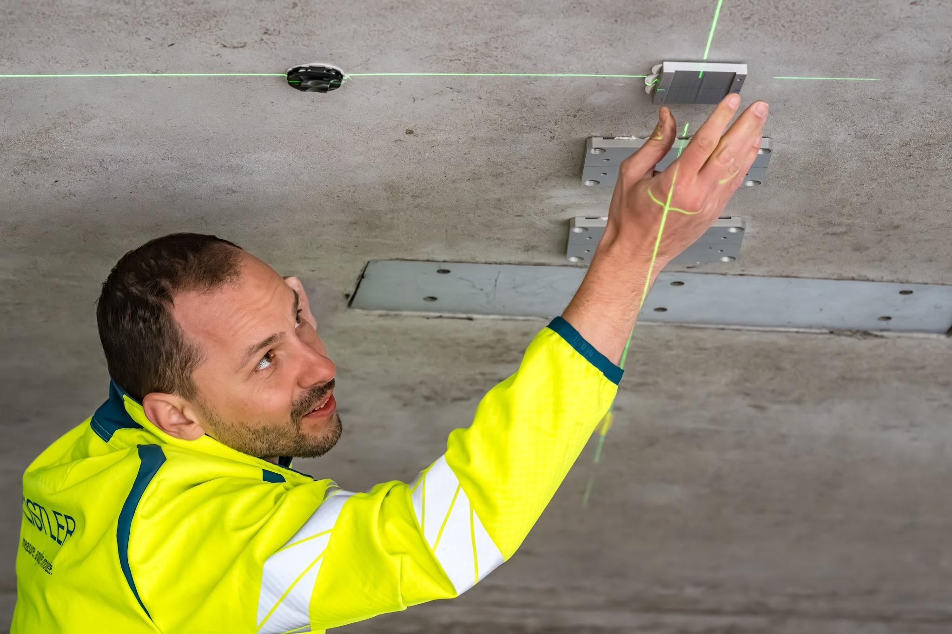
Kistler Instrumente AG
Live Bridge Monitoring
Explore Kistler's digital Structural Health Monitoring on a real bridge – connect with our team.
Ad
More options


Chat paused until usage resets at 2:59 PM
You’ve reached the limit for chats that include files or images. Start a new text-only chat or upgrade to continue now.
New chat
Claim free offer
what are the types of materials that LA bridges uses and what tech could be used to detect structural issues? how could we detect seimmic bearing joints strenght from an outside persepctive?
Sponsored options
Ad

