1. Architecture
   1. Flow chart of usability

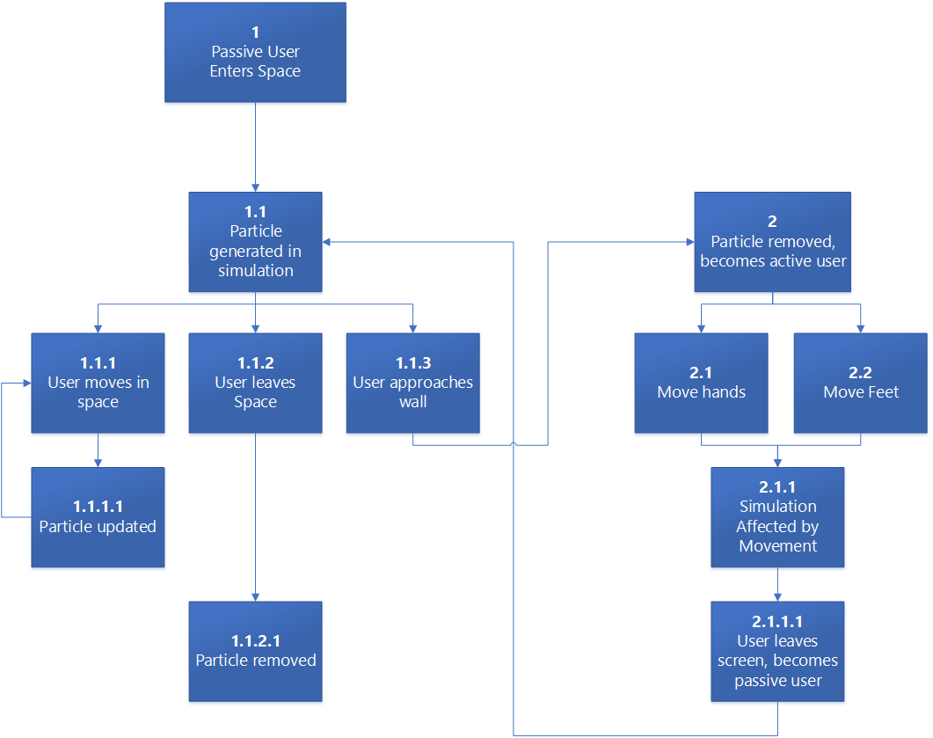

1. Wire Frames
   1. Mockup 2-4 different layouts
2. Diagrams & Physical Layout
   1. Diagram of installation setup

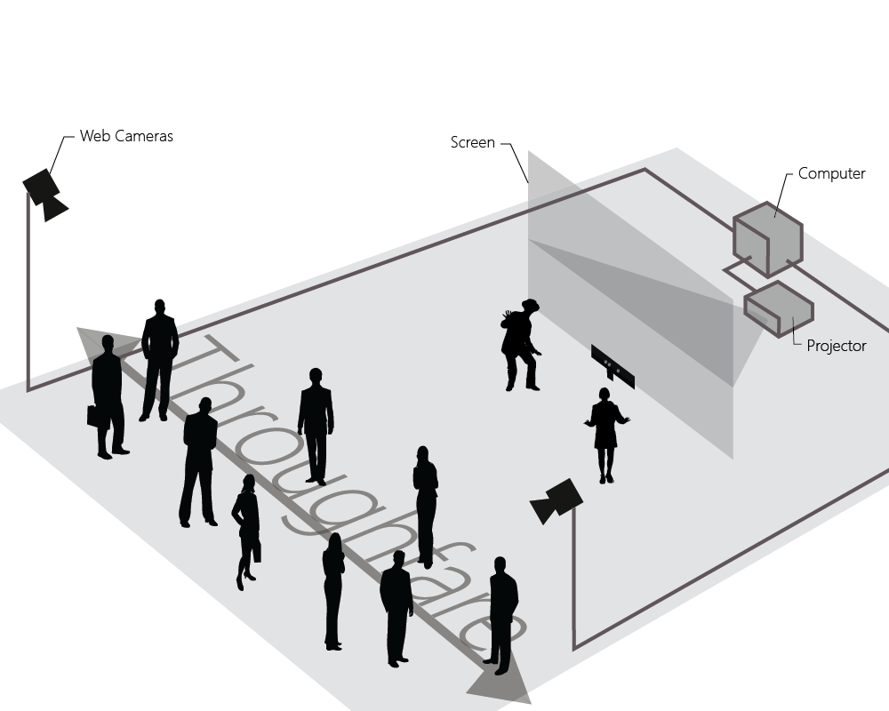

1. Design Comp
   1. Two complete mockups of visual
   2. Two different scenes / scenarios