Test 1: Click “new post” and leave Title and image blank.

Test:

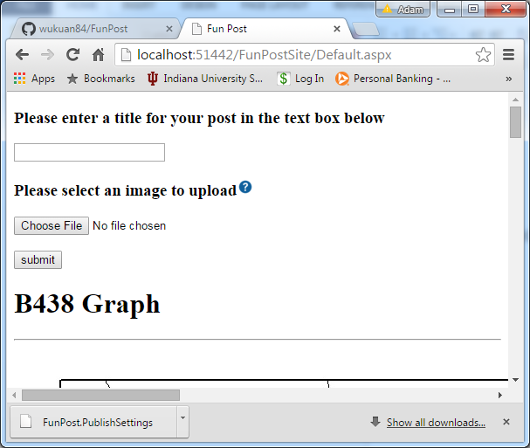

Result:

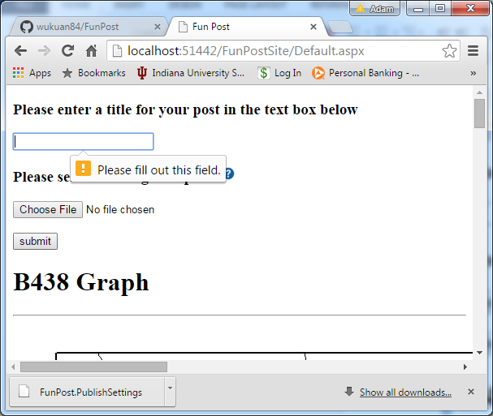

Test 2: Click “new post” button, enter a title but don’t insert and image.

Test:

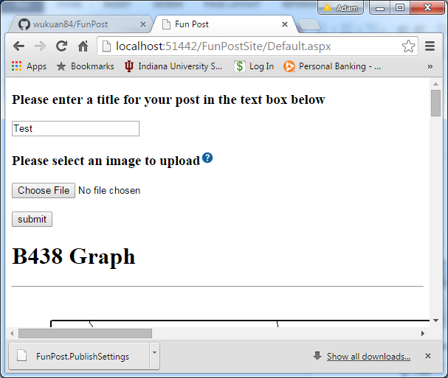

Result:

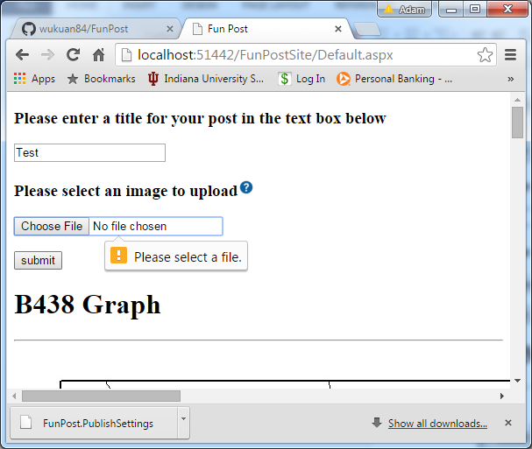

Test 3: Click the “new post” button, enter a title but insert and invalid image file.

Test:

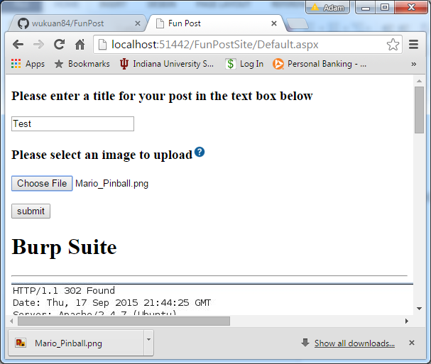

Result:

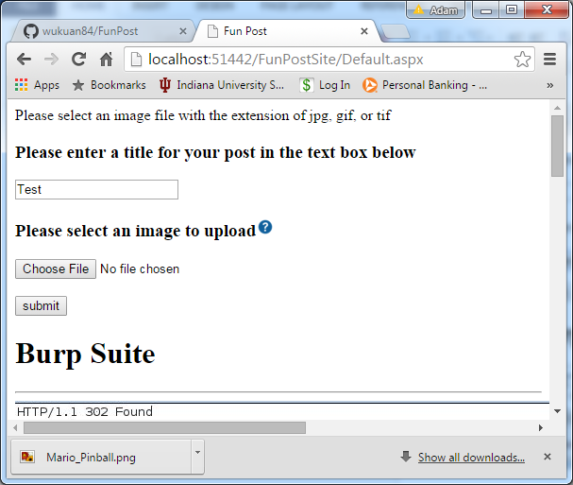

Test 4: Click the “new post” button, enter a title but insert a file that is not an image file.

Test:

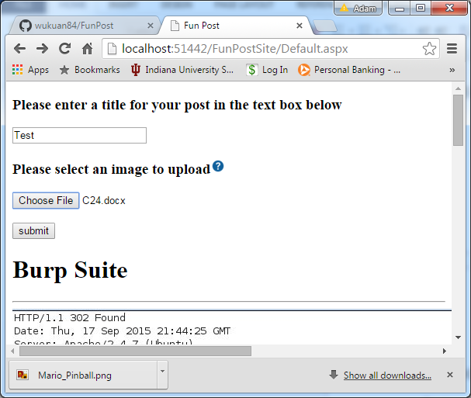

Result:

