When you load our web page you come to the main screen that looks something like this:

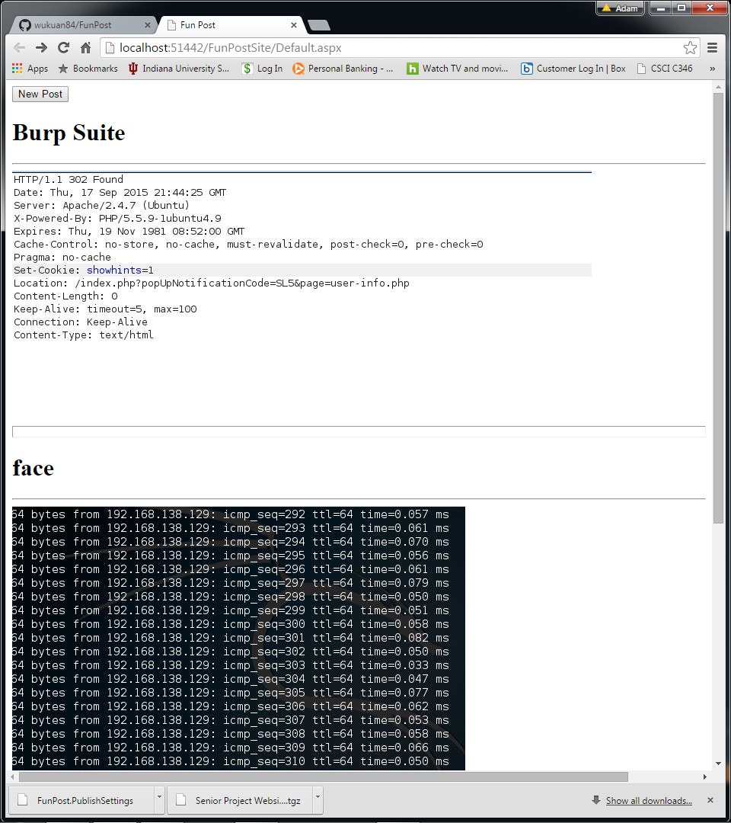

At the top of the screen there should be a button labeled “new post”. When this button is clicked the screen will look something like this:

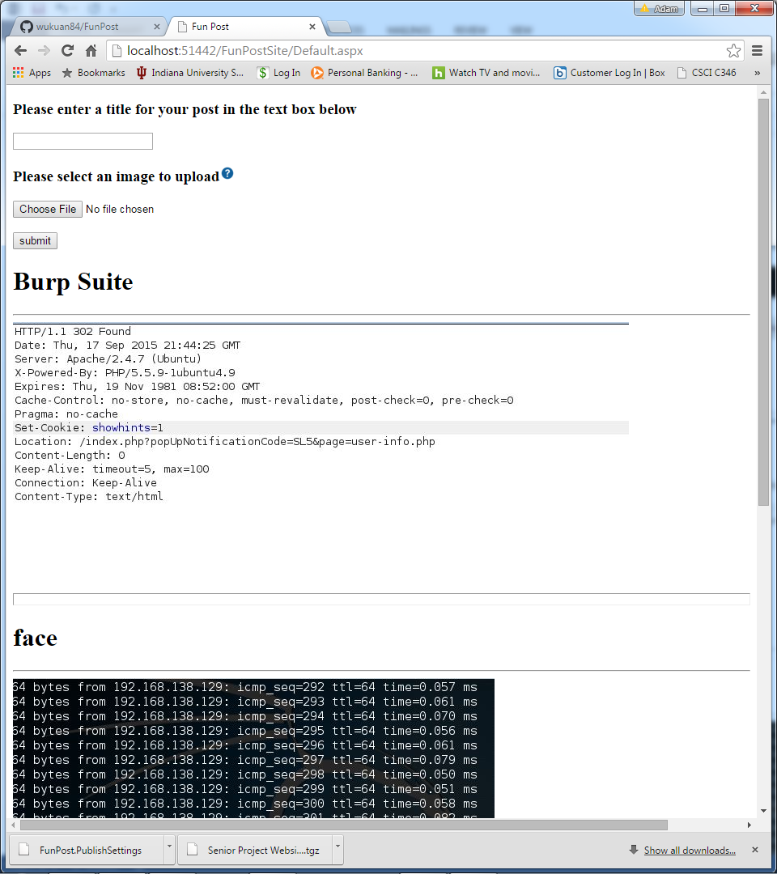

There will be a textbox in which you can enter a title for your post and a button that when clicked will allow you to select a file to upload. The site will only allow you to upload image files. The file types the site will currently allow are:

**.jpg**

**.gif**

**.tif**

When the file is selected it will appear to the right of the “Choose File” button. Below is an example of a post to the site.

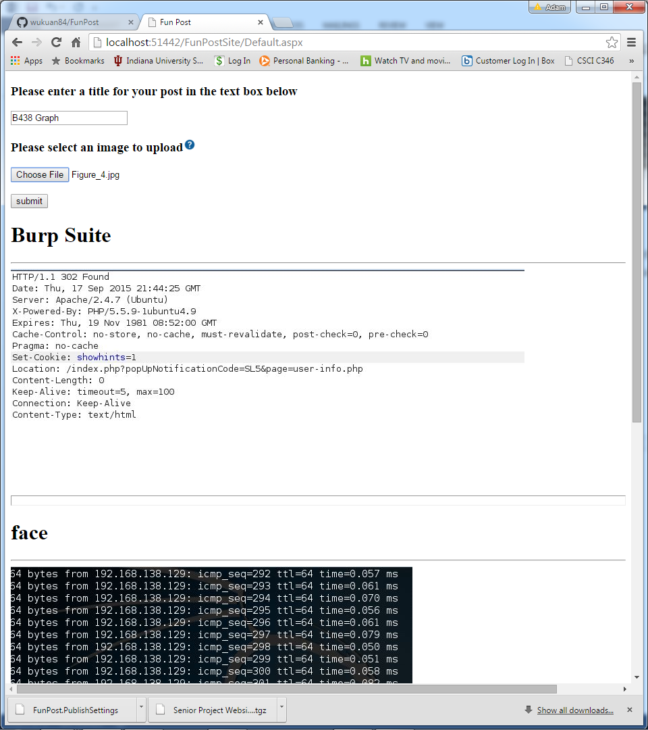

After the submit button is clicked the site will then look like the picture below, with the image you added being posted on the top of the sites feed.

