Module 2: Project Deliverable 3

Ryan Johnson,

Arizona State University

IFT 458

Professor Quach

March 28th

Screenshots of Questions/Answers

Question 1

Is the file tracked or untracked?

Answer

**It is untracked.**

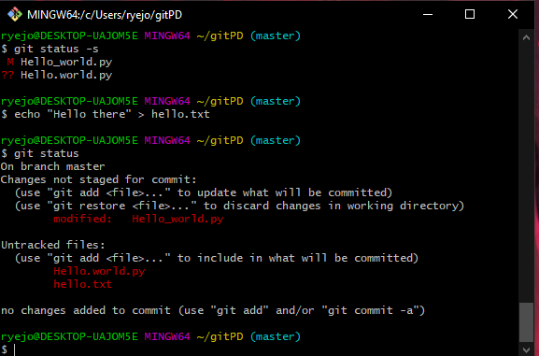

Question 2

Is the file tracked or untracked and what does “Changes to be committed” mean?

Answer

**It is now tracked as seen by it being in green text. Also, the changes that need to be committed implies that those files exists in the staging area and the next step is for them to be committed into the local repository.**

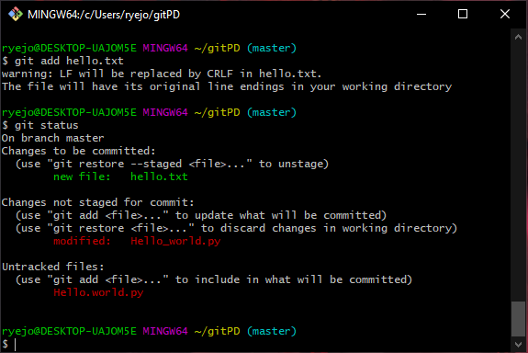

Questions 3

1. Why do you see the file listed twice?
2. Where is the version that is listed as Changes to be committed (in the working directory, staging area, or local repository)?
3. Where is the version that is listed as Changes not staged for commit (in the working directory, staging area, or local repository)?

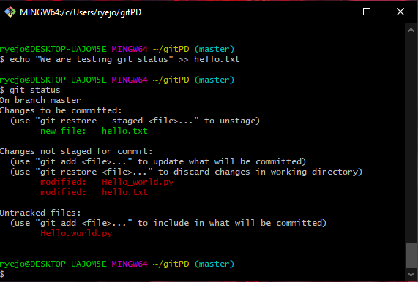

Answer

**A.) You see the file listed twice because there is one version of the same file in the working directory and another in the staging area.**

**B.) It is in the staging area. The phrase implies that this version’s next step is to the local repository using a commit.**

**C.) It is in the working directory. The phrase implies that this version’s next step is to the staging area since it is currently not staged.**

Question 4

Which version did you commit: the one in the staging area or the one in the working directory? (Hint: Which one is left [shows up in the status]? Note the changes not staged for commit part of the status message.)

Answer

**The one in the staging area was committed. The content is supposed to go through the staging area into the local repository.**

