Ryan Epstein

Day You Were Born Program

Software Design Document

**Table of Contents**

|  |  |  |
| --- | --- | --- |
| **1.** | **INTRODUCTION** | **2** |
| 1.1 | Purpose | 2 |
| 1.2 | Scope | 2 |
| 1.3 | Definitions and Acronyms | 2 |
| **2.** | **SYSTEM OVERVIEW** | **2** |
| **3.** | **SYSTEM ARCHITECTURE** | **2** |
| 3.1 | Decomposition Description | 2 |
| **4.** | **DATA DESIGN** | **3** |
| 4.1 | Data Description | 3 |
| **5.** | **COMPONENT DESIGN** | **3** |
| **6.** | **User INTERFACE DESIGN** | **4** |
| 6.1 | Overview of User Interface | 4 |
| 6.2 | Screen Images | 4 |
| **7.** | **REQUIREMENTS MATRIX** | **4** |
|  |  |  |
|  |  |  |
|  |  |  |
|  |  |  |
|  |  |  |
|  |  |  |

**1. INTRODUCTION**

**1.1 Purpose**

This software design document describes the system design of the Day You Were Born software. It is aimed at users who are curious about which day of the week they were born on.

**1.2 Scope**

The DYWB application will take input from the user in the form of their date of birth. Then DYWB will return the day of the week that the date provided fell on.

**1.3 Definitions and Acronyms**

*DYWB – Day You Were Born (name of the software)*

**2. SYSTEM OVERVIEW**

The system utilizes the Java calendar library to efficiently find the day of the week.

**3. SYSTEM ARCHITECTURE**

**3.1 Decomposition Description**

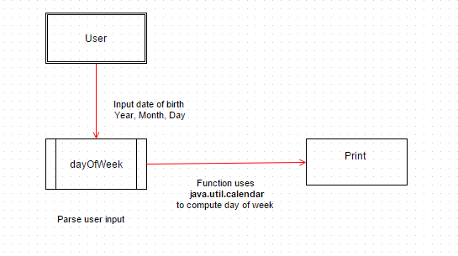

**4. DATA DESIGN**

**4.1 Data Description**

After the user inputs year, month, and day are saved as respective variables and passed to the dayOfWeek function.

.

**5. COMPONENT DESIGN – Pseudo Code**

class dayOfWeek

{

Void main()

{

String month

String day

String year

Get year born from user input

Get month born from user input

Get day born from user input

Concatenate strings to **year / month / day** format

Call dayOfWeek function on the string

}

String dayOfWeek(Date)

{

Call java SimpleDateFormat to try

if Date is valid input

Return day of the week from Date

Else

Return invalid date

}

}

**6. User INTERFACE DESIGN**

**6.1 Overview of User Interface**

The program is designed to be ran in a command-line environment.

**6.2 Screen Images**

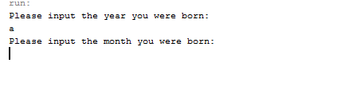

**7. REQUIREMENTS MATRIX**

Implement an application that will perform the following actions:

1. Prompt the user and read in value for the year of their birth (e.g. 1994)

2. Prompt the user and read in a value for the month of their birth(e.g. 2 for February)

3. Prompt the user and read in a value for the day of their birth (e.g. 14).

4. Print out the day of the week (Sunday, Monday, Tuesday, Wednesday, Thursday, Friday, or Saturday) on which that day falls for year.

e.g. "You were born on a Sunday"