KWIC Implemented with Main/Subroutine Architectural Style (Assignment 1)

Table of Contents

1.1 Introduction 1
1.1.1 Definition of the Problem 1
1.1.2 Example 2
1.1.3 Assignment 1 2
1.2 The Existing System 2
1.2.1 Architecture 2
1.2.2 Properties of the Existing KWIC System 3
1.2.3 Source Code and Documentation 3
1.2.4 Test Data 3
1.3 Data Representation 4
1.4 Processing Algorithm 6
1.5 Your Assignment 7
1.5.1 Programming Assignment 7
1.5.2 Understanding Check 7
1.6 Modification of the Existing Data Representation 7
1.7 Modification of Functionality of the Existing System 8
1.8 Questions 9

Introduction

Definition of the Problem
The Key Word In Context (KWIC) problem is defined as follows:
The KWIC index system accepts an ordered set of lines; each line is an ordered set of words, and each word is an ordered set of characters. Any line may be circularly shifted by repeatedly removing the first word and appending it at the end of the line. The KWIC index system outputs a listing of all circular shifts of all lines in alphabetical order.

Example
Consider the following set of lines:
- Star Wars
- The Empire Strikes Back
- The Return of the Jedi
The KWIC index system produces the following output (comparison is case-sensitive, that is capital letters are greater than small letters):
- Back The Empire Strikes
- Empire Strikes Back The
- Jedi The Return of the
- Return of the Jedi The
- Star Wars
- Strikes Back The Empire
- The Empire Strikes Back
- The Return of the Jedi
- Wars Star
- of the Jedi The Return
- the Jedi The Return of

Assignment 1
To accomplish the Assignment 1, you need first to get acquainted with the existing KWIC system. After that you need to extend the functionality of the existing system to meet the following requirements. Finally, you need to answer to these three questions.

The Existing System

Architecture
The solution with main/subroutine architectural style with shared data decomposes the system according to the four basic functiones performed: input, shift, alphabetize and output. These functiones are coordinated as subroutines by a main program, that sequences through them.
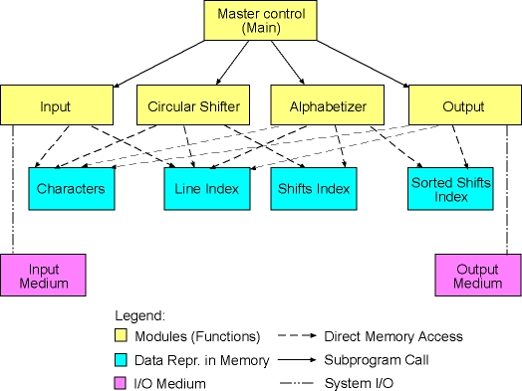

Properties of the Existing KWIC System
The existing KWIC system is characterized through:
- Data Representation
- Processing Algorithm

Source Code and Documentation
Here is the source code in Java for the existing KWIC system, and the automatically generated javadoc documentation for the system.

Test Data
Here is a sample input file for the KWIC system. Please, save the file on your local drive. Specify the name of the file at the command line as an argument to the KWIC program.

Data Representation
The current KWIC system represents its data in the following format:
- Characters from the input file are stored in a character array named chars_. Words are delimited by a single space character.
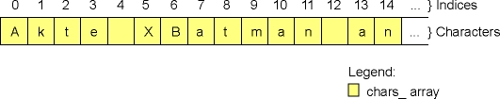
- line_index_ is an integer array, which keeps indices of characters from the character array. Each index kept in the line index array is the index of the first character of a particular line.
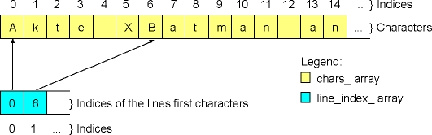
- Two dimensional integer array (matrix) named circular_shifts_ represents the set of all circular shifts of all original lines. A particular circular shift is represented as a pair of indices. The first value in such a pair is an index of the original line from the line index array. The second value in the pair is an index of a character from the character array. The character pointed by this index is the first character of a particular circular shift.
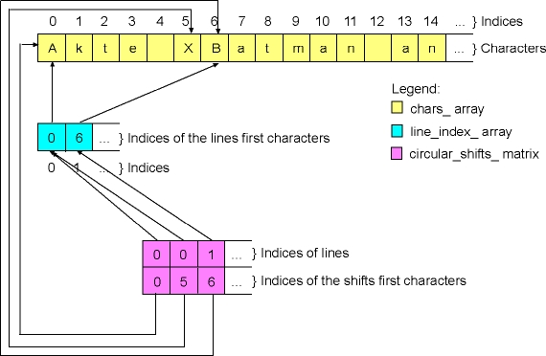
- Two dimensional integer array (matrix) named alphabetized_ represents the sorted lines. This array has the same format as the circular shifts array. The difference is that in the alphabetized array lines come in a different order, i.e., they are sorted alphabetically.
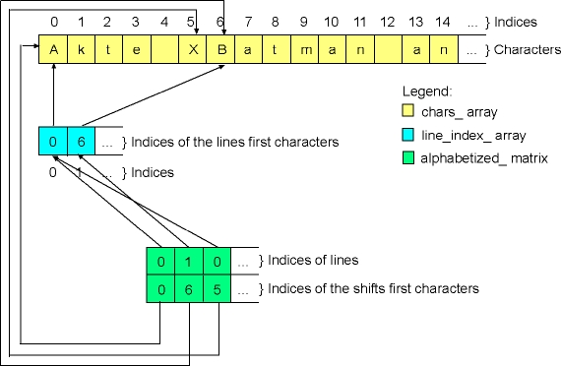

Processing Algorithm
The main function controls the execution of the KWIC program:
- The input function is called to read and parse the lines from an input file. This function reads and processes all lines at once and represents it by means of the character (chars_) and line index (line_index_) array, as described before.
- The main function calls the circularShift function, which produces circular shifts of each particular line and stores it in the circular shifts array (circular_shifts_), as discussed before.
- After the circular shifts have been produced, the main function calls the alphabetize function, which sorts circular shifts alphabetically. The result is stored in the alphabetized array (alphabetized_), as described before.
- Finally, the main function calls the output function, which prints the sorted lines.

Your Assignment

Programming Assignment
You need to modify the existing system in the following way:
- Modification of data representation
- Modification of functionality

Understanding Check
Finally, you need to answer to these three questions.

Modification of the Existing Data Representation
You need to modify the way how circular shifts and sorted circular shifts are represented by the KWIC system. In the new version, circular shifts should be now represented in the same way as the original lines, that is:
- All characters from all circular shifts should be stored in a new character array. For instance, consider the following original line: "Akte X". This line has two circular shifts (the first circular shift is equal to the original line): "Akte X", "X Akte". All characters from both circular shifts should be stored completely in the new character array one after another, as shown in the following figure.
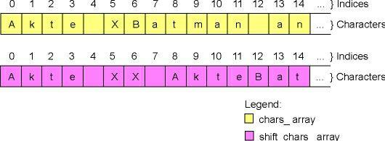
- Shift index is an integer array, which keeps indices of the first characters of circular shifts stored in the new character array.
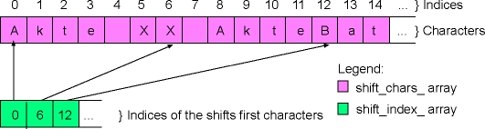
- The sorted shifts are represented in the same way and with the exactly same arrays as the circular shifts. Of course, the indices in the shift index array are arranged differently, i.e., they are sorted alphabetically.
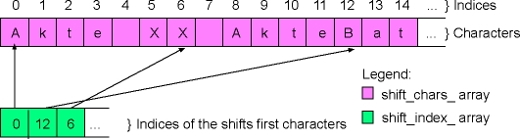

Modification of Functionality of the Existing System
You need to provide the existing KWIC system with additional functionality. The new KWIC system should be able to filter out some of the circular shifts that are produced. All circular shifts that start with a number, i.e., all shifts where the first character is a character between '0' and '9' should be removed from the shifts array before the sorting starts.
Hint: Add a new module, i.e., a new function to the existing sytem. The name of the new module can be filter, and it should be responsible for iterating through the produced shifts and removing all the shifts that starts with a number. The main function should call the filter function right after the circularShift function and just before the call of the alphabetizing function.
Thus, the architecture of the new system looks as shown in the following picture. Note, that the modification in data representation is already visible in the figure.
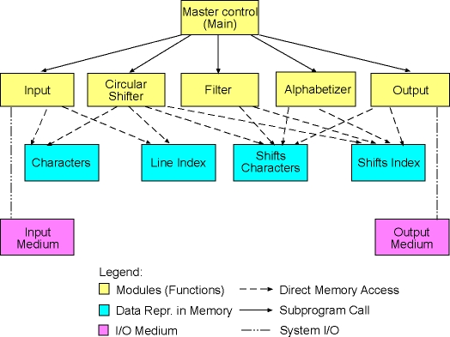

Questions
Please, answer the following questions:
- Which modules from the original KWIC system did you need to modify to implement the new data representation of circular shifts? What conclusion can you draw here? How does the KWIC system implemented by means of main/subroutine architecture with shared data withstand design changes in data representation?
- Which modules from the original KWIC system did you need to modify to add filtering function to the system? Was it difficult to add a new processing component (filter function) accessing the shared data? Can we conclude here that the KWIC system with main/subroutine architecture with shared data is robust to desing changes in system's function (assuming that new functions access the shared data)?
- Would it be difficult to reuse modules from the existing KWIC system in other systems? For example, suppose that in another software system we need to sort a number of lines. Suppose also that in this system lines are represented differently than in the existing KWIC system. Could we reuse the existing alphabetizing function as it is, or do we need to make some modification to the exisiting code to be able to reuse it?

