KWIC Implemented with Object-Oriented Architectural Style (Assignment 2)

Table of Contents

1.1 Introduction 1
1.1.1 Definition of the Problem 1
1.1.2 Example 2
1.1.3 Assignment 2 2
1.2 The Existing System 3
1.2.1 Architecture 3
1.2.2 Properties of the Existing KWIC System 4
1.2.3 Source Code and Documentation 4
1.2.4 Test Data 4
1.3 Static Class Diagram 5
1.3.1 What is a Static Class Diagram? 5
1.3.2 Static Class Diagram of the Existing System 5
1.4 Dynamic Sequence Diagram 8
1.4.1 What is a Dynamic Sequence Diagram? 8
1.4.2 Dynamic Sequence Diagram of the Existing System 8
1.5 Your Assignment 10
1.5.1 Programming Assignment 10
1.5.2 Understanding Check 10
1.6 Modification of the Existing Data Representation 11
1.7 Modification of the Existing Processing Algorithm 13
1.8 Questions 14

Introduction

Definition of the Problem
The Key Word In Context (KWIC) problem is defined as follows:
The KWIC index system accepts an ordered set of lines; each line is an ordered set of words, and each word is an ordered set of characters. Any line may be circularly shifted by repeatedly removing the first word and appending it at the end of the line. The KWIC index system outputs a listing of all circular shifts of all lines in alphabetical order.

Example
Consider the following set of lines:
- Star Wars
- The Empire Strikes Back
- The Return of the Jedi
The KWIC index system produces the following output (comparison is case-sensitive, that is capital letters are greater than small letters):
- Back The Empire Strikes
- Empire Strikes Back The
- Jedi The Return of the
- Return of the Jedi The
- Star Wars
- Strikes Back The Empire
- The Empire Strikes Back
- The Return of the Jedi
- Wars Star
- of the Jedi The Return
- the Jedi The Return of

Assignment 2
To accomplish the Assignment 2, you need first to get acquainted with the existing KWIC system. After that you need to extend the functionality of the existing system to meet the following requirements. Finally, you need to answer to these three questions.

The Existing System

Architecture
The solution with object-oriented architectural style decomposes the system into six modules:
- LineStorage module, responsible for holding all characters from all words and lines.
- Input module, responsible for reading the data from a file and storing it in LineStorage module.
- CircularShifter module, responsible for producing circular shifts of lines stored in LineStorage module.
- Alphabetizer module, responsible for sorting circular shifts alphabetically.
- Output module, responsible for prinitng the sorted shifts.
- Master control module, responsible for controling the sequence of method invokations in other modules.
Contrary to the main/subroutine solution, in the object-oriented solution the data is not shared between the computational components. Instead, each module provides an interface that permits other components to access data only by invoking methods in that interface. For example, LineStorage module provides the public interface that allows other modules to set character in a particular word in a particular line, read a specific character, read, set or delete a particular word in a specific line, read whole line at once, etc.
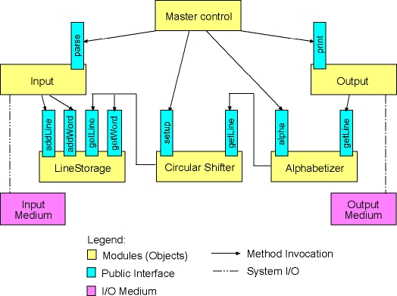

Properties of the Existing KWIC System
Since the existing KWIC system is an object-oriented system, it can be easily described by:
- Class Diagram, depicting the result of static analysis and design of the system.
- Sequence Diagram, depicting the dynamics of the system.

Source Code and Documentation
Here is the source code in Java for the existing KWIC system, and the automatically generated javadoc documentation for the system.

Test Data
Here is a sample input file for the KWIC system. Please, save the file on your local drive. Specify the name of the file at the command line as an argumnet to the KWIC program.

Static Class Diagram

What is a Static Class Diagram?
Static class diagram is the result of static analysis and design of the KWIC problem and proposed object-oriented architectural solution of the problem. Such diagram includes the following information:
- It describes how modules from the original architectural solution maps onto classes from an object-oriented programming language (Java in our case).
- It depicts the public interface of each identified class. (Since we have an object-oriented system here, each object of a class from the system encapsulates its data. That means that all information contained in an object of a particular class is hidden from the outside world, i.e. other objects in the system can not access it directly. To be still able to manipulate the data of an object, its class provides a public interface, i.e., a number of public methods, which are called by other objects.)
- It depicts instance variables (attributes) of classes, i.e., data representation from each class is shown in the diagram.
- Finally, the diagram shows how classes relate to each other. Class relations are shown by means of so-called associations.

Static Class Diagram of the Existing System
Here is the UML (Unified Modeling Language) class diagram of the current system.
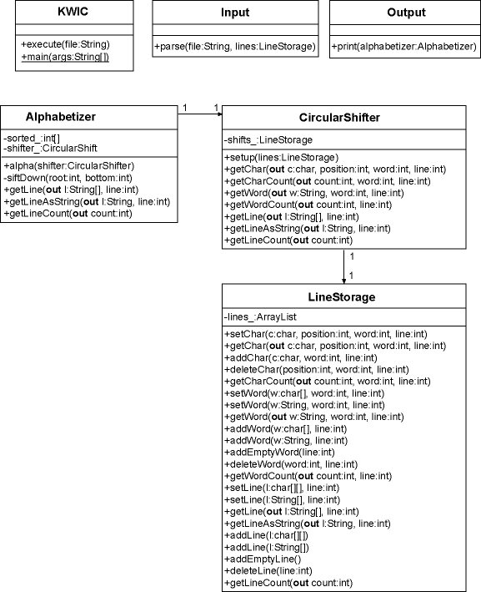
Here is a short description of the diagram:
- Each module from the architectural design maps exactly onto one class. Thus, there exist KWIC class (Master Control module), Input class, Output class, LineStorage class, CicrularShifter class and Alphabetizer class. Each class is represented as a rectangle box, having three horizontally arranged sub-boxes. The name of each class is written in the top sub-box.
- Public interface of each class is written into the bottom sub-box, as a list of method declarations. The plus (+) sign in front of a method name means that the method is defined as public and may be invoked by objects of other classes. The argument list is written within parenthesis. Each argument is represented with the name, its type and the direction in which the argument is passed. If there is no direction modifier that means that this method takes this argument, and if there is out modifier that means that the method returns this argument as a return value to the calling object. For example, +getChar(out c:char, position:int, word:int, line:int) method from the LineStorage class takes as arguments three integere values: position of the character, index of the word, and index of the line, and returns the value of that character.
- Instance variables (attributes) of a class are shown in the middle sub-box. The minus (-) sign in front of an instance variable means that the variable is defined as private and may not be manipulated by other objects directly. Instead, the public interface of the class should be applied to do so. That is completely in accordance with object-oriented principles of data encapsulation and information hiding, discussed above. After the minus sign, the name and the type of a particular instance variable are shown. For example, the LineStorage class has one private instance variable: lines_. This instance variable is of type ArrayList, and holds a list of lines.
- Finally, we have a number of associations between some of the classes. An association means that associated classes have as instance variables the objects of the associated class. For example, the Alphabetizer class has an association with the CircularShift class. That means that an object of the Alphabetizer class has as an instance variable an object of the CircularShift class. This variable is also depicted in the middle box of the Alphabetizer class. We can spot there shifter_ variable, which is of type CircularShifter. The numbering at each association end means that exactly one object of the Alphabetiter class holds exactly one object of the CircularShifter class.

Dynamic Sequence Diagram

What is a Dynamic Sequence Diagram?
Dynamic (interaction) diagrams describe how group of objects collaborate to execute a certain task in a running program. In other words these diagrams show graphically the processing algorithm and its dynamic behaviour in a running system. Sequence diagram is a special type of dynamic diagrams that describes the time sequence of method invokations on the run-time in the following way:
- Objects are shown as boxes at the top of the diagram.
- Time is represented with the so-called object's lifeline - vertical line beneath the object's box. The time increases downward along the vertical object's lifeline.
- Method invokation is simbolized through a horizontal line connecting two vertical object's lifelines. The name of the method is written above such horizontal line. Obviously, horizontal lines which are further downwardds on an object's lifeline are invoked later in time than methods represented as horizontal lines nearer to the top of the object's lifeline.
- Conditions for method invokation and iterative method invokations may be simbolized with special signs. For example, iterative method invokation is depicted with the * sign.

Dynamic Sequence Diagram of the Existing System
Here is the UML (Unified Modeling Language) sequence diagram of the current system.
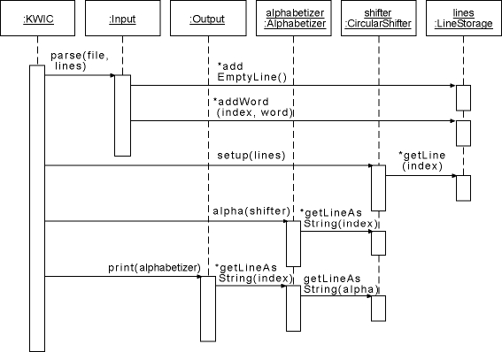
Here is a short description of the diagram:
- An object of the KWIC class controls the whole execution of the program. Firstly, the KWIC object invokes the parse method of an object of the Input class. This method takes as arguments the name of the file containing lines, and an object of the LineStorage class to store the data.
- The parse method of the Input object reads the data from the file. For each line in that file it creates a new line in the LineStorage object by invoking the addEmptyLine method on that object. After a new line has been created the Input object parses the line and adds all words (by means of addWord), one after another into the new line. The iterative property of this process is simbolized in the diagram with * signs in the front of the method names. After all words and lines has been processed, the parse method returns.
- The KWIC object invokes the setup method on an object of the CircularShifter class. This method takes as an argument the LineStorage object holding the lines and produces circular shifts of all lines at once. During the execution of the setup method, the CircularShifter object iterates through all lines in the LineStorage object, simbolized in the diagram with * sign in the front of the getLine method of the LineStorage object.
- After circular shifts have been created, the KWIC object invokes the alpha method of an object of the Alphabetizer class. This method takes as an argument the CircularShifter object and sorts circular shifts alphabetically. During this process the Alphabetizer object invokes getLineAsString method of the CircularShifter class a number of times. Again, this is simbolized in the diagram with * sign in the front of the getLineAsString method of the CircularShifter object.
- Finally, the KWIC object invokes the print method on an object of the Output class. This method takes as an argument the Alphabetizer object from the previous step. It iterates (* sign) then through all lines from the Alphabetizer object by invoking getLineAsString on that object. Notice that this method just forwards the request to the CircularShifter object to retrieve the data. Of course, the forwarded request does not include the original index, but the sorted one instead. When the print method returns, the execution of the program is finished.

Your Assignment

Programming Assignment
You need to modify the existing system in the following way:
- Modification of data representation
- Modification of processing algorithm

Understanding Check
Finally, you need to answer to these three questions.

Modification of the Existing Data Representation
In the current version of the LineStorage class we have the following data structure for storing lines:
- An instance variable with the name lines_ of type ArrayList holds all lines. The ArrayList class implements all standard dynamic list operations, i.e., we can add elements at the end of the list, we can insert elements in an arbitrary position in the list, we can delete elements, etc. An element stored in an instance of the ArrayList class can be any Java object. This can be done because instances of the ArrayList class hold instances of the Object class, which is the root of the single rooted Java class hierarchy, i.e., any Java class is a subclass of the Object class.
- In the current implementation lines_ variable holds objects of the ArrayList class. That is, each line is again represented through an object of ArrayList class. Inside this list we store words of that particular line. Words are stored as instances of the String class.
You need to modify the data structure for storing lines in LineStorage objects. The new data representation should look as follows:
- A new class should be defined, providing the storage for a single line and a public interface to manipulate the content of a line. The name of the new class should be Line.
- The Line class stores a line into an object of the ArrayList class. The name of this instance variable should be words_. Words should be stored as instances of the String class in the words_ object.
- The LineStorage class keeps lines in the same lines_ object. However, this list is now filled with instances of the Line class.
The following class diagram depicts the modifications you need to implement. Note, that just those two classes that are relevant for the modification are shown. All other classes remain the same.
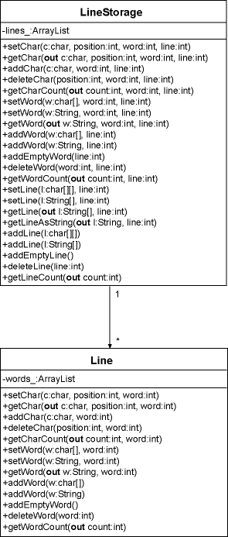

Modification of the Existing Processing Algorithm
First, you need to implement an interactive version of the KWIC index system. That means the system won't read lines from a file but lines are inserted interactively by means of a simple command line user interface. Here is a transcript of a sample session:
- Add, Print, Quit: a
- > Star Wars
- Add, Print, Quit: a
- > The Empire Strikes Back
- Add, Print, Quit: a
- > The Return of the Jedi
- Add, Print, Quit: p
- Back The Empire Strikes
- Empire Strikes Back The
- Jedi The Return of the
- Return of the Jedi The
- Star Wars
- Strikes Back The Empire
- The Empire Strikes Back
- The Return of the Jedi
- Wars Star
- of the Jedi The Return
- the Jedi The Return of
Further, you need to modify how line shifting is performed. In the current version all lines are read at once, and line shifting is done on all lines at once after they are read. In the new version you need to perform line shifting on each line as it is read from the command line. The following sequence diagram depicts the new situation.
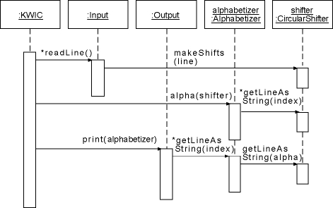
Here is a short description of the diagram. The KWIC object controls the command line interface. After a command for adding a line has been issued, the KWIC object invokes readLine method of the Input object. The Input reads the line and passes it to the CircularShifter object by invoking its makeShifts method. After shifts have been made, makeShifts and readLine methods return and the KWIC object is again in charge, waiting for a new command from the user.

Questions
Please, answer the following questions:
- Which modules from the original KWIC system did you need to modify to implement the new data representation of lines within the LineStorage class? What conclusion can you draw here? How does the KWIC system implemented by means of object-oriented architecture withstand design changes in data representation within a particular module? Is this true for any other object-oriented system?
- Which modules from the original KWIC system did you need to modify to implement a new processing algorithm in the system? Can we conclude here that the KWIC system with object-oriented architecture is robust to desing changes in processing algorithm of the system?
- Would it be difficult to reuse modules from the existing KWIC system in other systems? For example, suppose that in another software system we need to sort a number of lines. Suppose that the sorting algorithm expects lines to be represented as arrays of characters. Can you describe a possible object-oriented solution to reuse the LineStorage class without need to modify the source code of the class.

