Django-assessment

Task 1:

1. After cloning the repo, cd to the working directory which is “testing” and create superuser using the command “docker-compose run django-assessment/manage.py createsuperuser” and fill in all the required inputs.

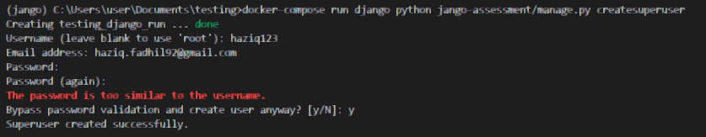

1. Later “docker-compose run django-assessment/manage.py makemigrations” and “docker-compose run django-assessment/manage.py migrate”
2. To run the docker container, type the command “docker-compose up --build” for first time. Later we can use “docker-compose up”.
3. Go to the “127.0.0.1:8000/admin” and login using the created superuser account
4. Then go to the top right of the page and click “add user”. it will redirect to the page to add user.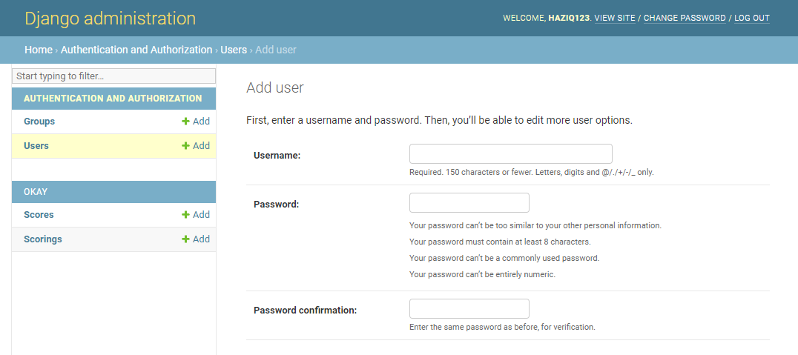
5. Fill in the required items and save.
6. Later logout and go to the required url 127.0.0.1:8000/okay/score/get_score

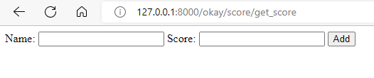

1. To ensure that the entered value is working we can login into admin and look at the app named Scores

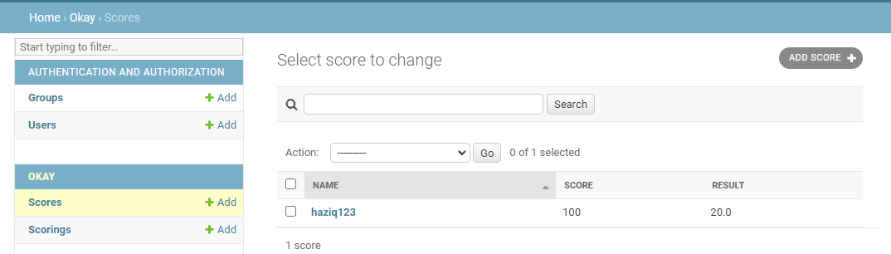

1. The result column is 20 because I used the formula result = score*20/100. so based on the image I keyed in the name as ‘haziq123’ and score as ‘100’ so the result would be ‘20’.

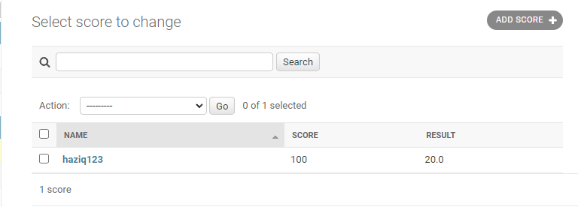

Task 2: Simple Admin Panel and Staff Can Edit too

1. For this task, we will create another user from superuser. First click add user from the top right of the page, then fill in the username and password and save.

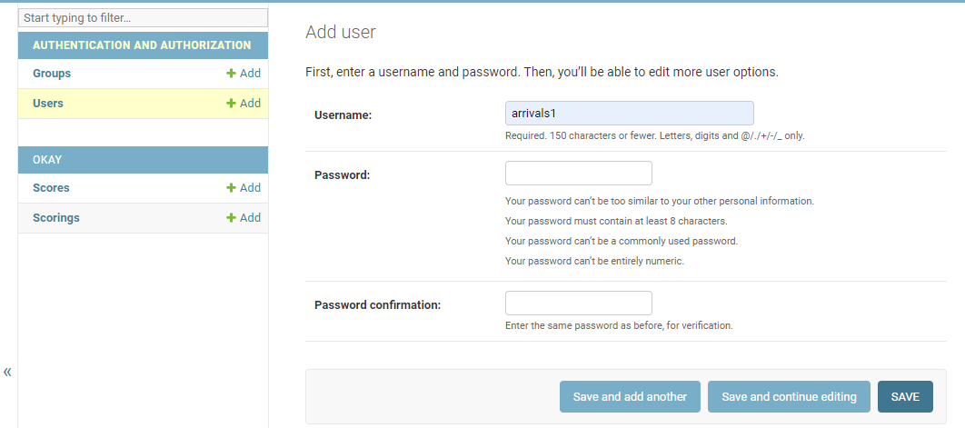

1. Then click on the user and edit the permissions so that it can view, edit, and remove tables. Save.

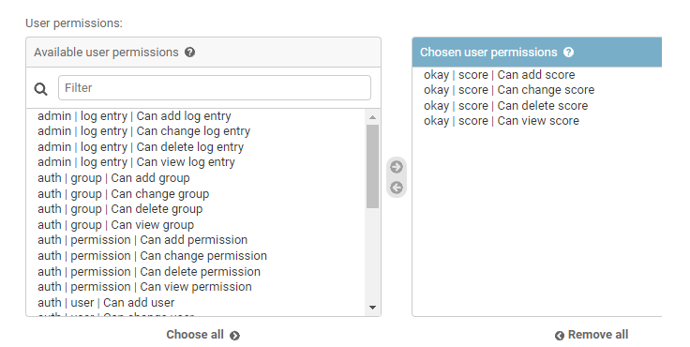

1. Then logout as superuser and login as user and click on the ‘Scores’. it will show as image shown below

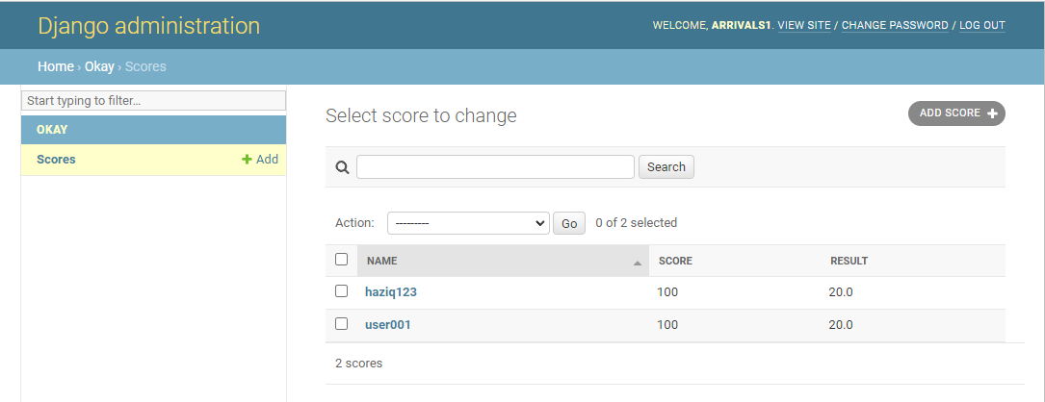

1. There we can make queries as shown in image below too.

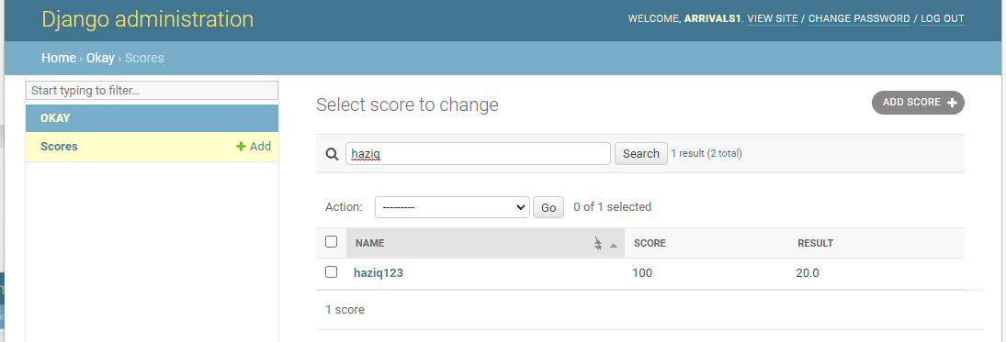

1. Click and we can view, edit or delete the values.

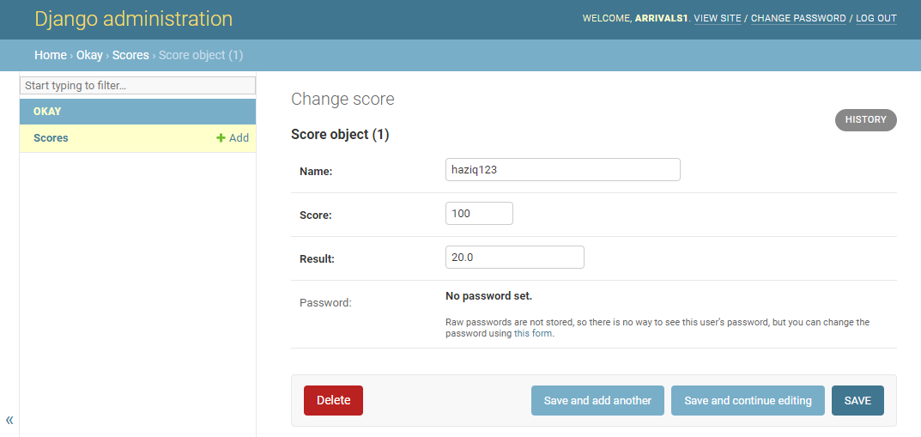

Task 3: Migrations.

1. A video will be attached to show how the migrations. <https://drive.google.com/file/d/1sDYXKYr5xenXbV1s1Y7hshAUAe77M29A/view?usp=sharing>

Task Bonus: open ended:

Todo_fastapi: <https://github.com/ryezaku/todo_fastapi>

Face_recognition_fastapi: <https://github.com/ryezaku/face_rec>