**Problem 1**: Map the ER model given in the Figure to the corresponding relational model. The ER model is a representation of SHIP TRACKING database.

For the write up below, I’ve placed each name in bold. Below the bolded name, are each scheme belonging to the name.

**Ship**

|  |  |
| --- | --- |
| SName | Owner |

**Ship-Movement**

|  |  |  |  |  |
| --- | --- | --- | --- | --- |
| Sname | Date | Time | Latitude | Longitude |

**Ship-Type**

|  |  |  |  |
| --- | --- | --- | --- |
| Type | Sname | Tonnage | Hull |

**Visits**

|  |  |  |  |
| --- | --- | --- | --- |
| SName | PName | StartData | End Data |

**Port**

|  |  |
| --- | --- |
| PName | SName |

**State/Country**

|  |  |  |
| --- | --- | --- |
| Name | Port Name | Continent |

**Ocean/Sea/Lake**

|  |  |
| --- | --- |
| Name | PortName |

**Problem 2:** Map the relational schema of Figure 6.14 into an ER schema. This is part of a process known as reverse engineering, where a conceptual schema is created for an existing implemented database. State any assumptions you make.

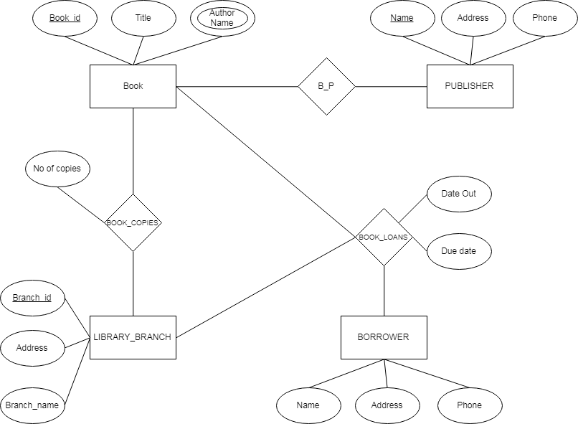

As we see from above, BOOK_AUTHORS is a multivalued attribute. This means that this attribute can be represented as a type that is defined as a weak entity. The BOOK_AUTHOR can vary from different variables. From figure 6.14, we see that it has more than one values that it is linked to. This means that it has more than one purpose.