**Question #1**

For the graph below, there are some points to keep in mind. Attributes that are underlined, are the primary keys necessary for the graph. Arrows between each box represent the flow and relationship between the two inferences. FK, which appear next to some attributes, stand for the “foreign keys.” As we look upon the graph, it does not contain any points of redundancy.This is due to the fact that any point of redundancy will in turn slow down the rate of data. Thus, using up too much space for storage. For an example, attributes such as course and student number can obtain a numerical value, in the sense of creating a much more efficient form of identification. However, with more values being added upon this system, this causes too many points to be reached by the system alone. The more paths causes the need for more storage; in turn causing the slow down of data transferring. Instead, the use of primary keys designates all the data upon one attribute. Using the foreign key (FK), this will connect other attributes simultaneously.

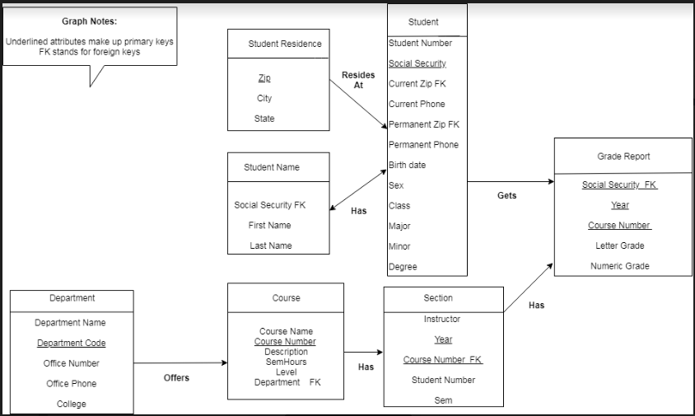

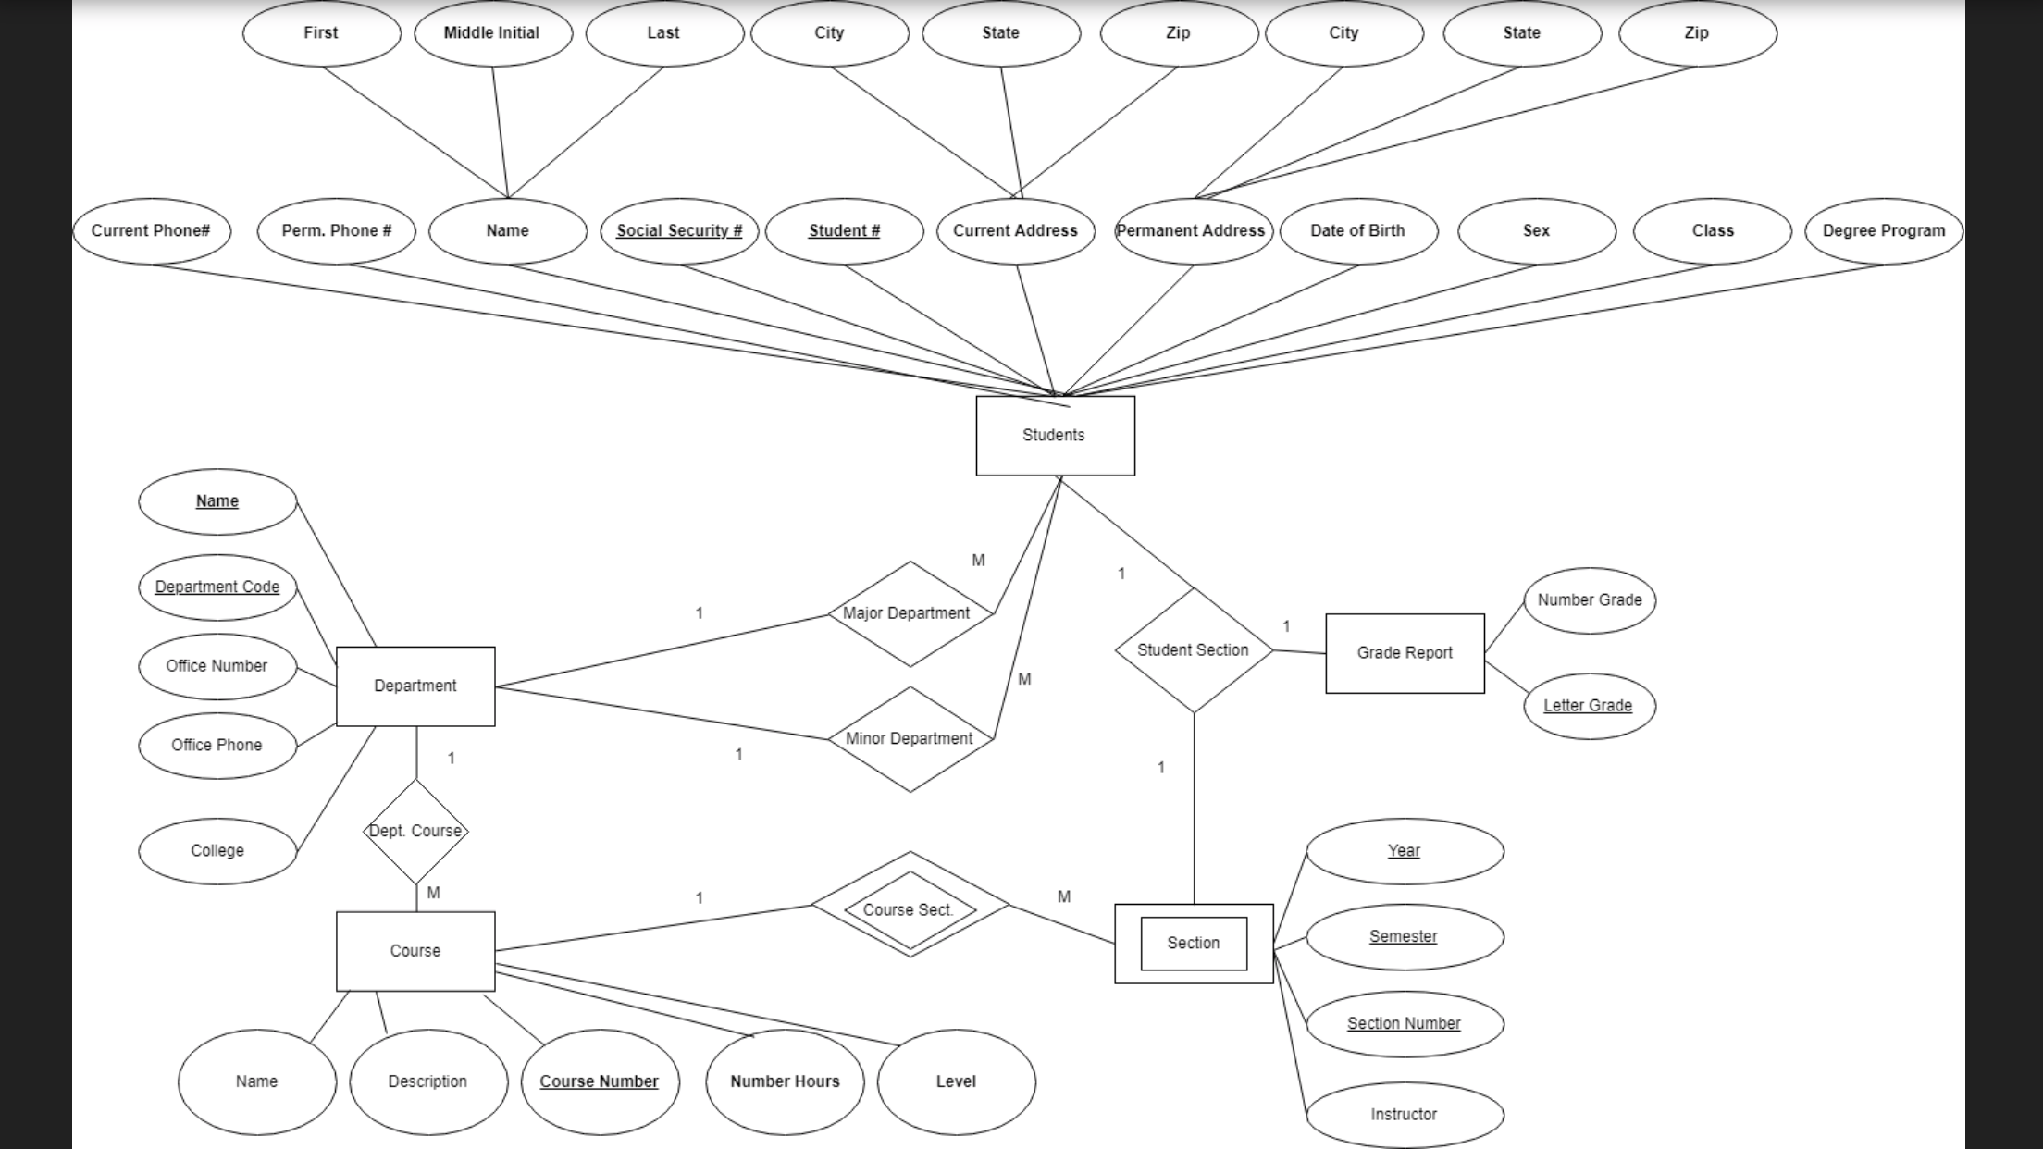

**Question # 2**

The repair key located on the graph represents both the repair dates, and vin numbers.

