Meeting agenda

**Date:** 2016-04-26

**Facilitator:** Andreas Carlsson  
  
**Participants:** Lina Blomqvist, Andreas Carlsson, Felix Engelbrektsson, Robin Lilius-Lundmark  
  
1. Resolve any issues preventing the team to continue (5 min)

No issues except keep on working hard.

Not enough graphics (Robin+Lina)

2. Reports (15 min) from previous meeting

Implemented AI

Explosions are working

Game area is larger (21 x 15 instead of 16 x 14)

Fixed graphic bugs

Not as much graphic generated as we would wish for, needs more for new   
 functions (tex Menu is hard to continue with without graphic)

3. Discussion items (35 min)   
 **- Go through planning again:**

We’ve got super flow, but need to get our focus on.

Things we need to focus on:

* All game specific administration, as new game, spawning on spawn points, death of character and respawn, timer of game and finally end of game.
* JUnit-testing of model
* Looking up multiplayer

**- Worked through a first menu mockup:**

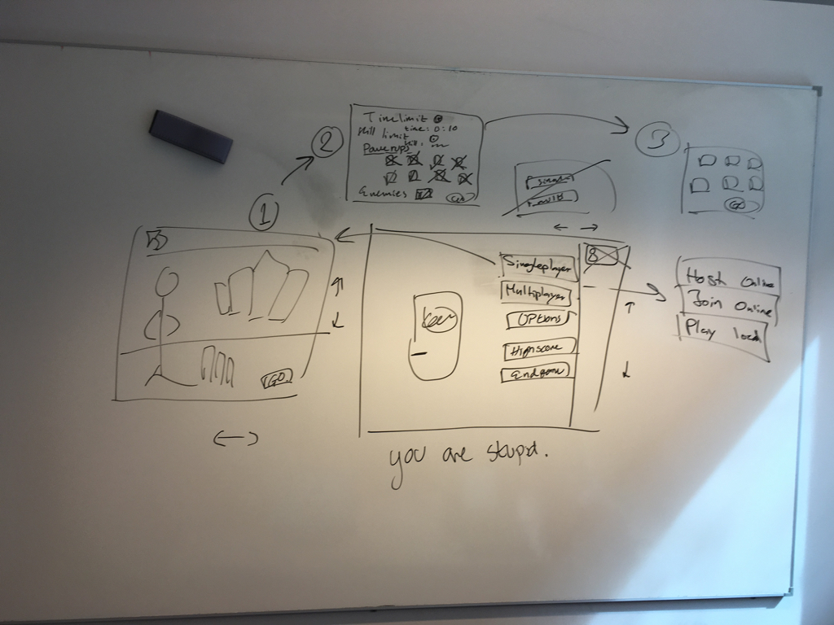

4. Outcomes and assignments (5 min)

Work on menu/game administrations (Lina/Andreas)

JUnit tester (Felix, testansvarig)

More graphics (Robin)

5. Wrap up  
 Next meeting thursday 28:th april