## Requirements and Analysis Document for Totally Vaporwave

## Version: 1.1

## Authors: Lina Blomkvist, Andreas Carlsson, Felix Engelbrektsson, Robin Lilius-Lundmark

## 1 Introduction

This section gives a brief overview of the project.

### 1.1 Purpose of application

Entertain users with a unique styled bomberman game.

### 1.2 General characteristics of application

Totally vaporwave

### 1.3 Scope of application

This is??

### 1.4 Objectives and success criteria of the project

A functional and fun game, available for everyone with an internet connection around the world. We want to separate ourselves from similar games with a vaporwave theme. It should also be possible for multiplayer gaming.

### 1.5 Definitions, acronyms and abbreviations

|  |  |
| --- | --- |
| **Character Move** | **Definition** |
| Move Character | A character moves seamlessly one tile in any direction. |
| Drop Bomb | A character places a bomb onto the current tile. |
| Die | A character’s health has come down to 0 and a death animation is played. |
| Re/Spawn | A character spawns in one of the designated spawn tiles of the current arena (often the arena’s corners). *A character respawns at the tile it died.* - Might be bad idea cuz ppl might just farm you over and over, especially CPU players |
| Pick Up Powerup | A character moves over a powerup symbol in the arena, which immediately boosts the powerup stat, e.g. a speed powerup raises character move speed. |
| Pick Up Superpowerup | A character moves over a super powerup symbol, which initiates the super power gained by it, during a countdown timer. When timer reaches zero, the super power stops. |

|  |  |
| --- | --- |
| **Stat** | **Definition** |
| Stat | Players current statistics in the game, like health, speed, number of bombs and bomb range. |
| Health | How many health points a character has. When those run out, the character dies. |
| Speed | The moving speed of a character. |
| Bombrange | How far the bomb reaches when exploding. |
| Love | A human emotion of no importance to robots. |
|  |  |
|  |  |
|  |  |
|  |  |

|  |  |
| --- | --- |
| **Super/Powerup** | **Definition** |
| Powerup | A collectible bonus item that increases a character stat. Can be picked up on the arena. Spawns in a random location at a random time. |
| Superpowerup | A collectible bonus item that makes something special happen in order to make it harder for the other players to play effectively. |
| Inventory Powerup | Increases the number of bombs the player can carry |
| Speed Powerup | Increases the character’s speed when moving. |
| Bombrange Powerup | Increases the character’s bomb range of the player. |
| Health Powerup | Increases or refills the character’s health by a set number of points. (Two different) If full health and it’s a refill nothing happens. |
| Energydrink Powerup | Speed powerup. |
| Illuminati Superpowerup | Freezes all other characters for a limited time. |
| Japanese Radio Station Superpowerup | Turns on a japanese radiosegment for all the other players in an attempt to annoy them. Maybe also annoying visuals? |
| The Grudge Superpowerup | Affects all other players. The grudge sound is played followed by a jumpscare picture in an attempt to annoy other players. |

|  |  |
| --- | --- |
| **Graphical Representation** | **Definition** |
| GUI | All the graphical interface elements, such as menus and HUD (see picture below). |
| HUD | A graphical representation of the in-game important stats, e.g. Speed, Health etc. |
| Bomb Blast | The visual explosion of the fire, reaching as long as the bombs range. |
| Sprite | A graphic representation of game elements on screen, such as characters, enemies or bombs. |
| Healthbar | A visual representation of how much health the player’s character have left. |
| Timebar | A visual representation of how much time there is left of the current game. |
| Super timebar | A visual representation of the countdown timer that comes with most super powerups. |
| Scorebar | A visual representation of the current player’s score. |
| Wall (destructable) | A visual representation of a block in the arena that cannot be walked through, but can be destroyed if within the bomb range when a bomb explodes. |
| Wall (indestructible) | A block in the arena that cannot be walked through, nor destroyed. |
| Arena | A visual representation of the the map where players and bombs are placed. |
| Tile | A visual representation of the map’s grid blocks, containing some kid of sprite, or being empty with the arena visible behind. |
| Character | Graphical representation of the player on the screen |

|  |  |
| --- | --- |
| **In game statistic** | **Definition** |
| Timelimit | The time the current game is supposed to be played. When the time has run out the game is over. |
| Kill limit | An optional maximum kill count. When any player reaches this limit, if it is active, the game is over. |
| Score | The score, a number of points, the player increases by killing enemies and/or other players. |
| Kill | When a player takes out another player’s character, by lowering its health below zero, mainly using bombs. |
| Kill count | The number of kills a player has accumulated. |
| Damage | When a character gains health haphazardly. |
|  |  |

|  |  |
| --- | --- |
| Game Logistic | Definition |
| Map | A gridmap where character position etc. is calculated. |
| Custom Map | A map with blocks placed by us, no computer generation needed. |
| Random Map | A map with different kinds of blocks randomly generated by the computer. |
| Block | A node in the gridmap. |

|  |  |
| --- | --- |
| **Player/Character** | **Definition** |
| Enemies | Adversaries of lesser intelligence. Controlled by the computer. |
| CPU | Computer controlled player, with AI that can compete with that of a human player. |
| Multiplayer | When 2-4 players of the humankind controls a character each, and tries to eliminate each other. |
| Player | The user in control of the character. |

|  |  |
| --- | --- |
| **Menu** | **Definition** |
| Start Menu | The first menu in the game, from which you can reach every aspect of the game. A hub, of sorts. |
| Play Option | The main option in the start menu that takes you to the game part, starting with character select, then game customisation, and finally the game begins. |
| Select Character | When the user selects a character from the character select screen before the game begins. |
| Game customisation | A section of the menu where decisions for the game is made. These include; which map to play, what kill and/or time limit to have, which powerups to allow in the game, and so on. A default option is always available. |
| Options Menu | A menu reachable both from the start menu and in-game. Standard options, such as display settings or sound settings, can be altered here. |
| Highscore Menu | A menu section in the menu tree where the highscore is shown. |
| High Score Check | Checking high score from the menu, from the single player game screen and when a game is won. |
|  |  |

|  |  |
| --- | --- |
| **Player Move** | **Definition** |
| Start Game | When a user begins a new round and after s/he has selected a character. |
|  |  |

|  |  |
| --- | --- |
| **Misc** | **Definition** |
| Planning | A way of making sure that all the stuff that we want to do, gets done. |
|  |  |
|  |  |

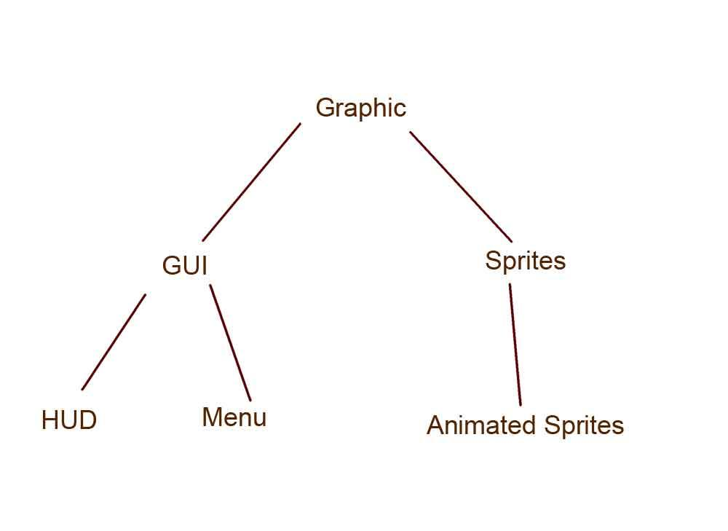

## 2 Requirements

In this section we specify all requirements

### 2.1 Functional requirements

* Scoreboard
* Character selection
* Playable rounds

### 2.2 Non-functional requirements

* Music and sound effects
* Pictures and icons

Possible NA (not applicable).

### 2.2.1 Usability

Implement support for use of external input devices (i.e. hand control )

### 2.2.2 Reliability

Strive for minimal number of crushes.

### 2.2.3 Performance

Application needs to respond instantly to users actions and the lag across computers in a multiplayer game has to be reduced to a minimum.

### 2.2.4 Supportability

### System requirements should be held to a minimum (Win 95)

### 2.2.5 Implementation

The application will be built using Java with minimal use of external resources

.

### 2.2.6 Packaging and installation

Package application as a jar-file. Installation is simply by dragging to file onto the desired location on the disk.

### 2.2.7 Legal

We won’t bother with the use of copyrighted material in the first version of the game. However it’s important to know what’s copyrighted and what’s not for the preliminary public release of the game.

### 2.3 Application models oklart

### 2.3.1 Use case model

UML and a list of UC names (text for all in appendix)

### 2.3.2 Use cases priority

1. Move
2. Place bomb
3. Stand within bomb radius
4. Get hurt
5. Power up

### 2.3.3 Domain model

UML, possible some text.

### 2.3.4 User interface Mockup

### 2.4 References

### 

### 

### APPENDIX

### 

Use cases

**Use Case: MoveCharacter**

**Summary:** SelectCharacter and StartGame Player wants to move the character one tile in any direction.

**Priority:** High

**Extends:** -

**Includes:** -

**Participators:** One player and the application.

**Normal flow of events**

|  |  |  |
| --- | --- | --- |
|  | **Actor** | **System** |
| 1 |  | Shows top-down view of map |
| 2 | Presses “wasd” -key |  |
| 3 |  | Moves player one tile in the direction pressed. |
| 2.1 | Player tries to move into a wall or end of map. | Nothing |
| 2.2 | Walks onto a mine. | See: WalksOntoMine |

**Exceptional flow**

There is no exceptional flow

**Use Case: PlacingABomb**

**Summary:** Player presses a key to drop a bomb

**Priority:** High

**Extends:** -

**Includes:** -

**Participators:** One of the players and application

**Normal flow of events**

|  |  |  |
| --- | --- | --- |
|  | **Actor** | **System** |
| 1 | Presses the “drop bomb” key |  |
| 2 |  | Places a bomb in the current location of the player. Cooldown begins. |

**Alternate flows**

|  |  |  |
| --- | --- | --- |
|  | **Actor** | **System** |
| 2.1 | Cooldown is not finished. |  |
|  |  | Nothing happens |

**Exceptional flow**

There is no exceptional flow

**Use Case: StandWithinBombRadius**

**Summary:** If a player stands within a bomb’s radius, the character will lose health points.

**Priority:** High

**Extends:** -

**Includes:** -

**Participators:** One of the players and application

**Normal flow of events**

|  |  |  |
| --- | --- | --- |
|  | **Actor** | **System** |
| 1 |  | Stands within bomb radius. Character loses health points in relation with distance from bomb. |

**Alternate flows**

**Exceptional flow**

There is no exceptional flow

**Use Case: PickupPowerup**

**Summary:** A special game feature that may differ with character.

**Priority:** Medium

**Extends:** -

**Includes:** -

**Participators:** One of the players and application

**Normal flow of events**

|  |  |  |
| --- | --- | --- |
|  | **Actor** | **System** |
| 1 | Walks onto a tile with a powerup |  |
| 2 |  | Power-up effect activates directly. A timer shows up in an empty box displaying how much longer the powerups effect will last. |

**Alternate flows**

|  |  |  |
| --- | --- | --- |
|  | **Actor** | **System** |
| 2.1 | Walks onto a tile with a power-up, but already has  a power-up. |  |
| 2.2 |  | Does nothing. |

**Exceptional flow**

There is no exceptional flow

**Use Case: GetHurt**

**Summary:** If a characters health points drop to or below zero the character dies and respawns after a short timer.

**Priority:** High

**Extends:** -

**Includes:** -

**Participators:** One of the players and application

**Normal flow of events**

|  |  |  |
| --- | --- | --- |
|  | **Actor** | **System** |
| 1 | Player stands in bomb/mine radius when it explodes. |  |
| 2 |  | Health points drops x points, depending on how close to the bomb the player was. |

**Alternate flows**

|  |  |  |
| --- | --- | --- |
|  | **Actor** | **System** |
| 2.1 | Player stands in bomb/mine radius when it explodes and health points drops below zero. |  |
|  |  | Removes the character from map and after a few seconds respawns it in a different location with full health. |

**Exceptional flow**

There is no exceptional flow

### GUI

### Domain model

### Use case texts

### 