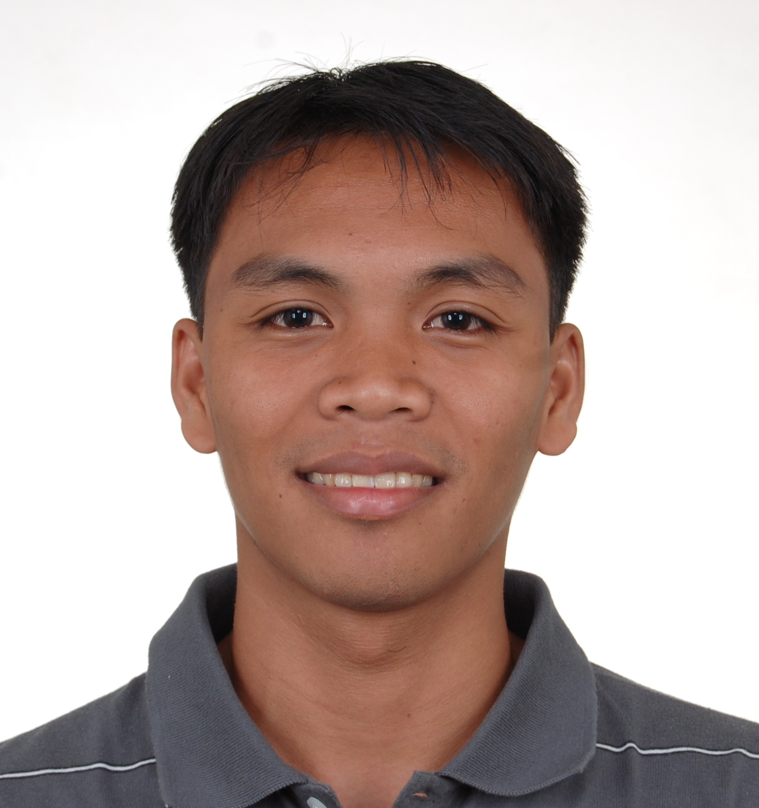
CURRICULUM VITAE
JAVE NHORIEL N. BORDAJE
Certified Public Accountant
P-9 Sta. Irene, Prosperidad, Agusan del Sur
Mobile Number: 09104770778
E-mail Address: jave_nhoriel@yahoo.com

DESIRED POSITION

Accountant II

CAREER OBJECTIVE:

- To be employed in an agency that has a continuing pursuit for excellence and good governance;
- To expose oneself to various challenging fields in auditing, accounting, business and public administration;
- To apply and improve leadership skills acquired in school;
- To get acquainted with government system and business trends;
- To serve the agency with all excellence and to be able to contribute to its success.

EDUCATIONAL ATTAINMENTS

Baccalaureate BACHELOR OF SCIENCE IN ACCOUNTANCY
Department of Accountancy
College of Business Administration and Accountancy
Mindanao State University, 9700 Marawi City
Academic Scholar
Department Service Awardee
April 2009

BACHELOR OF ACCOUNTING TECHNOLOGY
Department of Accountancy
College of Business Administration and Accountancy
Mindanao State University, 9700 Marawi City
Cum Laude
Academic Scholar
April 2008

Secondary STA. IRENE NATIONAL HIGH SCHOOL
Sta. Irene, Prosperidad, Agusan del Sur
Class Valedictorian
March 2004

Primary STA. IRENE CENTRAL ELEM. SCHOOL
Sta. Irene, Prosperidad, Agusan del Sur
Fourth Honorable Mention
March 2000

WORK EXPERIENCE

Accountant Provincial Accounting Office
Provincial Government Agusan del Sur
D.O. Plaza Government Center
Patin-ay, Prosperidad, Agusan del Sur
January 2010-Present

Accounting Responsibilities:

Preparation of separate monthly financial statements of General Fund-proper and General
Fund-20% which include:
- Trial Balance
- Balance Sheet
- Statement of Income and Expenses
- Statement of Cash Flows
- Report of Revenue and Receipts
- Supporting Schedules
Preparation of General Fund – Consolidated (General Fund-proper, General Fund-20%
and Economic Enterprises) which include.
- Trial Balance – Consolidated
- Balance Sheet – Consolidated
- Statement of Income and Expenses – Consolidated
- Statement of Cash Flows – Consolidated
- Report of Revenue and Receipts – Consolidated
- Supporting Schedules
Preparation of Statement of Cash Flows for Trust Fund
Preparing journal entries and supervising preparation by others
Posting of original entries to the general ledger accounts

Other responsibility
Preparation of the Provincial Fiscal Profile for the Strategic Financial Management Plan

Junior Cooperative Auditor Part-time
January 2010 - present

Instructor Mount Carmel College
San Francisco, Agusan del Sur
Part-time
2009 - present

Student Trainee Provincial Accounting Office
Provincial Government Agusan del Sur
D.O. Plaza Government Center
Patin-ay, Prosperidad, Agusan del Sur
250 hours
Summer of 2007

ORGANIZATIONAL AFFILIATION

Member Philippine Institute of Certified Public
Accountants (PICPA), Cagayan De Oro City 2009-present

Lifetime Member MSU Alumni Association 2009-present

President Junior Philippine Institute of Accountants (JPIA)
– Mindanao State University, Main Campus 2008-2009

Board Member National Federation of Junior Philippine Institute
of Accountants – Region 10 and CARAGA 2008-2009

VP-Non-Academic Affairs Junior Philippine Institute of Accountants (JPIA)
– Mindanao State University, Main Campus 2007-2008

Lifetime Member MSU-Commuters Hardcore 2006-present

Lifetime Member SINHS Alumni Association 2004-present

SEMINARS ATTENDED:

CERTIFICATES OF PARTICIPATION

“Public Financial Management Forum” held on April 21-24, 2010 at Citi Park Hotel, Cebu City

“Provincial Coaching on Public Financial Management” held on May 19-20, 2010 at Agusan del Sur Provincial Training Center, Prosperidad, Agusan del Sur.

Seminar on “Financial Reporting Disclosures,” December 7, 2008 at the College Of Business Administration and Accountancy, MSU- Marawi City.

Seminar on “Accounting for Changing Prices,” December 11, 2008 at the College Of Business Administration and Accountancy, MSU- Marawi City.

Seminar on “Special Reporting Issues,” February 4, 2009 at the College Of Business Administration and Accountancy, MSU- Marawi City.

Seminar on “Internationalization of Accounting Standards,” November 22, 2008 at the College Of Business Administration and Accountancy, MSU- Marawi City.

Seminar on “Taxation, Land Reforms and Cooperatives,” February 16, 2005 at the Academic Complex, MSU- Marawi City.

PERSONAL BACKGROUND

Date of Birth 15 May 1987
Place of Birth Agusan del Sur Provincial Hospital, Patin-ay, PADS
Citizenship Filipino
Civil Status Single
Height 5 feet and 8inches
Weight 141 lbs
Religious Affiliation Roman Catholic
Father’s Name Cornelio B. Bordaje (deceased)
Occupation Farmer
Mother’s Name Elenora N. Bordaje
Occupation Rural Health Midwife
Residential Address P-9, Sta. Irene, Prosperidad, Agusan del Sur
Special Skills Written and Oral Communication skills, literate in Microsoft Word, Excel and PowerPoint
Hobbies Playing basketball, volleyball and baseball and browsing the World Wide Web for updates
Languages Spoken Cebuano, Filipino, and English

CHARACTER REFERENCES

JOY DY LAGAT, CPA
Provincial Accountant-OIC
D.O. Plaza Government Center
Patin-ay, Prosperidad, Agusan del Sur
Cellular Phone Number: 09209061801

PROF. POTRE T. RIGA, CPA
Dean
College of Business Administration and Accountancy
Mindanao State University
Cellular Phone Number: 09155531251

I do hereby certify that the above statement are true, complete and correct to the best of my knowledge and belief and I agree that any misstatements as to material act will constitute grounds for immediate denial of my application.

JAVE NHORIEL N. BORDAJE
Applicant

